### Ajuste estado del estudio

### Agregar estado del estudio

1. Inicie sesión en BWCenter (nota: debe tener acceso administrativo para continuar)

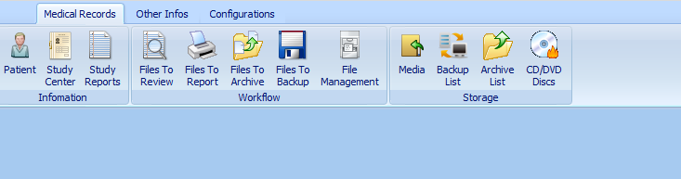

1. Haga clic en la otra pestaña de información.

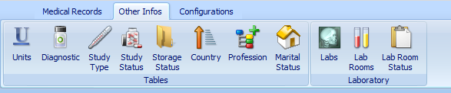

1. Haga clic en el estado del estudio.

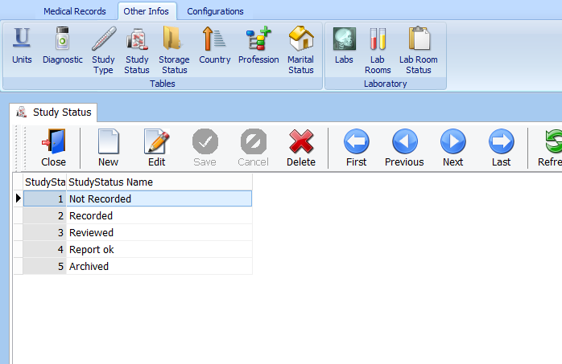

1. Haga clic en Nuevo.

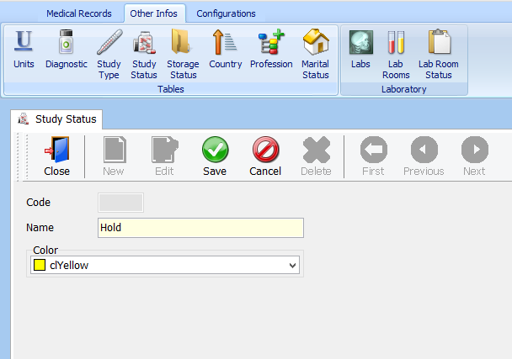

1. Ingrese el nombre del estado del estudio que está agregando y seleccione un código de color para él.
2. Haga clic en Guardar

### Eliminar el estado del estudio

1. Inicie sesión en BWCenter (nota: debe tener acceso administrativo para continuar).



1. Haga clic en la otra pestaña de información.



1. Haga clic en el estado del estudio.

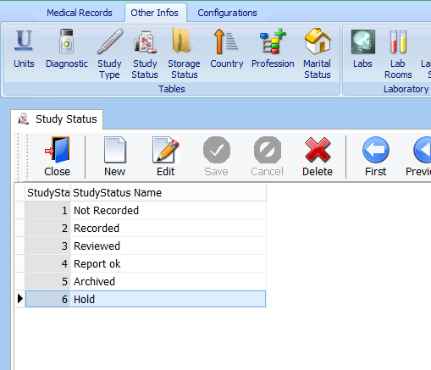

1. Seleccione el estado del estudio que desea eliminar.



1. Haga click en borrar.

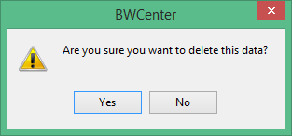

1. Haga clic en confirmar ( SI ).

### Ajuste estado de almacenamiento

Agregar estado de almacenamiento

1. Inicie sesión en BWCenter (nota: debe tener acceso administrativo para continuar)



1. Haga clic en la otra pestaña de información.



1. Haga clic en Estado de almacenamiento

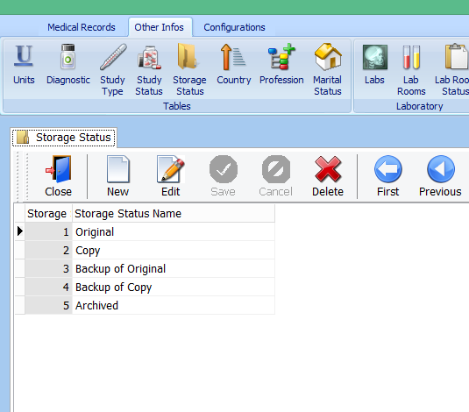

1. Haga clic en Nuevo

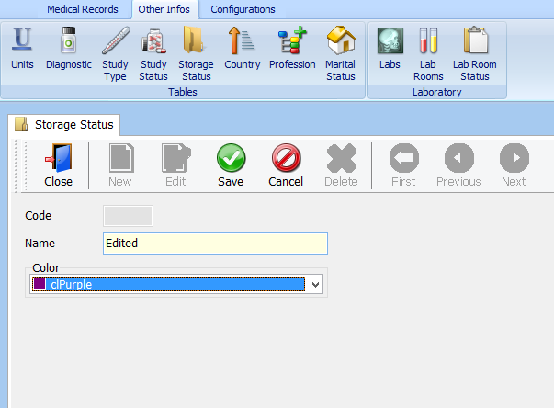

1. Enter the name of the storage status you are adding, and select a color code for it.
2. Click Save

### Removing Storage Status

1. Log in to BWCenter *(note: you must have administrative access to continue)*



1. Click on the other infos tab.



1. Click Storage Status

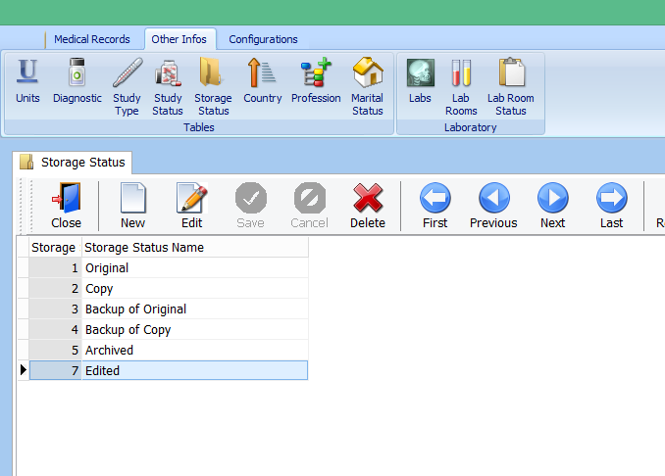

1. Select the Storage Status you want to remove.



1. Click Delete



1. Click Yes

## Adjusting Country Codes

### Adding Country Code

1. Log in to BWCenter *(note: you must have administrative access to continue)*



1. Click on the other infos tab.



1. Click Country

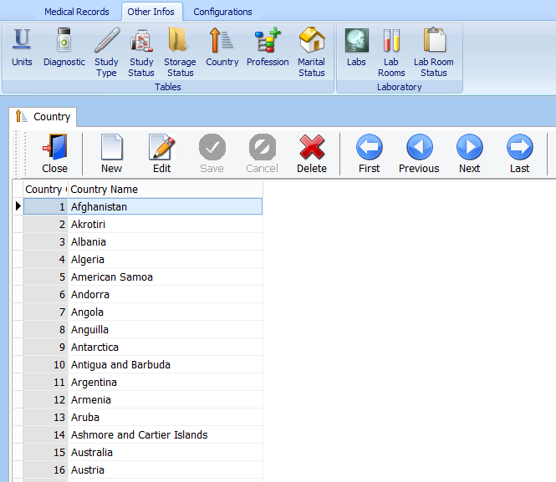

1. Click New

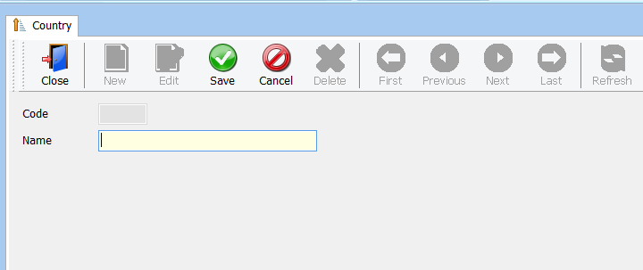

1. Enter the name of the country you are adding.
2. Click Save

### Removing Country Code

1. Log in to BWCenter *(note: you must have administrative access to continue)*



1. Click on the other infos tab.



1. Click Country

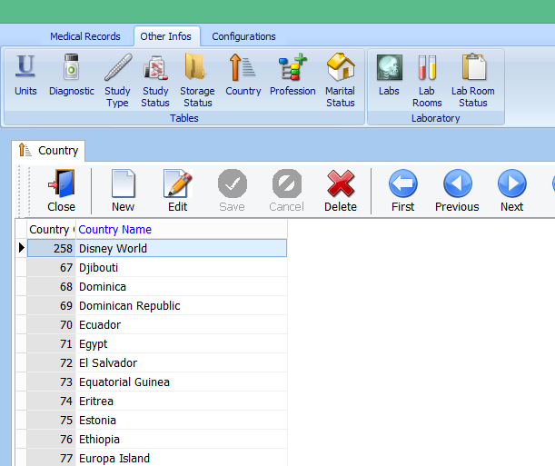

1. Select the County you want to remove.



1. Click Delete



1. Click Yes

## Adjusting Professions

### Adding Professions

1. Log in to BWCenter *(note: you must have administrative access to continue)*



1. Click on the other infos tab.



1. Click Profession

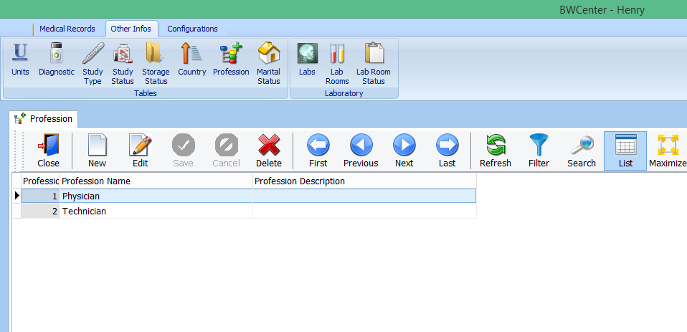

1. Click New

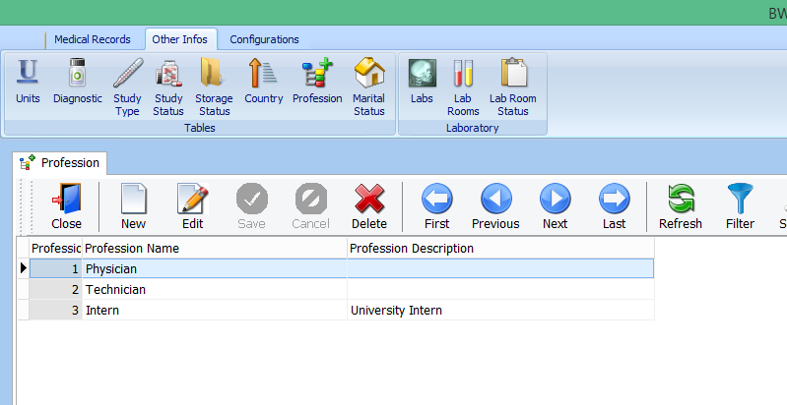

1. Enter the name of the profession you are adding
2. Click Save

### Removing Professions

1. Log in to BWCenter *(note: you must have administrative access to continue)*



1. Click on the other infos tab.



1. Click Profession

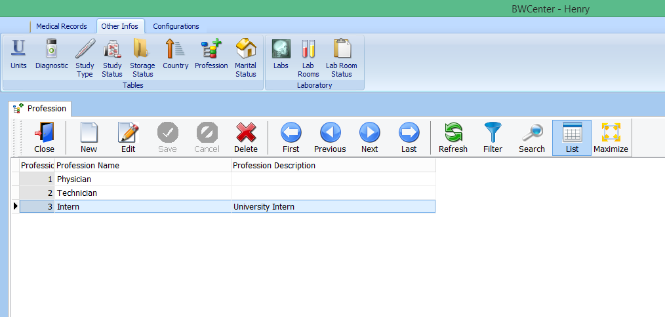

1. Select the Profession you want to remove.



1. Click Delete



1. Click Yes

## Adjusting Maritial Status

### Adding Marital Status

1. Log in to BWCenter *(note: you must have administrative access to continue)*



1. Click on the other infos tab.



1. Click Martial Status

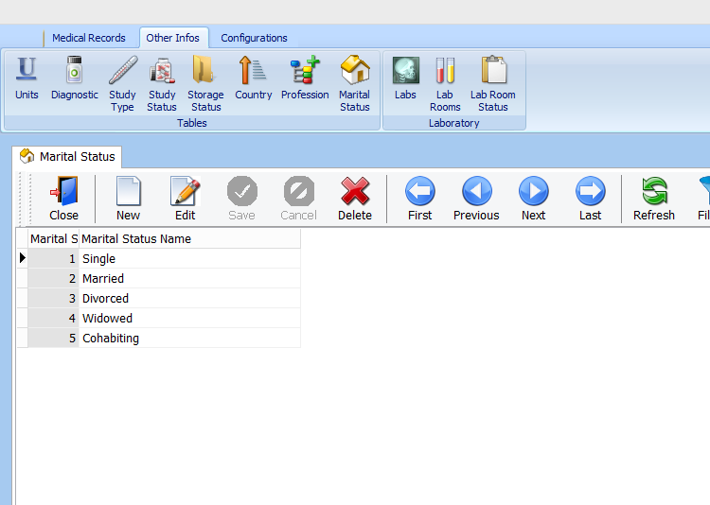

1. Click New

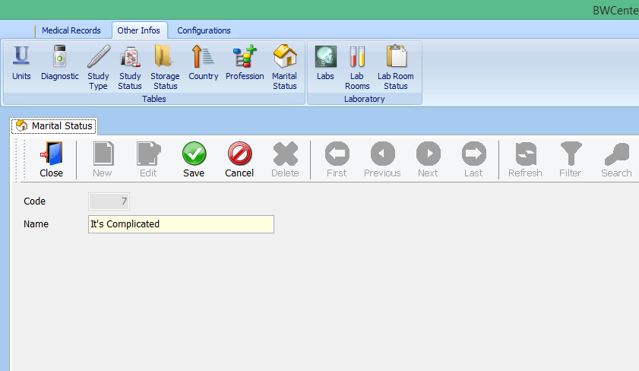

1. Enter the name of the marital status you are adding.
2. Click Save

### Removing Marital Status

1. Log in to BWCenter *(note: you must have administrative access to continue)*



1. Click on the other infos tab.



1. Click Martial Status

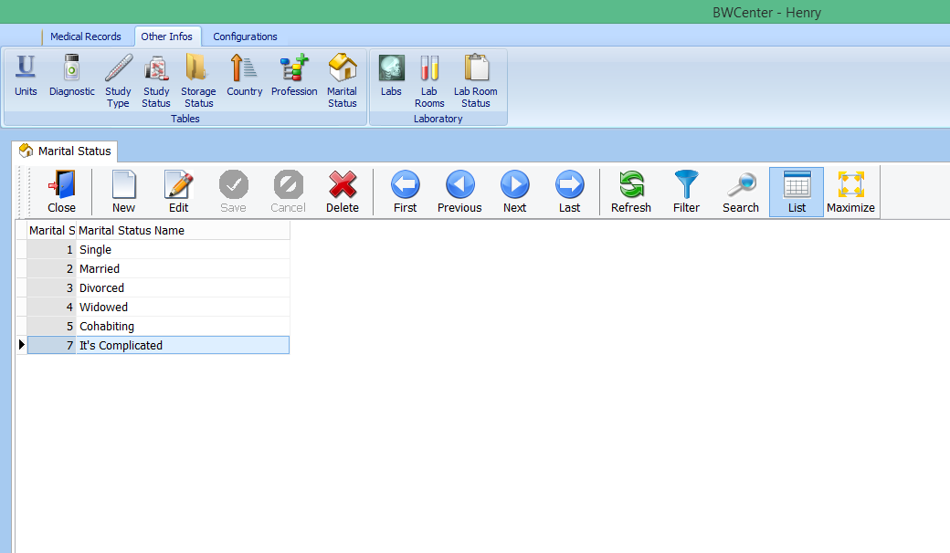

1. Select the martial status you want to remove.



1. Click Delete



1. Click Yes

## Adjusting Lab Room

### Adding Lab Room

1. Log in to BWCenter *(note: you must have administrative access to continue)*



1. Click on the other infos tab.



1. Click Lab Room

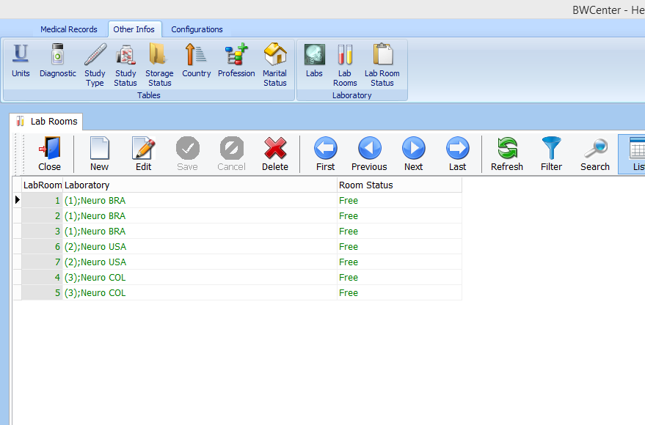

1. Click New

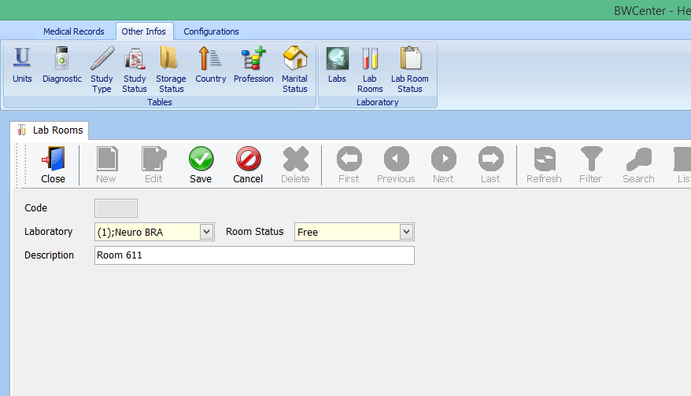

1. Select Laboratory where the rooms is in, select the Rooms Status, and enter a description (ex. Room#).
2. Click Save and Close

### Removing Lab Room

1. Log in to BWCenter *(note: you must have administrative access to continue)*



1. Click on the other infos tab.



1. Click Lab Rooms

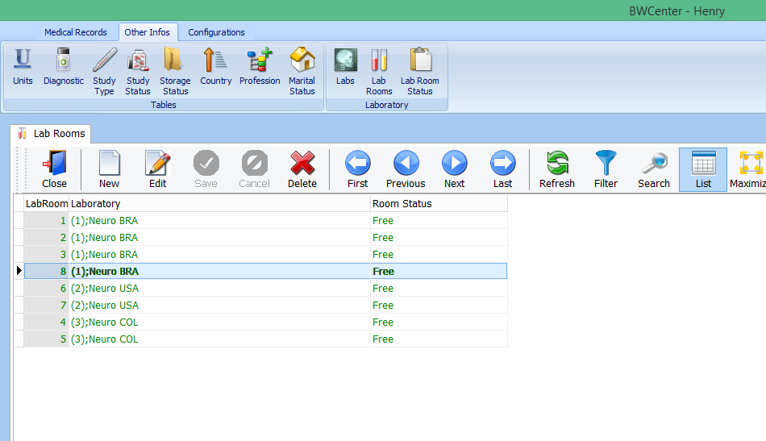

1. Select the room you want to remove.



1. Click Delete



1. Click Yes

## Adjusting Laboratory

### Adding Laboratory

1. Log in to BWCenter *(note: you must have administrative access to continue)*



1. Click on the other infos tab.



1. Click Labs

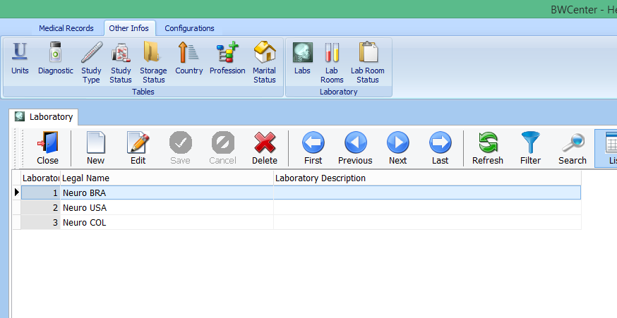

1. Click New

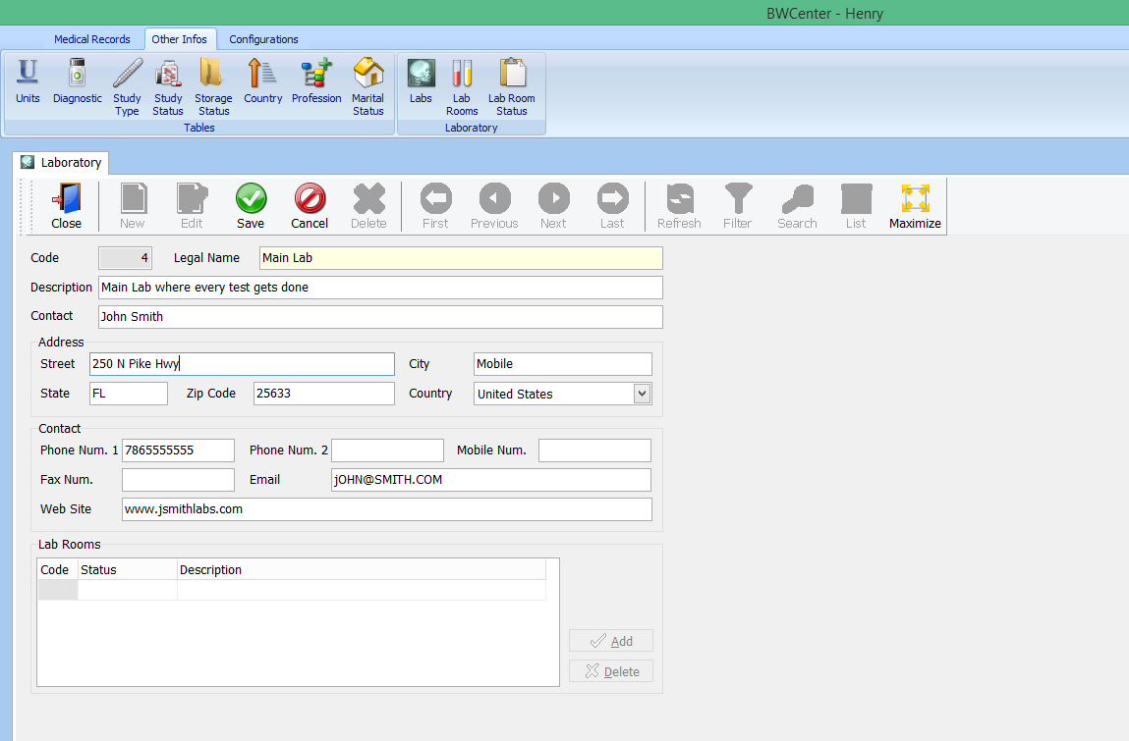

1. (Required) Enter the name of the laboratory you are adding.
2. Enter the Laboratory’s Demographic information.
3. Click Save and close

### Removing Laboratory

1. Log in to BWCenter *(note: you must have administrative access to continue)*



1. Click on the other infos tab.



1. Click Lab

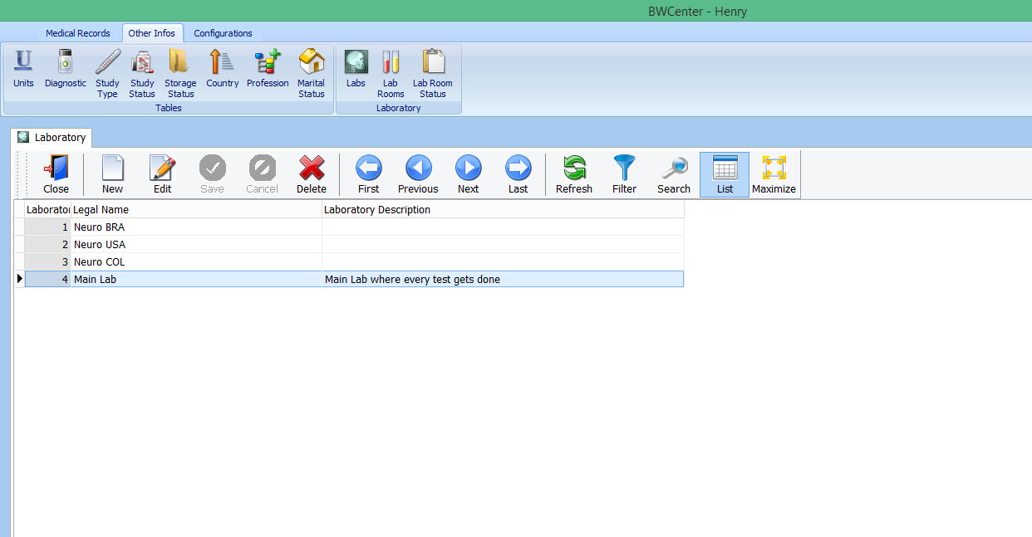

1. Select the Laborartory you want to remove.



1. Click Delete



1. Click Yes

## Adjusting Lab Room Status

### Adding Lab Room Status

1. Log in to BWCenter *(note: you must have administrative access to continue)*



1. Click on the other infos tab.



1. Click Lab Room Status

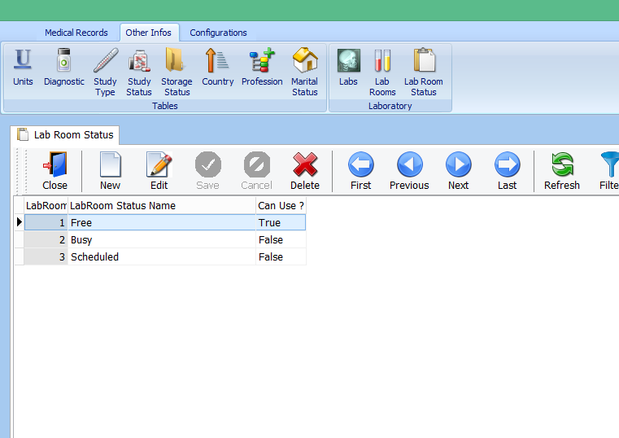

1. Click New

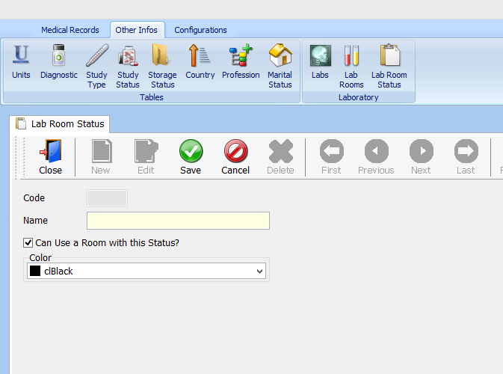

1. Enter the name of the room status to be added. Check if you want the new room status to consider the room active. Select a color for the room status.
2. Click Save and Close

### Removing Lab Room

1. Log in to BWCenter *(note: you must have administrative access to continue)*



1. Click on the other infos tab.



1. Click Lab Room Status

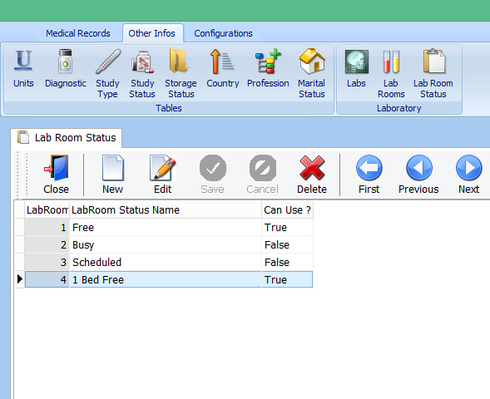

1. Select the room you want to remove.



1. Click Delete



1. Click Yes

# **Configurations**

## Access Control

### Create BWCenter User

1. Log in to BWCenter *(note: you must have administrative access to continue)*



1. Click on the configurations tab.

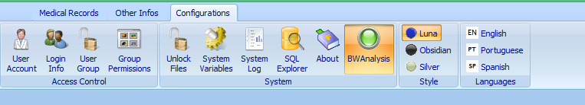

1. Click Login Info

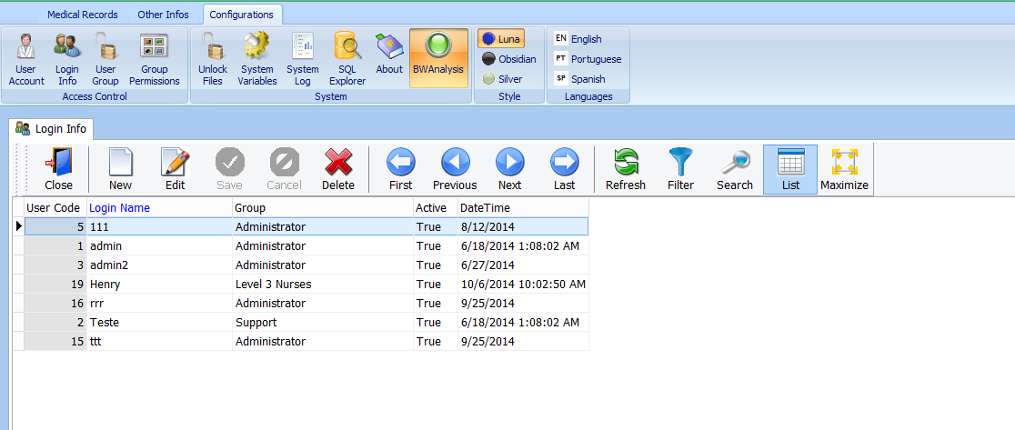

1. Click New

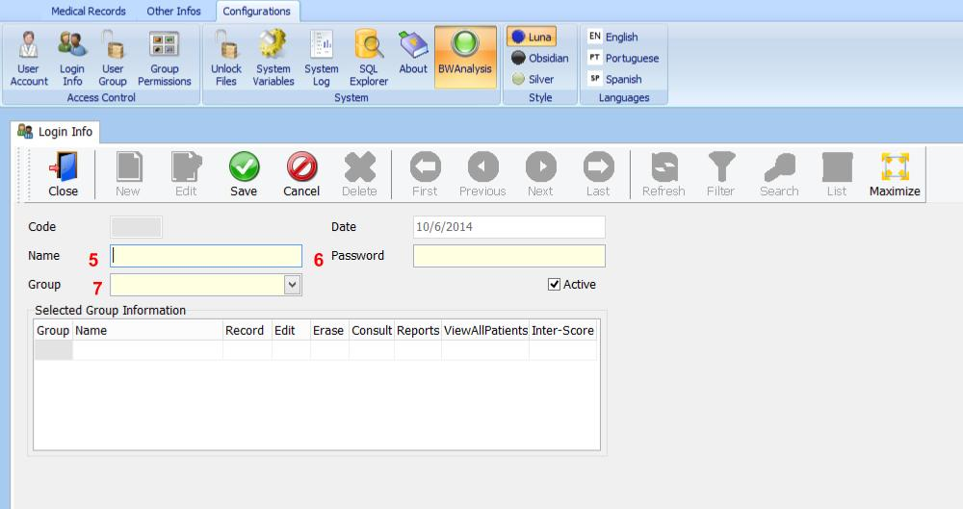

1. Enter desired username
2. Enter desired password
3. Select previously created user group
4. Click Save