### Create User Profile

User Profiles are used to add more detail about a specific user or non-users.

1. Log in to BWCenter *(note: you must have administrative access to continue)*

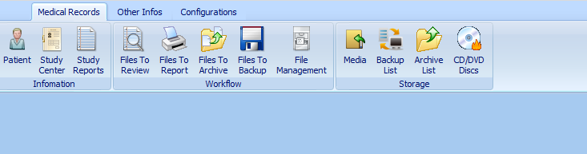

1. Click on the configurations tab.

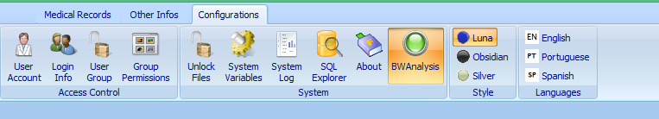

1. Click User Accounts
2. Click New

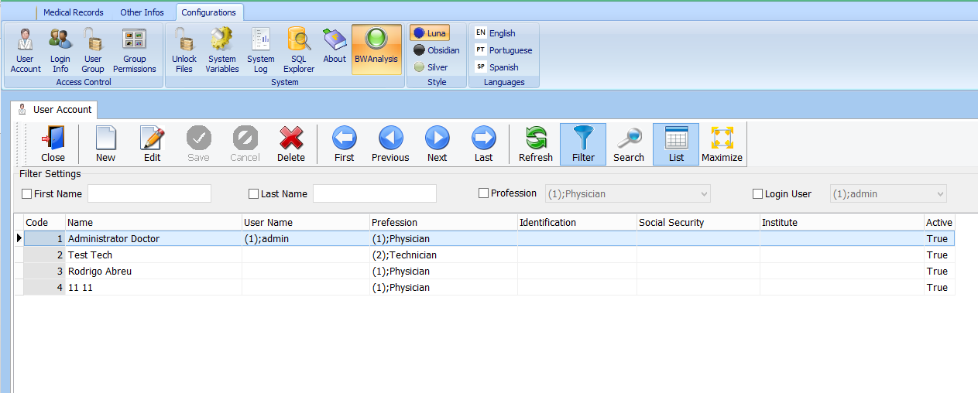

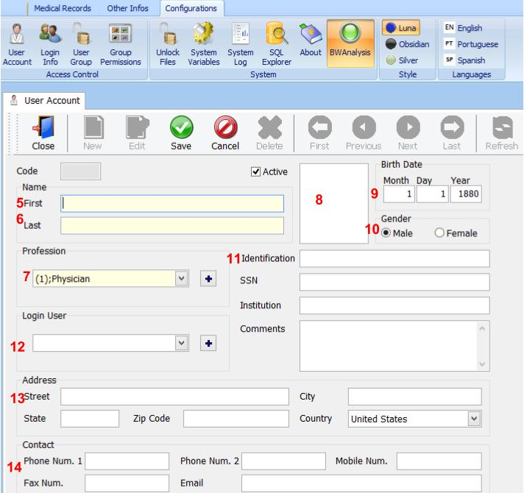

Required

1. First Name of personnel
2. Last Name of personnel
3. Profession of personnel (note: personnel with a profession of physician will be had to the referring physician list.)

Optional

1. Personnel’s photo
2. Personnel’s date of birth
3. Personnel’s gender
4. Personnel’s miscellaneous information
5. Personnel’s log in name (assigns an existing user or creates a new user)
6. Personnel’s demographic information
7. Personnel’s contact information
8. Click Save