### Creating User Groups

A group is a collection of user that can be managed as a single unit. Creating and adding users to group will give the system administrator greater control of the BWCenter’s users.

1. Log in to BWCenter *(note: you must have administrative access to continue)*

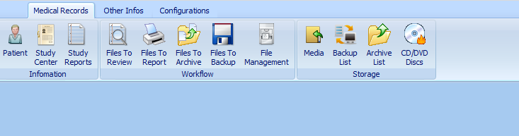

1. Click on the configurations tab.

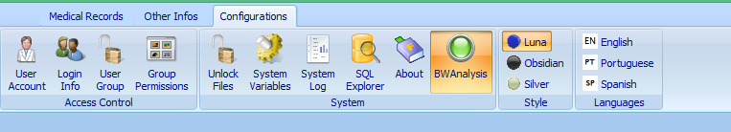

1. Click on User Group

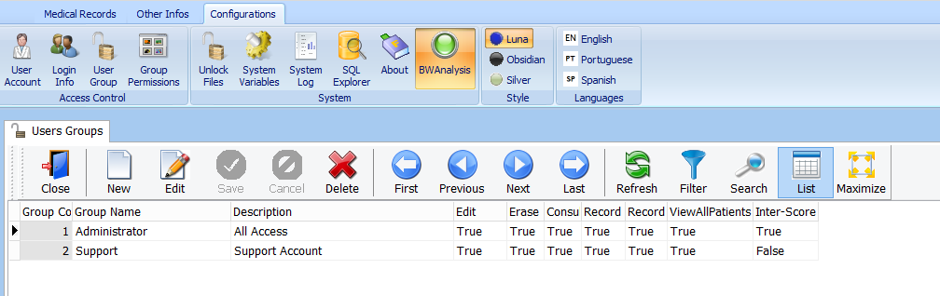

1. Click New

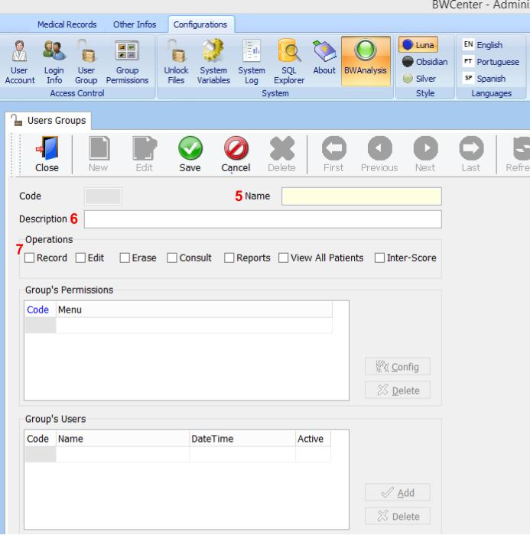

1. (Required) Enter the Name of the Group
2. Enter a description of the group
3. Click the operation you want enable for this group

|  |  |
| --- | --- |
| **Operations** | **Description** |
| Record | This will allow users records to be created. For example, Exam and Patients. |
| Edit | This will allow users edit records. |
| Erase | This will allow users remove records. |
| Consult |  |
| Reports |  |
| View all patients | This will the user access to all the patients records |
| Inter-Score | This will enable the Inter-scoring option for users |

1. Click Save.

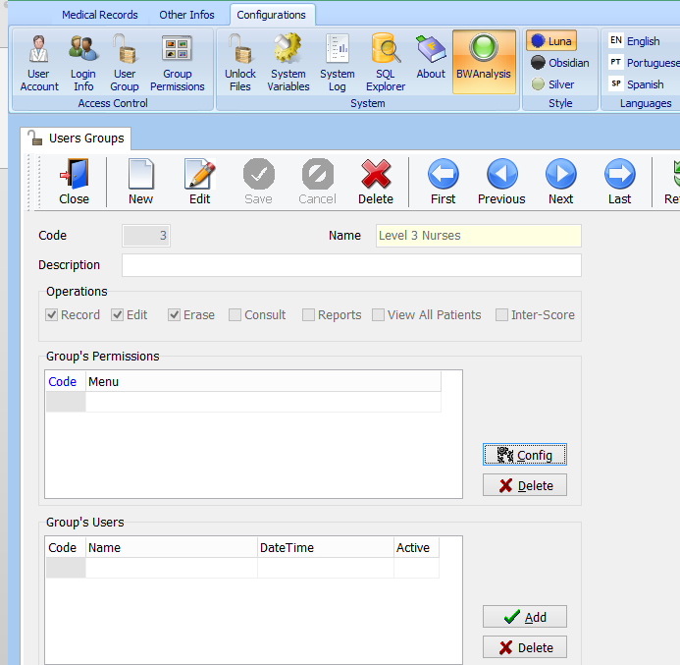

1. Click Config in the Group Permissions Section

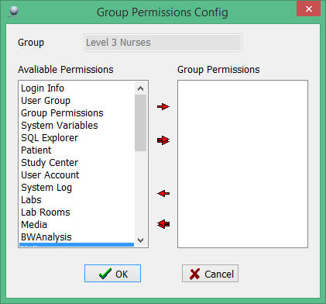

1. Select the features you want allow your user group to have access to.
2. Click OK



1. Click Add.

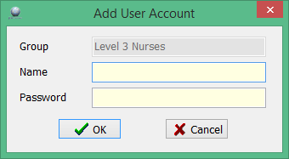

1. Enter the user name and password, to create a new user.
2. Click OK.