Archive Media

Archive mediums were designed store finalized patients studies and reports. Once and patients file has been archived, changes cannot be made. This will ensure the safekeeping, and integrity of the studies and reports.

To add an archive media follow the steps below.

1. Open BWCenter and log in. (note: you must have administrative access to continue)

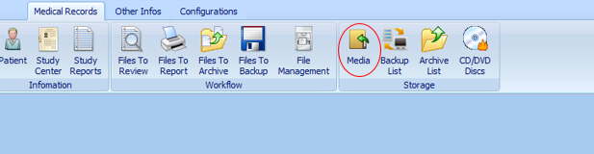

1. Click Media

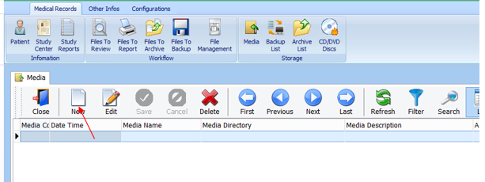

1. Click New

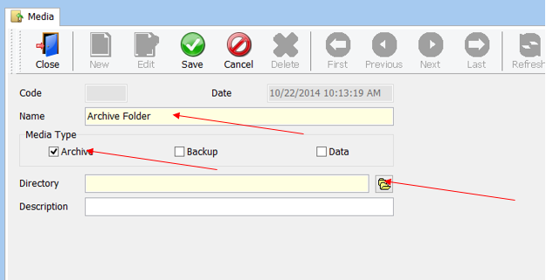

1. Enter the name of the media, select Archive, and click .

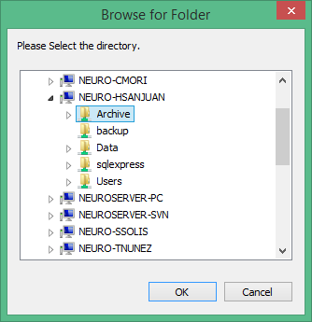

1. Locate, Select the folder, and click ok.

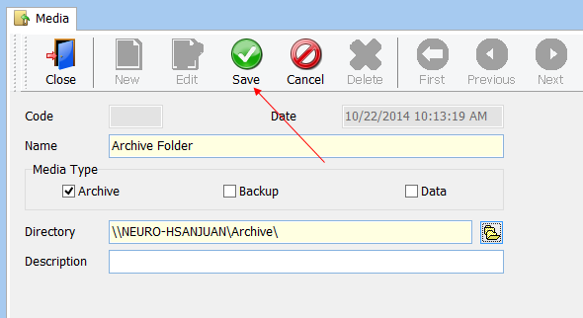

1. Click Save