# **Backup Media**

Backup mediums are used to maintain backups of patient information. This includes, patient studies and reports. Automatic backup can be enabled, to ensure backups are made every time there is a change on a patient’s file. See the System Variable of this guide for instruction to enable this feature.

To add a backup media, please follow the steps below.

1. Open BWCenter and log in. (note: you must have administrative access to continue)

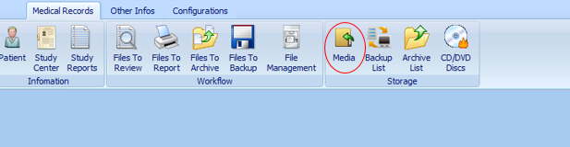

1. Click Media

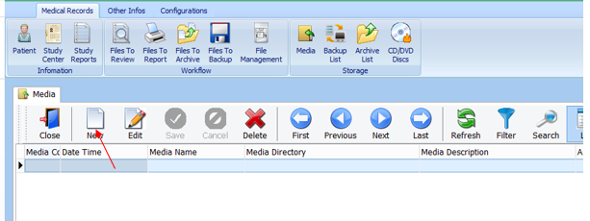

1. Click New

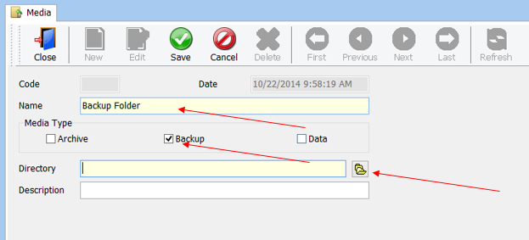

1. Enter the name of the media, select Backup, and click .

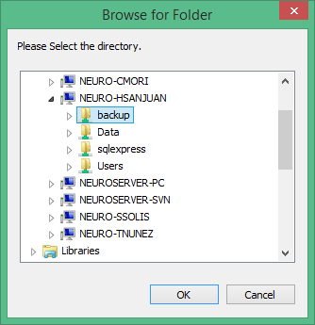

1. Locate, Select the folder, and click ok.

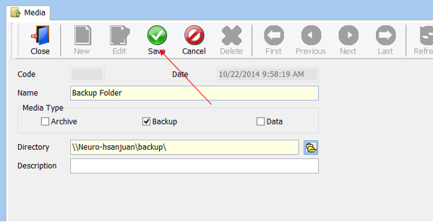

1. Click Save

# **Archive Media**

Archive mediums were designed store finalized patients studies and reports. Once and patients file has been archived, changes cannot be made. This will ensure the safekeeping, and integrity of the studies and reports.

To add an archive media follow the steps below.

1. Open BWCenter and log in. (note: you must have administrative access to continue)



1. Click Media



1. Click New

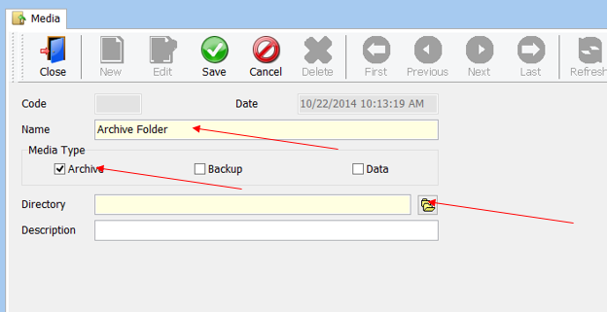

1. Enter the name of the media, select Archive, and click .

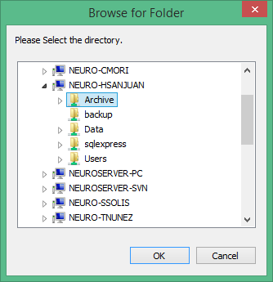

1. Locate, Select the folder, and click ok.

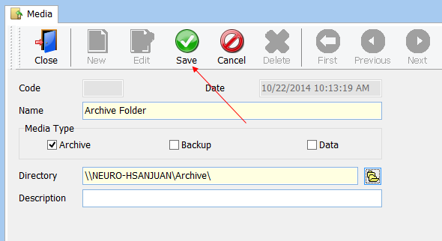

1. Click Save

# **P2P Media**

P2P storage mediums allow other computers on the network, with BWCenter to access patient files and information. To enable a P2P for BWCenter complete the steps below for each recording computer.

1. Open BWAnalysis folder. (C:\BWAnalysis)
2. Right Click on BWData and click properties.

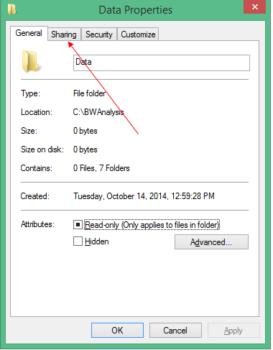

1. Click on the Sharing Tab

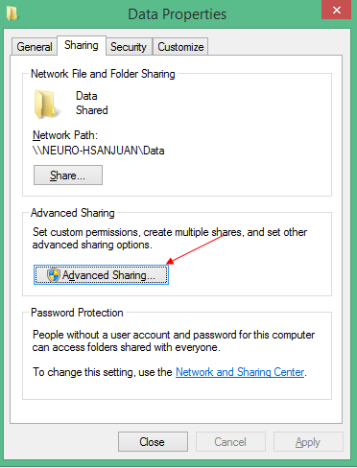

1. Click Advanced Sharing

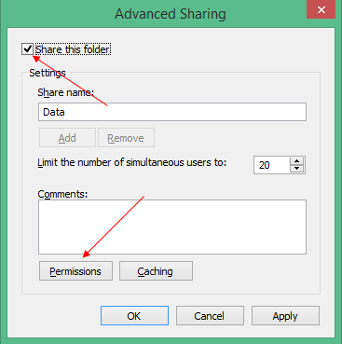

1. Check “Share this Folder” and click Permissions

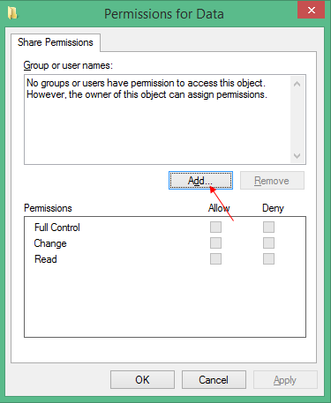

1. Click Add

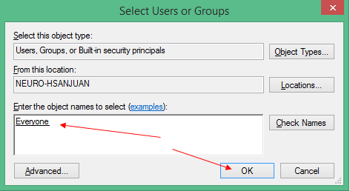

1. Enter the username you want to grant access or enter “Everyone”, and click OK.

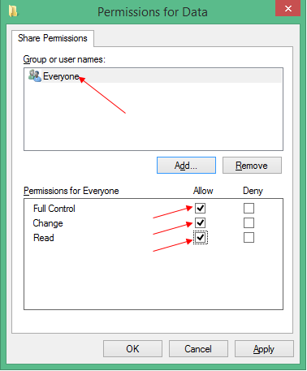

1. Select the User you have added and allow access to Full control, Change, and Read and click ok.

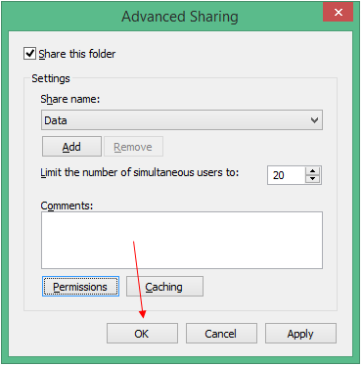

1. Click ok

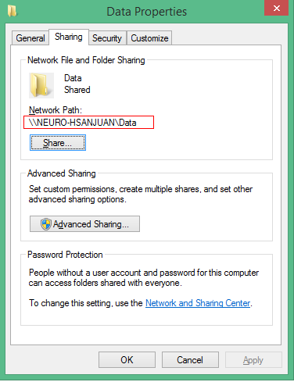

1. Record the Network Path and click Ok
2. Open BWCenter and log in. (note: you must have administrative access to continue)

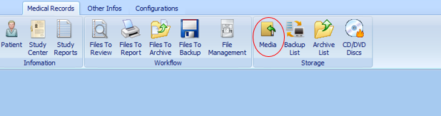

1. Click Media

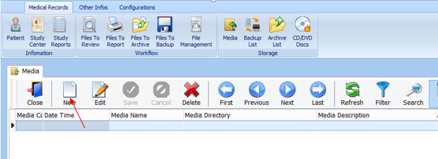

1. Click New

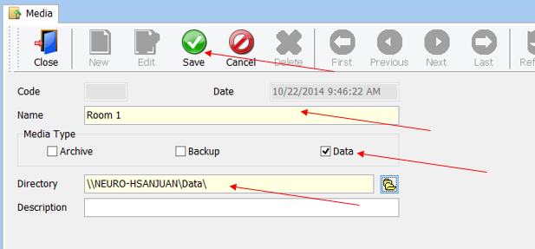

1. Enter the name of the computer, select data, enter the network path recorded in step 10 for directory, and click save.
2. Repeat the steps above for all recording computers.