P2P Media

P2P storage mediums allow other computers on the network, with BWCenter to access patient files and information. To enable a P2P for BWCenter complete the steps below for each recording computer.

1. Open BWAnalysis folder. (*C:\BWAnalysis*)
2. Right Click on BWData and click properties.

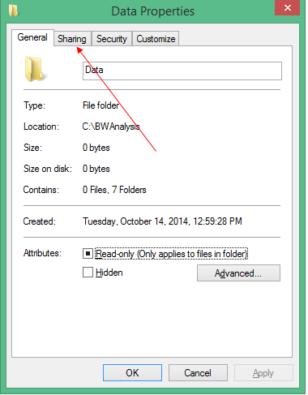

1. Click on the Sharing Tab

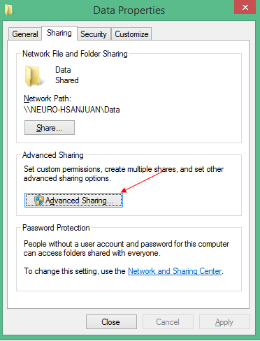

1. Click Advanced Sharing

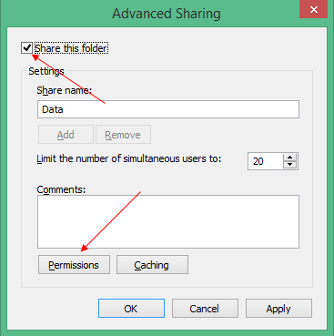

1. Check “Share this Folder” and click Permissions

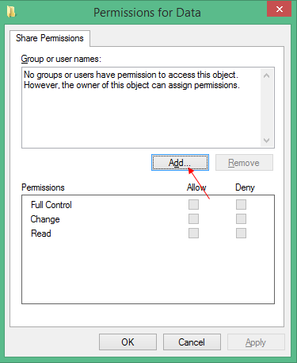

1. Click Add

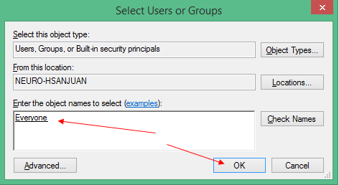

1. Enter the username you want to grant access or enter “Everyone”, and click OK.

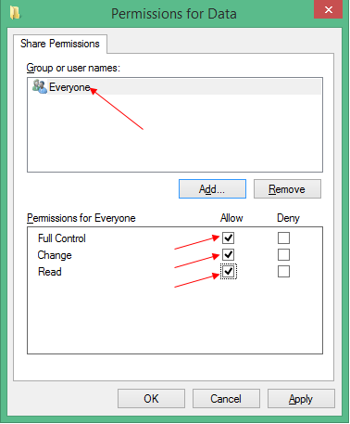

1. Select the User you have added and allow access to Full control, Change, and Read and click ok.

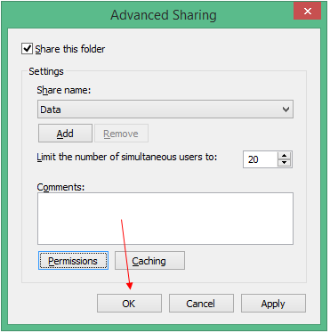

1. Click ok

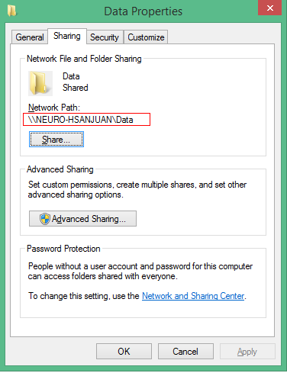

1. Record the Network Path and click Ok
2. Open BWCenter and log in. (note: you must have administrative access to continue)

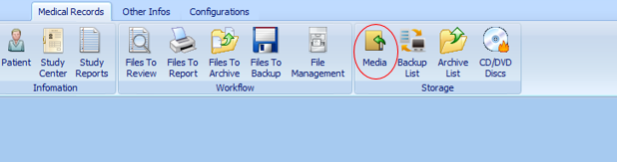

1. Click Media

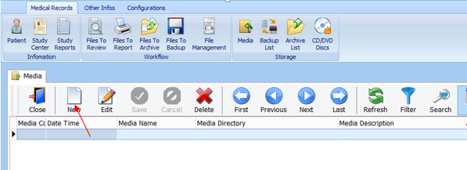

1. Click New

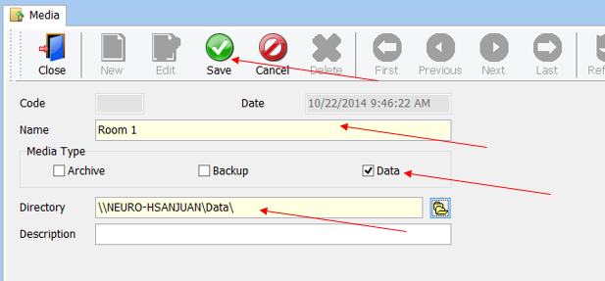

1. Enter the name of the computer, select data, enter the network path recorded in step 10 for directory, and click save.
2. Repeat the steps above for all recording computers.