Change Background Image

1. Open BWCenter

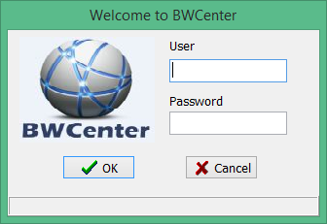

1. Enter Administrative Credentials

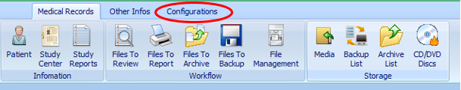

1. Click Configurations
2. Click System Variables
3. Double click Background Image
4. Click Edit
5. Click  and locate your image and click ok
6. Click Save.
7. Click Close and background should be set