Change BWAnalysis Languages

1. Open BWCenter

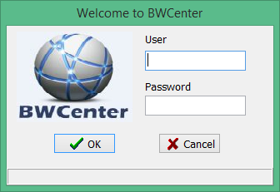

1. Enter Administrative Credentials

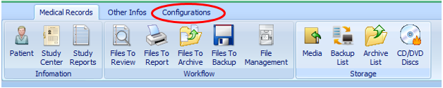

1. Click Configurations

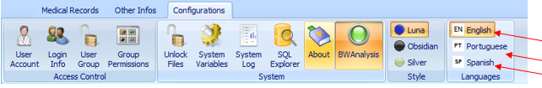

1. Select your desired language