Change Theme

1. Open BWCenter

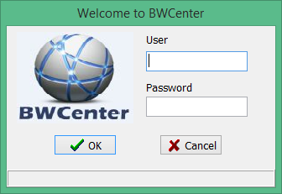

1. Enter Administrative Credentials

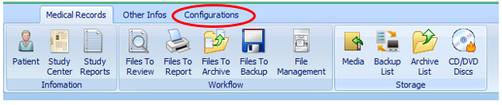

1. Click Configuration

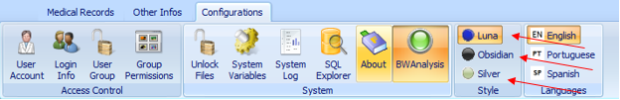

1. Select you preferred theme

**Example:**

Luna

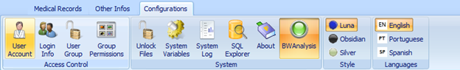

Obsidian

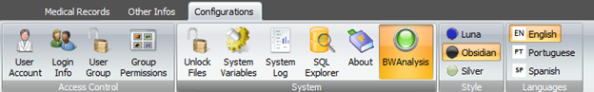

Silver

