System Variables

System Variables

System Variables, allow you to configure BWCenter’s Server to your specification. System Variable should only be changed by an experience computer user.

Default variable, such as, weight, length, pressure, and temperature can all be adjust to a specific unit of measure the user may desire.

For example, to change the default units of measure for weight follow the steps below.

1. Open BWCenter

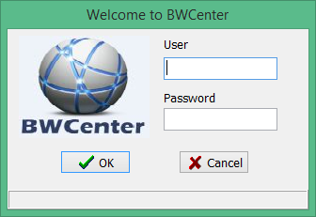

1. Enter Administrative Credentials

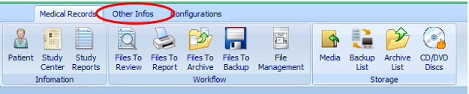

1. Click Other Infos

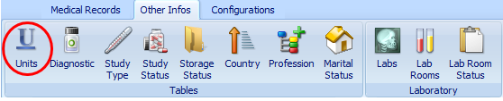

1. Click Units

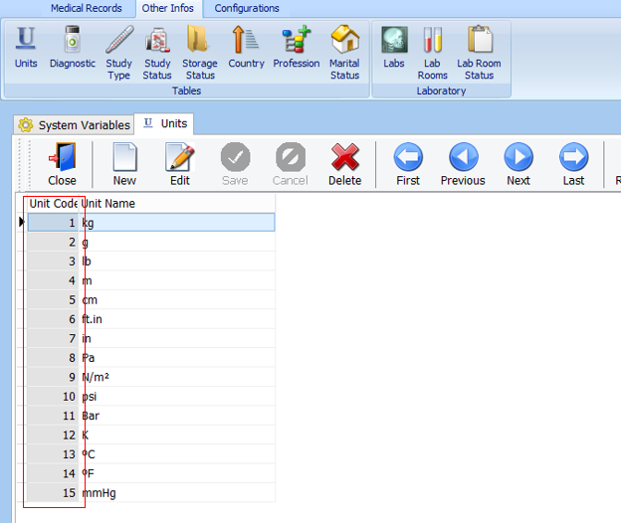

1. Record the Unit Code you want to set as default.

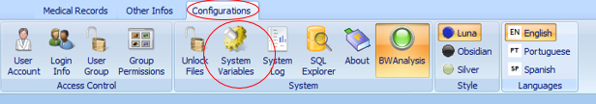

1. Click the Configurations and then click system variables

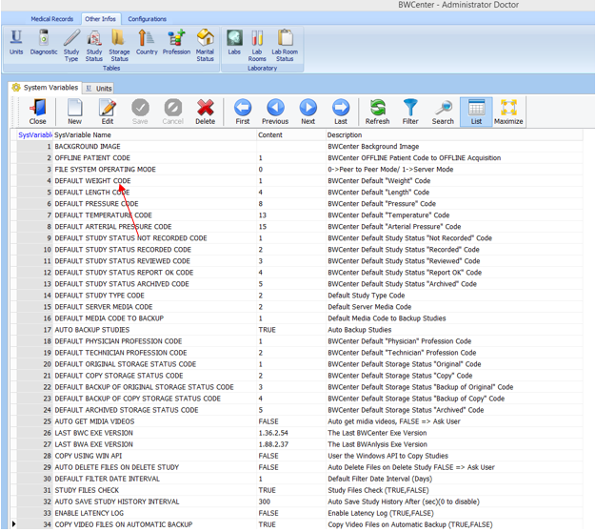

1. Double click default weight code

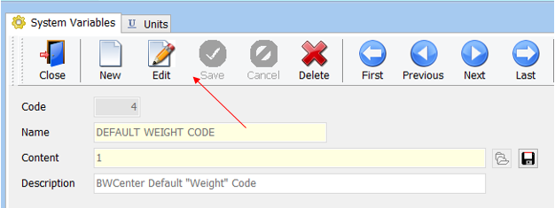

1. Click Edit

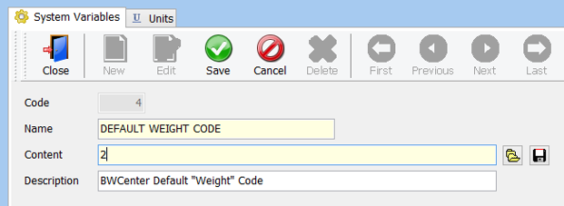

1. Enter unit code (recorded in step 5) in the content field and click .