Create a New Exam

1. Open BWCenter

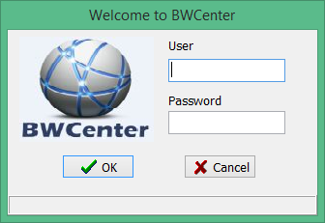

1. Enter Credentials

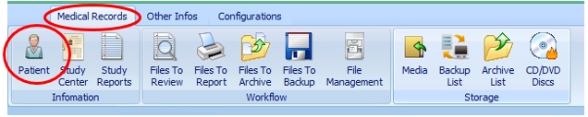

1. From the toolbar Click Medical Records> Patient
2. Create a find an existing or patient New Patient (Refer to Create a New Patient Section).

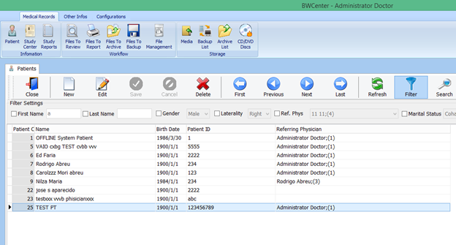

1. Double click on the desire patient file or click on desire patient click  .

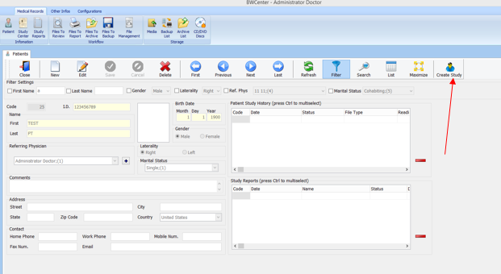

1. Click Create Study

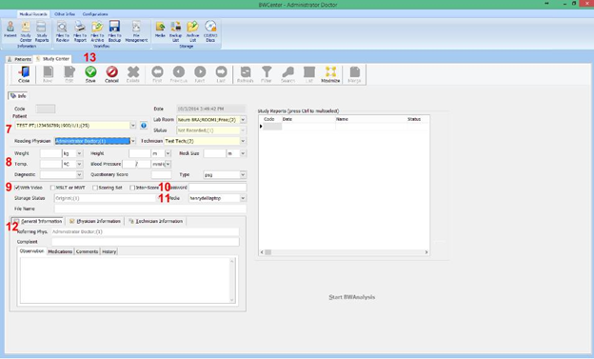

1. Verify the patent’s information.
2. Enter patient’s dimensions, vitals, Diagnostic
3. Select Test Type
4. To enable password protection, enter a password
5. Select Storage Device
6. Enter Miscellaneous
7. Click Save

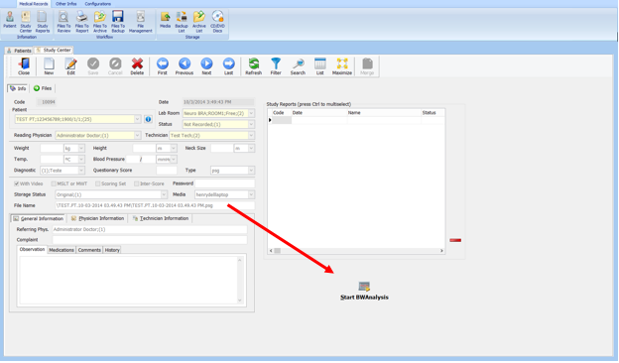

1. Click Start BWAnalysis
2. Click to start trace  and  to start recording trace.