Create a New Patient

1. Open BWCenter

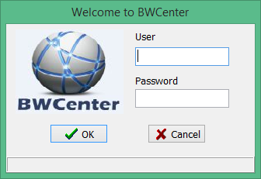

1. Enter Credentials

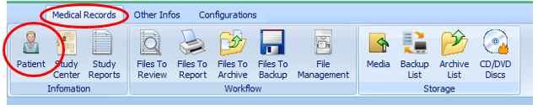

1. From the toolbar Click Medical Records> Patient

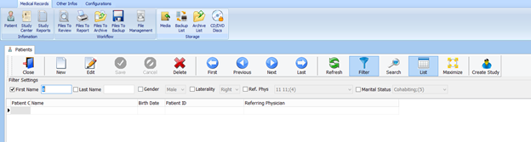

1. Click New.

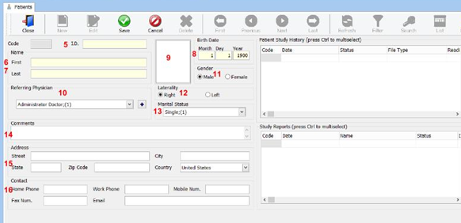

(Required)

1. Enter Patient ID
2. Enter Patient’s First Name
3. Enter Patient’s Last Name
4. Enter Patient’s Date of Birth

(Optional)

1. Insert Patients Photo
2. Referring Physician
3. Patient’s Gender
4. Patient’s Handedness
5. Patient’s Martial Status
6. Exam Comments
7. Patient’s Demographic information
8. Patient’s contact information

1. Click Save.
2. Your Patient has been created.