Removing Exams

1. Open and Log in to BWCenter

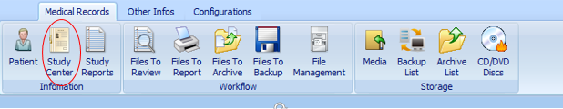

1. Click Study Center

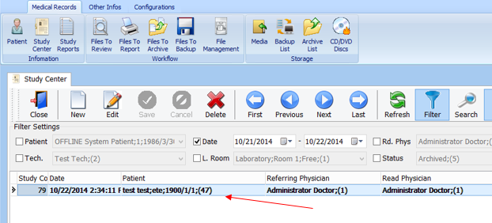

1. Select the study you want to remove
2. Click

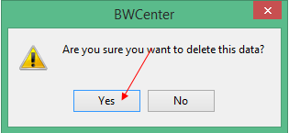

1. Click Yes

Remove Exams Method 2

1. Open BWCenter

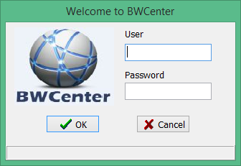

1. Enter Credentials

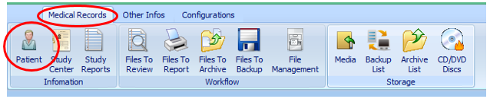

1. From the toolbar Click Medical Records> Patient

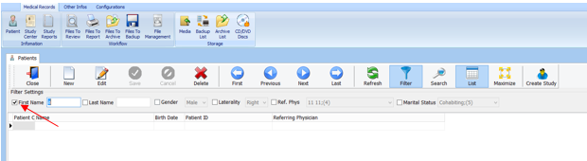

1. Uncheck the First Name filter.

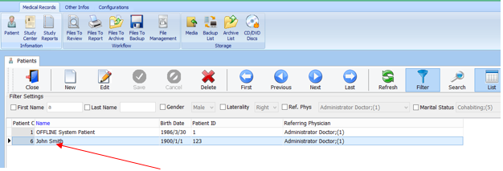

1. Double click on the patient file to view exam.

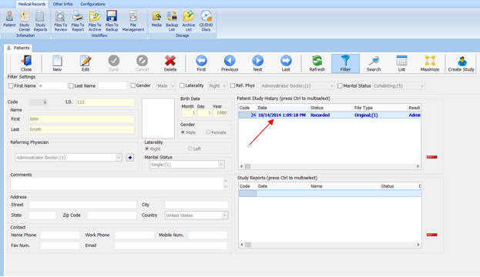

1. Select exams you want delete and click.