Removing Patients

1. Open BWCenter

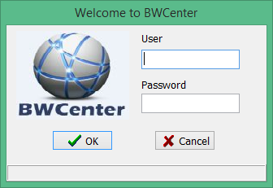

1. Enter Credentials

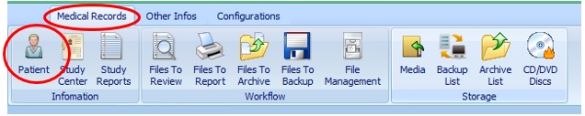

1. From the toolbar Click Medical Records> Patient

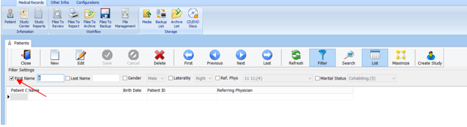

1. Uncheck the First Name filter.

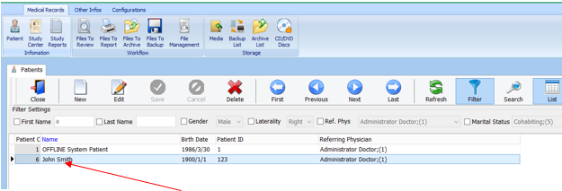

1. Select your patient ( hold CTRL, to select multiple patients)
2. Click 
3. By removing patients, you remove any files associated with that patient. This includes exams and report.