Manual Status Adjustments

To change the status of any exam, follow the steps below.

1. Open a Patient’s File

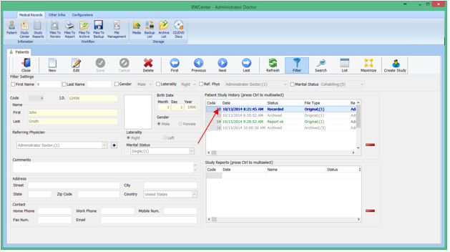

1. Double click the exam you want to change.

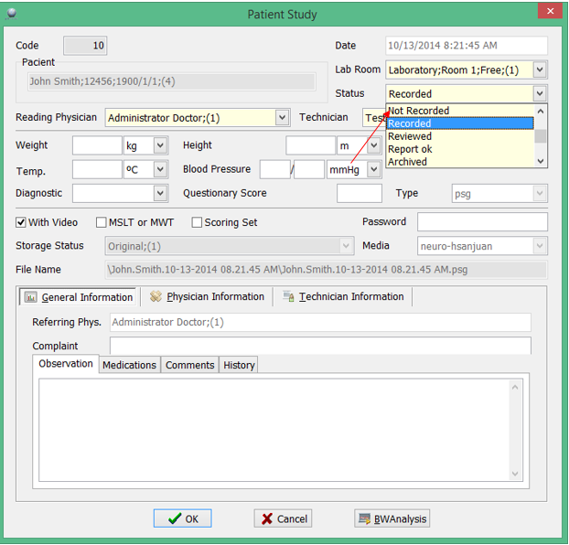

1. Choose your desired status.

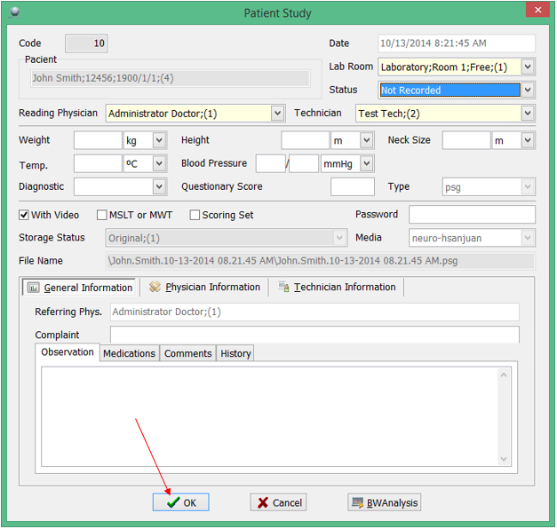

1. Click Ok to save changes. Please note, Exam with a status of Archived, cannot be changed.