Workflows

In BWCenter, the workflow can be used to maximize work efficiency. All studies are chronologically categorized in the following order:

1. Not Recorded – Exams that have been created and are ready to be recorded.
2. Recorded – Exams that are completed.
3. Reviewed – Exams that have been Staged and/or Scored.
4. Reported – Indicates reports have been generated for exam.
5. Archived – Indicates exam has been archived and no longer available for editing.

Each time an exam meets its criteria, BWCenter will prompt the user if they are ready to move the exam to the next status.

**Example Status  Confirmation**

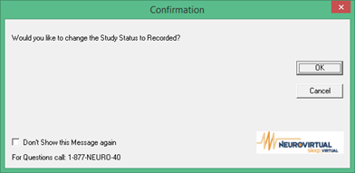

Workflow View

To simplify workloads, BWCenter workflow views allow to the user to view exams by their status. Once an exam has categorized as recorded, exams can viewed in the following order:

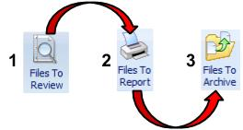

Once each step in the workflow has been completed, BWCenter will prompted the user if the exam is ready to be move to the next step.