Archiving Studies in BWCenter (Method 1)

*Ideally, studies should be archived after doctor has reviewed and created reports.  This is indicated in the study’s ‘****Status****’ which should say ‘****Report Ok’****.*

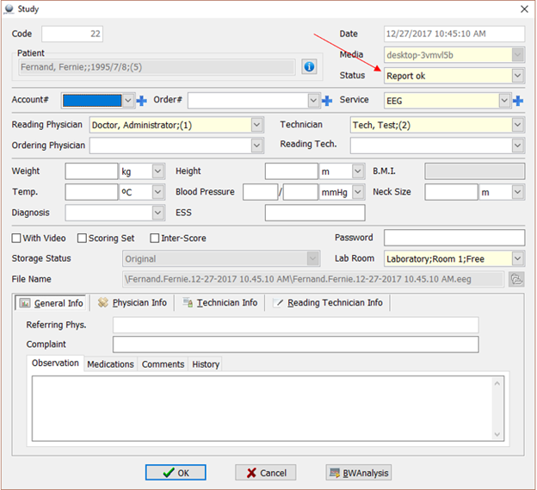

* Click ‘**Files to Archive**’.

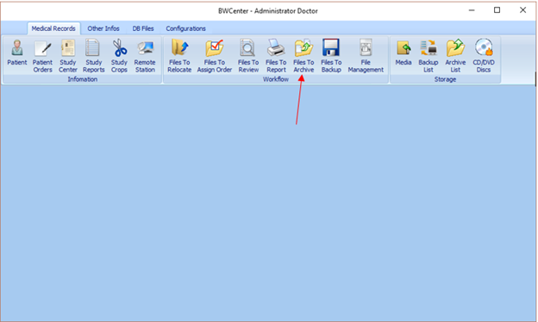

* Select the study to be archived and click ‘**Archive**’.

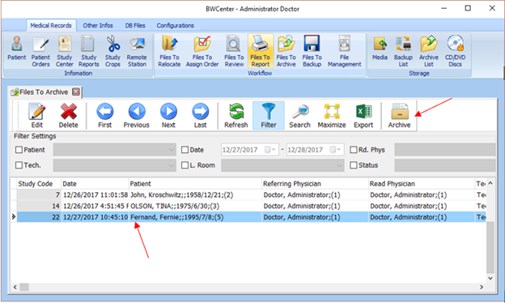

* Select ‘**Archive**’ from dropdown and click ‘**OK**’.

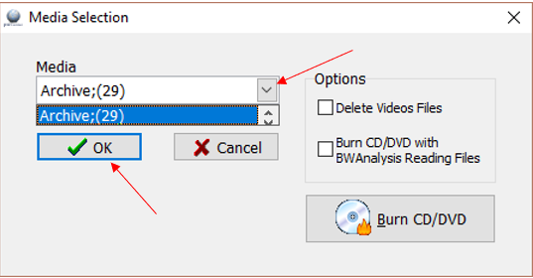

* Click ‘**Yes**’.

*\*\*\*Note that you will not be able to edit study any further once archived*\*\*\*

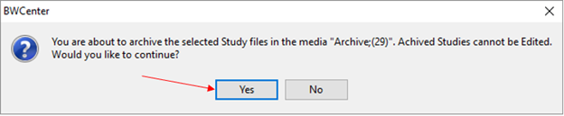

* Click ‘**OK**’.

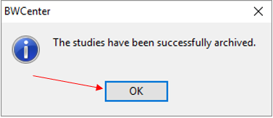

Archiving Studies in BWCenter (Method 2)

* Click ‘**File Management**’.

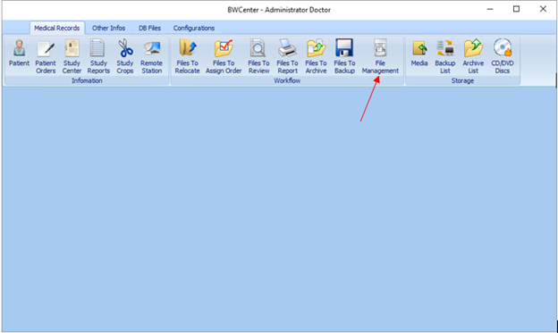

* Select study to archive.

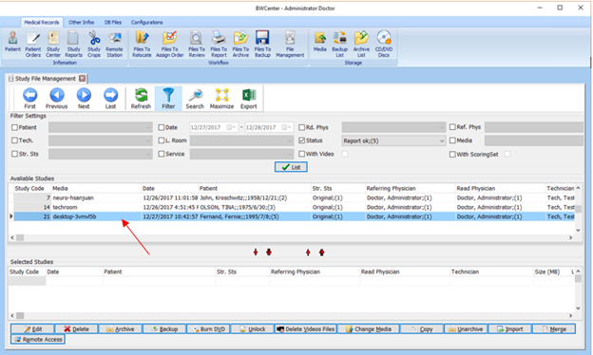

* Click down arrow icon indicated below to select study and bring it down.

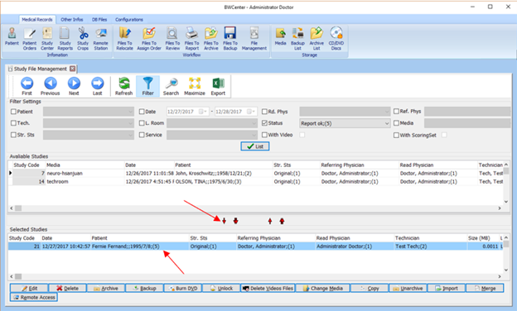

* Click ‘**Archive**’.

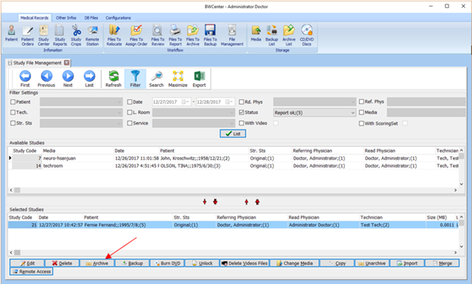

* Select ‘**Archive**’ from dropdown and click ‘**OK**’.



* Click ‘**Yes**’.

*\*\*\*Note that you will not be able to edit study any further once archived\*\*\**



* Click ‘**OK**’.

