Backing up Studies in BWCenter (Automatic Method)

* Click ‘**Configuration**s’ tab.

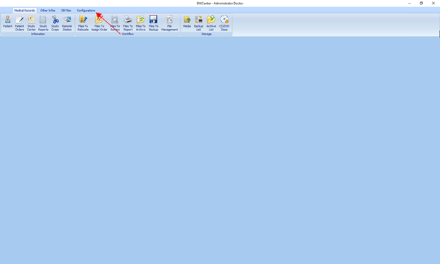

* Click ‘**System Variables**’.

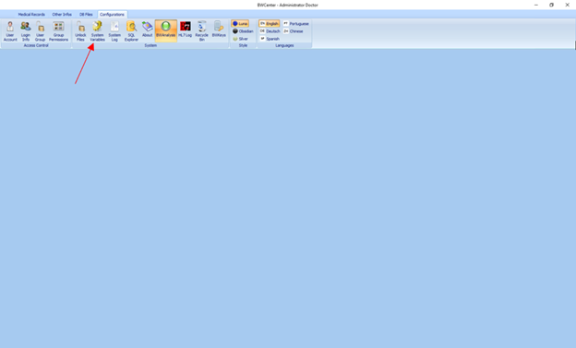

* Verify that line ’**17**’ **(AUTO BACKUP STUDIES)** is set to ‘**1**’.

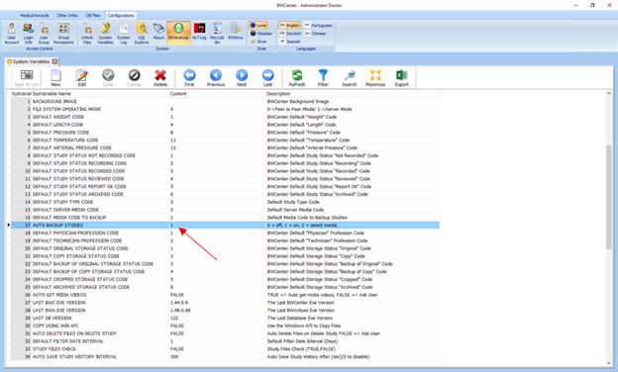

* Close System Variables by clicking the ‘**x**’ shown below.

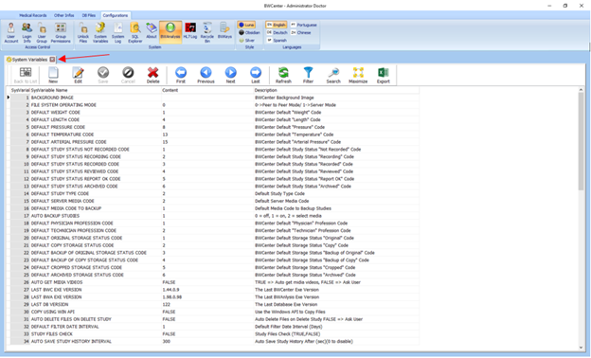

* Click ‘**Medical Records**’.

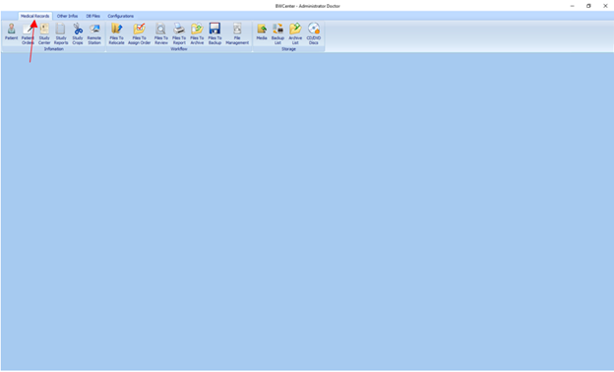

* Click ‘**Patient**’.

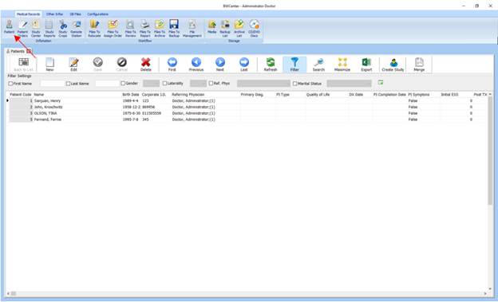

* Double click patient file.

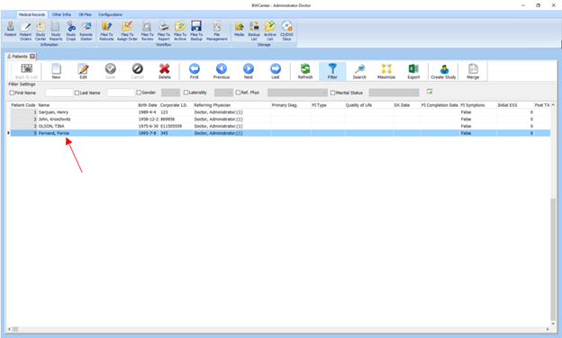

* Double click study.

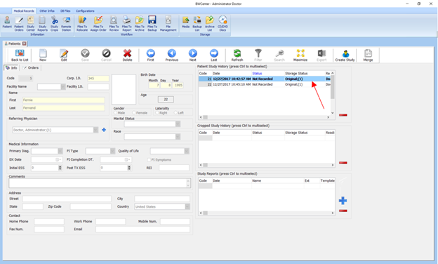

* Click ‘**BWAnalysis**’.

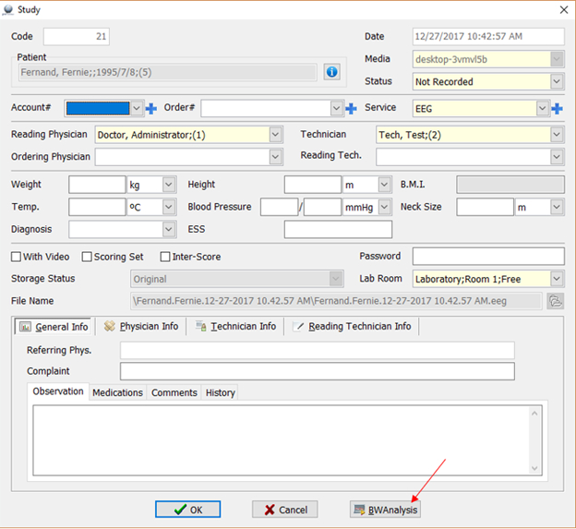

* Make ANY modification to study and close BWAnalysis by clicking the ‘**x**’.

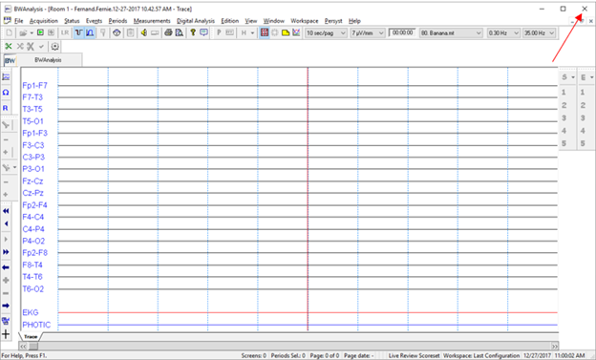

* A prompt will automatically pop up asking if you wish to backup study. Click ‘**Yes**’ to copy study.

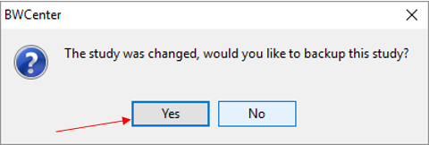

* Click ‘**Yes**’ again to backup study.

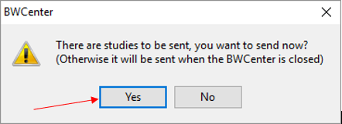

* Study will save in ‘**Backup**’ folder inside ‘**BWAnalysis**’ folder (This folder can also be accessed directly on desktop).

