How to Run BWCenter Offline

When BWCenter cannot connect with Server, you will receive the prompt below.  This typically happens when connection to the network is lost (ie. You have taken a laptop out of range of wireless connection).  Follow steps below to continue study.

1. Click ‘**Yes**’.

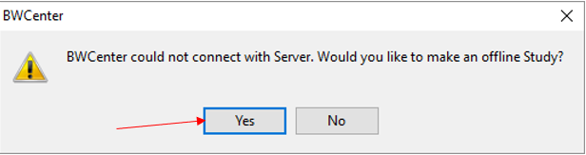

1. BWAnalysis will open. Select amplifier model and click ‘**OK**’.

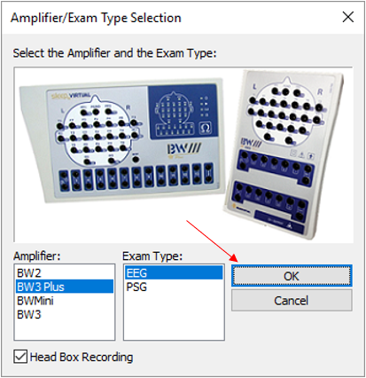

1. Enter patient information and click ‘**OK**’.

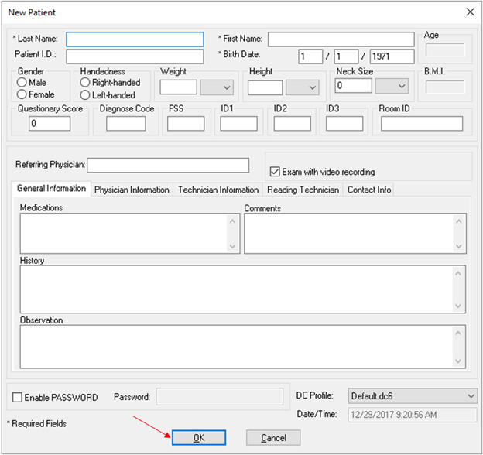

1. Perform study as usual and close BWAnalysis by clicking ‘**x**’.

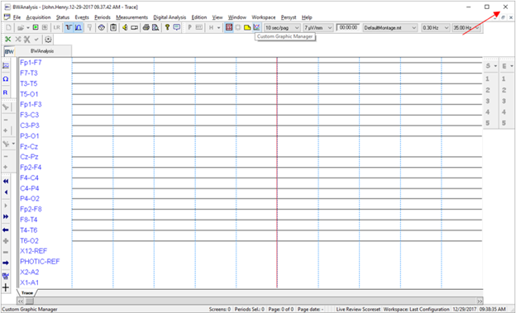

1. When back online, open BWCenter, enter credentials and Click ‘**OK**’.

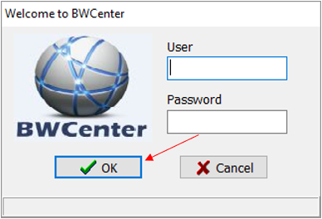

1. Click ‘**Yes**’.

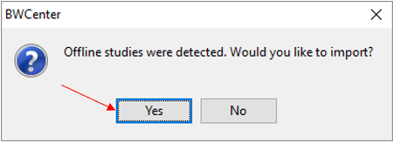

1. Select study to import and click ‘**OK**’.

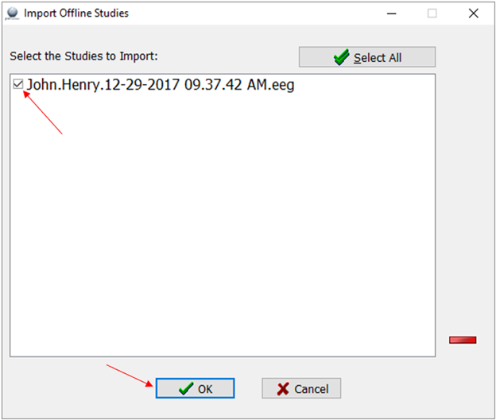

1. Click ‘**Auto Add**’.

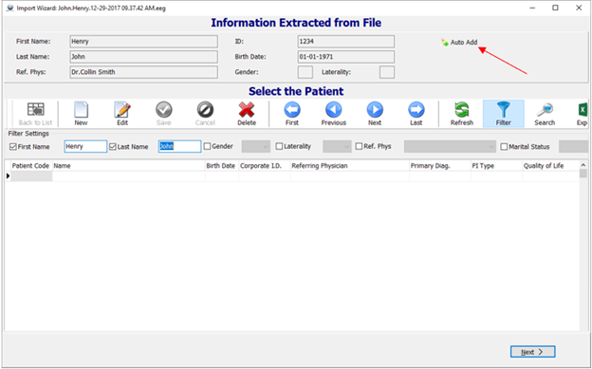

1. Enter any missing patient information and click ‘**Save**’. Then click ‘**Next**’.

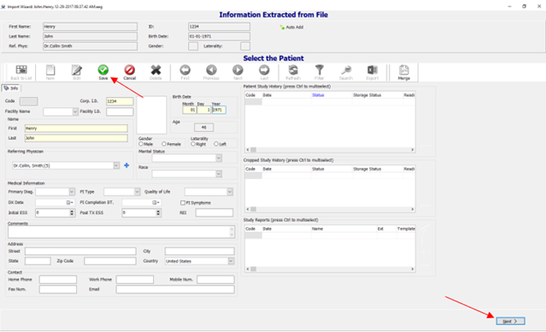

1. Select room and click ‘**Next**’.

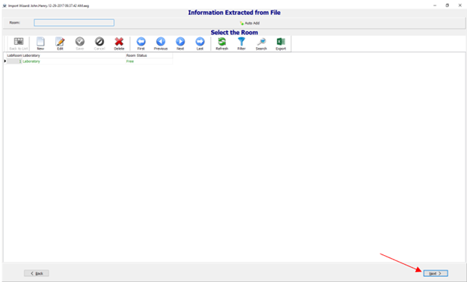

1. Click ‘**Auto Add**’.

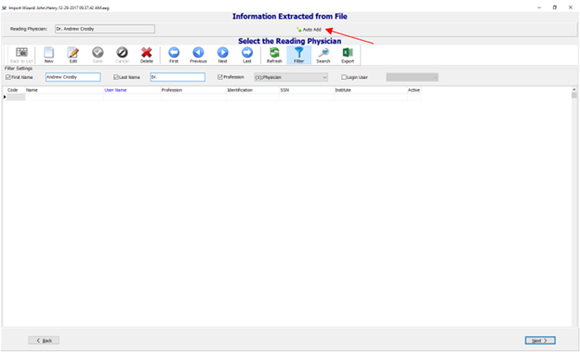

1. Enter any missing physician information and click ‘**Save**’. Then click ‘**Next**’.

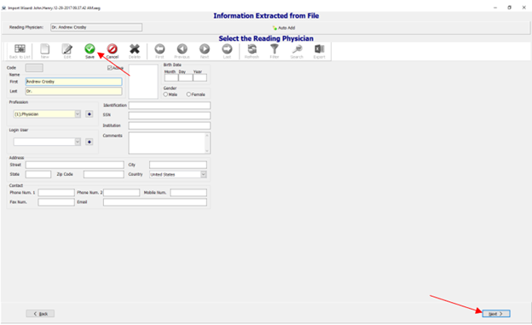

1. Click ‘**Auto Add**’.

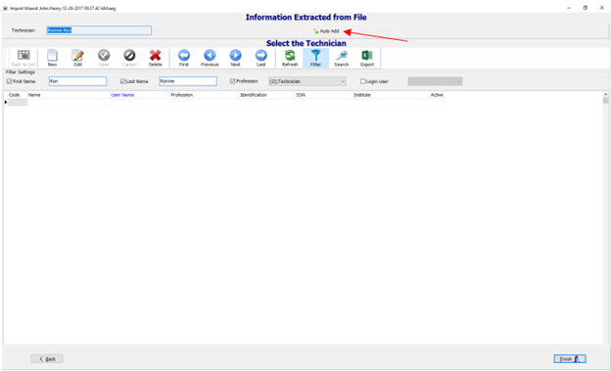

1. Enter any missing Technician information and click ‘**Save**’. Then click ‘**Finish**’.

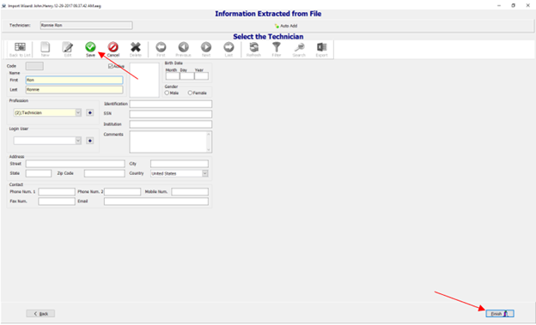

1. Click ‘**OK**’.

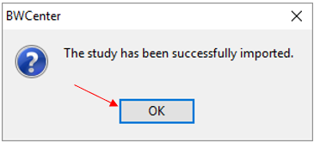

1. Verify information and click ‘**OK**’.

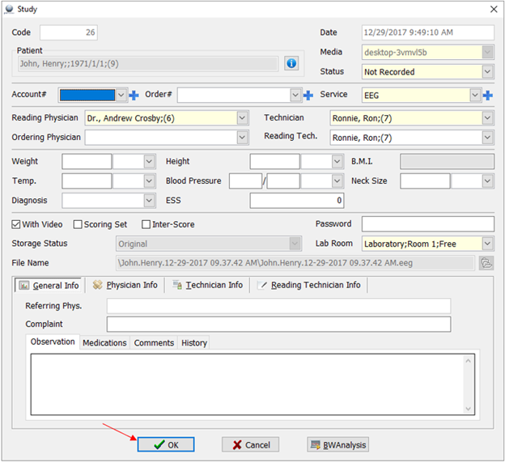

1. Click ‘**Patient**’.

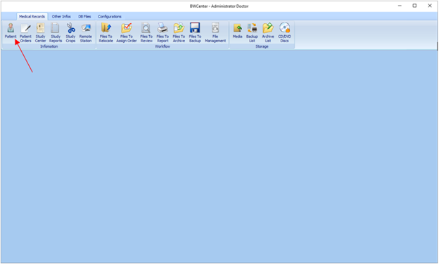

\*\*\**Study will now be listed for selection*\*\*\*

