Unarchiving Studies

1. Click ‘**File Management**’.

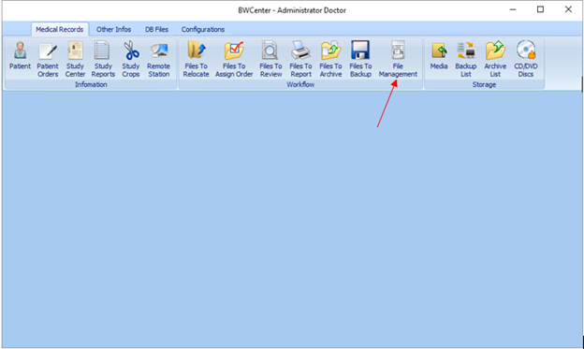

1. Select study to unarchive.

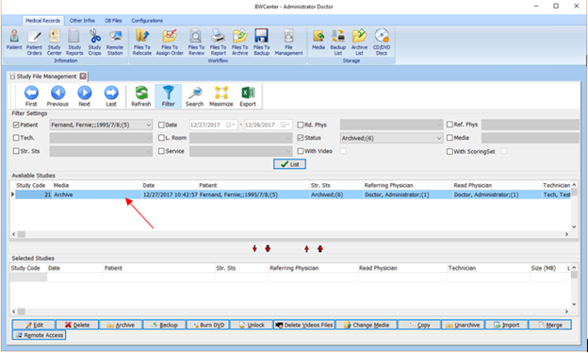

1. Click down arrow icon indicated below to bring study down.

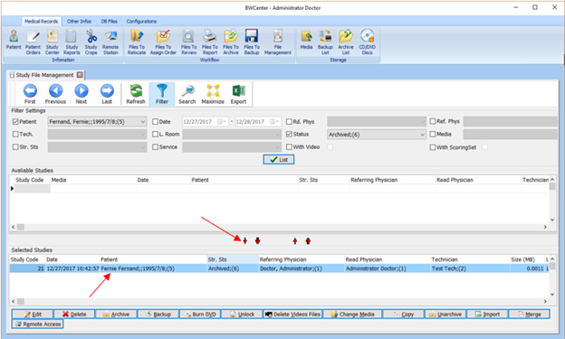

1. Click ‘**Unarchive**’.

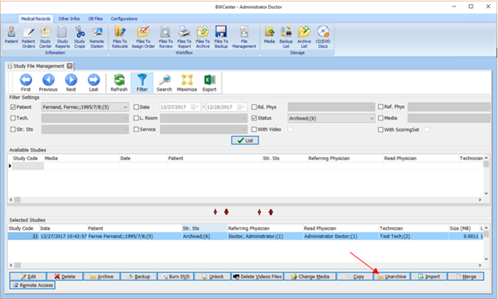

1. Click ‘**OK**’.

