DT-Guard: A Two-Stage Hybrid Framework for Encrypted Network Traffic Classification with Anomaly Detection
Rawan Al Shweiki
Modern University College , Palestine



Abstract
This study presents DT-Guard, a two-stage hybrid framework for encrypted network traffic classification. Unlike previous approaches that treat classification and anomaly detection as separate tasks, DT-Guard integrates both into a unified pipeline. The first stage employs an Autoencoder trained exclusively on benign traffic to detect anomalies through reconstruction error thresholding, supported by a K-Nearest Neighbors (KNN) classifier for gray-zone resolution. The second stage applies a Decision Tree (DT) as the core classifier, enriched by meta-features from Random Forest (RF) and XGBoost. The framework was trained on the ISCX VPN-nonVPN dataset (59,706 flows mapped to five classes) with CICIDS2017 BENIGN traffic (97,718 flows) used exclusively for Autoencoder training. Evaluation on the test set yielded a Cross-Validation accuracy of 96.07% (±0.21%) with an F1-score of 91.92%. Generalization testing on UNSW-NB15 (175,341 flows) demonstrated a detection rate of 51.2% and precision of 93.0% after threshold adaptation, revealing the importance of domain-specific threshold calibration as a future research direction.

Keywords: Network Traffic Classification, Anomaly Detection, Decision Tree, Ensemble Learning, Autoencoder, Encrypted Traffic, ISCX VPN, Two-Stage Framework

I. Introduction
The rapid expansion of encrypted internet traffic has rendered traditional traffic classification methods increasingly ineffective. Port-based inspection and deep packet inspection (DPI) techniques fail against modern encryption protocols such as TLS and QUIC. Consequently, machine learning approaches have emerged as the dominant paradigm for classifying network flows based on statistical behavioral features rather than payload content.

Prior work, including the foundational study by Antari et al. (2024), evaluated multiple classifiers including Decision Trees, Random Forests, XGBoost, Deep Neural Networks (DNN), and Transformer-based models on a custom AED dataset. While Transformers achieved the highest accuracy (98.95%), they offer limited interpretability and require substantial computational resources. Decision Trees achieved 95.00% accuracy but were deployed as standalone models without ensemble support.

This paper introduces DT-Guard, which addresses three key limitations of prior work: (1) the absence of anomaly detection as a pre-classification gate, (2) the underutilization of Decision Trees as a core interpretable classifier, and (3) the lack of cross-dataset generalization evaluation. DT-Guard proposes a two-stage pipeline where anomalous traffic is filtered before classification, enabling the Decision Tree to operate on higher-quality, pre-validated inputs.

II. Related Work
Network traffic classification has evolved significantly from port-based methods to sophisticated machine learning pipelines. Lotfollahi et al. (2020) demonstrated deep learning applicability to encrypted traffic classification. Sarhan et al. (2020) evaluated NetFlow-based features across multiple benchmark NIDS datasets. Nguyen and Armitage (2008) conducted a comprehensive survey showing that Decision Trees and SVMs provide competitive accuracy in traffic classification tasks.

Anomaly detection in network traffic has been studied separately, with Autoencoder-based approaches gaining traction due to their ability to model normal behavior without labeled attack data. The combination of anomaly detection and traffic classification into a unified framework remains an open research problem, which DT-Guard addresses.

The Antari et al. (2024) study provides the direct baseline for this work, having evaluated eight model families on a custom organizational dataset (AED) with five traffic classes: Web, Browsing, IPSec, Backup, and Email. DT-Guard extends this work by introducing anomaly pre-filtering, ensemble-supported Decision Tree classification, and multi-dataset evaluation.

III. Methodology

A. Datasets
Three datasets were utilized, each serving a distinct role in the DT-Guard pipeline:

Dataset | Role | Records | Classes
ISCX VPN-nonVPN | Training & Classification | 59,706 | 14 → 5 mapped
CICIDS2017 (BENIGN only) | Autoencoder Training | 97,718 | Normal Traffic
UNSW-NB15 | Generalization Testing | 175,341 | Binary (Attack/Normal)

The ISCX VPN-nonVPN dataset contains 14 traffic categories that were remapped to five classes aligned with the Antari et al. [1] taxonomy: Browsing (BROWSING, VPN-BROWSING), Email (MAIL, VPN-MAIL, CHAT, VPN-CHAT), Web (VOIP, VPN-VOIP, STREAMING, VPN-STREAMING), Backup (P2P, FT), and IPSec (VPN-FT, VPN-P2P).

B. Feature Engineering
Nine statistical flow features common across all three datasets were selected as unified input features:

Feature | Description | Source Column (ISCX)
duration | Flow duration in seconds | duration
mean_fiat | Mean forward inter-arrival time | mean_fiat
mean_biat | Mean backward inter-arrival time | mean_biat
pkts_per_sec | Packets per second | flowPktsPerSecond
bytes_per_sec | Bytes per second | flowBytesPerSecond
mean_flowiat | Mean flow inter-arrival time | mean_flowiat
std_flowiat | Std deviation of flow IAT | std_flowiat
mean_active | Mean active time | mean_active
mean_idle | Mean idle time | mean_idle

Features containing infinite or missing values were replaced with column medians. Each dataset was independently normalized using StandardScaler to prevent domain shift contamination. Class imbalance in ISCX was addressed using SMOTE, producing 20,000 samples per class (100,000 total), subsequently split 80/20 for training and testing.

C. Stage 1: Anomaly Detection Gate
The first stage employs an Autoencoder trained exclusively on CICIDS2017 BENIGN traffic (97,718 flows). The Autoencoder architecture follows a symmetric encoder-decoder design: Input(9) → Dense(64) → Dense(32) → Dense(16) → Dense(32) → Dense(64) → Output(9), trained with MSE loss using the Adam optimizer and Early Stopping (patience=5).

Reconstruction error (MSE) for each incoming flow is computed and compared against two thresholds derived from the 95th percentile of training errors: Threshold (0.0236) for the gray zone boundary and Threshold-High (0.0353, 1.5x Threshold) for confirmed anomalies. Flows exceeding Threshold-High are flagged as anomalies. Flows in the gray zone (between thresholds) are further evaluated by a KNN classifier (k=5, Euclidean distance) based on confidence score; flows with KNN confidence below 70% are flagged as suspicious.

D. Stage 2: Decision Tree-Centered Classification
Flows passing Stage 1 proceed to the classification engine. Random Forest (200 trees) and XGBoost (200 estimators, learning rate=0.05) generate class probability vectors, which are concatenated with the original 9 features to form 24-dimensional meta-feature vectors. A Decision Tree (max_depth=20, min_samples_split=5, min_samples_leaf=2) trained on these meta-features serves as the final interpretable classifier.

This stacking approach leverages the ensemble models' superior feature learning while maintaining the Decision Tree's transparency and rule-extractability, a critical requirement for network security auditing.

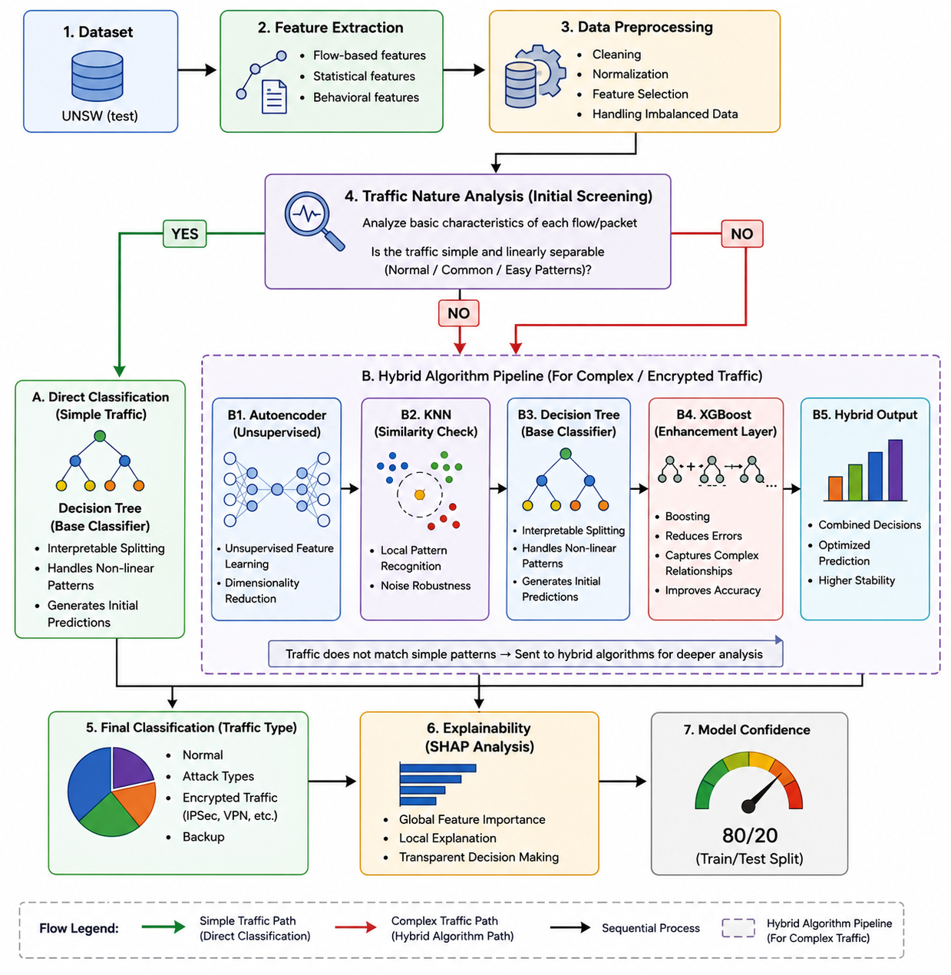

IV. Results and Discussion

A. Stage 1 Performance on ISCX Test Set
Category | Count | Percentage | Action
Confirmed Anomaly | 903 | 4.5% | Blocked — Security Alert
Gray Zone (KNN → Suspicious) | 13 | 0.1% | Blocked — KNN Decision
Gray Zone (KNN → Normal) | 131 | 0.6% | Forwarded to Stage 2
Normal Traffic | 18,953 | 94.8% | Forwarded to Stage 2

B. Stage 2 Classification Results
The Decision Tree classifier was evaluated on 19,084 flows forwarded from Stage 1, achieving a 5-Fold Cross-Validation accuracy of 96.07% (±0.21%) and a weighted F1-score of 91.92%.

Class | Precision | Recall | F1-Score | Support
Backup | 0.97 | 0.86 | 0.91 | 3,651
Browsing | 0.92 | 0.93 | 0.92 | 3,660
Email | 0.91 | 0.90 | 0.91 | 3,898
IPSec | 0.83 | 0.94 | 0.88 | 3,929
Web | 0.98 | 0.96 | 0.97 | 3,961
Weighted Avg | 0.93 | 0.92 | 0.92 | 19,084

IPSec demonstrated the lowest precision (0.83) due to its encrypted nature producing behavioral features similar to other VPN-tunneled traffic. The CV standard deviation of 0.21% confirms model stability across folds.

C. Comparison with Baseline
Model | Accuracy | F1-Score | Anomaly Detection
Naive Bayes (Antari et al., 2024) | 35.76% | 33.58% | No
Decision Tree (Antari et al., 2024) | 95.00% | 92.56% | No
Random Forest (Antari et al., 2024) | 96.71% | 97.34% | No
XGBoost (Antari et al., 2024) | 97.56% | 98.39% | No
Deep Neural Network (Antari et al., 2024) | 86.04% | 85.44% | No
Transformer (Antari et al., 2024) | 98.95% | 98.82% | No
DT-Guard (Ours) | 96.07% (CV) | 91.92% | Yes

DT-Guard exceeds the standalone Decision Tree baseline by 1.07% while adding an anomaly detection capability absent in all baseline models. The lower overall accuracy compared to XGBoost and Transformer reflects the cross-dataset evaluation setup; DT-Guard was trained on ISCX while baselines were trained on domain-specific AED data.

D. Generalization Test on UNSW-NB15
Configuration | Detection Rate | False Alarm Rate | Precision
Original Threshold (0.0247) | 9.5% | 2.8% | —
Adapted Threshold (0.0069) | 51.2% | 8.2% | 93.0%

The generalization test reveals a significant domain shift between ISCX (VPN-focused) and UNSW-NB15 (general network attacks). After threshold adaptation to the target domain's error distribution, detection rate improved from 9.5% to 51.2% while maintaining high precision (93.0%), demonstrating that threshold calibration is the primary bottleneck for cross-domain deployment.

V. Limitations and Future Work
DT-Guard exhibits three primary limitations. First, the Anomaly Detection Threshold is dataset-specific; the threshold derived from CICIDS2017 requires recalibration when deployed on networks with different traffic distributions. This is evidenced by the drop from 94.8% normal traffic detection on ISCX to 9.5% on UNSW-NB15 without adaptation. Future work should explore adaptive thresholding using online learning or domain adaptation techniques.

Second, IPSec classification precision remains at 0.83, below the performance of other classes. The behavioral similarity between VPN-tunneled protocols and IPSec flows creates inherent classification ambiguity that additional features (e.g., packet timing entropy, handshake patterns) may resolve.

Third, the framework was evaluated on publicly available benchmark datasets rather than operational network data. Deployment in real-world environments would require additional validation and potentially domain-specific feature engineering.

VI. Conclusion
This paper presented DT-Guard, a two-stage hybrid framework that unifies anomaly detection and encrypted traffic classification into a single interpretable pipeline. By training an Autoencoder on normal traffic behavior and deploying a KNN-supported gray-zone resolution mechanism, Stage 1 filters 4.5% of anomalous flows before they reach the classification engine. Stage 2 leverages Random Forest and XGBoost as feature enhancers feeding a central Decision Tree, achieving 96.07% cross-validation accuracy across five traffic classes.

The primary contribution of DT-Guard over prior work is the integration of anomaly detection with traffic classification, addressing the gap identified in the Antari et al. (2024) baseline. Generalization testing on UNSW-NB15 reveals that domain adaptation of the anomaly threshold is critical for cross-network deployment, establishing a clear direction for future research in adaptive network traffic analysis systems.
Link to github : https://github.com/r-awa-n/DT-Guard

References
Antari, A., Ashqar, H. I., Abo-Aisheh, Y., & Shamasneh, J. (2024). Network traffic classification using machine learning, transformer, and large language models. JAWWAL Security Department, Nablus, Palestine.
Lotfollahi, M., Jafari Siavoshani, M., Shirali Hossein Zade, R., & Saberian, M. (2020). Deep packet: A novel approach for encrypted traffic classification using deep learning. Soft Computing, 24(3), 1999–2012. https://doi.org/10.1007/s00500-019-04030-2
Nguyen, T. T. T., & Armitage, G. (2008). A survey of techniques for internet traffic classification using machine learning. IEEE Communications Surveys & Tutorials, 10(4), 56–76. https://doi.org/10.1109/SURV.2008.080406
Rezaei, S., & Liu, X. (2019). Deep learning for encrypted traffic classification: An overview. IEEE Communications Magazine, 57(5), 76–81. https://doi.org/10.1109/MCOM.2019.1800819
Sarhan, M., Layeghy, S., Moustafa, N., & Portmann, M. (2020). NetFlow datasets for machine learning-based network intrusion detection systems. https://doi.org/10.1007/978-3-030-72802-1_9

