
Team Name: | AKAV
 | Full Name | Imagine Cup  User Name | Email Address | Mobile Number | College
Team Member 1: | Abhirath Anuwal | Abhirath Anuwal | abhirath.anuwal@gmail.com | 9920249073 | VESIT(INDIA)
Team Member 2: | Kshitij Shah | Kshitij Shah | ksh1989@gmail.com | 9869921875 | VESIT(INDIA)
Team Member 3: | Ashutosh Raina | Ashutosh raina | ashutoshraina1989@gmail.com | 9699090749 | VESIT(INDIA)
Team Member 4: | Viraj Bedekar | VIRAJ BEDEKAR | viraj.bedekar@gmail.com | 9920673434 | VESIT(INDIA)
Mentor (if any): | Dhairya Pujara | dhairyap88 | dhairyap88@gmail.com | 980887967 | VESIT(INDIA)

* All team members and mentor (if any) must be registered on www.imaginecup.com

- What Problem are you trying to solve?
United nations millennium development goals are an extremely challenging theme for Imagine Cup. We look to solve the problem of healthcare system by providing an end to end solution which connects the people to healthcare providers. With a population just above one billion people, the physician-to-population ratio in India is 50-60 per 100,000.
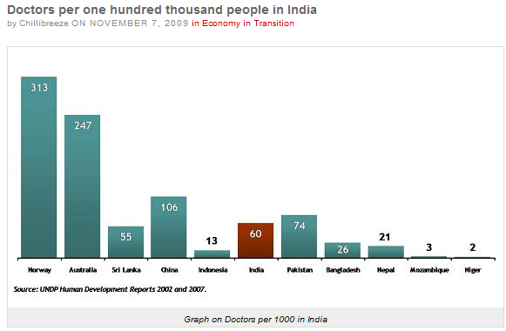
The distribution of practitioners is heavily skewed towards urban areas. This analytic perspective explains why some observers report that “India has enough physicians,” while many Indians, in fact, never receives the services of allopathic physicians at all.
Our solution looks to fulfill this gap by offering remote health care to people who have limited or no access to medical practitioners. Providing easy access to a patient’s health data for doctors and will make it easier to handle a large chunk of patients from the rural and semi-urban areas. By analyzing the trends in a particular the Health Official from the government can keep a tab on epidemics and suggest preventive measures.

- What is your proposed Solution to the problem?
  - Respond in less than 100 words.
NIDAAN is a comprehensive solution which
- The software proposes a concept of kiosks where the patients can go and enter their health data into the system using a Microsoft Health Vault.
- These kiosks will also have basic devices for measuring the basic parameters like temperature, blood pressure.
- A social entrepreneur can then ask the system to generate a case for the patient which will then be forwarded to a doctor who is already registered with the system.
- The doctor can see the Health parameters like (Blood Pressure, hemoglobin) and take the assistance of the system which can predict the most likely disease.
At this point the doctor can do any one of the following :-
- Ask questions to patient
- Request for more Health Parameters
- Diagnose the patient and Prescribe Medicine
- The medicine Centre which is associated with a Kiosk is then forwarded the case with the details of the prescribed medicine and the dosage which is then delivered to kiosk.
- The Patient can anytime update the health parameters, the system takes care that always the latest information is made available to the doctor.
- The Health official can see the data about each kiosk. Reports about the spread of a particular disease will also be made available for the official to monitor the spread of epidemics.
- Filtering of data based upon the geographical location enhances our ability to monitor the spread of epidemics especially in areas which need constant monitoring.

- Which Features of your software application have been implemented?

1. The software can use the existing hardware devices which take various medical parameters essential to monitor the health of a person (like body temperature, blood pressure, blood sugar level etc.). All devices can be connected to the Microsoft Health vault and can be used to input data into the health vault (Device Driver Development Kit (DDK) will achieve this).
2. The software has a UI which conforms to medical standards and uses MSCUI (Microsoft Health Common User Interface) and offers a rich and interactive platform through graphs and charts. Doctors can use these tools to analyze a patient.
3 .A Decision Support System (DSS) is the feature which predicts the likely disease caused by a combination of health parameters. This diagnosis will serve as a supplementary help to the doctors. The doctor can use the various analytic tools provided by the software take the final decision on necessary treatment to be undertaken.
4. The system also informs medical centers for exact location where drugs and medicines have to be distributed.
The medical centers will receive an email/sms informing them about the doctor, patient and the location where the medicines have to be delivered with information about the dosage as well.
5. The software also relays health tips and other health news to its patients via SMS and Entrepreneur/NGO for general awareness and specific information during epidemics.
6. The data the system has is analyzed and the trends in diseases are recognized to predict epidemic outbreaks, which is a very special feature. The system generates reports for each region allowing various filtering criteria like geographical location, disease, and time period. This feature enables the early containment of various diseases like Malaria, Dengue which are highly epidemic in nature.
7. Future scope: The concept of point to point drug delivery can be further enhanced by community pooling of unused but useful drugs from people willing to donate. This will lead to an optimal utilization of drugs. Arrangements can also be made for scheduling visits by doctors to a particular area and keeping a track of a patient’s appointment with various doctors including scheduling for needed surgeries.
The system can also act as a platform for getting second opinion from doctors by patients.

- Who will be the potential Users of your software application?
  - List the specific set of users who will be most likely to use your solution.
  - Have you conducted any surveys or trials with potential users? If yes, provide details.
1. NIDAAN provides everyone an entry point in the system and introduces them into the healthcare system. These members may belong to semi-urban towns, villages, areas which unreachable due to their tough terrain and topography. Villages with small-medium population size can also use the system to connect with the health-care facilities .Retirement communities and child care facilities can also use the system to minimize health risk.
2. The NGO's and Social Entrepreneur will interact with the system either standalone or on behalf of the above mentioned communities and manage their health care through NIDAAN.
3. The Doctors and medical attendants will use NIDAAN to interact with the patients. They will use the system to analyze the current medical condition of the patient and advise treatment or further tests as the case may be.
4. Individuals belonging to urban areas can use the NIDAAN to monitor the health of the entire family and keep in touch with a doctor all the time. This provides for an easy at home solution for the all those who have a hectic lifestyle and are especially at risk of cardio diseases.
5. Health Officials appointed by the government can use it as a tool to analyze trends and do analysis about the epidemics.

- What is your proposed software Architecture?
  - The text should clearly indicate how the Required and Optional Elements will be used.
  - Also, include diagrams.
To be eligible, your entry/entry materials must meet the following content and technical requirements:
- Entries must address a social cause connected to the 2010 Theme: "Imagine a world where technology helps solve the toughest problems".
- Any presentation or documentation that is a part of your entry must be in the English language. If a translator is needed, you are responsible to procure and to make usage of one.
- Either an implementation or the consumption of a XML Web Service.
- The application must run on the Microsoft .NET Framework. You may use any version of .Net.
- The application must be developed using at least one (1) of the products within the Visual Studio family (Express, Standard, Professional, or Team System) for development.
- The software application must be fully functional and implemented (i.e., visions for a software application or software applications that are not fully developed are not eligible).
Your team’s entry must include or use features of at least one (1) of the optional elements:
- Windows 7
- Windows Live SDK
- Use of Windows Mobile technologies
- Silverlight
- Azure for implementing a S + S architecture application
- Windows MultiPoint Mouse SDK

MICROSOFT HEALTH VAULT (PPE)
MICROSOFT HEALTH COMMON USER INTERFACE(MSCUI)
Visual Studio 2010(Beta2)
Microsoft .net Framework(3.5,4.0)
Silverlight 3.0(Optional)
JQuery
MS SQL Server 2005 (with Management Studio)
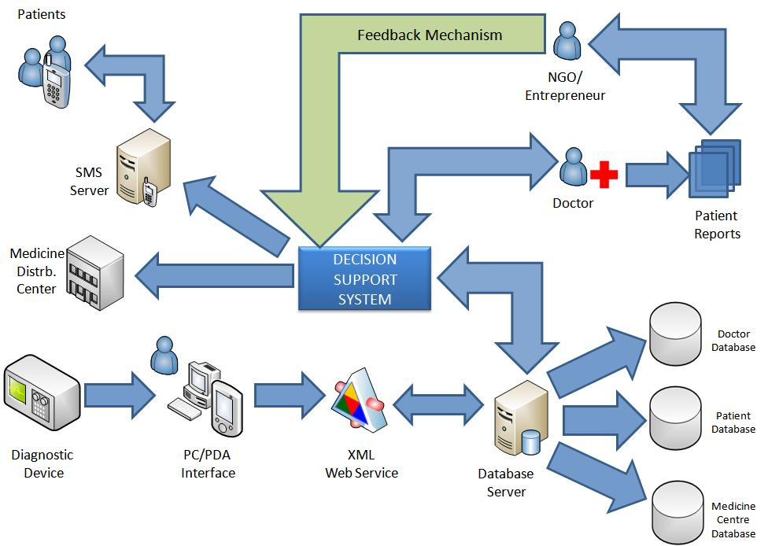

- Has your team utilized new Windows 7 features in the solution? (Yes/No)
No

- Has your team utilized new IE 8 features in the solution? (Yes/No)
No

- Explain why you think this solution has the potential to be deployed in real-life.
NIDAAN is a practical solution for managing the healthcare of India especially the rural India where the doctor to patient ratio is very low. NIDAAN will offer a complete end to end solution to all the users with an excellent platform to communicate effectively. Considering the present scenario where health facilities are at a premium, NIDAAN will cater to every corner of the country effectively making the solution not only practically implementable but also a comprehensive one.
All the hardware devices that are proposed to be used are readily available and also cheap considering the scale of implementation. Patients will no longer need to maintain their health records through files. The use of MS HEALTH VAULT primarily increases the portability of all the health data making it easier to carry the data wherever you go.
Doctors can also use the system to keep a track of their patients reducing cumbersome paperwork and increasing efficiency. The NGO and social entrepreneurs can use it as a tool to conduct mass surveys with greater efficiency and accuracy. Urban Households can also use the system to monitor their health and keep in touch with their family doctor to ensure regular monitoring.
NIDAAN has excellent business potential with a wide range of users.
NIDAAN can be used as health barometer for people who remain on the run (like frequent fliers).Kiosks can be installed at the various platforms like airports ,railway stations ,patients can then go to such kiosks use the various devices to enter the data into the system or the health vault .The system then evaluates such cases and sends them to doctors for immediate attention .
Corporate offices wanting to keep a check on the employee health can use the system as a platform to monitor the employee health and increase the overall efficiency of the organization.
Individuals can connect to their personal health advisers through NIDAAN and keep in touch even when they are at remote places.

