Roxanne Buenaventura
CSD-310
ASGN 4_2
26 June 2026

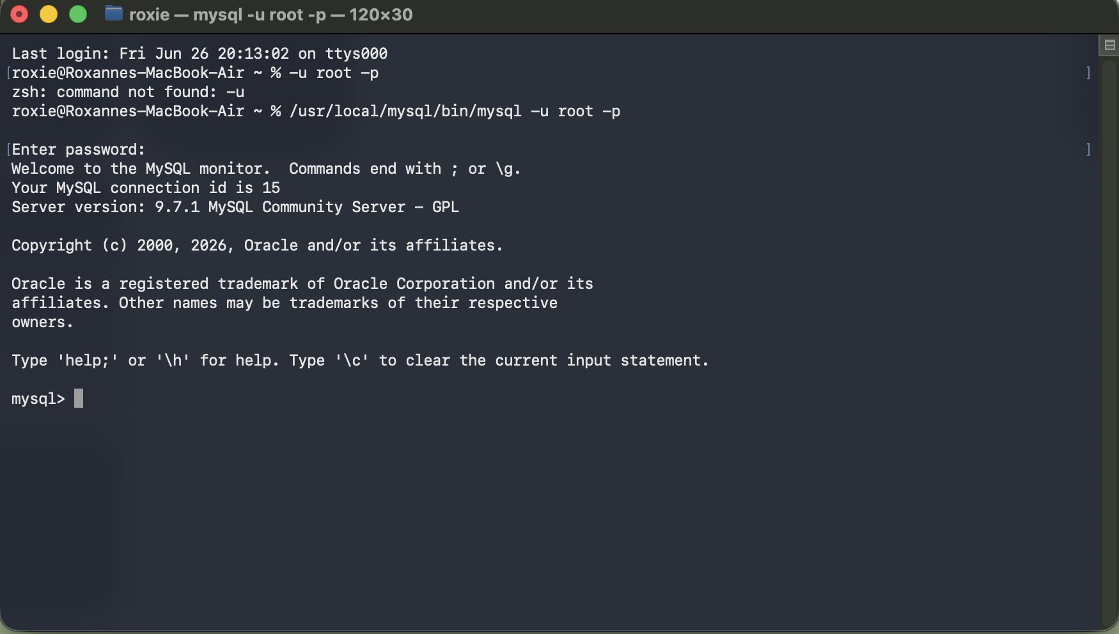
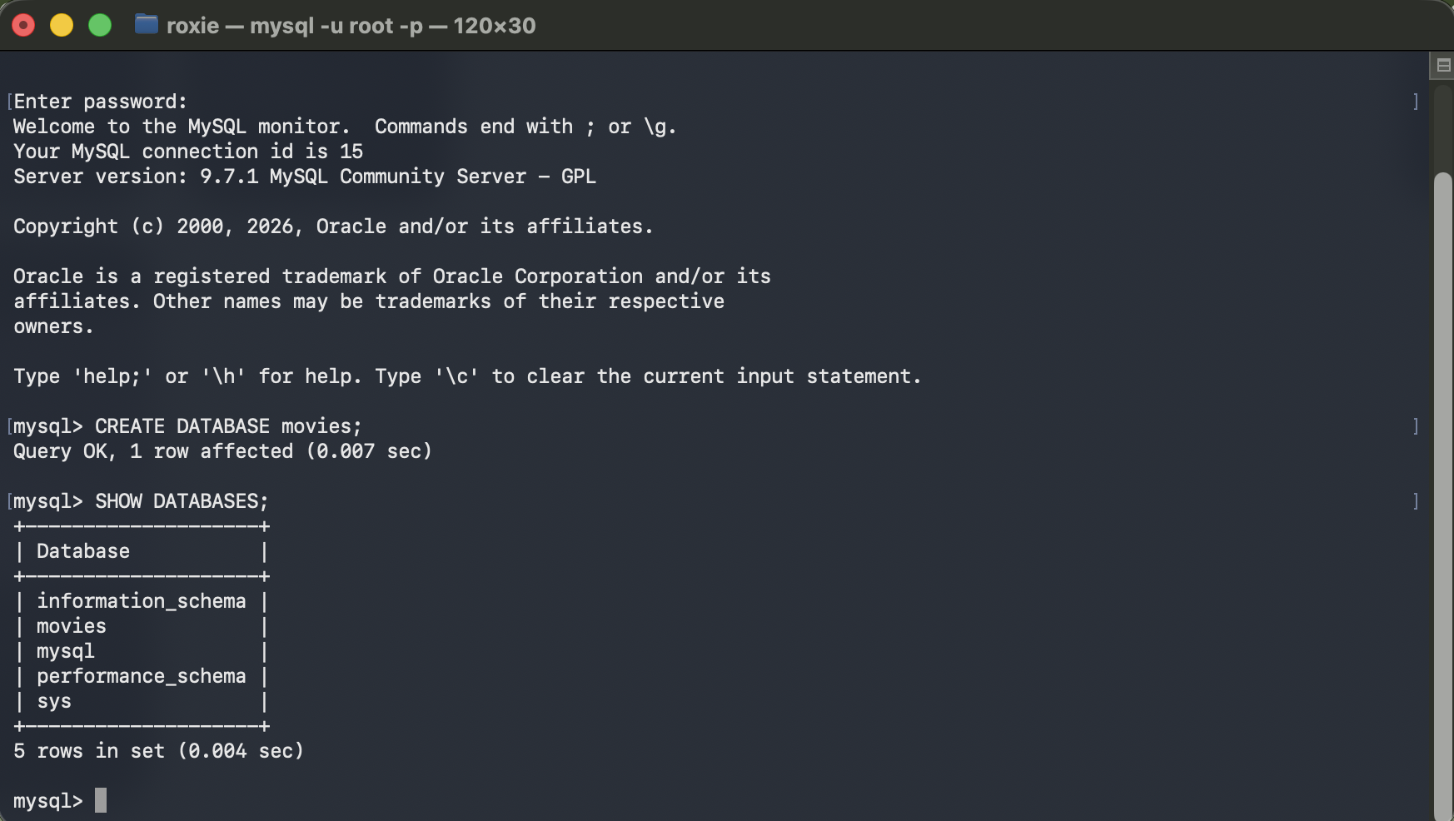
- The INSERT() command is used to plug in information to specific locations.
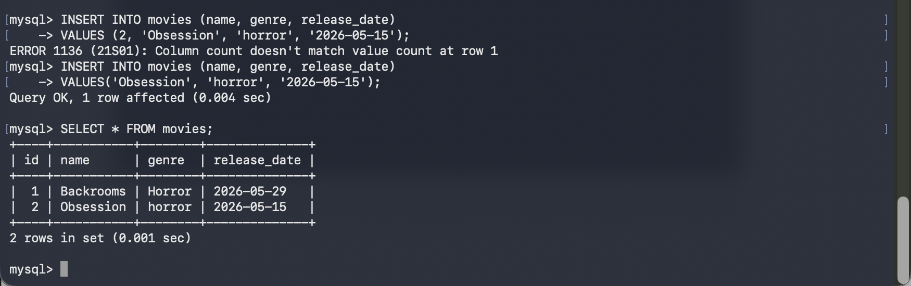
- LOCATE() is a great function which can be combined with other clauses to find the location of data
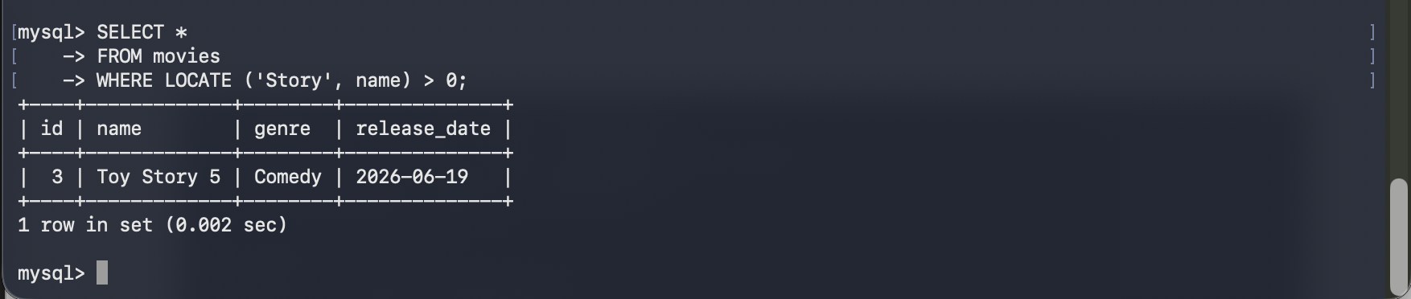
- The FIELD() function can be used to find the position of a value in a list of values.
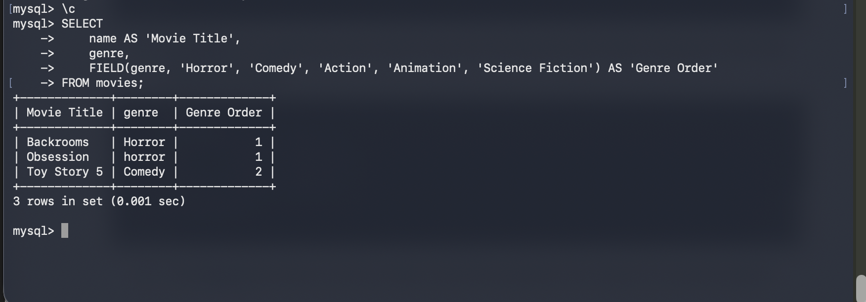
Here is me creating more user-friendly names using the AS keyword:
