Roxanne Buenaventura
CSD-310
Module 2_3ASGN
14 June 2026

ERD:
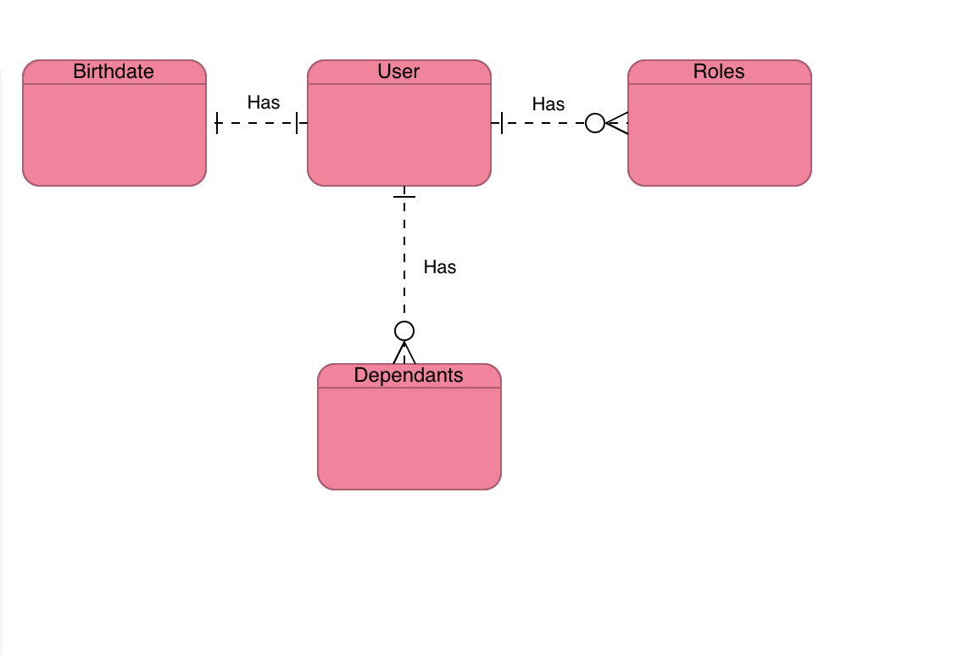

NoSQL:
{
“user”: “___”,
“birthdate”: “___”,
“roles”: [
{
“role_name”: “___”,
},
{
“role_name”: “___”,
},
]
“dependents”: [
{
“dependent_name”: “___”,
},
{
“dependent_name”: “___”,
}
]
}

