Roxanne Buenaventura
CSD325
ASGN 8_2
10 July 2026
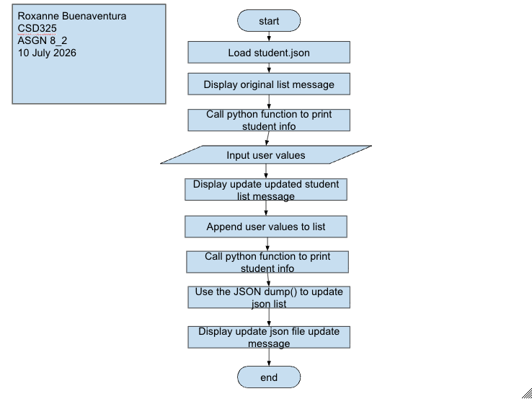
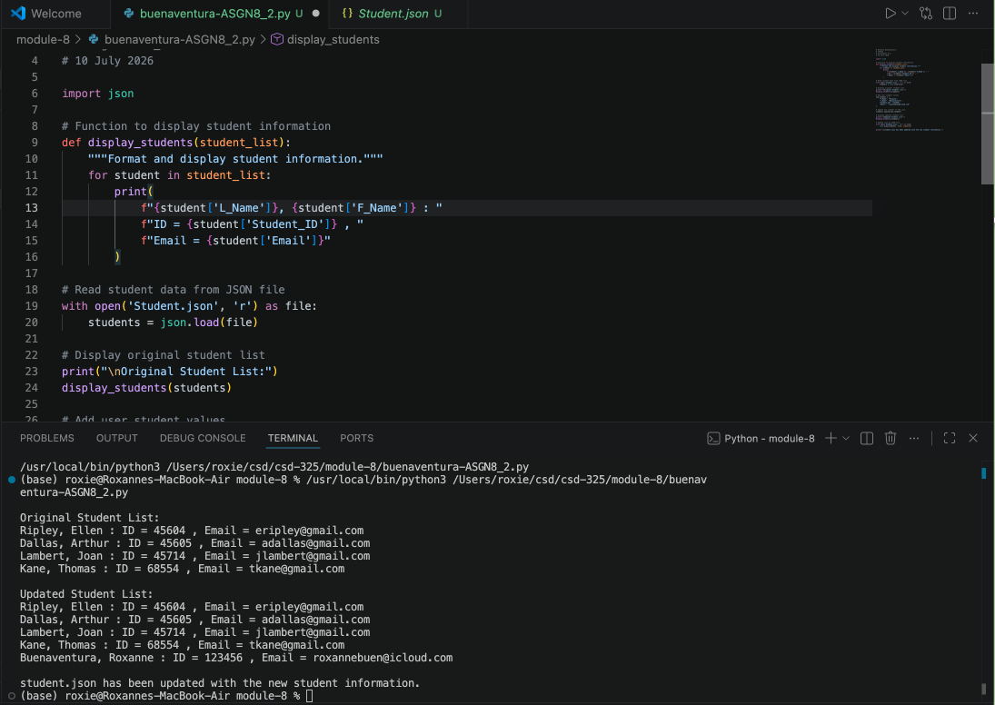
I didn’t receive a pop up regarding changing the student.json. When I looked into it I learned that VS code automatically reloads externally modified files without asking, which is why I didn’t receive that pop up.
