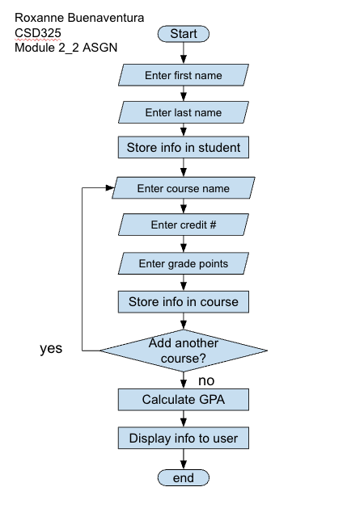
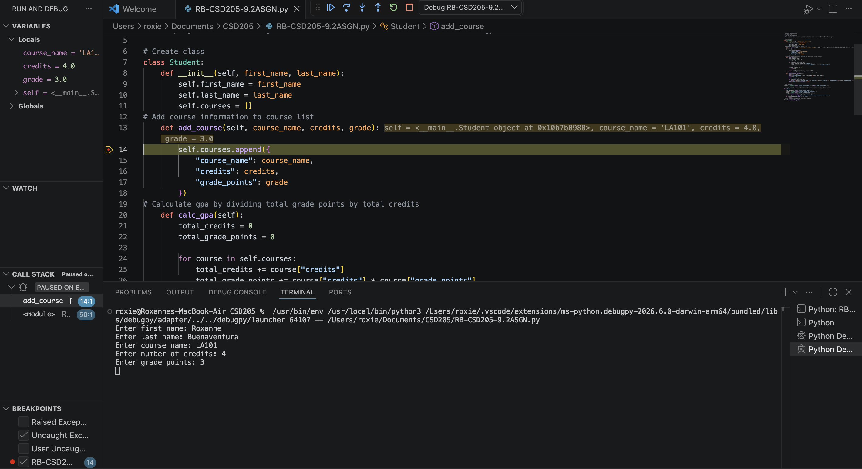Above we can see the breakpoint has been set and the program has been halted at the breakpoint with the yellow highlight.
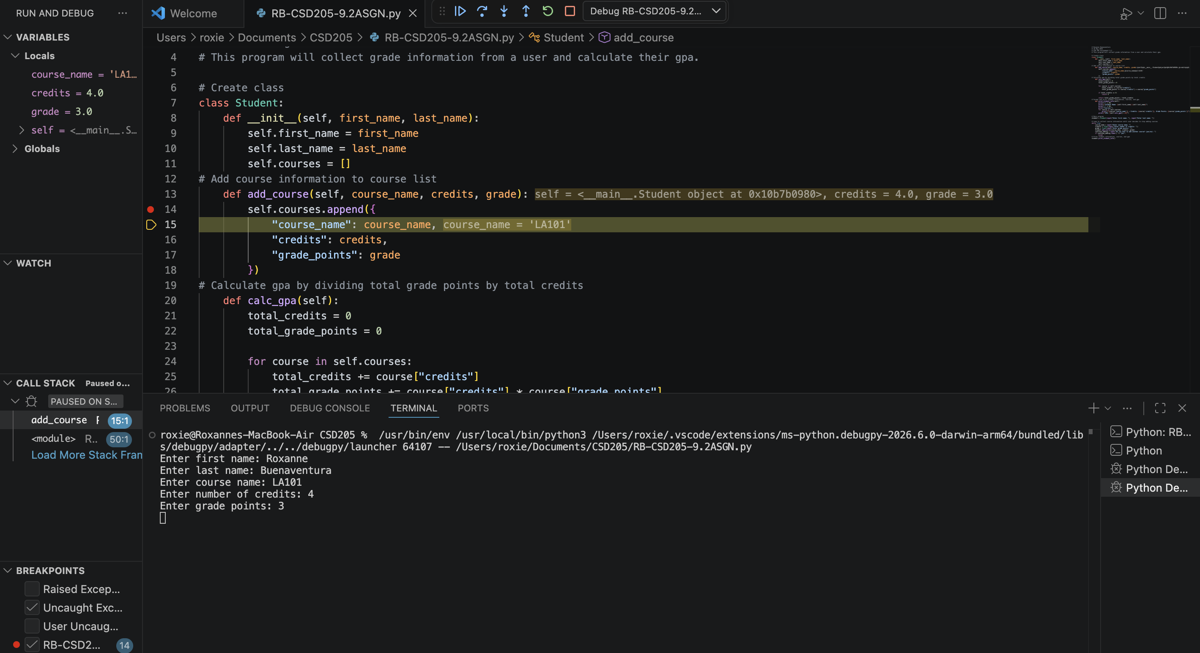
Above we can see that I’ve stepped into the function to see how its working and in the yellow highlight you can see the course name being appended into the list.
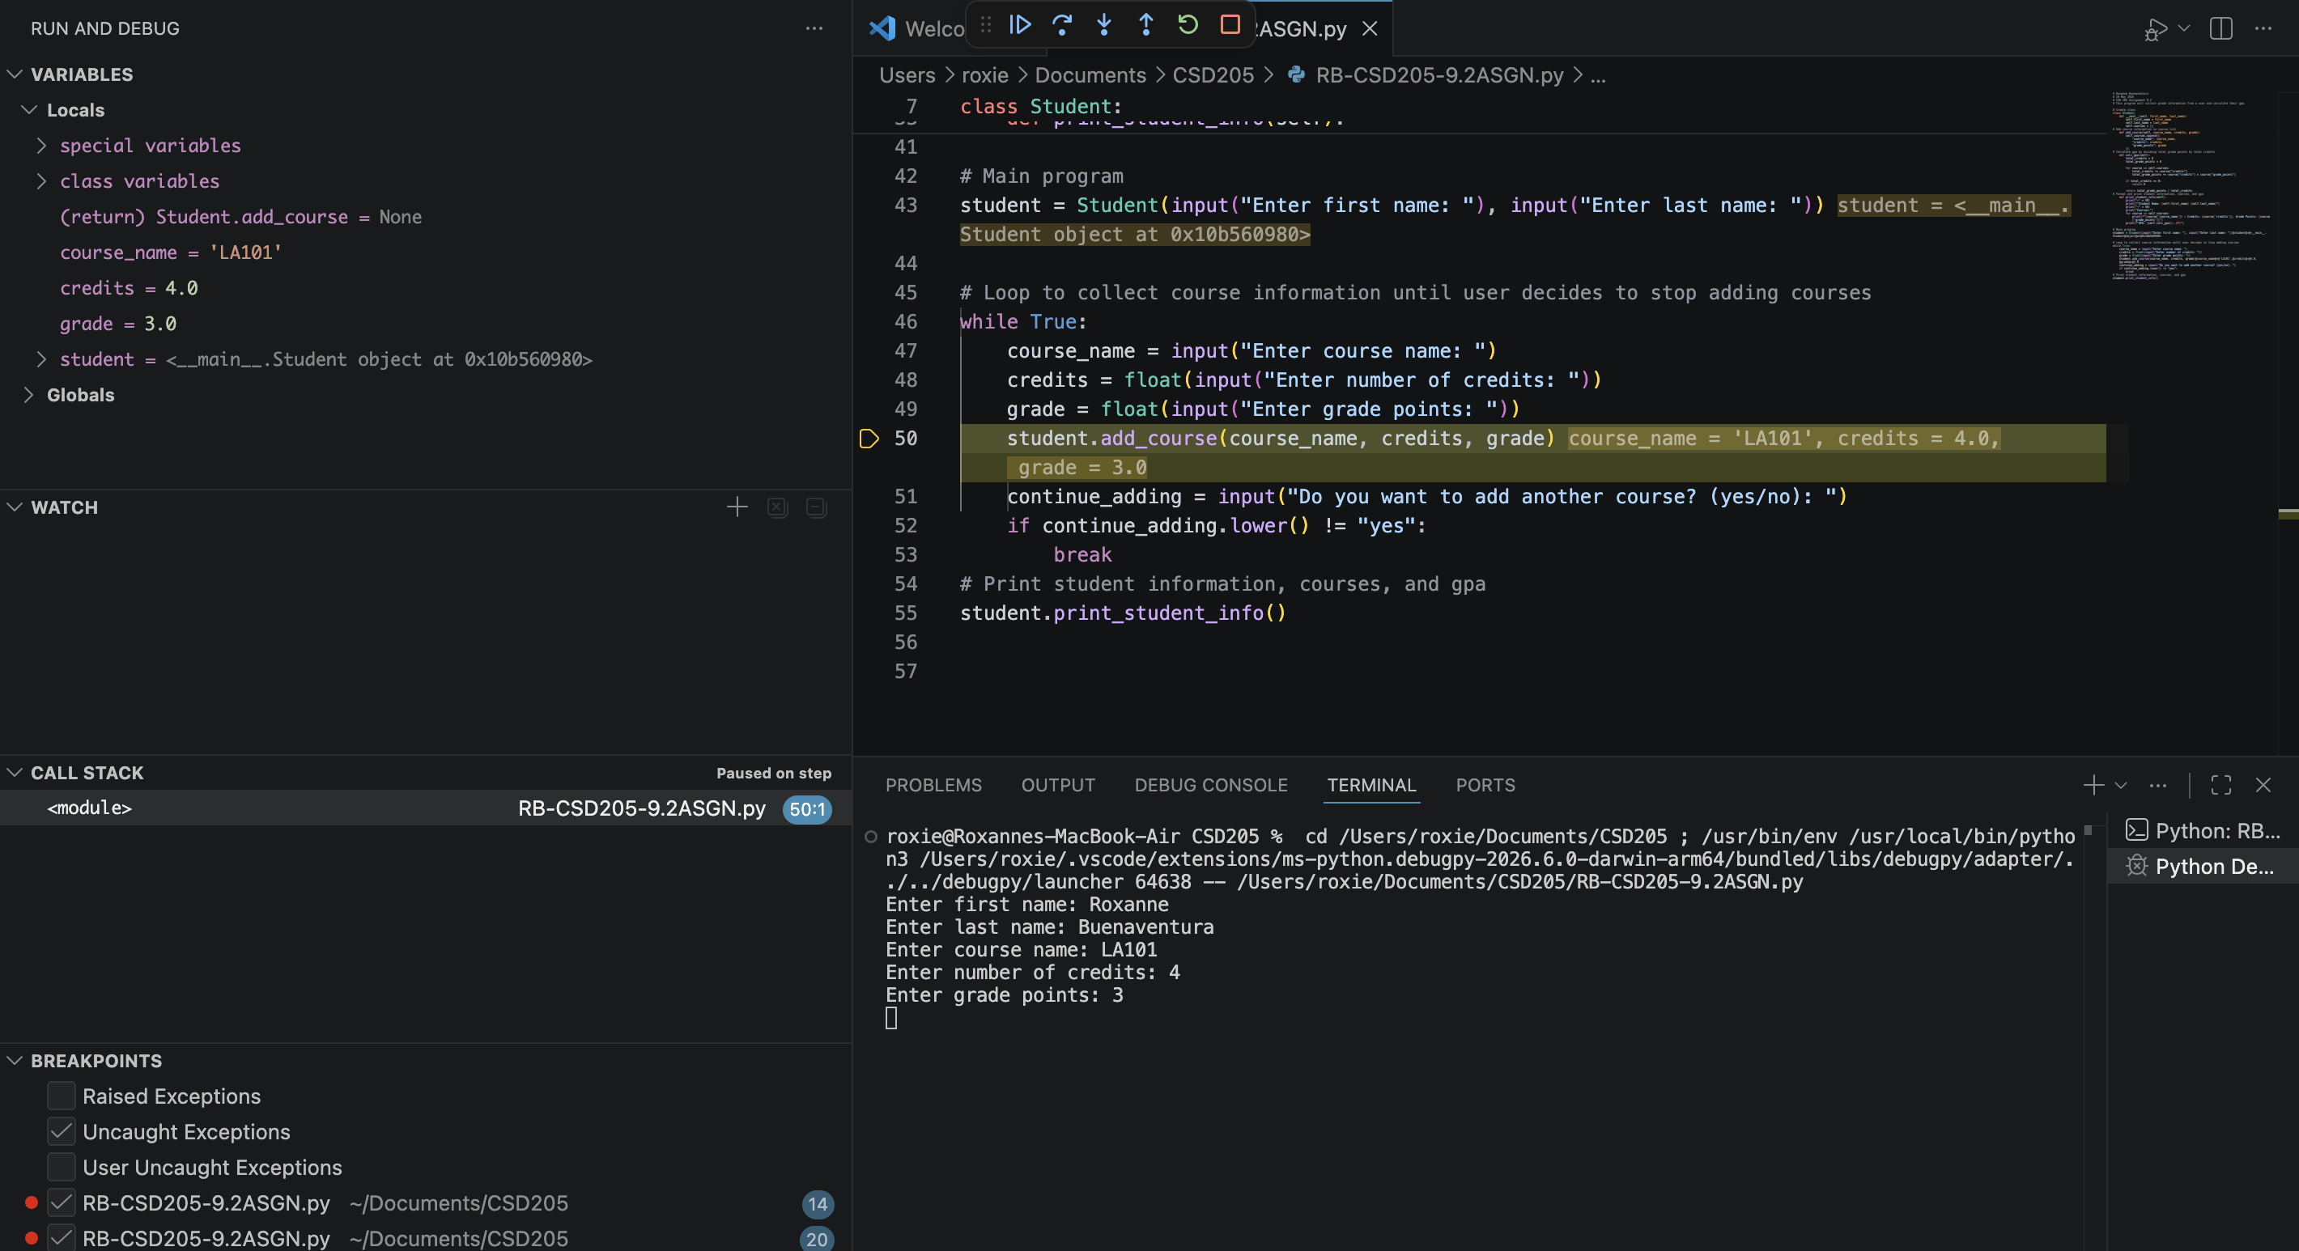
Above you can see that since we knew everything was going to run smoothly, we stepped over and now we’re at the next breakpoint shown here.

