Roxanne Buenaventura
CSD-420
Module 1.2 Assignment GitHub
25 October, 2026

Link to GitHub Repository: https://github.com/r-buenaventura/csd-420.git
Screenshot of local directory: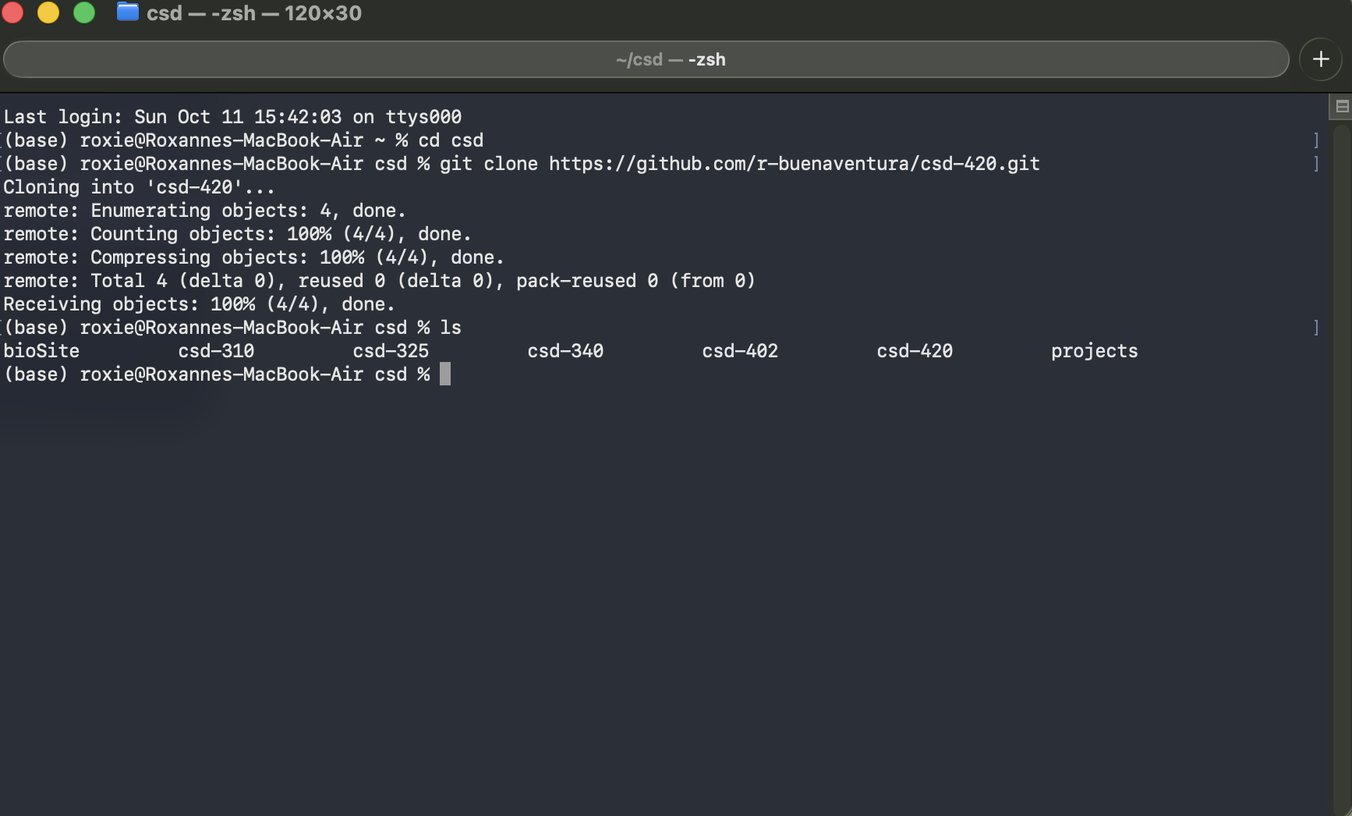
Screenshot of GitHub Repository:
