Design

The circuit uses a PIC microcomputer type 16F877; although this seems like overkill, the device is cheap and reliable and the only integrated circuits needed besides the PIC are a 5 volt regulator and an octal relay driver. This makes for a small unit which is easy to construct.

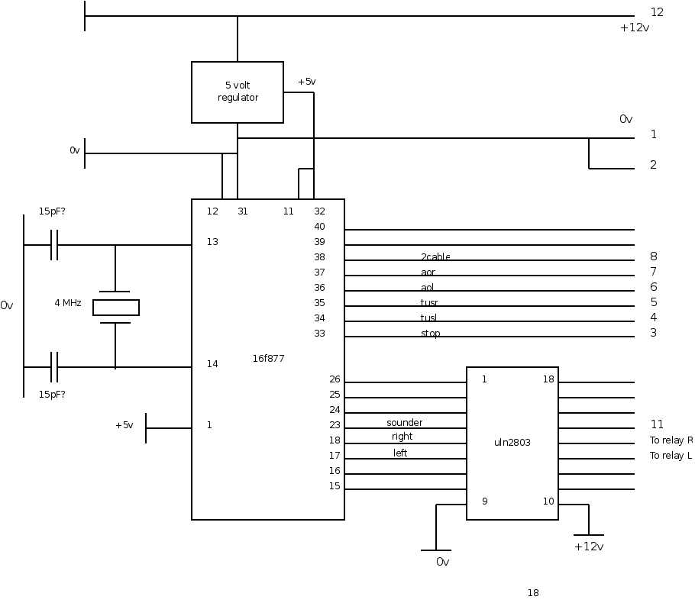
Relays are connected between 12 volts and the ULN2803 outputs; the latter incorporate inductive spike protection.

The PIC portb inputs have software-optional pull-up resistors, so the switches can be connected between zero volts and the inputs. Unused inputs may be left open-circuit.

Power supply

Since the unit operates on 12 volts (or 24 volts) but the microcomputer chip needs a 5 volt supply which must be provided using a 5 volt regulator such as a 5 volt LM340 or a 7805 regulator device. The pinout of these devices is as shown:-
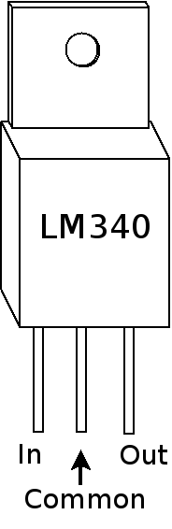

Construction

Having a number of “wire-wrap” sockets available, I used these, but the construction is not critical, although the connections from PIC to crystal and capacitors should be short, as should the connections to zero volts and power – that is to say, keep the supply well decoupled. This is simply good practice on any circuit.

Enclosure

A metal container – die cast or aluminium – is good practice for any such circuit. I put the relay bases on the outside of the box so that, should a relay fail, it could be replaced without opening the box. Given the nature of a tungsten lamp (heavy surge when lighting, short circuit when the bulb fails) a relay of a generous current rating is favoured. This is also the reason for avoiding a power semiconductor output.

Connection

It is intended that the wires carrying power to the relays and thence to the lights should be separate from the wires taking power to the control unit and only join near to the battery, so that any voltage drop in the heavy current lamp wiring will not affect the voltage at the control unit. If this is not done the heavy surge as tungsten bulbs heat up may cause the relays to have problems.

The switches are of course separate from the control unit. I chose to use two way switches for “Take up slack” and “All out” - so the user pulls the switch down to indicate take up slack and pushes it to signal all out.

My control panel was fixed in a plywood desk surface, so is somewhat different in layout from the one you may make for a hand-held unit – see 'SignalPanel1.ppt'. You might still make a front label by printing your design on a normal printer, cutting it out and laminating the sheet before sticking it down.

A standard 8 way cable should be suitable for the connections.

The unit as it was installed at Clevelands Gliding Club had a sounder much like a car or burglar alarm, mounted under the signal wagon, so it could be heard by the pilot awaiting launch.

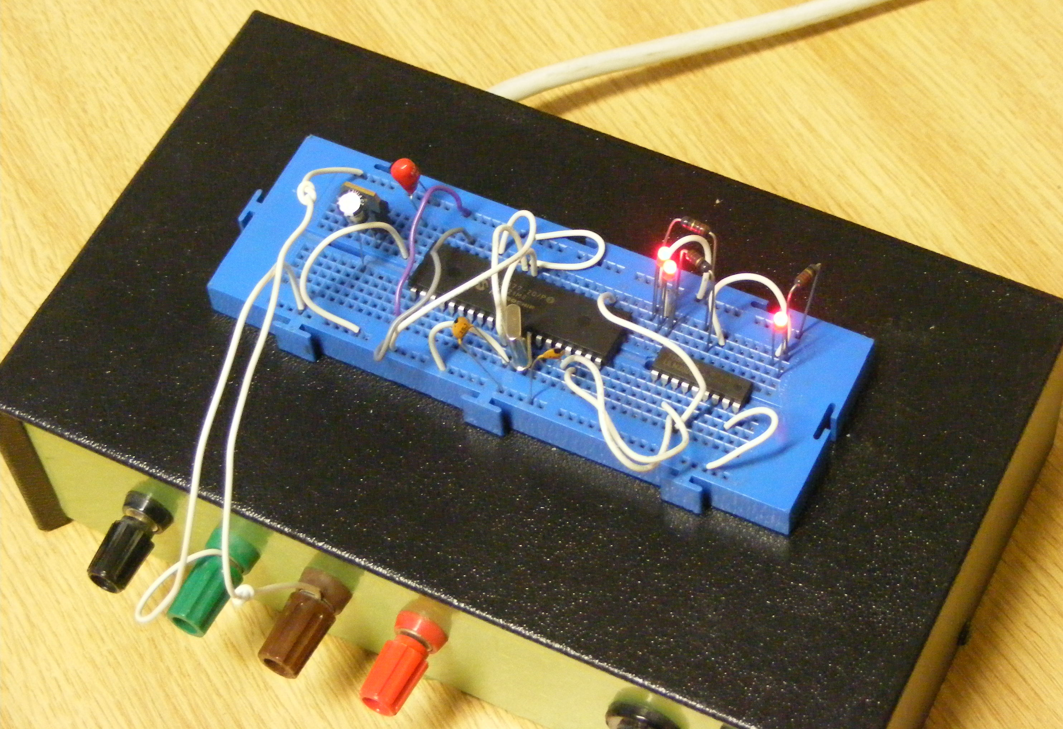

16f877 chip under verification test

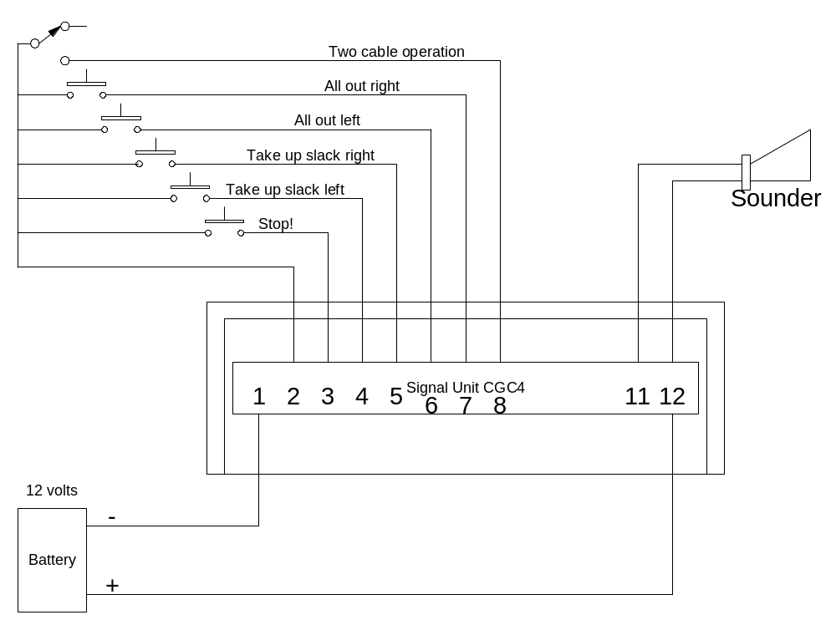

Licencing

The circuit design and software are made available under the General Public Licence (GPL) so that anyone may make use of it without restriction. If any part of this system is distribute all the files must be included including the GPL.

