Signal definitions

After looking for definitions of the “take up slack” and “all out” signals (and finding them not entirely consistently defined), I have stayed with those I understand to be acceptable:-

Signal | On time | Off time
Take up slack | 1 second | 3 seconds
All out | 0.5 second | 0.5 second
Stop | continuous (all lights)

Strictly speaking, I understand “all out” to be a brief flash every second. Half a second gives a headlight bulb time to light or go out.

Each time a switch is activated for a signal the relevant light should illuminate immediately, the cycle starting at that point. Experience of using a two lamp / two cable winch system makes it very clear that the lamp corresponding to the inactive cable should be lit when anything is happening on the active cable. This makes it much easier for the winch driver to determine which light is flashing.

Simulation

I am a Linux user by preference, and an enthusiast for “Free and Open Source Software” (FOSS), which is used here. I understand that the software tools used here are also available for Windows, but I don't use Windows on my current laptop.

The program is written in assembler code and assembled using 'gpasm'.

The 'gpsim' simulator program is started from a script file (because this is a convenient way of invoking the program with the appropriate parameters to specify the code to be loaded, the configuration to be used and the desired PIC chip).

The bash script file contains:-

#!/bin/sh

cd "/home/roger/Software/pic/CGC signal lights/Code"

gpsim -p 16f877 -s cgc_signals.cod -c netlist.stc

In the terminal window thus opened, the 'gpsim' commands following are invoked:-

**gpsim> scope.ch0="portc3"

**gpsim> scope.ch1="portc2"

**gpsim> scope.ch2="portc4"

Several other windows are opened showing the chip on a “breadboard”, a “scope” (i.e. software oscilloscope), the source code and much other information.

A window with control buttons and so forth appears, which may be used to control the operation of the simulator:-

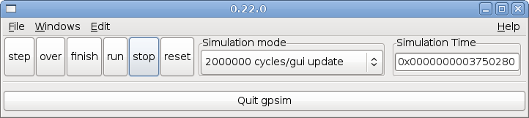

The tests and results.

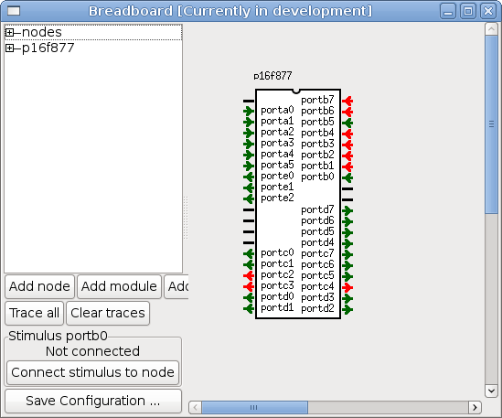
Double clicking on an input pin (in this case that means the 'portb' pins) changes its state. Here bits 'portb0' and 'portb5' are set to low; other pins are high as a result of the internal pull-up resistors.

In the test run, the first, brief, test state was with all inputs high; the second with portb5 (“two lamps”) and 'portb2' (“Take up slack left”) low, resulting in the “left” lamp, portc3, flashing, the “right” lamp is on continuously, and the sounder (portc4) is beeping in time with the light signals.

The third test state shows the result of all inputs high except portb5 (two lamps) and portb3 (Take up slack right), and the fourth all inputs high except portb5 and portb0 (stop).

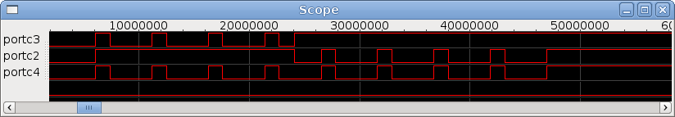

Similar tests using “all out” signals in place of “take up slack” give the following results:-

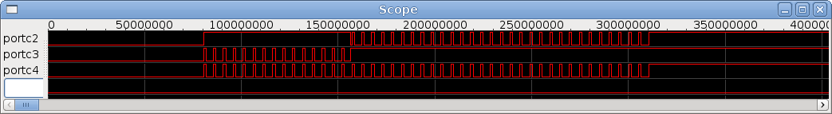

In the single signal lamp / single cable mode, either “take up slack” input and either “all out” input will give the same result, i.e. both lights flash together:-

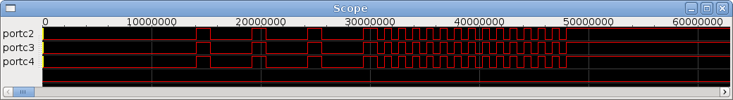

Summary

The simulation tests indicate that the software functions correctly. (Of course the unit has been used for some months at RAF Dishforth too!).

Appendix A: software design
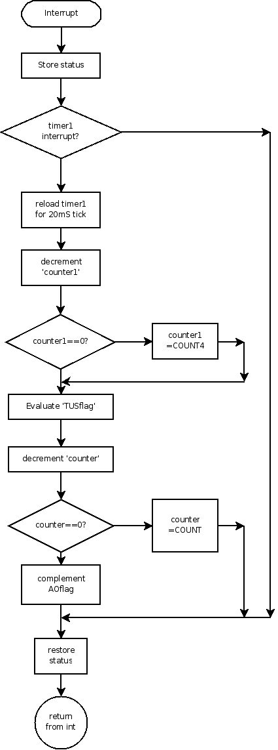

The interrupt service routine handles all timing functions, setting or clearing the flags for take up slack and all out signals.
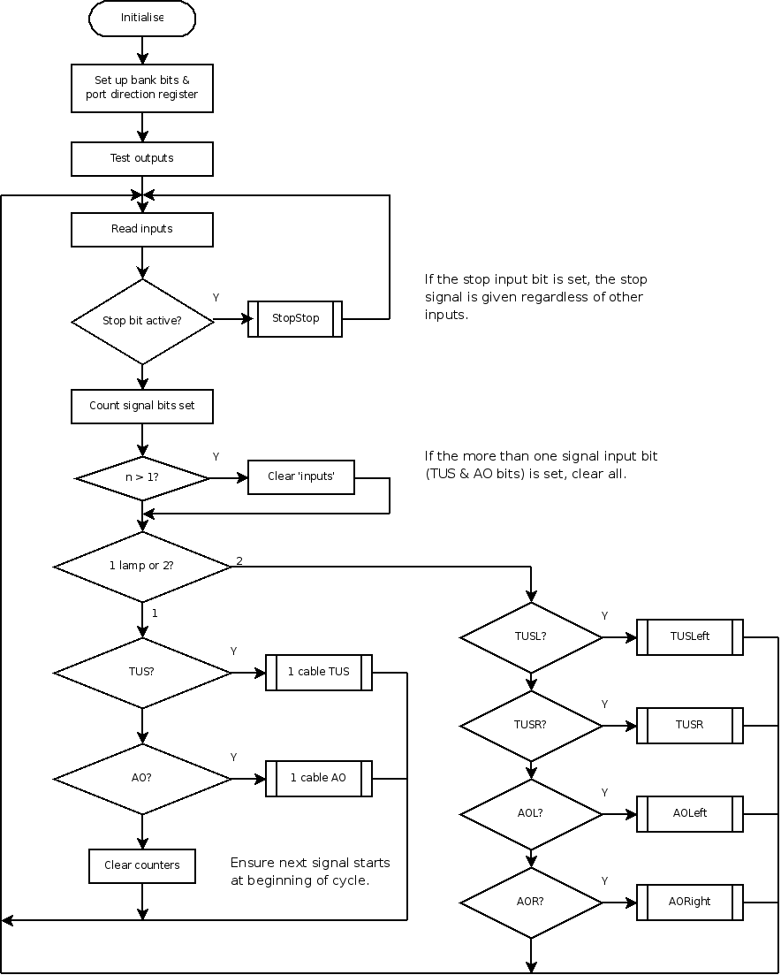

The “stop” signal is given priority. If the stop bit is not set the code checks for validity (no conflicting signals requested) then picks the correct subroutine for the chosen signal.

The subroutines select light on and off states based on flags ('TakeUpSlackFlag''AllOutFlag') which are set by the interrupt service routine.

The following constants define the signal timings:

Name | Hex | Dec | Action
COUNT | 0x19 | 25 | Defines 'All Out' frequency
COUNT4 | 0xc8 | 200 | Defines 'Take Up Slack' cycle time
DCOUNT | 0x32 | 50 | Defines 'Take Up Slack' “on” time

