Preparation

Ensure that you have the following libraries installed:
libgnome-2.0
libgnomeui-2.0
gdk-pixbuf-xlib-2.0
gtk+-2.0
gdk-2.0

I have a record of having needed the command:
sudo apt-get install libgnomeui-dev

Having fetched the contents of the GitHub repository, it should only be necessary to invoke the executable file 'Build' for the program to be compiled and linked.

Using 'rbfilter'

Run the program from a terminal; this can be done by means of 'Run'.

You will now see the "Control" window (as well as another, initially labelled "s-plane", where graphical results are to be shown). In this you may select low-pass, band-pass or high-pass, likewise choose between Bessel, Butterworth and Chebyshev and between Sallen-and-Key, Rauch and Discrete filters.

Of course, low pass filters pass signal frequencies below some value, band pass around some value, and high pass (obviously!) above one.

Bessel filters drop off in gain more gradually than the other types, being thus able to change the shape of a signal less, and in particular having very little overshoot. Chebyshev filters are used in audio applications where wave shape is inconsequential but the frequency response is critical. Butterworth filters are at best a compromise, achieving neither sharp frequency response cut-off nor faithful reproduction of wave shape.

Sallen and Key and Rauch filters are (analogue) active filters. Filter designs using high 'q' values (i.e. highly resonant stages) are unlikely to behave as predicted, due to component tolerances and the finite gain of the "operational amplifiers" used. Discrete filters, on the other hand, are almost always digital and their parameters can be defined very accurately if necessary. I have assumed that they are to be created as software.

Various numerical values can be set; exactly what parameters need to be set will depend on the type of filter etc.

Having entered the parameters, the buttons on the right of the control form bring up different graphs and diagrams on the graphical output form and numerical data in the terminal window.

Whatever the results of the software, it is strongly advised that you verify and validate them before making any real-world use of them.

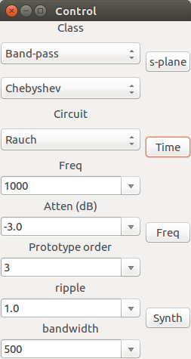
The control panel

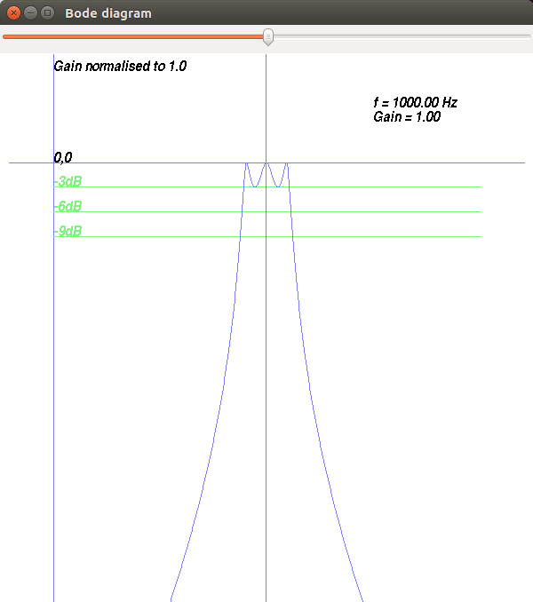
The frequency response or "Bode Diagram"
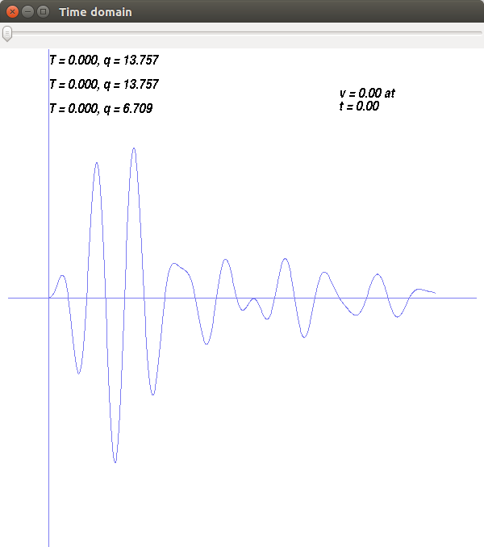
The time response to a step input

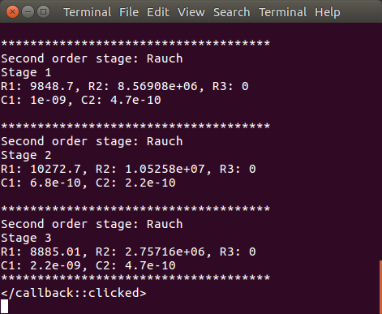
The component data in the terminal window

In the example used here, the 'q' values are high, so the filter may be difficult to realise, needing highly accurate components and very high quality amplifiers. A discrete version of the filter may be needed.

