'rbfilter' is intended to be used to design low-, band- and high-pass active and discrete filters of order 3 and greater, particularly having Bessel, Butterworth or Chebyshev characteristics; it can show the pole positions, frequency response and step response, and can find component values (using preferred values in the case of the capacitors).

Assuming the program is run from a terminal window, the program shows three windows; the terminal, a control window using which the specification of the filter can be entered and a results window in which the pole/zero configuration of the window, the step response or the frequency response of the filter may be shown.

Currently, the terminal window shows the component values when the "Synth" button is clicked.

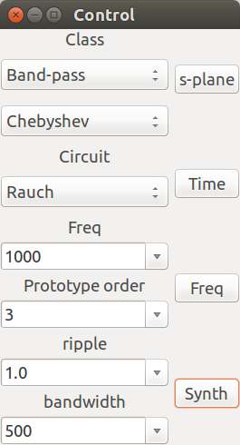
Figure 1

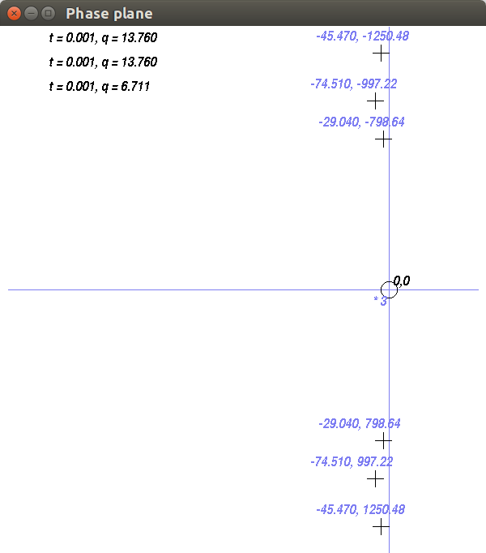
Figure 2

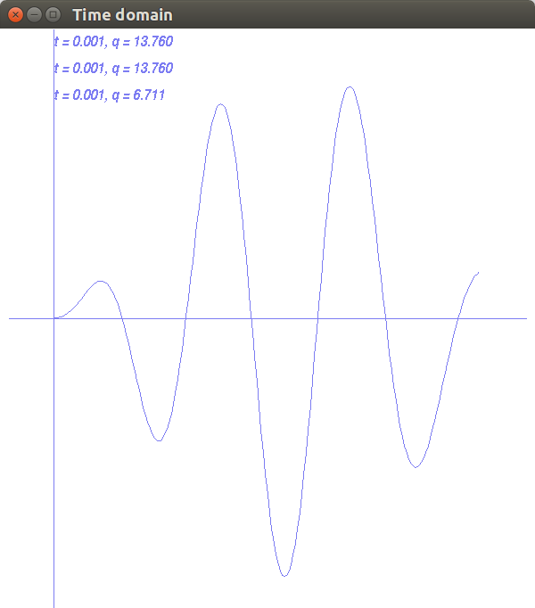
Figure 3

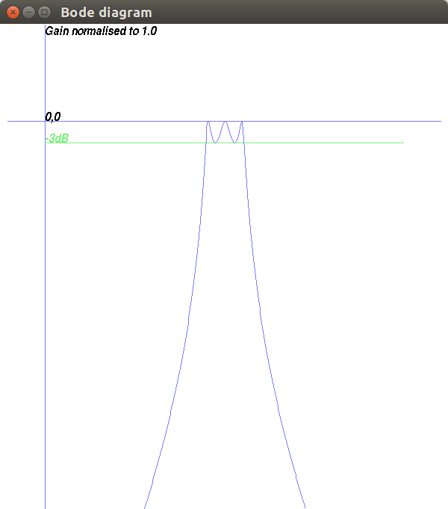
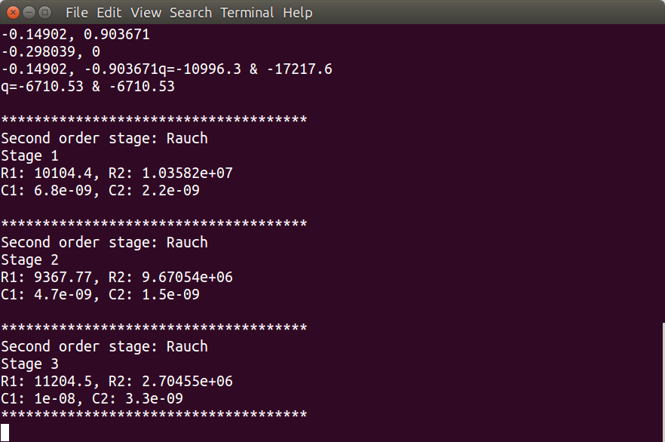
Figure 4

Figure 5

