AI Career Counsellor Chatbot – Internship Project Report

## 1. Abstract

The AI Career Counsellor Chatbot is an intelligent Streamlit-based web application that assists users in making informed career decisions. It leverages natural language processing (NLP), voice interaction, sentiment analysis, and multilingual translation to provide personalized career advice. This project aims to mimic the guidance of a human career counselor while being accessible and interactive.

## 2. Objective

To develop a voice-enabled, multilingual chatbot that suggests appropriate career paths based on user interests, mood, and personality traits using rule-based logic and sentiment analysis.

## 3. Tools & Technologies Used

- Python  
- Streamlit  
- TextBlob  
- SpeechRecognition  
- gTTS (Google Text-to-Speech)  
- Googletrans  
- playsound

## 4. Key Features

- Voice input and output using microphone and TTS  
- Sentiment analysis to detect enthusiasm or confusion  
- Multilingual translation (auto-translates input to English)  
- Career suggestions based on tech, arts, commerce, law, and medical streams  
- Clean UI with animated background and interactivity

## 5. System Workflow

1. User selects input mode (type or speak)  
2. Input is translated to English if necessary  
3. Sentiment analysis is applied using TextBlob  
4. Text is matched to predefined career paths  
5. Relevant advice, skills, and learning resources are displayed  
6. Advice is also spoken aloud using gTTS

## 6. Screenshots / Demo

The app includes a motion background, input fields, and dynamic recommendations with voice output.

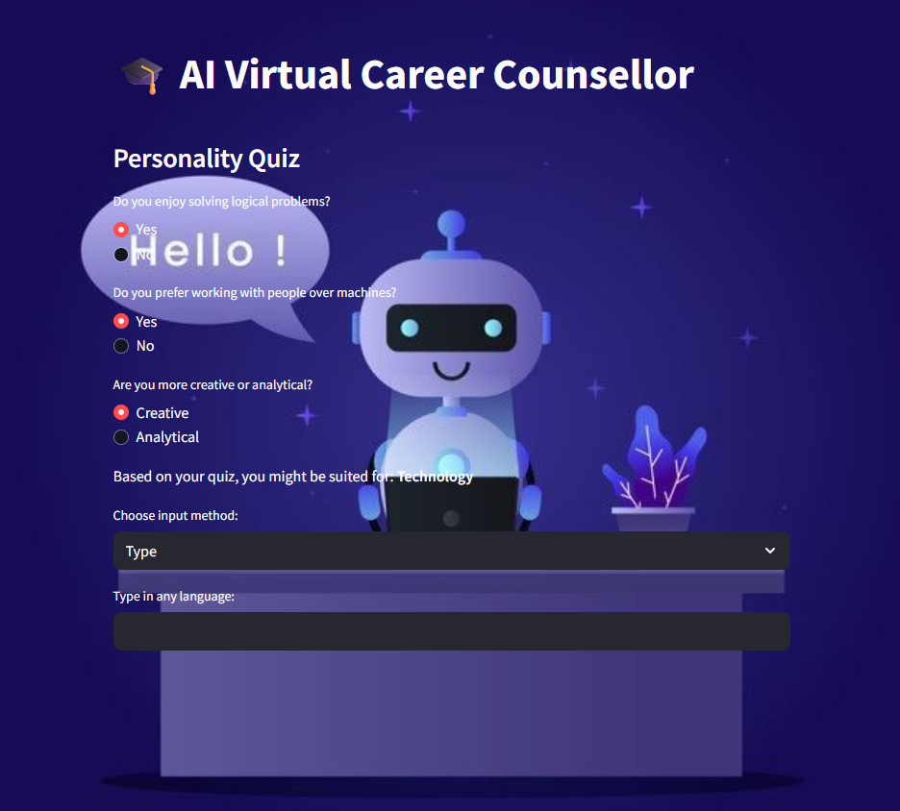

## 7. Results & Learnings

The chatbot works effectively with both voice and typed inputs, responding with context-aware suggestions. It helped improve understanding of real-time NLP, translation APIs, voice recognition, and Streamlit UI design.

## 8. Conclusion

This project demonstrates how AI can be used to guide students interactively and intelligently. It can be further enhanced with chatbot integration (like ChatGPT API), Firebase for authentication, or deeper personality testing.

## 9. Developer

RamCharan Mummadi  
Elevate Labs Internship – June 2025