Plant Disease Detection using CNN – Internship Project Report

## 1. Abstract

The Plant Disease Detection project is a deep learning-based web application that uses image classification to predict diseases in tomato plant leaves. Built using a Convolutional Neural Network (CNN), this project helps in early identification of common plant infections, enabling preventive care in agriculture.

## 2. Objective

To design and implement an image classification model that accurately predicts plant diseases from leaf images and present it through an interactive GUI using Streamlit.

## 3. Tools & Technologies Used

- Python  
- TensorFlow / Keras  
- NumPy  
- Pillow  
- Streamlit  
- PlantVillage Tomato Dataset

## 4. Key Features

- Upload image of tomato leaf  
- Predict disease using trained CNN model  
- Show prediction label and confidence  
- Streamlit interface with motion background  
- Clean and user-friendly GUI

## 5. System Workflow

1. Load pre-trained CNN model (.h5)  
2. Upload and preprocess image  
3. Predict class and confidence  
4. Display result with suggestions  
5. GUI handled by Streamlit

## 6. Dataset Used

The model was trained on a subset of the PlantVillage dataset containing tomato leaf images categorized into 4 classes:  
- Tomato___Bacterial_spot  
- Tomato___Early_blight  
- Tomato___Late_blight  
- Tomato___Healthy

## 7. Results & Accuracy

The trained CNN model achieved high validation accuracy (~95%) and works well on unseen leaf images. The app delivers fast and interpretable predictions.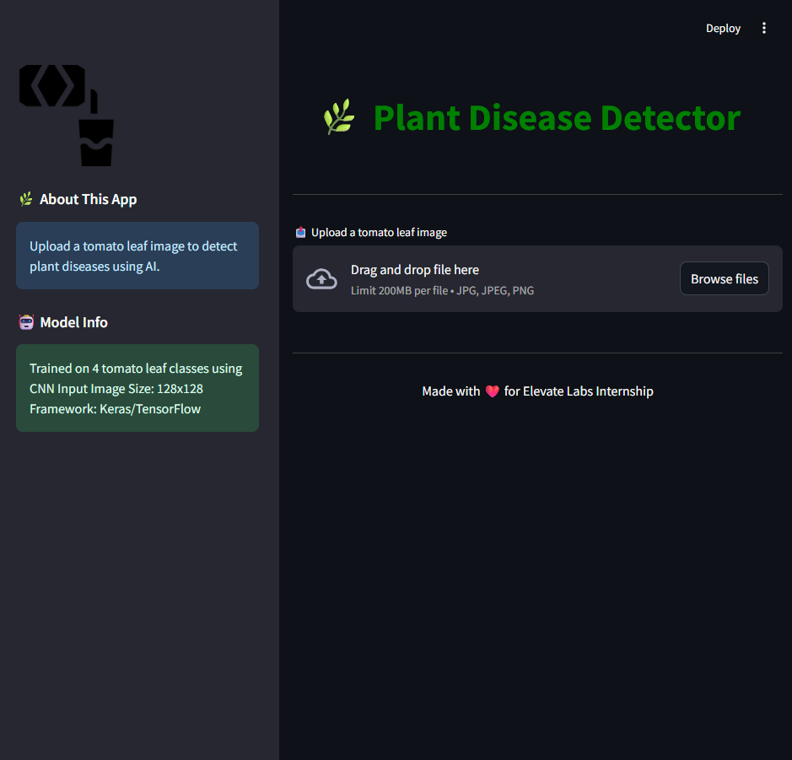 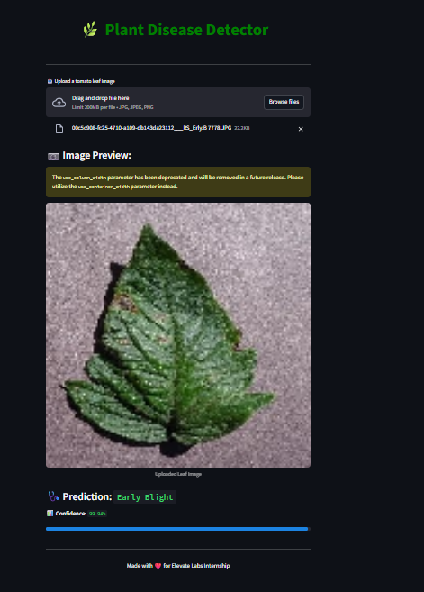

## 8. Conclusion

The project demonstrates the use of deep learning in agriculture and how AI can assist farmers and researchers in identifying crop diseases early. It can be further enhanced by adding more crop types and integrating smartphone image capture and cloud-based deployment.

## 9. Developer

RamCharan Mummadi  
Elevate Labs Internship – June 2025