Infographic Presentation (Prep)
Final Infographic Due: November 24
- Project title
Equitable Grade Weighting Matrix
- Group member names
Rachel Eglash, Peter Kudelin, Sena Lee
- Summary, including:
      - the research question and linear system or linear algebra-related mathematical model or theory that will be used to answer this question
Do different grade weighting methods produce more equitable outcomes across different demographic groups?
Additional research questions:
Which specific demographic groups does this apply to (gender, socioeconomic status, disability status, race, etc.)?
How does including homework and “employability,” (from Griffin’s dataset, or a combination of participation, attendance, and behavior from the UCI dataset) change the final grades for students in different demographic groups?
What is the magnitude of the equity gap (the difference in the mean grades) in different demographic groups under different grade weighting methods?
Which demographic groups benefit the most from traditional grading that includes non-academic factors, and which are most disadvantaged?
      - the name(s) of the linear algebra technique(s) from class used
Weighted linear combinations and matrix-vector multiplication
Student grades can be modeled as weighted linear combinations of multiple grade components. The different grade weighting methods represent different weights of vectors applied to the same group of students with their given grades (represented in a matrix). By calculating final grades using multiple different grade weighting methods using matrix-vector multiplication and comparing the equity gaps between different demographic groups, we can determine which grading method is most equitable (while still maintaining academic rigor requirements).

      - the motivation behind the project: why do you care about his application? Why should the reader care about this application?
As students, we all know that the grading system that our professors use can have a large impact on our academic trajectory, including things like college admission and future opportunities. However, some grading methods may disadvantage certain demographic groups, inadvertently or not, who face many systemic barriers outside the classroom.
Understanding which grading methods minimize demographic disparities is crucial for creating fair and equitable educational systems. This research provides data-driven insights that can help those of us who want to become educators, to use grading practices that accurately reflect student’s learning rather than perpetuating existing inequalities.
      - The field linear algebra techniques are applied to in this project (such as physics, ecology, chemistry, etc.)
Education
      - Definitions of any specialized terms or summaries of concepts related to the field someone from this class may not be familiar with. The only undefined terms may be terms from this class and its prerequisites.
Equity – Fairness in educational outcomes, where students from different demographic backgrounds have equal opportunity to demonstrate their knowledge and achieve success; in this project, equity refers to minimizing systematic differences in grades between demographic groups that result from factors unrelated to academic mastery
Grade weighting method – A system that assigns different percentages or weights to various components of a student's performance (such as assessments, homework, and employability) to calculate a final grade; different weighting methods prioritize different aspects of student performance
Demographic groups – Categories of students based on shared characteristics such as race, gender, socioeconomic status, or disability status; these groups are used to analyze whether grading methods produce systematically different outcomes for different populations
Gender – Demographic group; for the purposes of this project, the determination of a student's gender is binary (male or female)
Disability – Demographic group; for the purposes of this project, a student’s disability status is determined by whether or not they have an IEP or 504 plan
IEP – Individualized Education Plan; a legally binding document that outlines specialized instruction and services for students with disabilities; used as a measure for disability status in this project
504 plan – A plan that provides accommodations and modifications for students with disabilities; used as a measure for disability status in this project
SES – Socioeconomic Status; demographic group; for the purposes of this project, a student's SES is determined by whether or not they receive FRL
FRL – Free or Reduced Lunch; a federal program that provides meal assistance to students from low-income families; used as a measure for SES in this project
Race – Demographic group; for the purposes of this project, a student's race was either White, Black, Hispanic, Asian, or Other
Assessment score – A measure of a student's completion and performance on assignments completed outside of class
Homework score – A measure of a student's performance on tests and quizzes
Employability score – A measure of non-academic factors such as participation, attendance, and behavior
- Answer to the research question and solution of the linear system (or linear algebra-related mathematical model or claim)
      - Start with the research question and any additional context for the example shown. This could read like a word problem, without symbolic math or math-specific vocabulary. In other words, a student not in a math class should be able to read and understand the context and question.
To determine if different grade weighting methods produce more equitable outcomes across different demographic groups, we will start by determining the final grade using two different grade weighting methods (assessment-only and traditional) for 5 students which included one student from each race (White, Black, Hispanic, Asian, and Other).
The final grade for a given student is determined by a combination of their assessment score, homework score, and employability score. Each different grade weighting method uses a different combination or percentage from these three scores to determine the final grade.
For the assessment-only grade weighting method, 100% of the final grade comes from the assessment score (the homework score and employability score are not taken into account).
For the traditional grade weighting method, 70% of the final grade comes from the assessment score, 20% of the final grade comes from the homework score, and 10% of the final grade comes from the employability score.
We will compare the difference in these final grades from different grade weighting methods to determine if we see a significant change for certain races more than others (or another demographic group) when using different grade weighting methods.
By computing final grades under multiple weighting methods and calculating the resulting equity gaps between different demographic groups, we can determine which method minimizes disparities. The method that produces the smallest equity gaps while maintaining academic standards is the most equitable method.

      - Define all relevant variables used in the computation shown to answer the research question, including units (if applicable).
$m$ = total number of students
For student $i$ ($1≤i≤m$):
$a_{i}$ = assessment score
$h_{i}$ = homework score
$e_{i}$ = employability score
$g_{i}$ = final grade
where $a_{i},h_{i},e_{i},g_{i}∈\left[0,100\right]$
For each grade weighting method:
$w_{a}$ = weight for assessment scores
$w_{h}$ = weight for homework scores
$w_{e}$ = weight for employability scores
where $w_{a},w_{h},w_{e}∈\left[0,1\right] :w_{a}+w_{h}+w_{e}=1$
$A$ = $m×3$ matrix containing the three scores for each student
$w$ = $3×1$ vector containing the weights for the three scores for each student
$g$ = $m×1$ column vector containing the final grade for each student
      - Explain the steps require to "translate" the research question into an equation or computation. In other words, explain how someone could use linear algebra to answer the question? Try to teach your peers how to answer similar questions using linear algebra.
The general form of the linear system that we will be solving is $Ax=b$,
or more specifically for our research equation, $Aw=g$, where:
$A=\left[\begin{matrix}a_{1} & h_{1} & e_{1} \\ ⋮ & ⋮ & ⋮ \\ a_{i} & h_{i} & e_{i} \\ ⋮ & ⋮ & ⋮ \\ a_{m} & h_{m} & e_{m}\end{matrix}\right]$ , $w=$ $\left[\begin{matrix}w_{a} \\ w_{h} \\ w_{e}\end{matrix}\right]$, $g=\left[\begin{matrix}g_{1} \\ ⋮ \\ g_{i} \\ ⋮ \\ g_{m}\end{matrix}\right]$
Therefore, for a given grade weighting method, where $w_{a}+w_{h}+w_{e}=1$,
using weighted linear combinations and matrix-vector multiplication, the final grade for each student is calculated and is given by the equation:
$\left[\begin{matrix}a_{1} & h_{1} & e_{1} \\ ⋮ & ⋮ & ⋮ \\ a_{i} & h_{i} & e_{i} \\ ⋮ & ⋮ & ⋮ \\ a_{m} & h_{m} & e_{m}\end{matrix}\right]\left[\begin{matrix}w_{a} \\ w_{h} \\ w_{e}\end{matrix}\right]=\left[\begin{matrix}g_{1} \\ ⋮ \\ g_{i} \\ ⋮ \\ g_{m}\end{matrix}\right]$
For a given student $i$, their final grade for a given grade weighting method is:
$g_{i}=\left[\begin{matrix}a_{i} & h_{i} & e_{i}\end{matrix}\right]⋅\left[\begin{matrix}w_{a} \\ w_{h} \\ w_{e}\end{matrix}\right]=w_{a}⋅a_{i}+w_{h}⋅h_{i}+w_{e}⋅e_{i}$
In different grade weighting methods, the weights take assessment score, homework score, and employability score into account, where the weights for the three score must add to 1.
In the assessment-only grade weighting method, which only takes tests into account, the weight for the assessment score is 1, the weight for the homework score is 0, and the weight for the employability score is 0.
In the traditional grade weighting method, the weight for the assessment score is 0.7, the weight for the homework score is 0.2, and the weight for the employability score is 0.1.
      - You don't need to show all the computations, especially if they are lengthy. Label where the linear algebra techniques you named were used in this computation.
In Trial 1, we used a random number generator to randomly select a small sample of 5 students. Using matrix vector multiplication, we calculated the final grades for these 5 students using both the traditional grade weighting method and the assessment-only grade weighting method. We repeated this process in Trial 2 and Trial 3, with another randomly selected sample of 5 students
(see Figure 1). These computations are summarized in Figure 2.
Additionally, we created a computer program in C++ to calculate the final grades for all students using the assessment-only grade weighting method and the traditional grade weighting method.

This program can be found at this GitHub link:
https://github.com/r-eglash/Math2B-Project-Fall-2025/blob/main/Program_and_Raw_Data/main.cpp
The raw data for the assessment-only weighting method and the traditional weighting method can be found here:
https://github.com/r-eglash/Math2B-Project-Fall-2025/blob/main/Program_and_Raw_Data/Raw_Data/raw_data_full.csv
      - Write (in words) a conclusion interpreting the result of the computation, including any relevant units. Make sure to answer the research question you began with.
NEED TO DO
Things to discuss:
- determination of disability (undiagnosed disabilities)
- determination of race (biracial/multiracial students, and different subsets of populations like different Asian backgrounds)
- determination of SES (based on FRL)
- determination of gender (difference between school’s gender identity for student versus student’s own gender identity, including nonbinary)

      - Include a graph of the solution of the linear system used to answer your research question. If you didn't solve a linear system, provide a diagram or other graph that is related to the work you showed to answer the research question and that helps the reader interpret the context and solution. If using a graph, label the axes (including units). Provide a brief captain describing what the graph shows. If you show more than one IVP on your infographic, make sure to clarify which solution is in the graph.
The results from our data for the final grades for all students using two different grade weighting methods, assessment-only and traditional, are summarized in the bar graph in Figure 4. Each graph shows the average (mean) change in score (when changing from the assessment-only grade weighting method to the traditional grade weighting method) for each grade weighting method for each category in a given demographic (disability, race, socioeconomic status, gender).
Our results are also summarized in the pivot tables in Figure 5.
Figure 5a shows a pivot table for disability, where “yes” means the student has an IEP or 504 plan (and is considered “disabled” for the purpose of this project), and “no” means no IEP or 504 plan (and is considered “not disabled” for the purpose of this project). See the results section for a discussion on undiagnosed disabilities.
Figure 5b shows a pivot table for race, where a student is identified as “White,” “Black,” “Hispanic,” “Asian,” or “other.” See the results section for a discussion on biracial students (or students identifying as more than one category) and different subsets of populations (like different Asian backgrounds).
Figure 5c shows a pivot table for FRL (socioeconomic status). “Yes” means the student receives a free or reduced lunch (and is considered to have a lower socioeconomic status for the purpose of this project) and “no” means the student does not receive a free or reduced lunch (and is considered to have a higher socioeconomic status for the purpose of this project).
Figure 5d shows a pivot table for gender, where the school is identifying the student as either “male” or “female.” See results section for a discussion on the school’s gender identity for the student may differ from the student’s gender identity (or may identify as nonbinary).

- Cite all sources at the bottom of the infographic.
Cortez, P. and A. M. Gonçalves Silva. “Using data mining to predict secondary school student performance.” (2008). https://www.semanticscholar.org/paper/Using-data-mining-to-predict-secondary-school-Cortez-Silva/61d468d5254730bbecf822c6b60d7d6595d9889c
Griffin, Robert Thomas, "Grading and equity: Inflation/deflation based on race, gender, socio-economic and disability statuses when homework and employability scores are included" (2020). Dissertations and Theses @ UNI. 1045. https://scholarworks.uni.edu/etd/1045
Figure 1: Calculations for three samples of students using two grade weighting method

Figure 2: Summary of calculations from Figure 1

Trial 1
 | Student # | Final Grade Using Different Testing Methods |  | Demographic Information
 |  | Assessment-Only Method | Traditional Method | Disability | Race | FRL | Gender
 | 540 | 75.08 | 81.38 | No | White | Yes | Female
 | 245 | 55.97 | 59.505 | No | Black | Yes | Male
 | 708 | 44.5 | 42.701 | Yes | Black | Yes | Female
 | 530 | 77.87 | 83.726 | No | Hispanic | Yes | Male
 | 586 | 85.37 | 89.759 | No | White | Yes | Female
Trial 2
 | Student # | Final Grade Using Different Testing Methods |  | Demographic Information
 |  | Assessment-Only Method | Traditional Method | Disability | Race | FRL | Gender
 | 450 | 50.91 | 57.639 | No | Black | Yes | Female
 | 135 | 64.1 | 74.314 | No | White | No | Female
 | 280 | 56.28 | 48.706 | No | Black | Yes | Female
 | 20 | 60.31 | 66.877 | No | White | No | Female
 | 11 | 86.53 | 89.45 | No | White | Yes | Female
Trial 3
 | Student # | Final Grade Using Different Testing Methods |  | Demographic Information
 |  | Assessment-Only Method | Traditional Method | Disability | Race | FRL | Gender
 | 755 | 72.61 | 65.578 | No | Black | Yes | Male
 | 704 | 70.8 | 56.08 | No | Black | Yes | Male
 | 6 | 57.6 | 58.564 | No | White | Yes | Female
 | 281 | 75.67 | 83.627 | No | White | Yes | Female
 | 682 | 85 | 84.018 | No | White | Yes | Male

Figure 3: Graph and analysis of data from Figure 2

NEED TO DO

Figure 4: Mean Change in Score by Demographic

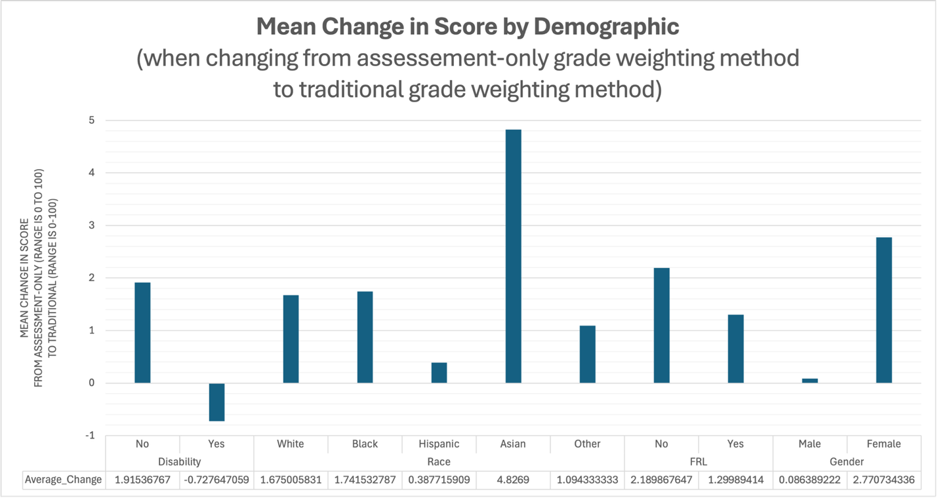

Figure 5: Pivot Tables by Demographic

Figure 5a: Pivot Table for Disability
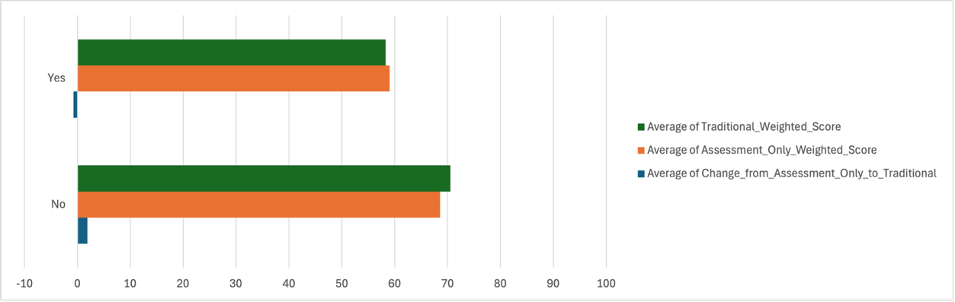

Figure 5b: Pivot Table for Race
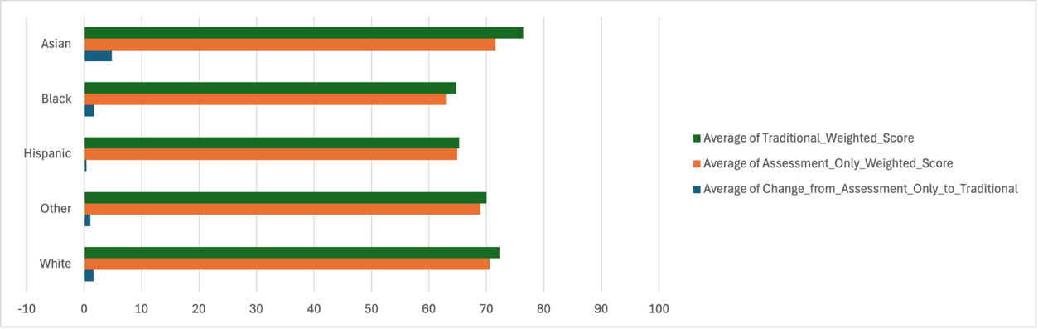

Figure 5c: Pivot Table for FRL (Socioeconomic Status)
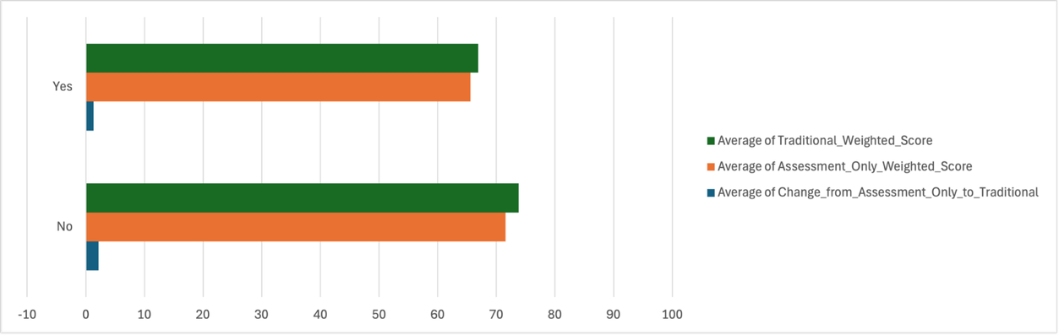

Figure 5d: Pivot Table for Gender
