INSTRUCTIONS

After you install R and RStudio please run the 2 scripts in the tests folder. These 2 scripts:

1_install_packages.R

2_test_installation.R

will install the necessary packages for the first class, and run two tests to make sure everything is installed correctly. After you run each script, take a screenshot of your RStudio window

Open RStudio, it will look something like below

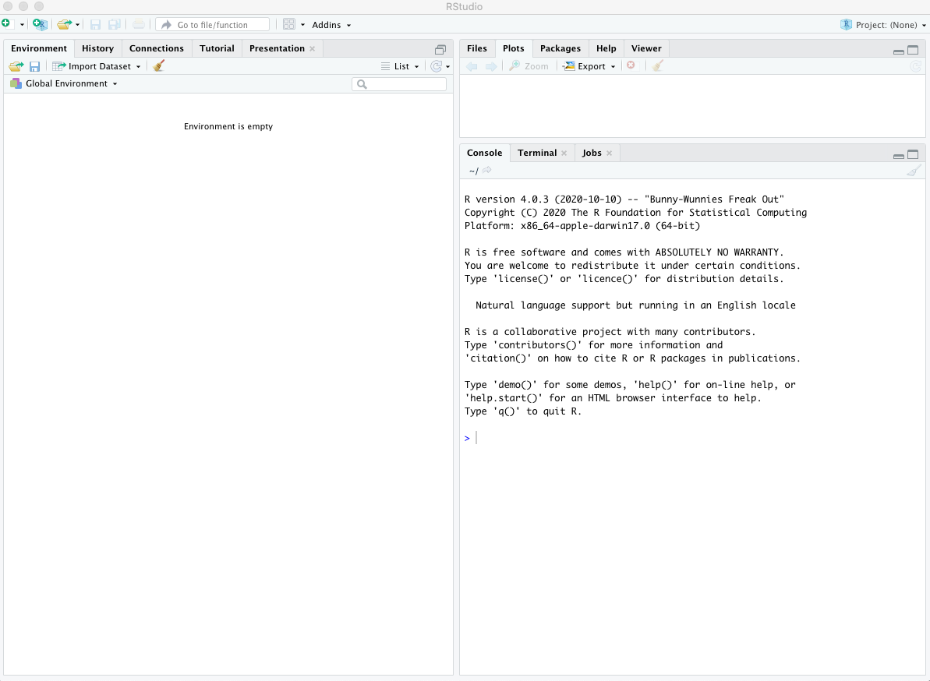

**OPEN script 1**

In the RStudio menu bar select File > Open File

Select 1_install_packages.R

You should be able to see a script that looks similar to below.

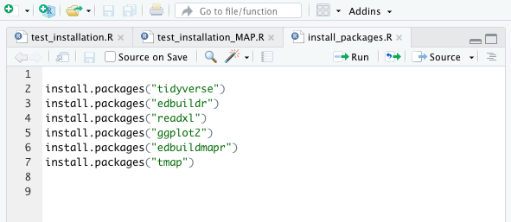

This script installs all of the external R packages needed for the workshop.

To run the script, click the Source button in the upper right corner of the script (See red circled area above). Then click the Run button next to it.

The RStudio Console window displays results, warnings, and other information about the script you ran. The RStudio Plots window displays any plots or maps. If the script has run successfully, RStudio should look similar to below: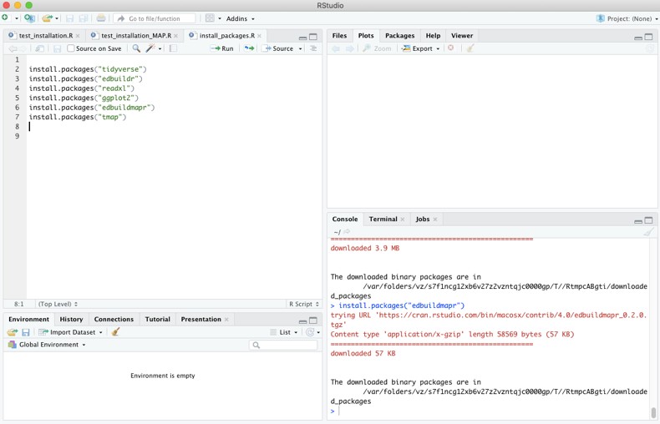

If there are errors in the console window, read them and try to resolve them if you feel able to. If you can’t resolve it, take a screenshot of your RStudio window and email it to Sara Hodges to schedule a help session. She has set aside time between 1and 3pm EST on Tuesday, June 1st to resolve technical issues.

Otherwise, take a screenshot of your RStudio window and move on to the next script.

**OPEN script 2**

In the RStudio menu bar select File > Open File

Select 2_test_installation.R

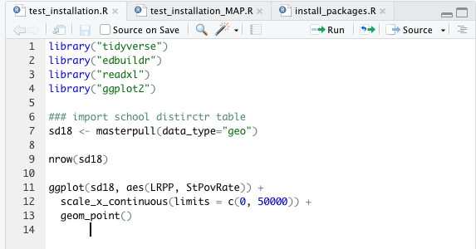

This script imports data and prints a scatterplot to verify that everything installed correctly.

To run the script, click the Source button in the upper right corner of the script (See red circled area above). Then click the Run button next to it.

If all goes well, your RStudio window will look similar to below

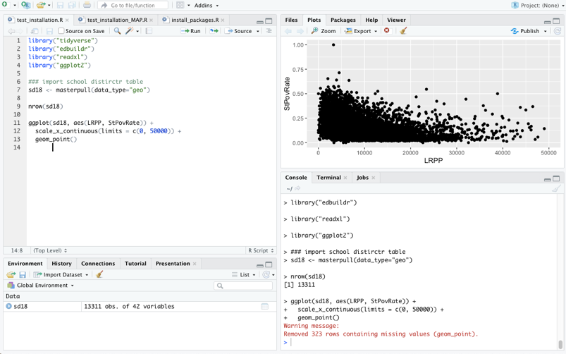

If there are errors in the console window, read them and try to resolve them if you feel able to. If you can’t resolve it, take a screenshot of your RStudio window and email it to Sara Hodges to schedule a help session. She has set aside time between 1and 3pm ET on Tuesday, June 1st to resolve technical issues.

Otherwise, please take a screenshot of your RStudio window and move on to the next script.

**FINAL STEP**

Email Sara Hodges with your GitHub username and attach the screenshots you took after you ran each script. If you have any issues, email Sara, with screenshots and she’ll help you resolve them before the first class. There will not be time to handle technical issues related to R, RStudio and external packages installation for each student during class, so please make sure to do this BEFORE CLASS.