summary(lm1 <- lm(outcomeMeasures ~ laborLand + panas + painExp +
expectations + fluidReal + intensePres + P006 +
tActualAct + P027 + P051 + tPerceivedAct, data = postDf))
#Call:
# lm(formula = outcomeMeasures ~ laborLand + panas + painExp +
# expectations + fluidReal + intensePres + P006 + tActualAct +
# P027 + P051 + tPerceivedAct, data = postDf)
#
#Residuals:
# Min 1Q Median 3Q Max
#-5.2638 -1.2019 0.0037 1.6547 3.5806
#
#Coefficients:
# Estimate Std. Error t value Pr(>|t|)
#(Intercept) -3.36404 5.70114 -0.590 0.561
#laborLand 0.11653 0.07066 1.649 0.113
#panas 0.04106 0.06467 0.635 0.532
#painExp 0.33184 0.12767 2.599 0.016 *
# expectations 0.46421 0.32722 1.419 0.169
#fluidReal 0.13718 0.14199 0.966 0.344
#intensePres -0.02924 0.12283 -0.238 0.814
#P006 0.34286 0.58221 0.589 0.562
#tActualAct -0.03960 0.26755 -0.148 0.884
#P027 0.64642 1.21413 0.532 0.600
#P051 -0.02037 1.42755 -0.014 0.989
#tPerceivedAct 0.20327 0.26128 0.778 0.445
#---
# Signif. codes: 0 '***' 0.001 '**' 0.01 '*' 0.05 '.' 0.1 ' ' 1
#
#Residual standard error: 2.838 on 23 degrees of freedom
#Multiple R-squared: 0.7166, Adjusted R-squared: 0.5811
#F-statistic: 5.287 on 11 and 23 DF, p-value: 0.0003808

slm1 <- step(lm1,direction = "both")
summary(slm1)
# summary(slm1)
#
# Call:
# lm(formula = outcomeMeasures ~ laborLand + painExp + expectations,
# data = postDf)
#
# Residuals:
# Min 1Q Median 3Q Max
# -5.6298 -1.0116 0.4798 1.6262 4.4504
#
# Coefficients:
# Estimate Std. Error t value Pr(>|t|)
# (Intercept) -6.657e-16 4.402e-01 0.000 1.000000
# laborLand 1.384e-01 5.624e-02 2.461 0.019638 *
# painExp 3.811e-01 1.023e-01 3.726 0.000777 ***
# expectations 3.432e-01 2.201e-01 1.559 0.129124
# ---
# Signif. codes: 0 '***' 0.001 '**' 0.01 '*' 0.05 '.' 0.1 ' ' 1
#
# Residual standard error: 2.604 on 31 degrees of freedom
# Multiple R-squared: 0.6784, Adjusted R-squared: 0.6472
# F-statistic: 21.79 on 3 and 31 DF, p-value: 8.786e-08
#

slm1$anova
# slm1$anova
# Step Df Deviance Resid. Df Resid. Dev AIC
# 1 NA NA 23 185.2487 82.32230
# 2 - P051 1 0.001640397 24 185.2504 80.32261
# 3 - tActualAct 1 0.181072874 25 185.4314 78.35680
# 4 - intensePres 1 0.444677151 26 185.8761 76.44063
# 5 - P027 1 2.730326634 27 188.6064 74.95101
# 6 - P006 1 2.496657882 28 191.1031 73.41127
# 7 - panas 1 4.819083230 29 195.9222 72.28293
# 8 - tPerceivedAct 1 6.652404256 30 202.5746 71.45160
# 9 - fluidReal 1 7.662210488 31 210.2368 70.75103

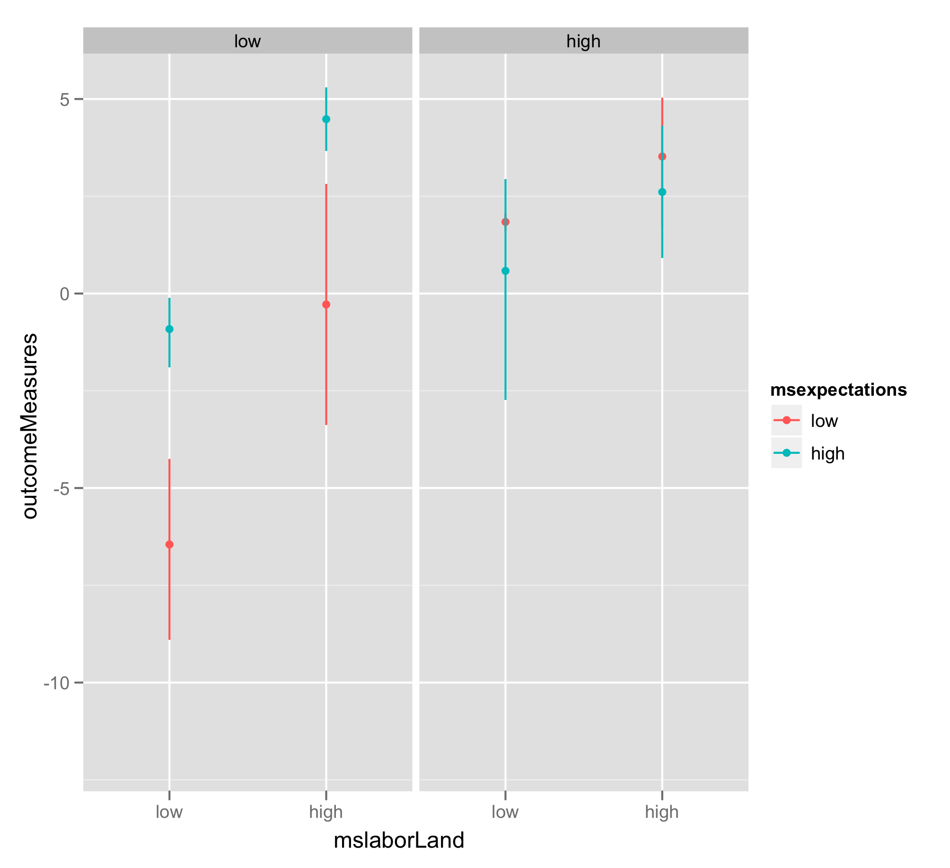
*two columns are for mspainExp

