For example n=200, d=1000

SDPT3:

[1] "Stop: max(relative gap, infeasibilities) <"
[2] "1e-08"
[1] " number of iterations = " "15"
[1] " primal objective value = " "45.0462217399926"
[1] " dual objective value = " "45.0462217343443"
[1] " gap := trace(XZ) = " "6.61707047773374e-09"
[1] " relative gap = " "1.46895127328157e-10"
[1] " actual relative gap = " "1.22665170307057e-10"
[1] " rel. primal infeas = " "8.74367572759726e-11"
[1] " rel. dual infeas = " "5.63500435308415e-15"
[1] " norm(X), norm(y), norm(Z) = " "52.1292935623439"
[3] "37.947549959216" "56.9714420480438"
[1] " norm(A), norm(b), norm(C) = " "647.629473755165"
[3] "14.1774468787578" "20.0116445595608"
[1] " Total CPU time (secs) = " "9.53099999999998"
[1] " CPU time per iteration = " "0.635399999999999"
[1] " termination code = " "0"
[1] " Percentage of CPU time spent in various parts"
[1] " preproc pred predstep corr corrstep misc"
elapsed
7.448594 69.869912 1.793957 8.308854 1.668065 10.910617
[1] 1.316472e-09

Smooth Newton:

Using sparse constraint and jacobian matrices.
Iteration 1 complete. Magnitude = 15.37777.
Iteration 2 complete. Magnitude = 1.210872.
Iteration 3 complete. Magnitude = 0.9954773.
Iteration 4 complete. Magnitude = 0.8158209.
Iteration 5 complete. Magnitude = 0.6454474.
Iteration 6 complete. Magnitude = 0.4424488.
Iteration 7 complete. Magnitude = 0.3237122.
Iteration 8 complete. Magnitude = 0.2050409.
Iteration 9 complete. Magnitude = 0.1198501.
Iteration 10 complete. Magnitude = 0.1078792.
Iteration 11 complete. Magnitude = 0.03977312.
Iteration 12 complete. Magnitude = 0.0002372387.
Iteration 13 complete. Magnitude = 2.08255e-05.
Iteration 14 complete. Magnitude = 6.469891e-07.
Solution achieved within tolerance for socp.
[1] 4.012648e-10
user system elapsed
31.004 1.862 32.847

Scatter Plot:

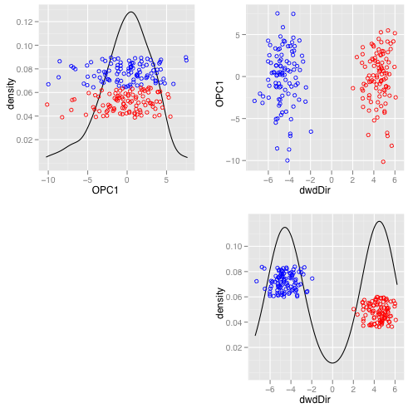

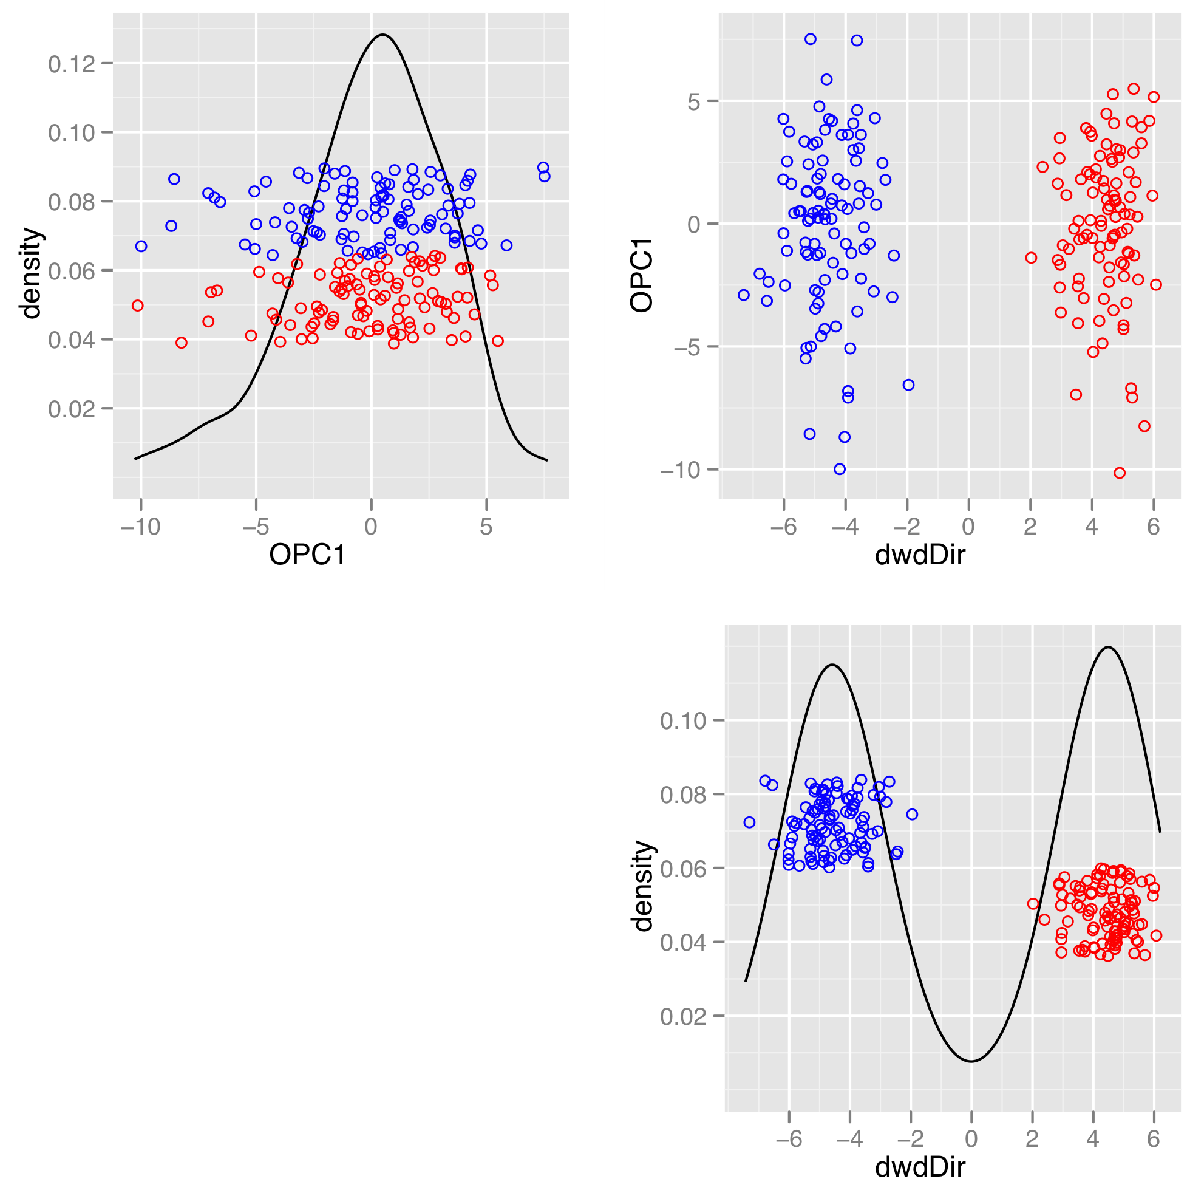

IRIS data: n=100, d=4

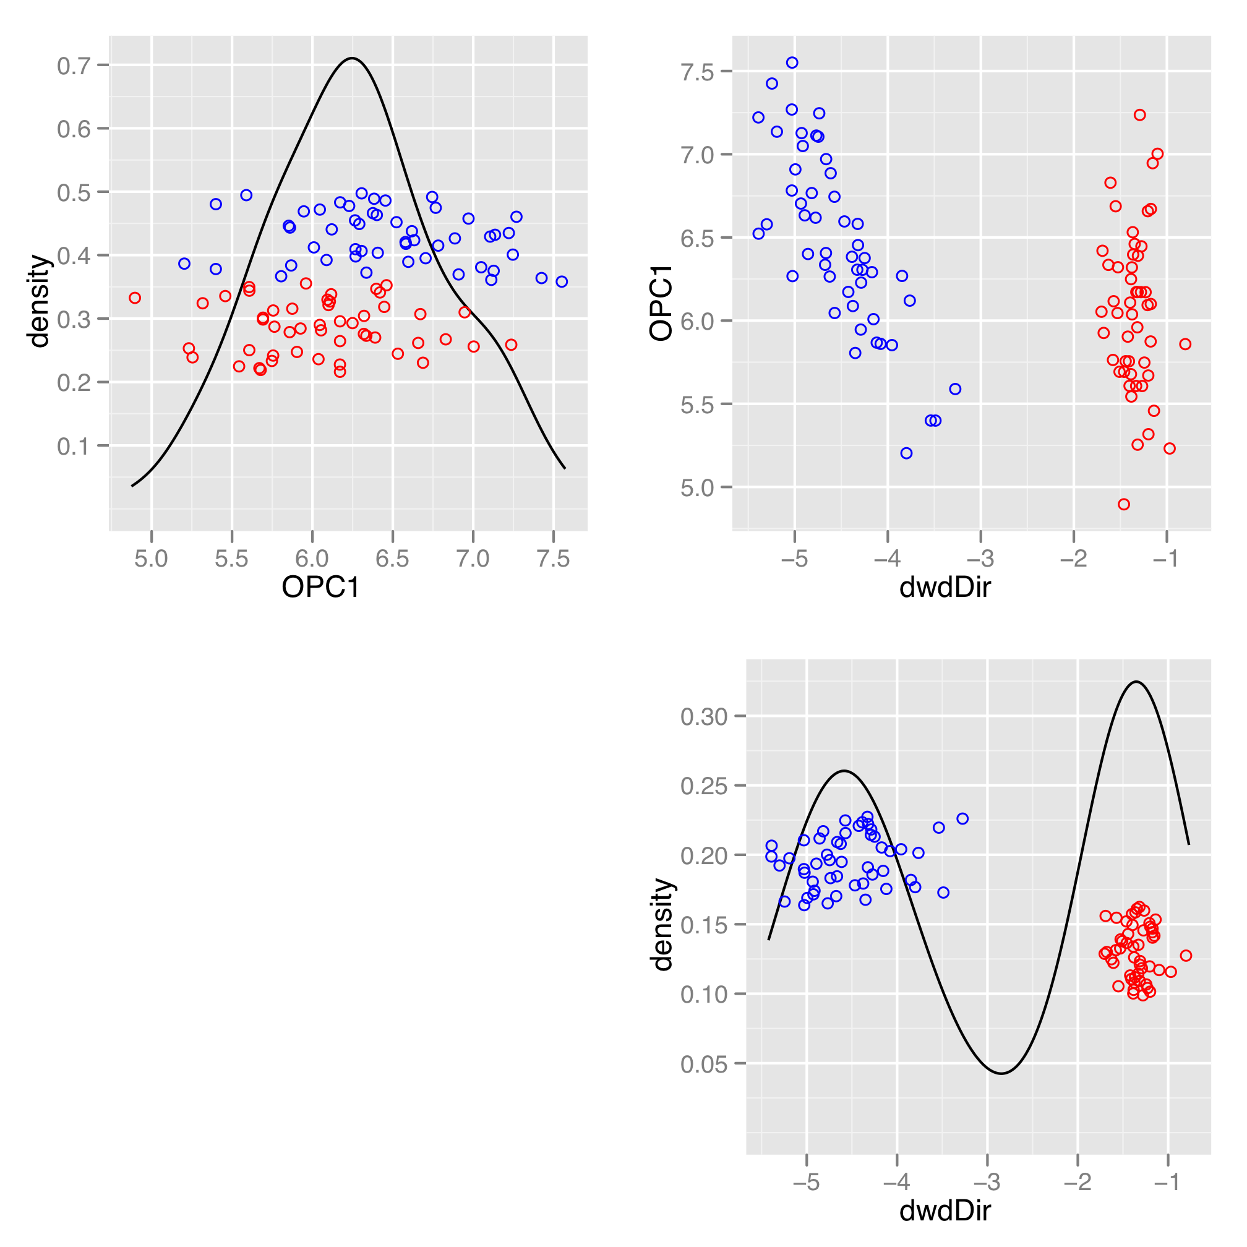

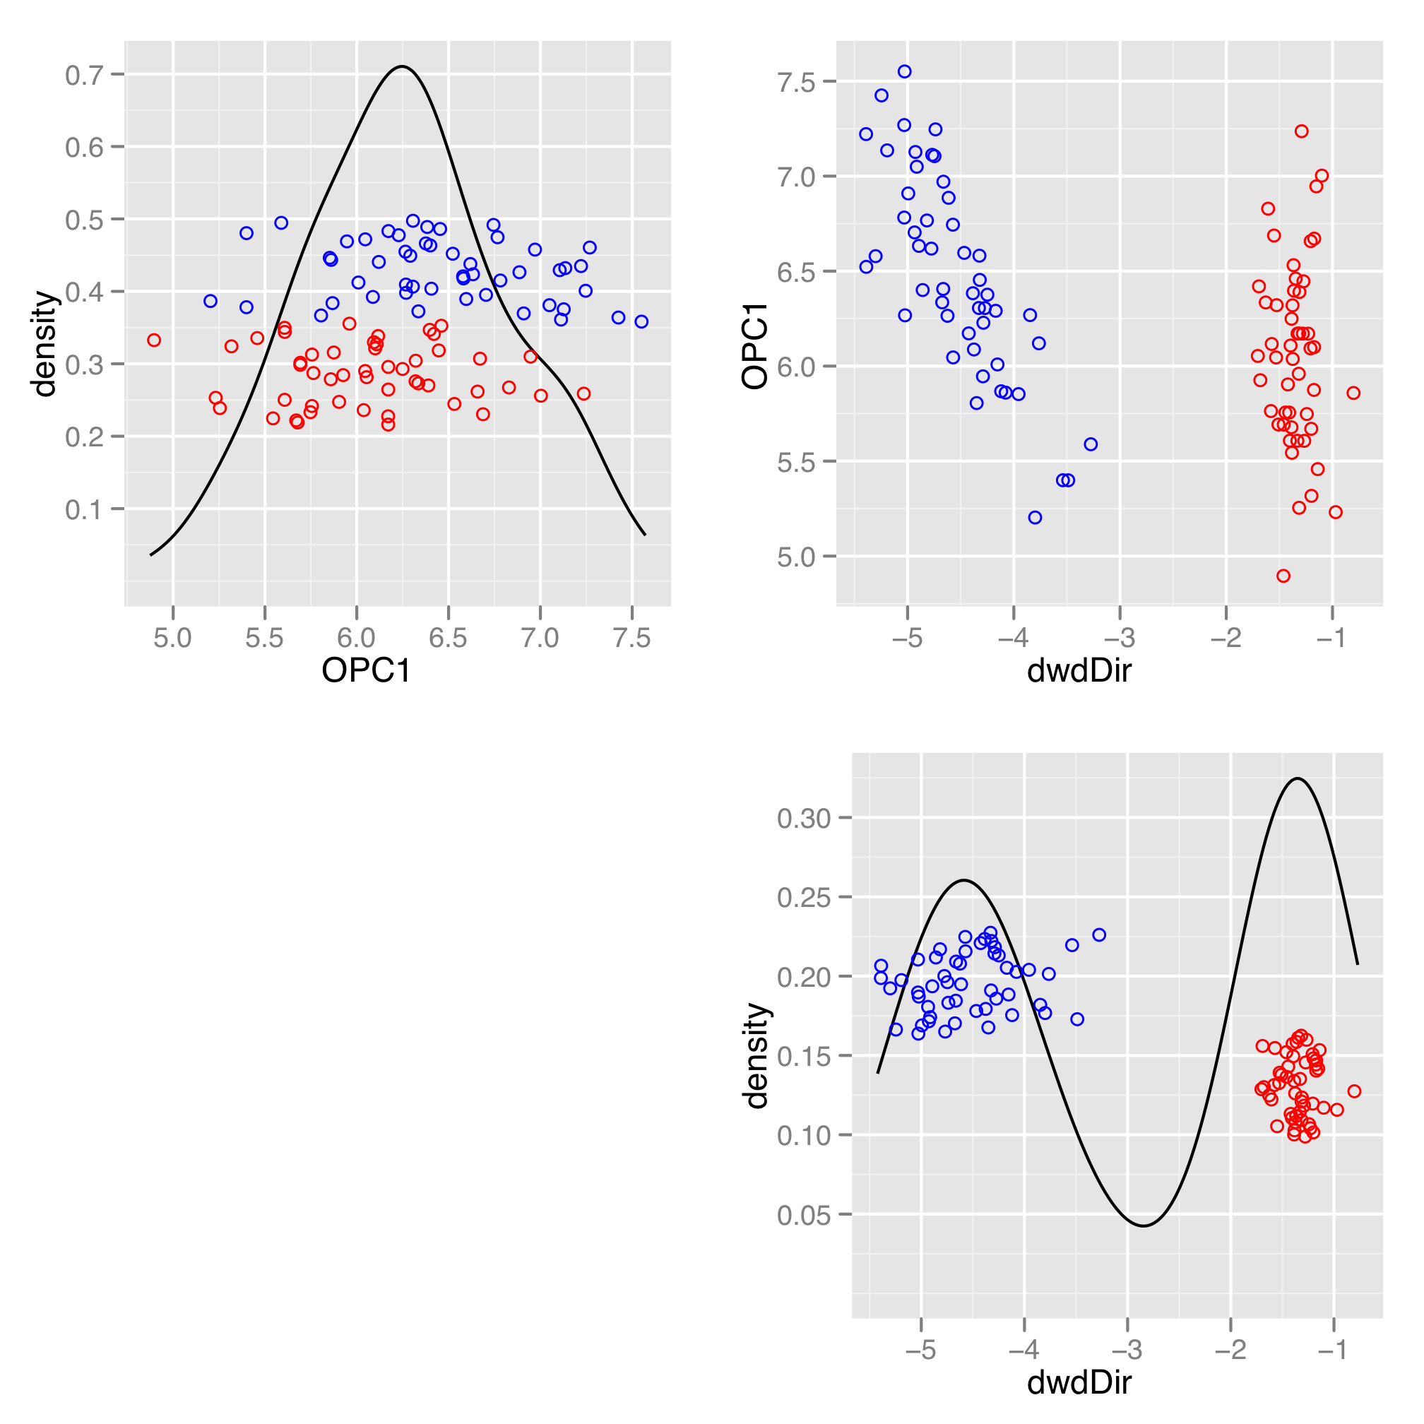

Problems:

- In some cases: SDPT3 version is not convergence, and the results are not consistent with Matlab version. Need to check.
- Contact Jason for collaboration
- Write software package for CRAN

