Examples

Notes

Some other things to think about as you create ODF templates:

- The first line of block code chunks (i.e. ending with “>>=”) should not have line breaks (on the screen, the expressions can span multiple lines – don't hit enter to create a line break). The same is true for entire Sexpr expressions.
- Formatting R code requires some care since a block of R code should have uniform formatting. For example:
- Typing text in some programs may generate or convert characters to values that cannot be parsed in R. For example, typing double quotes on each side of a word ("a word") may be automatically converted to non-standard quotes (e.g. “a word”).
- Mixed formatting of R code (such as “round(sqrt(2), 2)”) is a bad idea. Be careful when copying and pasting.

The remained of this file is to demonstrate the various Sweave options, odfWeave features and as a set of test cases.

In-Line Sweave Chunks

This file was processed on Tue Aug 24 10:44:32 2010

1.41 (if the entire in-line code has the same formatting, it persists)

abcd

e,f,g,h,i,j (white space check)

k,l,m,n,o (non-standard quote check)

Options and Hooks

SweaveOpts{print=false}

Figure Chunks
The default image type is png, which is not available on Linux by default. For non-windows systems, it uses the bitmap device to roughly the same effect. This device assumes that you have Ghostscript installed. When this document was written, OpenOffice accepted the following formats:

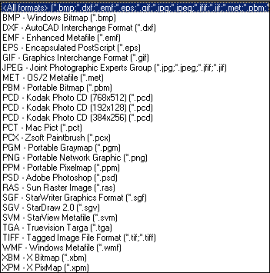

The function odfWeaveControl has options to control the plots. There are arguments for the type of plot (e.g. png) and the default height and width of plots. You can always manually resize the plots in the finished document. Also, the Open Document Format saves the image file so the original file is always retrievable.

To add images that were not created by R, the function odfInsertPlot will copy the image into the archive and create the XML statements to render it. There are a few differences in usage here compared to the previous chunks. We will be printing the XML, so results = xml is needed, as is printing the object via cat. However, the fig argument is defaulted to FALSE.



Here are some more examples:

This is figure = TRUE:

> plot(1:10, pch = 1:10)
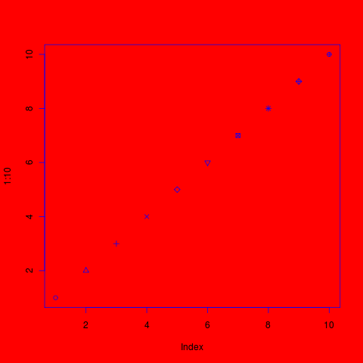

This is figure = TRUE, echo = FALSE (after a new hook):

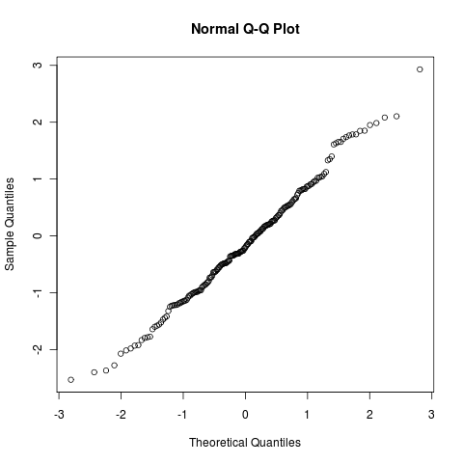

Code Chunks

This is echo = FALSE and print = FALSE:

This is echo = TRUE and print = TRUE:

> testing1 <- summary(prcomp(test))
Importance of components:
PC1 PC2 PC3 PC4 PC5
Standard deviation 1.193 1.036 0.980 0.892 0.819
Proportion of Variance 0.289 0.218 0.195 0.162 0.136
Cumulative Proportion 0.289 0.507 0.702 0.864 1.000

This is echo = TRUE and print = FALSE:

> testing2 <- summary(lm(X1 ~ ., data = test))

This is echo = FALSE and print = TRUE:

Min. 1st Qu. Median Mean 3rd Qu. Max.
-1.98700 -0.77550 0.04530 -0.01038 0.54580 2.44800

This is echo = FALSE and print = FALSE:

Bartlett test of homogeneity of variances

data: test$X1 and factor(rep(letters[1:2], each = 20))
Bartlett's K-squared = 1.2071, df = 1, p-value = 0.2719

This is verbatim = TRUE

We can test this my writing a really long command so that is it takes more than one line to parse

> summary(lm(test$X1 ~ test$X2 + test$X3 + test$X4, method = "qr",
+ model = TRUE, x = TRUE, y = TRUE))

Call:
lm(formula = test$X1 ~ test$X2 + test$X3 + test$X4, method = "qr",
model = TRUE, x = TRUE, y = TRUE)

Residuals:
Min 1Q Median 3Q Max
-1.94563 -0.73078 0.09331 0.60276 2.42384

Coefficients:
Estimate Std. Error t value Pr(>|t|)
(Intercept) -0.01665 0.15852 -0.105 0.917
test$X2 -0.04145 0.15324 -0.270 0.788
test$X3 0.13561 0.16522 0.821 0.417
test$X4 -0.08023 0.16404 -0.489 0.628

Residual standard error: 0.9916 on 36 degrees of freedom
Multiple R-squared: 0.02286, Adjusted R-squared: -0.05857
F-statistic: 0.2807 on 3 and 36 DF, p-value: 0.839

> mean(1:10)

Tables and Lists
The functions to produce these directly create XML, so use results = xml
A data frame:
 | Sepal.Length | Sepal.Width | Petal.Length | Petal.Width | Species
1 | 5.1 | 3.5 | 1.4 | 0.2 | setosa
2 | 4.9 | 3.0 | 1.4 | 0.2 | setosa
3 | 4.7 | 3.2 | 1.3 | 0.2 | setosa
4 | 4.6 | 3.1 | 1.5 | 0.2 | setosa
5 | 5.0 | 3.6 | 1.4 | 0.2 | setosa

and once without the rownames:
Sepal.Length | Sepal.Width | Petal.Length | Petal.Width | Species
5.1 | 3.5 | 1.4 | 0.2 | setosa
4.9 | 3.0 | 1.4 | 0.2 | setosa
4.7 | 3.2 | 1.3 | 0.2 | setosa
4.6 | 3.1 | 1.5 | 0.2 | setosa
5.0 | 3.6 | 1.4 | 0.2 | setosa

and now with custom headers:
Sepal Length | Sepal Width | Petal Length | Petal Width | Species
5.1 | 3.5 | 1.4 | 0.2 | setosa
4.9 | 3.0 | 1.4 | 0.2 | setosa
4.7 | 3.2 | 1.3 | 0.2 | setosa
4.6 | 3.1 | 1.5 | 0.2 | setosa
5.0 | 3.6 | 1.4 | 0.2 | setosa

A character vector:
setosa | versicolor | virginica

or transposed:

setosa | versicolor | virginica

A numeric vector:

-0.21
1.61
1.65
-0.42
0.69

We will try to make the package more robust to how the user creates the document. Feedback is always welcome.

