Analysis of the iris Data

Created on Fri Jul 23 16:33:32 2010

(Notice that the since the Sexpr was bolded, the result is bolded. Don't half-bold the command, it will throw and error in R since xml and R code would be inter-mixed. This is also true of code chunks, so be careful how you copy and paste.)

To mimic the R documentation of the iris data,

This famous (Fisher's or Anderson's) iris data set gives the measurements in centimeters of the variables sepal length and width and petal length and width, respectively, for 50 flowers from each of 3 species of iris. The species are setosa, versicolor, virginica.

I like lists (not really). Here is a bulleted list of the species:
- setosa
- versicolor
- virginica

We can make a fancy plot of the data using lattice and insert that into the document.

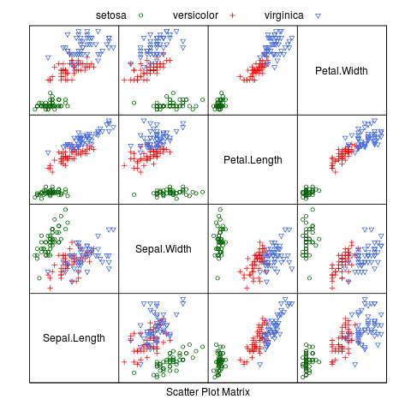

We can also create a table of the correlation matrix for the virginica species:

 | Sepal.Length | Sepal.Width | Petal.Length | Petal.Width
Sepal.Length | 1.000 | 0.457 | 0.864 | 0.281
Sepal.Width | 0.457 | 1.000 | 0.401 | 0.538
Petal.Length | 0.864 | 0.401 | 1.000 | 0.322
Petal.Width | 0.281 | 0.538 | 0.322 | 1.000

or show the means (ignoring species):

Sepal.Length | Sepal.Width | Petal.Length | Petal.Width
5.84 | 3.06 | 3.76 | 1.2

Here is an example of changing the formatting within a table. Let's make the font red for the minimum mean value:

Sepal.Length | Sepal.Width | Petal.Length | Petal.Width
5.84 | 3.06 | 3.76 | 1.2

To process this file, you might use:

library(odfWeave)
odfWeave("/path/to/simple.odt", "/path/to/output.odt")

and that produces the final odt file.

The following R packages were loaded when this analysis was run:
base (2.11.1) | grDevices (2.11.1) | MASS (7.3-6) | stats (2.11.1)
datasets (2.11.1) | grid (2.11.1) | methods (2.11.1) | utils (2.11.1)
graphics (2.11.1) | lattice (0.18-8) | odfWeave (0.7.14) | XML (3.1-0)

