The following section tests various combinations of options for tables.

A basic table with row names and default headers, plus write a caption

> odfCat("The version of R is", R.Version()$version.string)
The version of R is R version 2.11.1 (2010-05-31)
> odfTable(iris[1:3, 2:5])
 | Sepal.Width | Petal.Length | Petal.Width | Species
1 | 3.5 | 1.4 | 0.2 | setosa
2 | 3.0 | 1.4 | 0.2 | setosa
3 | 3.2 | 1.3 | 0.2 | setosa

Now remove the row names and mod the headers

> odfTable(iris[1:3, ], useRowNames = FALSE, colnames = gsub("\\.",
+ " ", names(iris)))
Sepal Length | Sepal Width | Petal Length | Petal Width | Species
5.1 | 3.5 | 1.4 | 0.2 | setosa
4.9 | 3.0 | 1.4 | 0.2 | setosa
4.7 | 3.2 | 1.3 | 0.2 | setosa

A table of a numeric vector. It should be vertically oriented (like a nx1 vector) and should not show the full precision of the data points

> odfTable(rnorm(10))
2.5537
-1.0809
-0.6110
0.5945
-0.8548
0.4312
0.4095
0.3163
-0.5308
-1.0643

The next table tests that factors show up as text and that table defaults to 1xn when there are less than 5 elements.

> odfTable(levels(iris$Species))
setosa | versicolor | virginica

Just as a test, define a small table to hold the larger table to limit the span

0.457788
0.339628
0.003845
0.099158
0.159372
-0.799233
-0.709506
-0.086425
0.619398
1.069319

Now we test changing style assignments in the middle of the document.

> tt <- getStyles()
> originalStyles <- tt
> tt$cellText <- "ArialHighlight"
> setStyles(tt)
> odfTable(iris[1:3, 2:5], useRowNames = FALSE)
Sepal.Width | Petal.Length | Petal.Width | Species
3.5 | 1.4 | 0.2 | setosa
3.0 | 1.4 | 0.2 | setosa
3.2 | 1.3 | 0.2 | setosa

Now change them back (no output generated)

We can differentially change formatting of table elements

> newStyles <- tableStyles(iris[1:3, ], useRowNames = FALSE, header = names(iris))
> newStyles$text[2, 3] <- "ArialHighlight"
> odfTable(iris[1:3, ], useRowNames = FALSE, style = newStyles)
Sepal.Length | Sepal.Width | Petal.Length | Petal.Width | Species
5.1 | 3.5 | 1.4 | 0.2 | setosa
4.9 | 3.0 | 1.4 | 0.2 | setosa
4.7 | 3.2 | 1.3 | 0.2 | setosa

> newStyles <- tableStyles(iris[1:3, ], useRowNames = TRUE, header = names(iris))
> newStyles$text[2, 3] <- "ArialHighlight"
> odfTable(iris[1:3, ], useRowNames = TRUE, style = newStyles)
 | Sepal.Length | Sepal.Width | Petal.Length | Petal.Width | Species
1 | 5.1 | 3.5 | 1.4 | 0.2 | setosa
2 | 4.9 | 3.0 | 1.4 | 0.2 | setosa
3 | 4.7 | 3.2 | 1.3 | 0.2 | setosa

A basic bulleted list of data

> odfItemize(levels(iris$Species))
- setosa
- versicolor
- virginica

The following section tests various combinations of options for code chunks.

Here we can test that no output or code are shown

Now test that the code shows up:

> set.seed(345)
> x <- rnorm(200)
> test <- data.frame(matrix(rnorm(200), nrow = 40))

This chunk tests that the print option works:

Min. 1st Qu. Median Mean 3rd Qu. Max.
-1.83000 -0.68850 -0.05015 -0.13540 0.35770 1.74500

Here we test that eval does what is should

> mean(1:10)

The following section tests in-line code.

This file was processed on Tue Aug 24 10:45:28 2010

1.41 (if the entire in-line code has the same formatting, it persists)

abcd

e,f,g,h,i,j (white space check)

k,l,m,n,o (non-standard quote check)

The following section tests various combinations of options for figure code chunks.

SweaveOpts{print=false}

This plot should have a red background and a blue foreground
> plot(1:10, pch = 1:10)
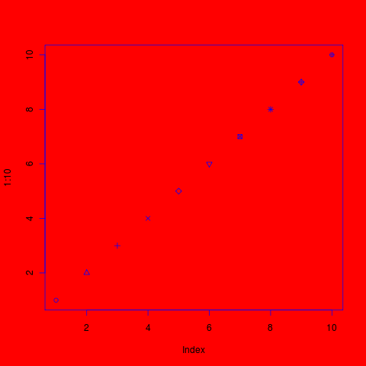

Now we reset the hook and everything should look normal (but smaller)
> adjustImageSize(4, 4)
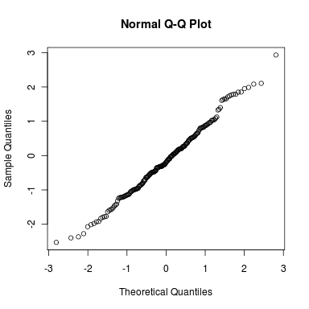

> adjustImageSize(4, 4, scale = 1.75)
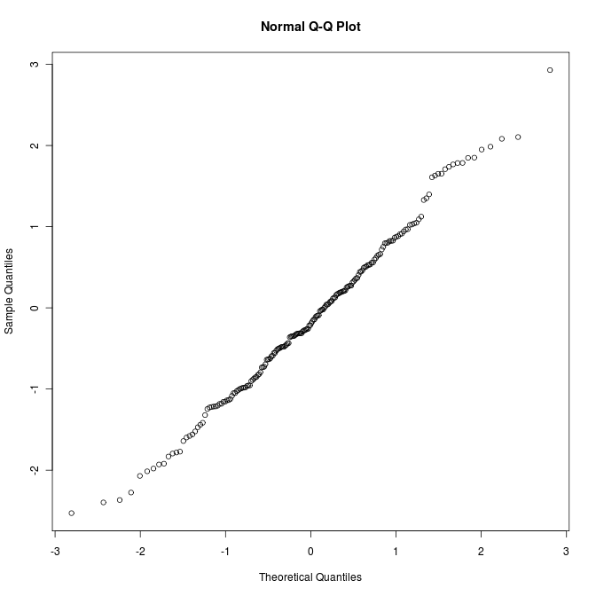

> currentPath <- getwd()
> setwd(system.file())

# test to make sure that changing the working directory does not disrupt the image insertion
> qqnorm(rnorm(200))
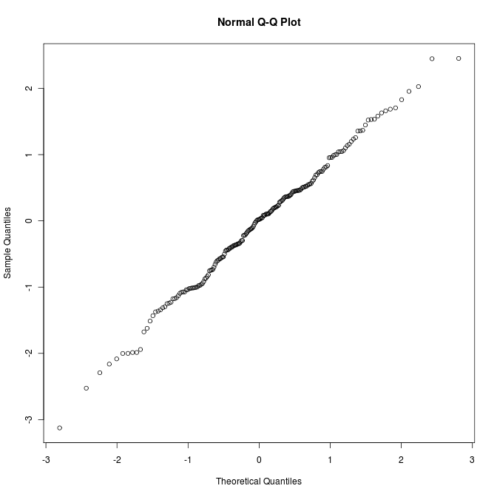

> setwd(currentPath)

Testing character sets

> testChar <- "这是中文字符。"
> testChar2 <- paste("text:", testChar)
> print(testChar)
[1] "这是中文字符。"
> print(testChar2)
[1] "text: 这是中文字符。"
> print(grep("这", testChar2))
[1] 1

> print("it worked")
[1] "it worked"

