Manipulating FLR objects with apply and sweep

Laurence Kell
<Laurie.Kell@iccat.int>
&
Ernesto Jardim
<ernesto@ipimar.pt>

7. September 2010

Table of Contents
1 Introduction 3
2 FLQuant 3
2.1 Apply 3
2.2 Sweep 5
2.3 Re-shaping 5
2.4 Random Variables 8
3 FLQuants 9
3.1 Lapply 9
4 FLR Complex objects 10
4.1 Qapply 10
5 FLPar 10
5.1 Sweep 11
6 Conversions 11

Introduction
R has many functions and methods for manipulating data objects such as arrays, data.frames and lists. Once FLR is based on object oriented (OO) programming where data (i.e. objects) and actions (i.e. methods) are grouped together in S4 classes, these methods can be used with FLR. For example an FLQuant is derived from an array and so can be manipulated using functions written for arrays, while an FLR class has similarities to a list (in that it can contain a variety of data types) and functions that work for lists have been overloaded so that they work for FLR classes.
In R there are a set of methods that replace “for loops” like apply and sweep. To the new user this can appear to be confusing but using them speeds up code, helps conceptually by moving towards a "whole object" view and makes the code more readable. The apply family of functions allow functions to be applied on subsets of different types of R classes (i.e. lapply, tapply, sapply, rapply, mapply, etc). Sweep is useful when trying to perform an operation on two arrays that might have different dimensions.
We show how these and related functions can be used within FLR. Firstly showing how R functions used for arrays can be used with the FLQuant class, we then describe additional features and functions that have been added to FLR. Following this we describe functions that have been added for the FLR classes themselves. Let's start by loading FLCore and some data sets distributed with it.

FLQuant
> library(FLCore)
> data(ple4)
> data(ple4sex)
> data(nsher)

Apply
The apply function in base R applies a function to the margins of an array and returns a vector or array or list of the values obtained, i.e.
A simple example is the computation of means and sums over one or more dimensions of the FLQuant matrix.
apply(X,INDEX,FUN)
X | the array to be used.
MARGIN | a vector giving the subscripts which the function will be applied over. 1 indicates rows, 2 indicates columns,c(1,2) indicates rows and columns. For an FLQuant 1,2,3,4,5,6 indicate age, year, unit, season, area and iter.
FUN | the function to be applied. In the case of functions like+,%*%, etc., the function name must be quoted.
... | optional arguments to FUN.

The function is particularly useful for operations that require combining the dims of an FLQuant, e.g. calculating trends over time or finding the average values at age. For example one can compute the catch in weight with
> apply(catch.n(ple4), 1, mean)
An object of class "FLQuant"
, , unit = unique, season = all, area = unique

year
age 1
1 172759.0
2 286083.4
3 167406.7
4 89902.2
5 46690.4
6 22864.2
7 12323.7
8 6252.9
9 3824.0
10 8922.3

units: thousands
> apply(catch.n(ple4), 2, sum)
An object of class "FLQuant"
, , unit = unique, season = all, area = unique

year
age 1957 1958 1959 1960 1961 1962 1963 1964 1965
all 274463 348703 486073 500309 505585 554529 601358 578332 761373
year
age 1966 1967 1968 1969 1970 1971 1972 1973 1974
all 800262 649376 508329 466118 614984 442137 419151 458236 749838
year
age 1975 1976 1977 1978 1979 1980 1981 1982 1983
all 931012 679285 769163 704027 940585 700393 687764 1023162 1132551
year
age 1984 1985 1986 1987 1988 1989 1990 1991 1992
all 1166447 1142931 2143204 2354937 1922494 1468754 1075597 1097352 850222
year
age 1993 1994 1995 1996 1997 1998 1999 2000 2001
all 655108 515380 497708 697998 1061143 1187466 868346 648722 947864
year
age 2002 2003 2004 2005 2006 2007 2008
all 789193 873227 733308 662652 741494 516023 580831

units: thousands
or mean fishing mortality with
> flq <- apply(catch.wt(ple4) * catch.n(ple4), 2, mean)
> print(xyplot(data ~ year, data = flq, type = "l", main = "Catch in weight",
+ ylab = "ton"))
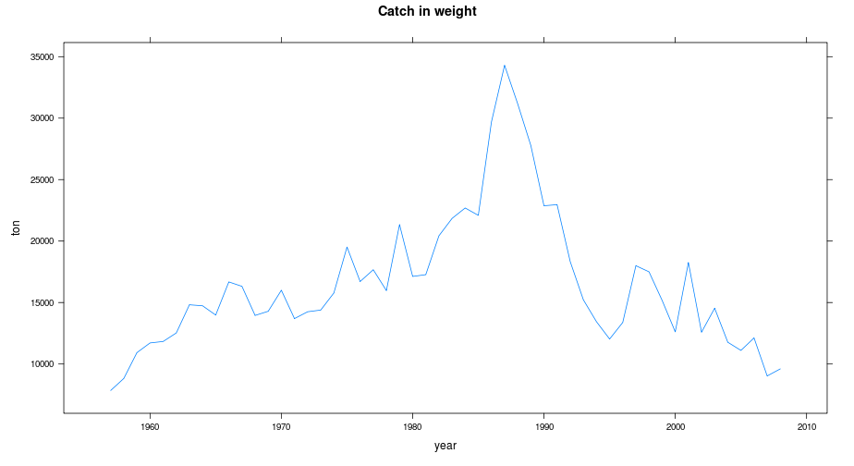
or recruitment by sex
> flq <- apply(harvest(ple4)[as.character(3:6)], 2, mean)
> print(xyplot(data ~ year, data = flq, type = "l", main = "Mean f",
+ ylab = ""))
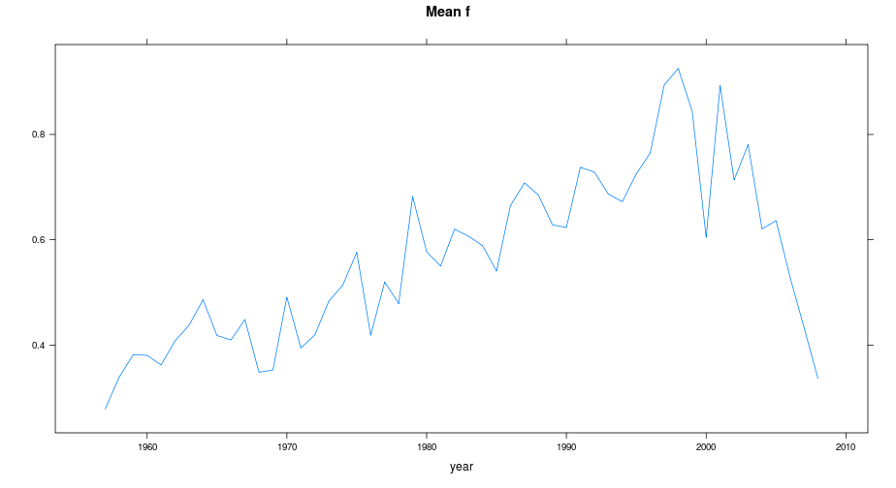
or look at trends in mature and immature catch
> flq <- apply(rec(ple4sex), c(2, 3), sum)
> print(xyplot(data ~ year, group = unit, data = flq, type = "l",
+ main = "Recruitment", ylab = "number os individuals"))
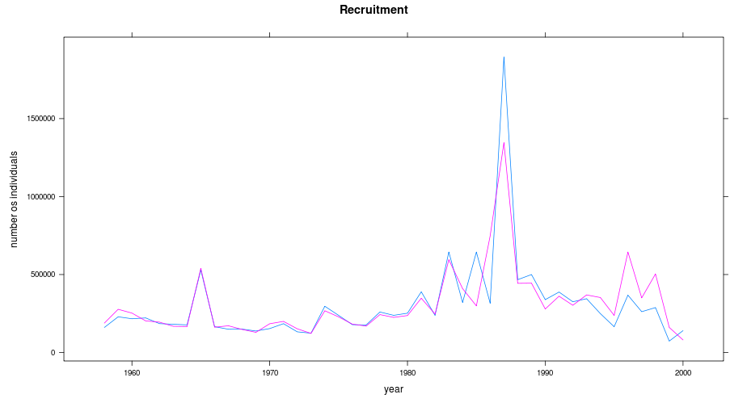

The apply family
> matCatch <- apply(catch.wt(ple4) * catch.n(ple4) * mat(ple4),
+ 2, mean)
> immCatch <- apply(catch.wt(ple4) * catch.n(ple4) * (1 - mat(ple4)),
+ 2, mean)
> flqs <- FLQuants(imm = immCatch, mat = matCatch)
> print(xyplot(data ~ year, groups = qname, data = flqs, type = "l",
+ main = "Trends in mature and immature catch", ylab = "ton"))
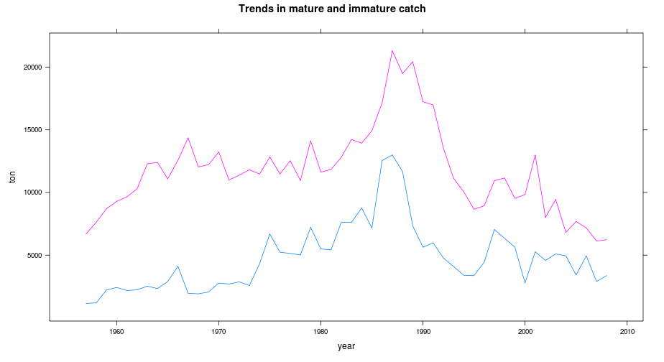
To simplify some common operations with apply and make the code more readable, a set of wrappers are implemented in FLR to compute sums, totals, means and vars for each FLQuant dimension. These are named by the combination of the dimension and the computation, e.g., to compute the sum over an FLQuant dimension use xxxSums (i.e. quantSums, yearSums, …). xxxSums “condenses” the xxx dimension by summing up across it, i.e. for FLQuant objects with just age and year.
Where there are other dimensions using apply becomes more difficult
> flq1 <- apply(catch.n(ple4), 1, sum)
> flq2 <- yearSums(catch.n(ple4))
> all.equal(flq1, flq2)
[1] TRUE
> flq1 <- apply(catch.n(ple4), 2, sum)
> flq2 <- quantSums(catch.n(ple4))
> all.equal(flq1, flq2)
[1] TRUE
xxxTotals is similar but rather than “condensing” a dimension it replicates the sum across it, making it easy to calculate proportions for example. These methods are only implemented for quant and year.
> flq1 <- apply(catch.n(ple4sex), c(1:2, 4:6), sum)
> flq2 <- unitSums(catch.n(ple4sex))
> all.equal(flq1, flq2)
[1] TRUE
xxxMeans and xxxVars are useful summary methods, although the names may be confusing since to calculate the mean by age you have to use yearMeans.
> yearTotals(catch.n(ple4))[, as.character(2004:2008)]
An object of class "FLQuant"
, , unit = unique, season = all, area = unique

year
age 2004 2005 2006 2007 2008
1 733308 662652 741494 516023 580831
2 733308 662652 741494 516023 580831
3 733308 662652 741494 516023 580831
4 733308 662652 741494 516023 580831
5 733308 662652 741494 516023 580831
6 733308 662652 741494 516023 580831
7 733308 662652 741494 516023 580831
8 733308 662652 741494 516023 580831
9 733308 662652 741494 516023 580831
10 733308 662652 741494 516023 580831

units: thousands
> flq <- catch.n(ple4)/yearTotals(catch.n(ple4))
> print(bubbles(age ~ year, data = flq, main = "Proportion at age by year"))
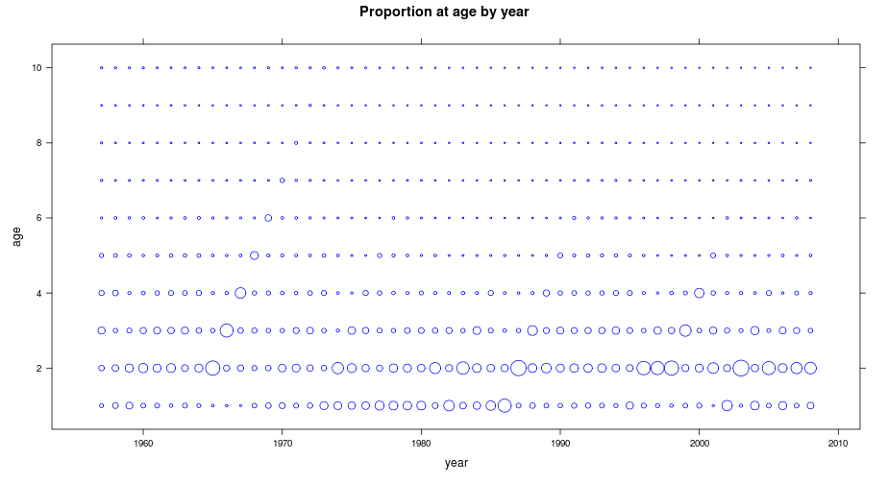
Combining these methods make it simple to compute other statistics like the coefficient of variation
> yearVars(catch.wt(ple4sex))
An object of class "FLQuant"
, , unit = male, season = all, area = unique

year
age 1
1 0.01401351
2 0.00098992
3 0.00108040
4 0.00172071
5 0.00262924
6 0.00304352
7 0.00325781
8 0.00526777
9 0.00407896
10 0.00648250
11 0.00673112
12 0.00754950
13 0.02284452
14 0.03602802
15 0.02287087

, , unit = female, season = all, area = unique

year
age 1
1 0.01378140
2 0.00201949
3 0.00239446
4 0.00321595
5 0.00434408
6 0.00470233
7 0.00458162
8 0.00310044
9 0.00848206
10 0.00648272
11 0.00924828
12 0.00920520
13 0.01532536
14 0.02941595
15 0.06100897

units: NA

Sweep
> sqrt(yearVars(catch.wt(ple4sex)))/yearMeans(catch.wt(ple4sex))
An object of class "FLQuant"
, , unit = male, season = all, area = unique

year
age 1
1 1.524037
2 0.129218
3 0.120186
4 0.131541
5 0.140081
6 0.132601
7 0.125734
8 0.149398
9 0.125572
10 0.148333
11 0.147301
12 0.147094
13 0.245902
14 0.298204
15 0.224549

, , unit = female, season = all, area = unique

year
age 1
1 1.515901
2 0.159042
3 0.151813
4 0.147431
5 0.136782
6 0.116272
7 0.100123
8 0.073513
9 0.110405
10 0.088979
11 0.096753
12 0.091153
13 0.110257
14 0.143566
15 0.191992

units: NA NA
sweep return an array/FLQuant derived from an input array/FLQuant by sweeping out a summary statistic
The function is useful when performing an operation on two arrays which don´t have the same dimensions, for example when calculating catch proportions (see yearTotals example above), selection pattern by first scaling fishing mortality-at-age by the average value or looking at sex ratios where numbers by sex are divided by total numbers
sweep(x, MARGIN, STATS, FUN="-", check.margin=TRUE, ...)
x | an array of FLQuant
MARGIN | a vector of indices giving the extents of x which correspond to STATS.
STATS | the summary statistic which is to be swept out.
FUN | the function to be used to carry out the sweep. In the case of binary operators such as "/" etc., the function name must backquoted or quoted. (FUN is found by a call to match.fun.)
check.margin | logical. If TRUE (the default), warn if the length or dimensions of STATS do not match the specified dimensions of x. Set to FALSE for a small speed gain when you know that dimensions match.
... | optional arguments to FUN.

> flq <- sweep(catch.n(ple4), 2, apply(catch.n(ple4), 2, sum),
+ "/")
> print(bubbles(age ~ year, data = flq, main = "Proportion at age by year"))
> fbr <- apply(harvest(ple4)[ac(3:6)], 2, mean)
> selPattern <- sweep(harvest(ple4), 2, fbr, "/")
> print(xyplot(data ~ age, groups = year, data = trim(selPattern,
+ year = c(2004:2008)), type = "l", main = "Selection pattern over the last 5 years",
+ ylab = ""))
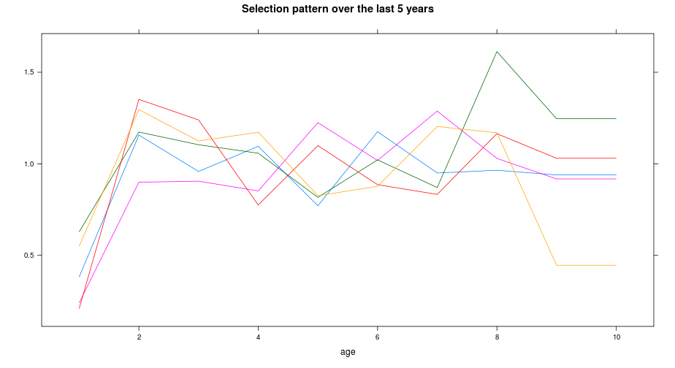

Re-shaping
> num <- sweep(stock.n(ple4sex), c(1, 2), apply(stock.n(ple4sex),
+ c(1, 2), sum), "/")
> print(xyplot(data ~ age | unit, groups = year, data = trim(num,
+ year = c(1996:2000)), type = "l", main = "Sex ratio between 1996 and 2000",
+ ylab = ""))
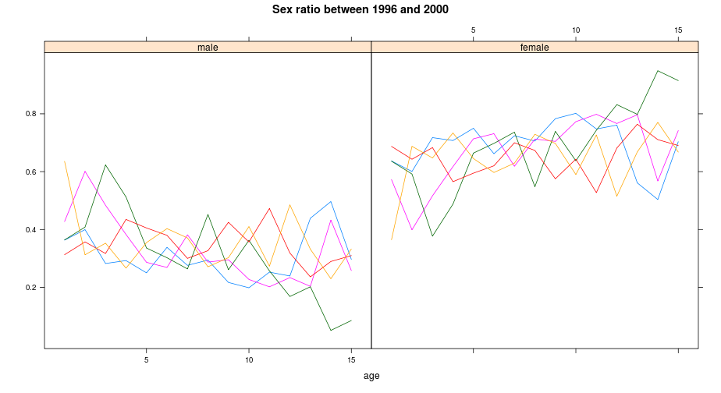
Often the dimensions of an FLQuant have to be changed, e.g. to add or remove extra years or ages, this can be done by trim and window. The first allows the selection of different dimensions at once in a very flexible way, while the second deals only with year but allows it to be extended. When conducting Monte Carlo Simulations iterations can be added using propagate, or using the random variable methods (e.g. rnorm). Changing other dimensions can be a bit more tricky as this depends upon what the FLQuant represents, for example if you increase the number of seasons, sexes or areas how does weight-at-age change or how should mortality be partitioned ? expand provides a method for increasing the size of an FLQuant without actually filling up the new object with values. In cases where there is an accepted algorithm, for example to create a plusgroup then a specific method such as setPlusGroup can be implemented.
Some examples below, note that the selection does not need to be continuous
trim(x, ...)
x | an FLQuant.
... | The dimensions of the FLQuant to be trimmed, which can any of year, unit, season, area or iter. In the case of the quant dimension it will depend on its name, usualy age or all, but it can be something else that the user must know. In case of doubts run quant on your object. In any case the trim information is given in a numeric or character vector that must be in agreement with the dimensions of the quant. No point on selecting year 1 if it does not exist ...

Bare in mind that when changing the information about a stock by trimming some information, the other information must also be computed, e.g., if 'age' is trimmed in ple4, catch, landings and discards need to be recalculated. However, the effect of getting rid of younger ages is not necessarily the same as getting rid of older ages since often the oldest age is a plus group and represents the sum of all ages greater or equal to that age.
> trim(catch.n(ple4), year = c(2000:2008), age = c(1:4))
An object of class "FLQuant"
, , unit = unique, season = all, area = unique

year
age 2000 2001 2002 2003 2004 2005 2006 2007 2008
1 106056 34804 311003 68309 233397 96478 220828 78598 135786
2 187647 388808 193978 560788 191141 342682 244064 224345 263599
3 91904 240444 136274 101562 221343 72076 177680 106621 80258
4 230201 123671 61739 68836 43238 103120 35910 57788 44207

units: thousands
> trim(catch.n(ple4sex), year = c(1995:2000), unit = "female",
+ age = 10:14)
An object of class "FLQuant"
, , unit = female, season = all, area = unique

year
age 1995 1996 1997 1998 1999 2000
10 2318.98 1848.49 1716.03 1317.92 657.66 1054.35
11 727.62 977.43 1310.99 730.05 411.88 633.39
12 599.75 448.37 634.74 1163.33 414.76 349.49
13 560.61 210.95 298.14 592.06 611.70 224.43
14 296.50 199.10 218.98 315.91 218.08 367.98

units: NA
Another example to illustrate trim's flexibility
As mentioned above, to select and extend continuous years on the object use
> trim(catch.n(ple4), year = c(1990:1995, 2000, 2008), age = c(4:1))
An object of class "FLQuant"
, , unit = unique, season = all, area = unique

year
age 1990 1991 1992 1993 1994 1995 2000 2008
4 139099 156894 106842 84252 81274 79230 230201 44207
3 266440 225170 179701 146463 137320 97151 91904 80258
2 311831 344841 263573 208032 140851 119251 187647 263599
1 146864 184587 142165 99832 63516 126614 106056 135786

units: thousands
A simple example
window(x, start, end)
x | an FLQuant.
start | First year in new FLQuant
end | Last year in new FLQuant

While more technical manipulations like setting a new plus group can be done with
> window(catch.n(ple4), 2005, 2010)
An object of class "FLQuant"
, , unit = unique, season = all, area = unique

year
age 2005 2006 2007 2008 2009 2010
1 96478 220828 78598 135786 NA NA
2 342682 244064 224345 263599 NA NA
3 72076 177680 106621 80258 NA NA
4 103120 35910 57788 44207 NA NA
5 21746 45525 16408 31758 NA NA
6 15610 6965 24293 6217 NA NA
7 5489 5721 2663 15634 NA NA
8 2615 2247 3505 1803 NA NA
9 2223 1235 543 673 NA NA
10 613 1319 1259 896 NA NA

units: thousands
A simple example
setPlusGroup(x, plusgroup, ...)
x | an FLQuant.
plusgroups | the age for the new plus group
... | not implemented for the moment.

Note that when applied to a FLQuant the method simply computes the average of the age groups to be merged.
> setPlusGroup(catch.n(ple4), 5)[, ac(2005:2008)]
An object of class "FLQuant"
, , unit = unique, season = all, area = unique

year
age 2005 2006 2007 2008
1 96478.0 220828.0 78598.0 135786.0
2 342682.0 244064.0 224345.0 263599.0
3 72076.0 177680.0 106621.0 80258.0
4 103120.0 35910.0 57788.0 44207.0
5 8049.3 10502.0 8111.8 9496.8

units: thousands
> quantMeans(catch.n(ple4)[ac(5:10), ac(2005:2008)])
An object of class "FLQuant"
, , unit = unique, season = all, area = unique

year
age 2005 2006 2007 2008
all 8049.3 10502.0 8111.8 9496.8

units: thousands
Expanding in general can be done with
Note that the usage of expand for the non-numeric dimensions like unit and area can be tricky. For example if you add extra seasons or units what should be the new stock weights-at-age?
expand(x, ...)
x | an FLQuant.
... | The dimensions of the FLQuant to be expanded, which can any of year, unit, season, area or iter. In the case of the quant dimension it will depend on its name, usualy age or all, but it can be something else that the user must know. In case of doubts run quant on your object. In any case the expand information is given in a numeric or character vector that must be in agreement with the dimensions of the quant. In particular it must start on the initial value of the dimension. This is redundant and likely to be changed in the future.

And to expand and fill the empty information at once use
> expand(catch.n(ple4), age = 1:12)[, ac(2005:2008)]
An object of class "FLQuant"
, , unit = unique, season = all, area = unique

year
age 2005 2006 2007 2008
1 96478 220828 78598 135786
2 342682 244064 224345 263599
3 72076 177680 106621 80258
4 103120 35910 57788 44207
5 21746 45525 16408 31758
6 15610 6965 24293 6217
7 5489 5721 2663 15634
8 2615 2247 3505 1803
9 2223 1235 543 673
10 613 1319 1259 896
11 NA NA NA NA
12 NA NA NA NA

units: thousands
> expand(catch.n(ple4), unit = c("unique", "female"))[, ac(2005:2008)]
An object of class "FLQuant"
, , unit = unique, season = all, area = unique

year
age 2005 2006 2007 2008
1 96478 220828 78598 135786
2 342682 244064 224345 263599
3 72076 177680 106621 80258
4 103120 35910 57788 44207
5 21746 45525 16408 31758
6 15610 6965 24293 6217
7 5489 5721 2663 15634
8 2615 2247 3505 1803
9 2223 1235 543 673
10 613 1319 1259 896

, , unit = female, season = all, area = unique

year
age 2005 2006 2007 2008
1 NA NA NA NA
2 NA NA NA NA
3 NA NA NA NA
4 NA NA NA NA
5 NA NA NA NA
6 NA NA NA NA
7 NA NA NA NA
8 NA NA NA NA
9 NA NA NA NA
10 NA NA NA NA

units: thousands
Note the effect of the fill.iter argument.
propagate(object, ...)
object | an FLQuant.
... | These can be iter , the number of iters to be added, and fill.iter a logical defining it the new iters should have the same information as the first (the default) or not.

Random Variables
> flq <- propagate(catch.n(ple4), 10)
> all.equal(iter(flq, 1), iter(flq, 10), check.attributes = FALSE)
[1] TRUE
> flq <- propagate(catch.n(ple4), 10, fill.iter = FALSE)
> all.equal(iter(flq, 1), iter(flq, 10), check.attributes = FALSE)
[1] "'is.NA' value mismatch: 520 in current 0 in target"
In FLR random variables are modelled in the 6th dimension of the FLQuant i.e. iter. Some distributions are already implemented in FLR making coding easier and more readable, which interact directly with FLQuants.
- runif(n, min, max)
- rnorm(n, mean, sd)
- rlnorm(n, meanlog, sdlog)
For all of these check the relevant help page for a description of each argument. FLR's implementation simply allows the usage of FLQuant objects for the arguments.
> flq <- rnorm(100, m(ple4), sd = 0.3)
> print(bwplot(data ~ year | factor(age), data = trim(flq, age = 1),
+ main = "I know so much about natural mortality !", ylab = "",
+ xlab = "year"))
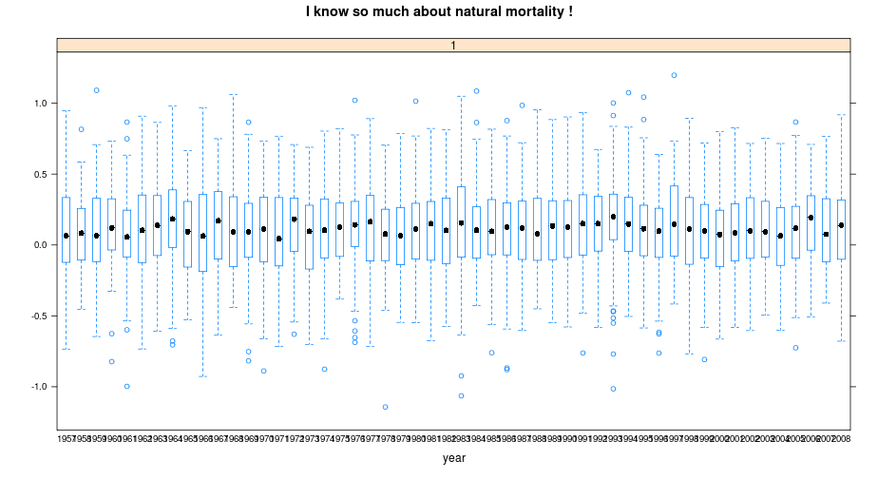
runif can be used to generate other distributions, since if you set min=0 and max=1, then it returns the probability of a value and if you know the quantile function either empirical (e.g. qnorm) or non-parametric from a model fit (e.g. the residuals) then an appropriate pdf can be generated.
> flq <- rlnorm(100, m(ple4), sd = 0.3)
> print(bwplot(data ~ year | factor(age), data = trim(flq, age = 1),
+ main = "I know its log-normal !", ylab = "", xlab = "year"))
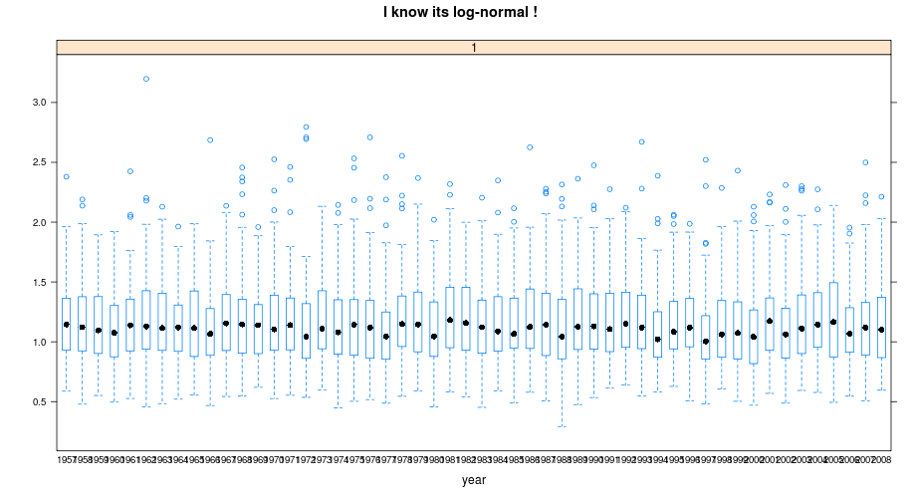
Creating an non-parametric random variable can be done using the basic R methods, sweep, apply and propagate.

FLlst and FLQuants
> selPat <- sweep(harvest(ple4), 2, fbar(ple4), "/")
> mnSel <- apply(selPat, 1, mean)
> selRsd <- log(sweep(selPat, 1, mnSel, "/"))
> rvSel <- propagate(selRsd, 100)
> rvSel[] <- c(selRsd)[sample(1:length(selRsd), prod(dim(rvSel)),
+ replace = T)]
> rvSel <- sweep(exp(rvSel), 1, mnSel, "*")
> pfun <- function(x, y, ...) {
+ panel.grid(h = -1, v = -1, col = "white", lwd = 2)
+ panel.bwplot(x, y, ...)
+ }
> pset <- list(background = list(col = "gray95"), plot.symbol = list(pch = 19,
+ cex = 0.5))
> print(bwplot(data ~ factor(age), data = rvSel, par.settings = pset,
+ panel = pfun))
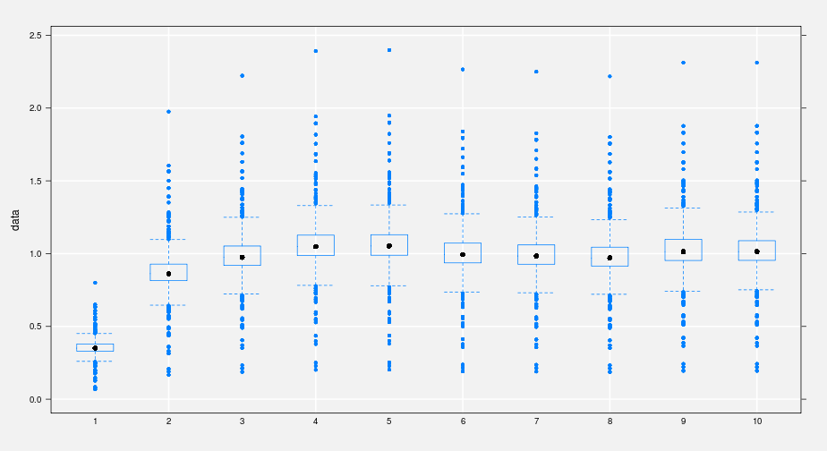
The methods applied to FLQuant can also be used for the generic FLlst objects and more directly to FLQuants, by using lapply. Which will apply a function over all elements in a list. For more information on lapply look for the help pages.
The examples below illustrate the functionality of lapply. Check that if the function applied does not return a number then the output of lapply will be a list instead of an FLlst object. The as method is used to coerce objects between classes, here it is used to coerce a FLStock object into a FLQuants list.
lapply(X, FUN, ...)
X | an FLlst object
FUN | the function to be applied to each element of ‘X’. In the case of functions like ‘+’, ‘%*%’, etc., the function name must be backquoted or quoted.
... | optional arguments to ‘FUN’

Remember that units return a character with the units of the data, which is not possible to coerce into a FLQuant.
> flqs <- as(ple4, "FLQuants")
> flqs2 <- lapply(flqs, yearMeans)
> lst <- list()
> length(lst) <- length(flqs)
> names(lst) <- names(flqs)
> for (i in 1:length(flqs)) lst[[i]] <- yearMeans(flqs[[i]])
> all.equal(flqs2, lst, check.attributes = FALSE)
[1] TRUE
> is(flqs2)
[1] "FLQuants" "FLlst" "list" "vector"
> flqs3 <- lapply(flqs, units)
> is(flqs3)
[1] "list" "vector"
The next example is based on a function that calculates the average of the last n years.
More complicated procedures could be written in the same way, e.g. creating random variables from weights-at-age by turning the non parametric random variable example into a function and then using lapply with it.
> wts <- FLQuants(stock.wt = stock.wt(ple4), catch.wt = catch.wt(ple4),
+ landings.wt = landings.wt(ple4), discards.wt = discards.wt(ple4))
> mnWts <- lapply(wts, function(x, nyrs) apply(x[, dim(x)[2] -
+ 0:nyrs], 1, mean), nyrs = 3)
Now suppose one is dealing with a large simulation study and using lists of FLStock objects, the so called FLStocks, which is an extended class of FLlst. From this object one is interesting in extracting all the catch matrices,
because catch.n is a method one can apply it with lapply and get those slots, with the benefit of generating a FLQuants object, instead of a simple list. One way of introducing variability in catch-at-age in all FLStocks is the following:
> stks <- FLStocks(stk1 = ple4, stk2 = ple4, stk3 = ple4)
> is(stks)
[1] "FLStocks" "FLlst" "list" "vector"
> flqs <- lapply(stks, catch.n)
> is(flqs)
[1] "FLQuants" "FLlst" "list" "vector"
Note that one can embed lapply within other lapply calls but be aware that the sequence of methods can have a large impact on the speed and memory used.
> stkS <- lapply(stks, function(x) {
+ catch.n(x) <- rlnorm(1000, catch.n(x), sd = 0.3)
+ x
+ })
An interesting method, with lots of applications for ploting is mcf, wich makes FLQuants compatible with respect to their dimensionality. Hence, the FLQuants in the returned object all have the same dimensions, padded with NAs if necessary.
> system.time(lst1 <- lapply(lapply(stkS, catch.n), trim, age = 1:3))
user system elapsed
0.900 0.040 0.947
> system.time(lst2 <- lapply(lapply(stkS, trim, age = 1:3), catch.n))
user system elapsed
0.350 0.000 0.361
> all.equal(lst1, lst2)
[1] TRUE
A simple example is
mcf(object, ...)
object | A list of FLQuant, not necessarily a FLQuants.
... | Not imlpemented for the moment.

FLR Complex objects
> flqs <- mcf(list(f = fbar(ple4)[, ac(1995:2008)], ssb = ssb(ple4)[,
+ ac(1990:2008)]))
> is(flqs)
[1] "FLQuants" "FLlst" "list" "vector"
> print(xyplot(data ~ year | qname, data = flqs, scales = list(y = "free"),
+ type = c("a"), main = "A stock summary", ylab = ""))
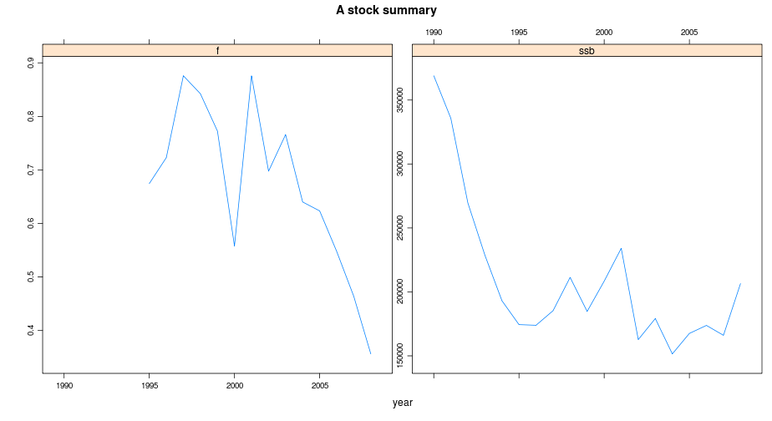
Examples of FLR complex objects are FLBiol, FLStock and FLIndex, often you may wish to process all of them using the same function, this can be done using qapply.
The examples below illustrate the funcionality of qapply.
qapply(X, FUN, ...)
X | an FLR object, FLStock, FLBiol, FLFleet, FLIndex, etc
FUN | the function to be applied to each element of ‘X’. In the case of functions like ‘+’, ‘%*%’, etc., the function name must be backquoted or quoted.
... | optional arguments to ‘FUN’

Final thoughs
> dm <- qapply(ple4, dim)
> do.call("rbind", dm)
[,1] [,2] [,3] [,4] [,5] [,6]
catch 1 52 1 1 1 1
catch.n 10 52 1 1 1 1
catch.wt 10 52 1 1 1 1
discards 1 52 1 1 1 1
discards.n 10 52 1 1 1 1
discards.wt 10 52 1 1 1 1
landings 1 52 1 1 1 1
landings.n 10 52 1 1 1 1
landings.wt 10 52 1 1 1 1
stock 1 52 1 1 1 1
stock.n 10 52 1 1 1 1
stock.wt 10 52 1 1 1 1
m 10 52 1 1 1 1
mat 10 52 1 1 1 1
harvest 10 52 1 1 1 1
harvest.spwn 10 52 1 1 1 1
m.spwn 10 52 1 1 1 1
> ple4new <- qapply(ple4, apply, 1, mean, na.rm = TRUE)
> all.equal(ple4new, qapply(ple4, yearMeans))
[1] TRUE
> ple4new <- qapply(ple4, function(x) {
+ names(dimnames(x))[1] <- "what"
+ return(x)
+ })
> unlist(qapply(ple4new, quant))
catch catch.n catch.wt discards discards.n discards.wt
"what" "what" "what" "what" "what" "what"
landings landings.n landings.wt stock stock.n stock.wt
"what" "what" "what" "what" "what" "what"
m mat harvest harvest.spwn m.spwn
"what" "what" "what" "what" "what"
As with all computing languages there's more than one way of doing the same thing and the “best” way will depend on the objectives of the analysis. Writing one off functions can often help in analyses, however if one is interested in speed it's a good idea to test your code and try to compute everything on the lowest level of the language. Using functions can also obscure what is being done and clarity is important for transparency.
FLR provides a few methods to deal with its objects which in our view cover all the important manipulations one is required to do. The biggest value is on the mixing and combination of these methods, but off course if something is missing R is a great language for quick development. Another major gain is in using other packages which may have implemented better methods than ours, that's the case of plyr (http://had.co.nz/plyr/).

