Incorporating Uncertainty into Stock Projections

V.R. Restrepo and L.T. Kell
San Sebastian, January 2002

1. OVERVIEW

A stock projection basically requires a population model, a management strategy to be applied into the future, and a characterization of uncertainty.

There are many population models in use in fisheries science: Production models, age-structured sequential population analyses, statistical catch-age models, etc.

Management strategies tend to be either constant-catch ones, or those that attempt achieving a target linked to a “biological reference point” (Fmsy, Fmax, F0.1, Bmsy, etc.).

Uncertainty plays an important role in all aspects of projections. It is present in the form of the population model, because no model can mimic reality 100%. It is also present in our estimate of the current status of the stock due to observation errors, i.e. even if we had a perfect model we could not measure the fisheries and stock variables with perfect accuracy. And uncertainty in the future is especially important: it can refer to random processes that affect the population in the future (e.g., recruitment variability) or to the implementation of future management regimes (e.g., quota over-harvests).

When making projections, it is very important to maintain consistency. For example, one would obviously want to use the same type of population model to estimate current stock status and to make projections. Similarly, it is important to maintain consistency in the characterization of uncertainty between the estimation of current stock status and the projection of future stock status.

2. MODEL FITTING

There are several approaches for fitting models to observed data. All of the approaches aim to minimize discrepancies between the observed data and the data that are predicted conditional on a given model with a given set of parameters.

2.1 Maximum Likelihood

The Maximum Likelihood (ML) method seeks to find the parameter values that maximize the likelihood of having observed the data at hand (conditional on the model form).

The ML method requires a definition of how residual errors are distributed around the model’s expectations. That is, it requires a probability density function (pdf) for the observations.

The pdf for the Normal Distribution is typically assumed in models with a simple error structure:

(2.1)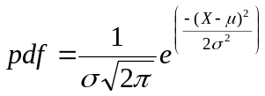.

Here, μ is the mean and σ is the standard deviation; these are the 2 parameters that define the pdf.

For a given set of observations, Likelihood is defined as the product of the individual pdfs for the observations, given a set of parameter values:

(2.2) 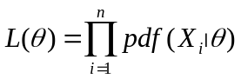. In the normal distribution example,

(2.3) 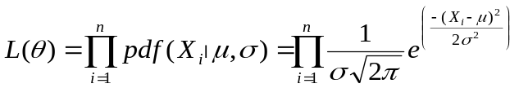.

To obtain ML estimates of μ and σ for a given set of observations, one would look for the values of these parameters that result in a maximum value of L(θ). Equivalently, one could look for the maximum value of the natural logarithm of L(θ), which is easier to compute and is less affected by machine precision (due to multiplying probability values that are often much smaller than 1.0). The Log-Likelihood is:

(2.4) 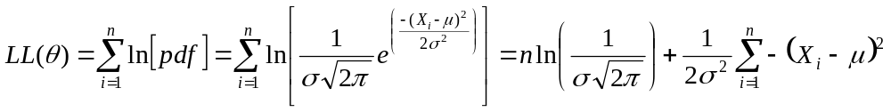.

Finding a maximum for LL(θ) on the above example is simple. In model applications, one won’t be estimating the mean μ and standard deviation σ of a distribution, but rather a set of parameters that give model predictions, 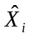, which can be compared against the observations, 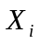.

For example, consider a linear regression of the form 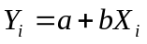. The log-likelihood to be maximized would be

(2.5) 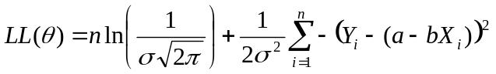.

Simplifying,

(2.6) 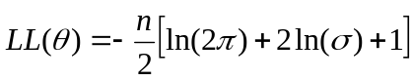,

where (2.6.1) 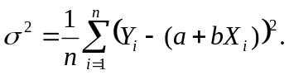

Another type of error structure assumed often is the Lognormal Distribution. In this case, the pdf is

(2.7) 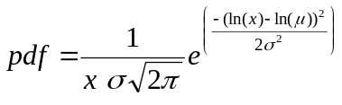

the log-likelihood in a linear regression example will be similar to the one above:

(2.8) 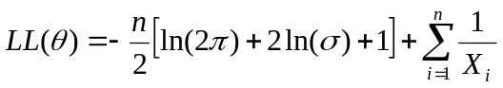,

with (2.8.1) 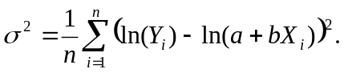
Notes:
- Maximizing LL(θ) is the same as minimizing -LL(θ).
- For the purpose of finding a maximum (or minimum), constants such as 2π can be ignored.
- ML assuming normally-distributed errors with constant variance is equivalent to Least-Squares.
- The spreadsheet “srr_fits.xls” contains examples of ML parameter estimation using Excel.

2.2 Bootstrapping

Bootstrapping is a useful approach for estimating uncertainty in parameter estimates. The method consists of re-sampling observations, with replacement, and repeating the estimation procedure many times. The final distribution of the estimates is taken to be a picture of the uncertainty in the parameter estimates.

Most types of bootstraps are said to be conditional. That is, the re-sampling is based on the original model fit. An un-conditional bootstrap would be based on the original observations instead, without reference to the original model fit.

Another way to define bootstraps refers to whether or not parametric assumptions are made during re-sampling. A conditional non-parametric bootstrap uses the distribution of residuals from the original fit as the unique set from which bootstrap samples are created. The new bootstrap observations, Y*, are computed as 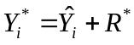, where R* is one of the n available residuals 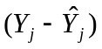chosen at random.

A conditional parametric bootstrap is similar, except that the R* are taken from a theoretical distribution that is defined by the assumptions made in obtaining the basic model fit. For instance, if the model assumes lognormal errors, then the residuals will be generated randomly from a lognormal distribution with parameters 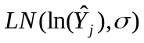.

2.3 Other approaches

3. PRODUCTION MODEL EXAMPLE

There are many types of production models in use. The one covered here is a discrete version of the generalized production model, which can be easily implemented in a spreadsheet.

3.1 Theory

The basic population model is

(3.1) 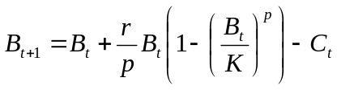
where r is the growth rate, K is the carrying capacity, and p is a shape parameter. When p=1, the model becomes the Schaefer (logistic) type in which MSY is obtained at a biomass equal to K/2.

The equilibrium statistics for the model are computed as:

(3.2) 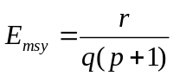
(3.3) 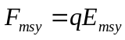
(3.4) 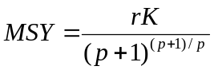
(3.5) 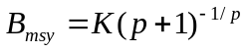

3.2 Application

3.2.1 ML Fit

3.2.2 Bootstrap

3.2.3 Projections

4. AGE-STRUCTURED EXAMPLE

3.1 Theory

3.2 Application

3.2.2 Equilibrium Yield

3.2.3 Bootstrap

3.2.4 Projections

