CSA
CATCH-SURVEY ANALYSIS

Assessment Program Documentation

B. MESNIL
IFREMER – Laboratoire MAERHA
Nantes (France)

April 2004



Contents

Overview p. 3

1. Getting started p. 5
1.1. Installation p. 5
1.2. Data format p. 7
1.3. Known problems p. 8

2. Essentials of the method p. 9
2.1. Population dynamics p. 9
2.2. Estimation, error structures p. 10
2.3. Stock trends p. 12

3. Running the programs p. 14
3.1. Program CSAo p. 14
3.2. Program CSAme p. 17

4. Results and diagnostics p. 18
4.1. Stock trends p. 18
4.2. Diagnostics p. 19
4.3. Same data with s searched p. 24

5. The S-plus implementations p. 26
5.1. Installation P. 26
5.2. Use p. 26
5.3. Extras p. 28
5.4. Mixed-error variant p. 28

Acknowledgements p. 31

References p. 32

Appendices:
A. Estimation of s ratio by SSQ profiling p. 35
B. Derivatives in all-observation-error approach p. 37
C. Derivatives in mixed-error approach p. 43
D. Summary of methods' specifications p. 46

Overview

In essence, Catch-Survey Analysis (CSA) is an assessment method that aims at estimating absolute stock abundance given a time series of relative abundance indices, typically from research surveys, by filtering measurement error in the latter through a simple two-stage population dynamics model known in the literature as the Collie-Sissenwine (1983) model.

CSA is one attempt to fill the gap between age-based methods, involving sequential population analyses (in the generic sense, including VPA etc.) for estimation, and biomass dynamic (or surplus production) models. The former require relatively long time series of catch-at-age data which (i) are generally expensive to process and more so as they need to be provided on a routine basis, (ii) must be reliable over the whole age range (errors in some cells affect estimates for younger ages in each cohort), and (iii) are simply unavailable for a number of species for which age determination is still an open question. Surplus production approaches may not provide reliable estimates when variations in stock abundance are more influenced by changes in recruitment than by response to fishing intensity, but even if information about recruitment strength is available, they cannot make use of it.

The starting point for CSA is that one is able to partition the survey data into 2 stages. The younger stage comprises the "recruits" which should be from a single year class. This group can be identified based on actual age readings when feasible, or alternatively by counting animals below a distinct cut-off length class in the length composition of the survey catch; there may be vicious cases but, in general, spotting the younger age group(s) out of length composition data is possible, notably when these analysed on short time steps. Animals of all larger lengths or ages are accumulated into the second stage, called "fully-recruited", which is akin to a super plus-group. In addition, one must provide an estimate of the total catch (fishery's removal) in number in each year. The main advantage of CSA is that catch data need not be provided by age; however, if the reported catches are inexact for any reason, CSA is not better off than VPA, say: CSA is not a fishery-independent method.

The population structure considered by CSA is illustrated with the simple sketch below where R and N denote stock abundance in number by stage, which are the quantities that one typically wants to estimate in a stock assessment:

Year/  stage | 1 | 2 | … | y | … | Y
Recr. | R₁ | R₂ | … | R_{y} | … | R_{Y}
Full-R | N₁ | N₂ | … | N_{y} | … | N_{Y}

The survey data must be provided with that same structure, by stage and year, and catch data simply by year (in general). An estimate of natural mortality M must also be provided; all current versions assume a single M for both stages but some allow for year specific M s.

This amounts to a fairly small demand in data compared to VPA. If you have such data in hand, you are ready for a CSA assessment. This manual will guide you on how to do it.

A word of caution: care has been taken to test the programs and validate the results in simulations or against results in the literature. However, they are still in an early stage of development and may not be fully proven nor foolproof. Some known problems awaiting a solution are listed in Section 1.3 that you are invited to read. It is likely that more intensive usage, e.g. in working group environments, will reveal needs for improvements and perhaps silly bugs. Feed-back will be welcome but, for the moment, these CSA implementations must be viewed as experimental tools. Please use them in that spirit and, sorry, at your own risk.

1. Getting started

1.1. Installation

The package includes 2 optional programs to run CSA, with versions for Windows or for Unix platforms:
- CSAo : fits CSA assuming only measurement error in the indices;
- CSAme : fits CSA with a choice between measurement only or measurement and process error structures (explained in section 2).

CSAo is recommended to start with and as the "normal" tool. The CSAme variant is offered for further investigations (checking whether results would significantly differ when process error is considered, with different weightings). Both involve non-linear least-squares (NLLS) minimisation using the Marquardt-Levenberg algorithm, which was preferred over the Nelder-Mead simplex because it runs much faster; a drawback is that the implementation used cannot be constrained to positive estimates but no problem of non-feasible estimates was encountered so far, unless some input was badly wrong. A simplex variant (del2s) allowing for mixed-error is available on request for problematic cases.

Simplified version of CSAo and CSAme (without bootstrap nor retrospective analyses) are provided as scripts to run in Splus (CSAo.ssc and CSAme.ssc). The guide for these implementations is presented in Section 5.

Windows environment.

Copy the executable programs (extension .exe) to any desired directory on your PC, using File Explorer. If you are interested in looking into the code, also copy the source files (.for) to an appropriate directory and read them with any text editor you like (see also Comments, next page).

You may wish to copy a shortcut to the desktop or to an application group, which allows you to set the path to the working directory where you store data for your stock (click right on the icon and edit the properties panel). The programs let you specify the absolute path to the files, but it may be less tedious to set the full path in the shortcut when it is a bit cumbersome.

The programs are started by double-clicking the shortcut or the .exe file in the File Explorer panel. A window then pops up where the program will run interactively. This window behaves like any standard Windows application: you can resize it, scroll up and down, tile with other applications, copy/paste, etc.

Unix environment.

The Unix versions are only provided as source files (extension .f). You must copy these to the desired directory and compile them by invoking the Fortran compiler in your system.
Note: the programs are written in fairly standard Fortran 77 and should be accepted by any F77 or more recent compiler; each source includes the main program and all necessary subroutines in a single file (you don't need to set up a Make file).

In the command window, go (cd) to your data directory and keyin the program name at the prompt (full path name, or just name if the path to the program's directory is included in the 'path' environment variable).

Comments:

Apart from availability of a Fortran compiler for Unix implementations, the programs do not require any special software other than the operating system. In particular, no graphic library is invoked that would complicate portability. All outputs are formatted as comma-separated fields enabling easy import into a number of software (e.g. Excel, Splus, R) for further analyses and plotting.

The only differences between the sources for Windows and Unix relate to the specifications of I/O files and to fetching the date. File definition is treated in subroutines deffic (input files) and defout (output files) which have system specific contents but the same calling syntax. For the date, the Unix versions (for Sun Solaris at least) use an intrinsic function fdate, whereas a subroutine also called fdate and using the same calling syntax had to be explicitly coded in the .for sources; its internal syntax is for a Watcom compiler and may need to be changed for recompilation with a different software. These specific subroutines are grouped at the very end of the source files in order to be easily located.

1.2. Data format

An example data file (sim_DAL20.dat) is provided and should be used as a template for your applications. Its content is duplicated here:

Simul. Age-Len - cut 25.7 - mesh 20 - NO qtrend
1, 20
Year, CatRec, CatFull , Urec , Ufull , Wrec , Wfull, Srat, M
1, 64.4, 3991.7, 8.715, 42.924, 0.084, 1.950, 1.0, 0.200
2, 86.4, 4144.5, 10.140, 38.230, 0.084, 2.017, 1.0, 0.200
3, 43.2, 4165.5, 4.611, 35.418, 0.086, 1.960, 1.0, 0.200
4, 103.8, 4088.1, 9.114, 28.834, 0.083, 2.106, 1.0, 0.200
5, 122.5, 3979.1, 9.514, 26.966, 0.084, 1.922, 1.0, 0.200
6, 139.1, 3842.9, 9.409, 25.889, 0.084, 1.700, 1.0, 0.200
7, 131.9, 3514.8, 8.929, 25.043, 0.084, 1.507, 1.0, 0.200
8, 174.8, 3376.7, 11.726, 24.285, 0.084, 1.397, 1.0, 0.200
9, 115.6, 3369.8, 7.940, 25.965, 0.085, 1.244, 1.0, 0.200
10, 193.3, 3349.2, 12.906, 24.376, 0.083, 1.256, 1.0, 0.200
11, 182.3, 3466.6, 12.348, 27.011, 0.084, 1.149, 1.0, 0.200
12, 73.4, 3564.6, 5.189, 28.633, 0.087, 1.116, 1.0, 0.200
13, 89.9, 3161.1, 7.065, 24.300, 0.084, 1.305, 1.0, 0.200
14, 184.6, 2690.0, 16.901, 22.606, 0.083, 1.397, 1.0, 0.200
15, 131.1, 2305.5, 14.501, 29.358, 0.085, 1.152, 1.0, 0.200
16, 87.8, 2187.3, 11.450, 33.374, 0.085, 1.127, 1.0, 0.200
17, 80.7, 2223.9, 12.221, 34.385, 0.084, 1.234, 1.0, 0.200
18, 88.1, 2141.1, 15.570, 35.812, 0.084, 1.327, 1.0, 0.200
19, 57.9, 1967.0, 12.343, 39.680, 0.085, 1.339, 1.0, 0.200
20, 57.6, 1823.5, 14.075, 40.477, 0.084, 1.447, 1.0, 0.200

- The first record is a title identifying your data, which should include any useful information for house keeping. The programs replicate it (up to 60 characters) into the output files.
- The second record has two fields specifying the first and the last data years. You would normally use 4-digit years but 'ranks' as used here are also acceptable.
- The third record is SKIPPED by the programs; it should be used, for your own needs, to label the data columns (but see note (ii)).
- Then, for each year, you should have a record with 9 items in that order: year (see note (iv)); fishery's catch of recruits and fully recruited in number (see note (v)); recruits and fully-recruited survey indices; recruits and fully-recruited mean weights in the stock (see note (vi)); relative variation in the recruits to fully-recruited survey catchability ratios s; and natural mortality M .

Notes:
- In records with several items, data are read in 'free format' and should thus be separated by a comma or at least one blank; in this example, leading blanks have been added so that data look nicely aligned (like a fixed-width format) but this is not required.
- However, if you intend to read your data into Splus in order to use the CSA script (Section 5), data should be separated by commas. Moreover, it is strongly recommended that your column labels in record 3 comply exactly (including case) with the format used in this example if intended to be read to name the S+ dataframe columns.
- In each record, only the necessary number of data items is read; any excess data value on a line is ignored (i.e. treated as comments). Likewise, anything beyond the terminal year's M is ignored: the space can be freely used for comments. The example file is one case of such usage: data were generated from an artificial population whose true states are perfectly known; a table with the true values is written under the data section in that file for information and easy reference.
- Year is repeated to facilitate data management but the values given here are ignored by the program; that is, no check is made that these year labels are consistent with the information in record 2, which takes priority.
- In principle, CSA only requires the total catch by year. However, in anticipation of future needs (e.g. simulation of management regimes), a split by stage has been allowed for at the outset. It is expected that if the survey catch can be "staged", then the fishery's catch also can be, using the same criterion (e.g. some cut-off length). If not, allocate the total catch to one the stages and fill the other column with zeroes; this will have no effect on model fitting.
- Mean weights are only used to translate stock numbers into biomass and have no other role in CSA estimation. Since stock numbers (R or N) estimated by CSA refer to the start of each year, mean weights should in principle also refer to years' start (so called 'stock weights' in ICES jargon). In practice, however, they are likely to be computed from length composition of the survey catch, either side of a cut-off length.

1.3. Known problems

Bugs in the code will be corrected as soon as possible. However, some tricky problems occur only in specific environments and are more difficult to resolve. They are listed below.

- Windows XP only: when you are asked to specify a pathname for input or output file (steps 1, 5 and 6 in Section 3.1), entering any sequence "\c" or "\C", for example if your path is "mydata\csa", is interpreted as CTRL-C and interrupts the program. Forcing the programs to run in Windows 95 or 98 compatibility mode does not cure the problem, nor does use of a C-type syntax "\\c". Only a brute force fix can be proposed at present: move your data to a sub-directory whose name does not start with a "c". Help welcome.

2. Essentials of the method

This section recalls basic elements of the method needed to let you understand what is behind the questions asked in the run dialogue and respond appropriately.

2.1. Population dynamics

As illustrated earlier, the population is supposed to be structured in two stages, the recruits and the fully-recruited. Population dynamics is described by a discrete difference model:
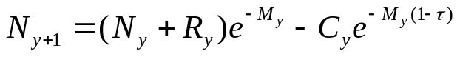 [1]
where:
y : time step, typically annual. Years may be defined either on a calendar basis or as the interval between regular surveys. The year range is [1, Y].
N_{y} : population size, in number, of fully recruited animals at start of year y;
R_{y} : population size, in number, of recruits at start of year y;
C_{y} : catch in number during year y (known);
M_{y} : instantaneous rate of natural mortality (equal for both stages, assumed);
τ : fraction of the year when the catch is taken, e.g. 0 if the fishing season is early in the year, or 0.5 if the catch is taken midway through the year or, by resemblance with Pope's (1972) cohort approximation, evenly over the year.

Estimating the time series of N_{y} and R_{y} given the catches is the basic task of any assessment but, as with other methods, this requires additional information in the form of relative indices n_{y} and r_{y} of abundance for each stage, typically from surveys, which are assumed to be proportional to absolute population sizes N_{y} and R_{y}. The indices are deemed to be measured with some (log-normal) observation error:
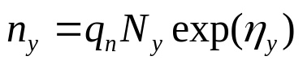 ; y= 1, Y [2]
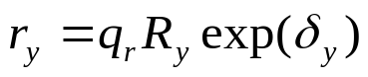 ; y= 1, Y-1 [3]
where:
q_{n} and q_{r} : catchability coefficients of fully-recruited and recruits, respectively, in the survey, supposed to be constant with time;
η and δ : normally distributed random variables.

A constraint must be imposed whereby the survey catchability of the recruits is some fraction s of that of the fully-recruited:
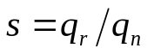 [4]
Unfortunately, in practice, s cannot be estimated together with other parameters; it is strongly (negatively) correlated with q_{n} in the estimation. It has to be set by the assessor based on external information. This is all the more annoying that absolute estimates of R and N have been shown to be very sensitive to the choice of the catchability ratio s. A device is proposed to search for a plausible value of s in absence of relevant data (see Appendix A).

In these programs, allowance is made for s to vary with time (if there is appropriate information to support this). This is done by considering that s is the product of relative annual factors, specified in the data file (cf. 1.2), by an overall scaling factor input interactively when prompted (step 4 in Section 3.1).

It is important to emphasise that the catchabilities considered in CSA relate to the survey (a term used in its broad sense to designate any appropriate source of consistent relative abundance indices) and not to the fishery (unless one uses total CPUE's as indices, which is not recommended).

2.2. Estimation, error structures

Mixed errors

The traditional approach (Collie and Sissenwine, 1983; Conser, 1995; Cadrin et al., 1999; Cadrin, 2000) approach to CSA parameter estimation assumes a mixture of measurement errors in the indices (equations [2] and [3] above) and of process errors (errors in population dynamics equation [1], e.g. in catch, M or s). For estimation in presence of process error, equation [1] is recast in terms of the survey indices:
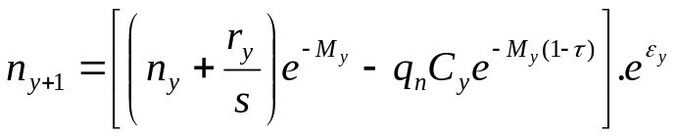 [5]

where ε is a normally distributed process error; it can be multiplicative as used by default here but is sometimes considered additive (the exponential at the far right is replaced by +ε_{y}).

In a least-squares approach, the parameters are estimated by minimising an objective function of the general form :
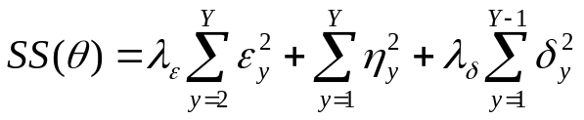 [6]
where λ_{ε} and λ_{δ} are the (user defined) relative weights of the process error ε and of the observation error on recruits δ, relative to the observation error on the fully-recruited η, and θ is the set of parameters. Each term in SS is the sum of squared deviations between observed and fitted quantities in each iteration.

Given time series of catches C and of abundance indices r and n for Y years, 2.Y parameters have to be estimated: q_{n} + {r₁ … r_{Y-1}} + {n₁ … n_{Y}}, using a set of Y equations [2], Y-1 equations [3] and Y-1 equations [5] (i.e. 3Y-2 residual terms, leaving Y-2 degrees of freedom).

Estimation assuming mixed errors is implemented in the CSAme programs. There are several drawbacks when considering process errors. First, use of equation [5] implies that indices must be available for all years (no missing data). Then there is the difficult choice of whether process error is multiplicative or additive; when [6] combines normal process errors and log-normal measurement errors, the former may be of much larger magnitude and drive the estimation. Finally, there is often no clear basis to choose the relative weight for the process error (λ_{ε}); fortunately, estimates are weakly sensitive to this choice. In addition, one may argue that the process error terms ε are in fact differences between two internally computed quantities rather than between real data (observations) and model predictions. This is why the current trend (Collie and Kruse, 1988; Zheng et al., 1997) is to abandon the mixed error approach in favour of an all-measurement error structure.

Measurement errors only

Two variants of all-measurement errors estimations are implemented. The CSAme program also uses a form based on the indices (equation [5], but without the process error term). In this case the parameters to estimate are q_{n} + the indices {r₁ … r_{Y-1}}+ the index n₁ for the first year, i.e. only Y+1 parameters for the same number Y-2 of degrees of freedom, which is more parsimonious and should in principle make estimation better behaved.

The CSAo program makes a better use of the advantages afforded by this choice of error structure. First of all, the parameters searched are directly the absolute abundance of recruits {R₁ … R_{Y-1}} in all years except the last and that of the fully-recruited in the first year (N₁, all others being derived by forward projection using equation [1]), in addition to q_{n}. In principle, this enables CSA assessments to be performed even when some indices are missing. In this form, it is also possible to consider several series of indices in tuning.
Further, since estimates of absolute abundance are 'known' in each iteration, estimates of catchability q_{n} in each year can be computed. Thus, rather than being searched by the NLLS algorithm, q_{n} is computed as a geometric mean (consistent with the assumption of log-normal error):
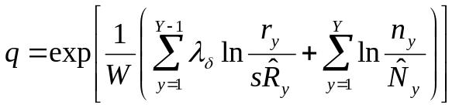 [7]
where W is the sum of weights, that is W= [(Y-1)*λ_{δ} + Y*1] in the case where no index data is missing (otherwise, discount the weight, λ or 1, of each missing index). Providing this equation releases an extra degree of freedom and the reduction in the number of parameters searched is likely to improve the behaviour of the minimisation algorithm (see Appendix B).

2.3. Stock trends

Whereas CSAo directly estimates the absolute abundance R_{y} and N_{y}, the CSAme variant predicts fitted indices (noted with a hat) from which absolute stock numbers by stage must be derived as:
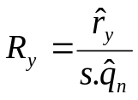 y= 1,Y-1 [8]
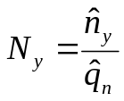 y= 1,Y [9]

In all instances, the recruitment for the terminal year (or its index) is set aside in the fitting procedure. An estimate is thus obtained using an analogue of equation [8] where the numerator is replaced by the observed index value for year Y.

Given mean weights by stage (provided in the input data file), stock abundance in number is translated into biomass using:
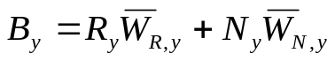 [10]
With the simplified stock structure considered by CSA it is generally not possible to estimate the spawning stock biomass (SSB) and hence corresponding reference points nor stock-recruitment relationships; it is unlikely that spawners make up a constant fraction of the abundance of fully-recruited. One exception is when the stages are defined such that the fully-recruited happen to coincide with fully mature animals, in which case the second right-hand term in [10] is SSB. In some instances, analysis of the length composition of survey catches may provide an estimate of the year specific fractions of mature animals within the fully-recruited stage and corresponding mean weights, thus enabling to estimate SSB; this has to be done outside the programs here.

Two measures of fishing mortality are computed. Following Conser (1995a), one (noted F*) is obtained, by analogy with age structured models, as:
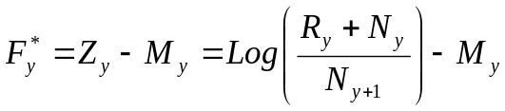 y<Y [11]
However, F* is not defined for the final year, which may be annoying since this is often the year of major interest for managers, and unrealistic (negative) values are sometimes obtained (in some cases this may serve to signal inadequate input choices).

The alternative measure of fishing pressure is the harvest rate h. In its simplest form, it is calculated in each year as the catch divided by the sum of recruits and fully recruited. Collie and Kruse (1998) propose the variant:
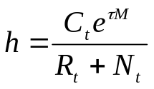 [12]
from which they derive an analogue of fishing mortality as F=-Log(1-h). However, this F can be interpreted properly only if the vulnerability of the recruits to the commercial fishery can be specified. Moreover this variant of h just scales the simpler form by a constant factor, thus both show the same pattern with time.

In these implementations, it was deemed preferable to allow for distinct harvest rates (straight catch/abundance ratios) for the recruits and the fully-recruited whenever catches are known by stage; this may be of interest for some catch prediction scenarios. In the same spirit as the ICES (and others') usage of the average F, which is computed over fully selected ages, the harvest rate for the fully-recruited can be used as the summary index of fishing intensity for communication with managers who generally want a single measure.

Other useful management-related quantities not implemented in these programs are proposed by Conser (1995a).

3. Running the programs

Once started as explained in Section 1, the programs run in interactive mode: questions are displayed and you reply by entering a character string or a number. For numbers, a default value is always proposed and can be accepted by just pressing the Enter key. In general, the value proposed initially is a sensible choice for a base run but sometimes it is only provided to comply with the syntax of the subroutines that handle input; these have the advantage of trapping faulty input (e.g. illegal characters, except D of E for reals in scientific notation) that would otherwise crash the program. In subsequent runs within a session, the proposed defaults are the values used in the previous run.

3.1. Program CSAo

Step 1. The program starts with a welcome message recalling its purpose and options, then asks for the path and name of the input data file. Specify the drive (Windows version only, default is C:), then the path (max. 30 characters for Windows, 40 for Unix, default is current directory) and the file name proper (up to 20 characters). Do not specify the leading or trailing \ (or / in Unix) in the path and file strings, and remember that Windows is not case sensitive whereas Unix is. You will be prompted again for this information if the file cannot be located.

The program then reads the data file (run-time error may occur if the file format or year range are incorrect). If your data series exceeds the allowed dimension (currently 25 years), the program will skip as many records as necessary to retain only the data for the most recent 25 years; a message will tell you. The current limit is deemed sufficient (if not excessive) keeping in mind that (i) CSA assumes a constant survey catchability over the period, and (ii) the number of parameters to be estimated increases with the number of years and the NLLS algorithms used may not behave that well when there are too many parameters.

Step 2. Next prompt asks you to set the fraction of the year when the catch is discounted. This corresponds to the choice of the parameter τ in Eq. [1]. You would normally enter 0 (for start of year) or 0.5 (for mid-year, consistent with the Baranov catch equation) which is the initial default. Choice of τ has predictable effects on estimates (Collie and Kruse, 1998): abundance estimates, in number or biomass, for all years are scaled up by exp(τM) while q_{n} is scaled down by exp(-τM). Thus, if M= 0.2, choosing τ= 0.5 inflates all estimates of recruitment and biomass by 10.5% compared to those obtained with τ= 0.

Step 3. Next setting is the weight applied to the recruit indices residuals in the objective function (λδ in Eq. [6]), relative to the residuals for the fully-recruited. Beware: increasing this weight means that measurement error on recruits is less than on fully-recruited (in other words, you have more confidence in the recruits indices). If you play with this option, you will see in the diagnostics that a larger weight results in a smaller contribution of the recruits residuals to the overall sum of squares. The default of 1.0 is probably the most reasonable; results are weakly sensitive to this value anyway.

Step 4. You are then asked to set the scaling factor for the annual catchability ratios s (Eq. [4]) provided in the data file. In principle, these should have been given as relative quantities (ratios of each annual value to some baseline value such as the time series mean) in which case you enter here the absolute (nominal) value; for example, if you assume that s= 0.5 in absolute value and ignore inter-annual variations in s, you would set all relative values in the data file at 1.0 and enter 0.5 as the scaling factor. However, if you have chosen to set absolute values (e.g. 0.5) in the data file, then you would enter a scaling factor of 1 (for the base run at least) when prompted. Exploration of CSA so far indicates that the method provides reliable indications about relative stock trends (year-to-year changes) but that absolute estimates of stock numbers and biomass are highly sensitive to the magnitude of input s: setting s too high results in over-estimation of abundance (under-estimation of fishing pressure), and vice-versa when it is set too low, without changing the general pattern of the stock trajectory. Thus, for any data set, you will likely want to make several runs in which you will vary the s value input at this step in order to evaluate the sensitivity of the results.
Two options are provided for setting s:
* Option 1: 'profiling the SSQ'. The program scans a specified range of s factors and retains the value that yields the smallest SSQ (see Appendix A for explanation and warning). To choose this option, reply 'Y' (or 'y' or just press Enter) at the prompt and set the bounds for the s factors range. Redo if the search fails.
* Option 2: 'imposed s'. Reply 'n' and enter the desired s factor value (a default of 1.0 is proposed in the first run).

Step 5. The program then sets up the initial values for the search algorithm. These are obtained as follows: starting with a value of 0.1, q is repeatedly divided by 10 until it finds an acceptable value (catch < stock size in all years), then the recruit indices are divided by s*q and the fully-recruited index in the first year by q to give the first guesses for the absolute stock sizes. The Marquardt search is then invoked 5 times from different starting values (estimates from the previous call randomly disturbed under a uniform distribution spanning ± 30% of each estimate). A table with some key results is displayed enabling to check the stability of the solution. NB: convergence is deemed achieved when relative changes between two consecutive iterates is at most 10⁻⁴; if results in the table differ by less than this, there is no reason to worry.
In the worst case, you may observe that the results do not make sense and/or that the algorithm failed to converge. In general, this has to be blamed on an inappropriate choice of s in Step 4. In case of convergence failure, you are offered the option to retry with a different s (reply Y or y or press Enter; any other response stops the program). Otherwise, take the shortest route to the end of the program and resume with different inputs (see Steps 7 and 8).

Step 6. Here you choose where the output should be directed. The screen is offered by default and this is most useful in exploratory trials. Subsequent results (commented in Section 4) will be displayed in different 'pages' separated by a pause; press Enter to view the next page. Otherwise (any reply ≠ 0), you will have to specify the path and name for an output file on disk. The syntax is the same as for the input file (Step 1). If the file already exists, you will be asked whether you want to overwrite it (reply Y or y) or specify another name (N or n); the append option (A or a) only works if the file is still open (not likely to be the case, and not recommended anyway) otherwise you will be asked a new name (like with N). In accordance with ICES rules, output files begin with a header recalling various run information, including the user name that you will be asked to enter now (up to 15 characters).

Step 7. This is the bootstrap section of the program. The default (recommended) number of bootstrap replicates is currently 500 (this is also the limit size for the array where bootstrap results are stored: if you enter a larger number, it is replaced by 500). However, if you want to skip the bootstrap (e.g. if you got silly results in Step 5), enter 0 here.
You will be asked whether you want to save the individual bootstrap results to a special file. This option is mostly intended for future needs (to be interfaced with a prediction program) or if you want to examine bootstrap distributions of stock sizes by stage in addition to those of biomasses which are tabulated by the programs; the file is formatted with comma-separated fields and each record starts with a key character (R, N, B or q) for indexing purposes. In most instances you will not need this file and be happy enough with the default choice (N).
Once the bootstrap is completed, the program runs a retrospective analysis, provided that your data cover at least 10 years, without asking your intervention.
Note that the option for setting s adopted in Step 4 for the base run also applies to the bootstrap and the retrospective analysis. If you chose option 1, the output will display additional statistics showing the s values obtained in the various replicates (bootstrap can be slowed down significantly with this option); otherwise, the same imposed s is used.

Step 8. If output was directed to a file, its name is recalled in a message and the file is closed. You are then proposed to make another run with the same data set (input file). If you wish so, reply Y or y and the program resumes in Step 2 above (this facility just avoids Step 1 which may be tedious when path names are cumbersome). Any other response (including just pressing Enter) terminates the program. Click the  button at the top right to leave the session (Windows versions only).

3.2. Program CSAme

The major differences with CSAo occur in Step 3. First, you are asked to choose the assumed error structure. The default (1) is a mix of process and measurement errors (see Section 2.2); CSAo would be a better choice if you want to consider the alternative option of all-measurement error (2) but if you are interested in looking at the sensitivity of results to the choice of error structure, it is convenient to make comparative runs within the same program. If mixed error is assumed, you are then asked to specify the relative weight given to process residuals in the objective function (λε in Eq. [6]). Default is 1.0 and, as indicated earlier, keep in mind that increasing this weight implies that you are more confident that stock dynamics complies with Eq. [1] than you have confidence in the ability of survey indices to track abundance. WARNING: do not set this weight to zero to emulate an all-measurement error approach, the program is likely to crash: as explained in Section 2, the parameters to estimate are different in either case and, in fact, it is a very large weight that is needed to mimic all-measurement error. Then, as in CSAo above, specify the relative weight for the recruit indices residuals (default = 1.0). Finally, specify whether you assume the process errors to be additive (normal, enter 1) or multiplicative (log-normal, enter 2); both forms appear in the literature and I am not in a position to make a recommendation, but choice 2 is proposed by default. As mentioned earlier, if additive process errors are assumed, their contribution to the sum of squares may largely dominate that of the measurement errors on the indices and thus drive the estimation.

Rather than an automatic search for 'minimum SSQ profile s' (see Appendix A), an option is provided to search it by trial and error. You can loop over to change the range bounds and the step until you obtain the s factor with the desired accuracy. However, contrary to CSAo, the bootstrap and retrospective will only use this s estimate as a fixed input.

Another important difference with CSAo is that mixed-error versions do not accept any missing survey index.

Specifics of del2s (for the moment): a less stringent convergence criterion (10⁻³ instead of 10⁻⁴ relative change) is imposed in the NLLS search; no restart procedure (to check stability of results) is implemented as yet, although this would probably be desirable. Note a specific prompt: you are asked to set the maximum number of times the objective function is called; this must be a large number (5000 is the default); in addition to an inadequate choice of s, convergence failure may occur if this number is too small. Retry with a larger number if necessary.

4. Results and diagnostics

The various elements of a CSAo run's output on screen or file are commented in this section, with notes on the specifics of CSAme where appropriate. The results reproduced below are those of a run with the example data set provided with the package (and in Section 1.2) with the following settings: catch discounted at mid year (τ= 0.5), fixed s= 0.995, weight of recruits residuals λδ= 1.0. This print-out can thus serve to verify that the program installed on your computer works as intended.

4.1. Stock trends

The first Table displays the 'assessment results', i.e. for each year the CSA estimates of population size of recruits and fully-recruited, the total stock biomass (Eq. [10]), the fishing mortality F* (Eq. [11]) and the harvest rates (catch divided by population size, both in number) by stage. The input catch and the assumed s ratio and natural mortality M are then recalled. Remember that, for the final year, the population size of recruits is derived from the observed index and that F* is not defined. The estimate of fully-recruited survey catchability is then displayed.

Simul. Age-Len - cut 25.7 - mesh 20 - NO qtrend
CSA Population Estimates

Year , RecN , FullN , TSBiom , F* , HRrec, HRfull , CatRec, CatFull, Sratio, M
1, 8031.8, 39386.3, 77477.9, 0.099, 0.008, 0.101, 64.4, 3991.7, 0.995, 0.20
2, 9352.9, 35152.5, 71688.2, 0.111, 0.009, 0.118, 86.4, 4144.5, 0.995, 0.20
3, 4253.5, 32609.7, 64280.8, 0.135, 0.010, 0.128, 43.2, 4165.5, 0.995, 0.20
4, 8414.1, 26372.8, 56239.6, 0.143, 0.012, 0.155, 103.8, 4088.1, 0.995, 0.20
5, 8783.5, 24688.2, 48188.4, 0.146, 0.014, 0.161, 122.5, 3979.1, 0.995, 0.20
6, 8684.2, 23693.0, 41007.6, 0.146, 0.016, 0.162, 139.1, 3842.9, 0.995, 0.20
7, 8236.1, 22905.1, 35209.9, 0.139, 0.016, 0.153, 131.9, 3514.8, 0.995, 0.20
8, 10806.5, 22196.7, 31916.5, 0.127, 0.016, 0.152, 174.8, 3376.7, 0.995, 0.20
9, 7317.3, 23807.2, 30238.1, 0.132, 0.016, 0.142, 115.6, 3369.8, 0.995, 0.20
10, 11889.7, 22328.8, 29031.9, 0.122, 0.016, 0.150, 193.3, 3349.2, 0.995, 0.20
11, 11384.8, 24810.4, 29463.5, 0.118, 0.016, 0.140, 182.3, 3466.6, 0.995, 0.20
12, 4785.5, 26332.4, 29803.3, 0.138, 0.015, 0.135, 73.4, 3564.6, 0.995, 0.20
13, 6511.3, 22185.4, 29498.9, 0.134, 0.014, 0.142, 89.9, 3161.1, 0.995, 0.20
14, 15483.7, 20553.2, 29998.0, 0.092, 0.012, 0.131, 184.6, 2690.0, 0.995, 0.20
15, 13278.1, 26903.5, 32121.5, 0.069, 0.010, 0.086, 131.1, 2305.5, 0.995, 0.20
16, 10497.7, 30693.2, 35483.5, 0.063, 0.008, 0.071, 87.8, 2187.3, 0.995, 0.20
17, 11205.0, 31665.6, 40016.6, 0.061, 0.007, 0.070, 80.7, 2223.9, 0.995, 0.20
18, 14269.7, 33014.2, 45008.5, 0.054, 0.006, 0.065, 88.1, 2141.1, 0.995, 0.20
19, 11344.2, 36695.8, 50099.9, 0.048, 0.005, 0.054, 57.9, 1967.0, 0.995, 0.20
20, 12969.5, 37499.6, 55351.4, 0.000, 0.004, 0.049, 57.6, 1823.5, 0.995, 0.20

q =, 0.10907E-02

4.2. Diagnostics

A simple but conventional goodness-of-fit diagnostic is given by the residual some of squares SS (Eq. [6]) or by the residual mean square (RMS), which is SS divided by the number of degrees of freedom (number of years minus 2 or, for CSAo, minus 1 further reduced by the number of missing indices). This diagnostic is not terribly useful and may even be misleading: trials with simulated data show that a smaller RMS can be achieved under settings for which the results are in fact further away from the truth.

SSQ =, 0.571E-03
RMS =, 0.300E-04

Residuals

The next set of Tables shows the residuals by source of error and their contribution to the sum of squares, with account of the weighting. For measurement errors, the Tables show the observed index, the predicted index, the 'raw' Log-residual (Log(predicted / observed)), the standardised residual and the percentage contribution to SS (used to spot out influential data and perhaps outliers). The standardised residuals are computed as follows, e.g. for the recruit indices:
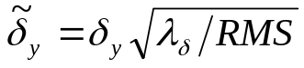 [13]
where δ is the raw Log-residual, λ_{δ} is the relative weight and RMS is as explained above.

If the CSAme program is run assuming a mixed-error structure, a similar panel is also displayed for the process errors and their contribution to SS. Process error is the difference between the fully-recruited index predicted with Eq. [5] for the following year, given parameter estimates for the current year, and the NLLS estimate of that index. The column for raw residuals is labelled 'RawRes' because process error residuals can be computed as arithmetic differences or as Log of ratios depending on the choice of additive or multiplicative error; the choice made is recalled in the output file's heading section.

Simulated Age-Len Data - cut 25.7 - mesh 20 - NO qtrend
Residuals:

Obs Error on Recruits - Wgt**2= 1.00 => Share of SSQ = 30.43%
Index, Obs , Pred , LnResid , StdRes , %SSQ
Ur 1, 8.715, 8.716, 0.0002, 0.0298, 0.00
Ur 2, 10.140, 10.150, 0.0010, 0.1827, 0.18
Ur 3, 4.611, 4.616, 0.0011, 0.2015, 0.21
Ur 4, 9.114, 9.131, 0.0019, 0.3468, 0.63
Ur 5, 9.514, 9.532, 0.0019, 0.3489, 0.64
Ur 6, 9.409, 9.424, 0.0016, 0.2993, 0.47
Ur 7, 8.929, 8.938, 0.0010, 0.1880, 0.19
Ur 8, 11.726, 11.728, 0.0001, 0.0258, 0.00
Ur 9, 7.940, 7.941, 0.0001, 0.0242, 0.00
Ur 10, 12.906, 12.903, -0.0002, -0.0398, 0.01
Ur 11, 12.348, 12.355, 0.0006, 0.1069, 0.06
Ur 12, 5.189, 5.193, 0.0009, 0.1562, 0.13
Ur 13, 7.065, 7.066, 0.0002, 0.0334, 0.01
Ur 14, 16.901, 16.804, -0.0058, -1.0551, 5.86
Ur 15, 14.501, 14.410, -0.0063, -1.1496, 6.96
Ur 16, 11.450, 11.393, -0.0050, -0.9181, 4.44
Ur 17, 12.221, 12.160, -0.0050, -0.9111, 4.37
Ur 18, 15.570, 15.486, -0.0054, -0.9858, 5.11
Ur 19, 12.343, 12.311, -0.0026, -0.4705, 1.17

Obs Error on FullRecr - Wgt**2= 1.00 => Share of SSQ = 69.57%
Index, Obs , Pred , LnResid , StdRes , %SSQ
Un 1, 42.924, 42.958, 0.0008, 0.1461, 0.11
Un 2, 38.230, 38.341, 0.0029, 0.5273, 1.46
Un 3, 35.418, 35.567, 0.0042, 0.7670, 3.10
Un 4, 28.834, 28.765, -0.0024, -0.4389, 1.01
Un 5, 26.966, 26.927, -0.0014, -0.2624, 0.36
Un 6, 25.889, 25.842, -0.0018, -0.3328, 0.58
Un 7, 25.043, 24.983, -0.0024, -0.4413, 1.02
Un 8, 24.285, 24.210, -0.0031, -0.5661, 1.69
Un 9, 25.965, 25.966, 0.0001, 0.0095, 0.00
Un 10, 24.376, 24.354, -0.0009, -0.1651, 0.14
Un 11, 27.011, 27.061, 0.0018, 0.3345, 0.59
Un 12, 28.633, 28.721, 0.0031, 0.5577, 1.64
Un 13, 24.300, 24.198, -0.0042, -0.7710, 3.13
Un 14, 22.606, 22.417, -0.0084, -1.5293, 12.31
Un 15, 29.358, 29.344, -0.0005, -0.0901, 0.04
Un 16, 33.374, 33.477, 0.0031, 0.5616, 1.66
Un 17, 34.385, 34.538, 0.0044, 0.8076, 3.43
Un 18, 35.812, 36.008, 0.0055, 0.9980, 5.24
Un 19, 39.680, 40.024, 0.0086, 1.5744, 13.05
Un 20, 40.477, 40.901, 0.0104, 1.8996, 18.99

Approximate variances

Approximate variance and CV of each parameter, based on the analytical Jacobian (see Appendices B and C) are then listed:

Approximate Variances & CVs:
Param, Var , CV%
R 1, 0.2879E+04, 0.7
R 2, 0.3524E+04, 0.6
R 3, 0.7897E+03, 0.7
R 4, 0.2590E+04, 0.6
R 5, 0.2694E+04, 0.6
R 6, 0.2608E+04, 0.6
R 7, 0.2403E+04, 0.6
R 8, 0.3691E+04, 0.6
R 9, 0.2015E+04, 0.6
R 10, 0.4395E+04, 0.6
R 11, 0.4119E+04, 0.6
R 12, 0.9573E+03, 0.6
R 13, 0.1701E+04, 0.6
R 14, 0.7720E+04, 0.6
R 15, 0.6567E+04, 0.6
R 16, 0.4520E+04, 0.6
R 17, 0.5225E+04, 0.6
R 18, 0.8418E+04, 0.6
R 19, 0.5801E+04, 0.7
N 1, 0.2520E+05, 0.4

The CSAme program also produces a Table with the estimate and CV of each parameter (Ur and Un denote the fitted indices for recruits and fully-recruited, respectively). As discussed by Conser (1995a), there are problems with these SE's and CV's: the estimates are often large, implying that the linear approximation may be poor; rather than CV of individual parameters, we are generally more interested in evaluating the precision of results of management interest (e.g. biomass). The bootstrap discussed below thus appears to provide more useful information about precision of the assessment.

Bootstrap

These programs implement a 'non-parametric, model conditioned' type of bootstrap, that is: the raw residuals from the base model fit above are saved; then a number of pseudo data sets are formed in which the fitted survey indices are perturbed by applying randomly drawn residuals. Draws are made with replacement within the appropriate error source: measurement error only for recruits, measurement error and then, if assumed in CSAme, process error for the fully-recruited. This procedure is repeated 500 times (default) here.

Since fully-recruited catchability q_{n} is a key parameter in this method and assuming that biomass is generally the result of major interest, bootstrap distributions are only provided for these two quantities (but other results are in the bootstrap file if you chose to create one). The distributions are summarised in a Table showing key percentiles. Only the valid bootstrap runs (successful convergence of the NLLS algorithm, and of the Brent routine when option 1 is used for s) are taken into account, and the number of these is recalled in the heading.

Percentiles in 500 bootstrap runs
, Min , p5 , p10 , p25 , Med , Avg , p75 , p90 , p95 , Max
B 1,77033.4, 77477.3, 77562.8, 77648.0, 77792.0, 77797.6, 77938.1, 78057.5,78113.5, 78468.6
B 2,71192.9, 71691.1, 71761.1, 71858.0, 71991.1, 71994.0, 72121.5, 72249.4,72309.2, 72641.0
B 3,63853.8, 64279.8, 64336.9, 64441.6, 64556.9, 64559.9, 64679.8, 64787.7,64852.8, 65257.6
B 4,55811.7, 56236.7, 56287.8, 56383.6, 56504.5, 56504.2, 56616.8, 56727.5,56791.3, 57221.8
B 5,47829.4, 48162.1, 48218.7, 48302.8, 48409.2, 48417.3, 48526.5, 48612.6,48678.3, 49039.4
B 6,40698.5, 40967.9, 41027.9, 41100.8, 41189.3, 41201.2, 41301.8, 41380.8,41441.0, 41747.5
B 7,34947.6, 35158.9, 35220.4, 35284.5, 35366.6, 35376.9, 35471.2, 35537.2,35588.2, 35924.3
B 8,31694.4, 31863.9, 31917.1, 31983.3, 32062.2, 32068.7, 32158.5, 32219.4,32269.5, 32605.7
B 9,30057.1, 30195.7, 30227.9, 30294.3, 30372.7, 30375.9, 30452.5, 30524.2,30556.8, 30831.5
B10,28872.1, 28987.2, 29023.4, 29086.4, 29162.5, 29165.9, 29238.8, 29307.8,29339.5, 29581.8
B11,29295.1, 29419.8, 29460.4, 29520.4, 29592.3, 29593.6, 29668.0, 29735.0,29766.1, 29977.4
B12,29665.6, 29762.2, 29793.9, 29853.2, 29932.8, 29933.7, 30006.4, 30070.5,30109.8, 30360.4
B13,29322.6, 29456.0, 29488.4, 29552.4, 29633.0, 29636.4, 29717.6, 29779.4,29824.0, 30106.3
B14,29785.9, 29942.8, 29982.9, 30048.1, 30137.9, 30138.6, 30228.3, 30295.2,30345.9, 30597.5
B15,31948.1, 32068.6, 32104.4, 32175.7, 32259.1, 32261.9, 32343.4, 32423.4,32469.5, 32653.5
B16,35315.5, 35430.0, 35468.7, 35544.2, 35626.2, 35634.7, 35720.2, 35816.5,35861.6, 36061.7
B17,39782.9, 39947.0, 39997.0, 40081.2, 40177.8, 40183.6, 40283.3, 40372.0,40439.1, 40672.5
B18,44733.0, 44934.4, 44977.6, 45082.6, 45184.4, 45191.9, 45308.2, 45410.9,45478.5, 45738.5
B19,49745.4, 49998.4, 50055.1, 50181.2, 50286.5, 50294.6, 50422.7, 50541.0,50610.4, 50911.1
B20,54978.3, 55246.7, 55297.1, 55426.6, 55557.2, 55560.8, 55690.4, 55813.1,55890.8, 56258.0
q ,0.1075E-02,0.1082E-02,0.1083E-02,0.1085E-02,0.1087E-02,0.1087E-02,0.1089E-02,0.1091E-02,0.1092E-02,0.1095E-02,

The Table shows the medians (Med) and the means (Avg), which can give you an idea of whether bias in biomass estimates is worth worrying about.

Two simple statistics based on the bootstrap are then provided: the probabilities that the biomass in the final year is less than it was by the start of the series (mean of 3 first years) and in the recent period (mean of final-4 to final-2, i.e. excluding 2 most recent years). These means are recomputed in each bootstrap run and a counter just accumulates how many times the estimate of final biomass is less than either mean, then the total is divided by the number of valid bootstrap runs. In this example, it is certain that biomass is currently less than it was at the start of the series but also that it has increased compared to the recent past.

Prob.[B 20 < Bearly] = 100.0%
where Bearly = meanB 1- 3
Prob.[B 20 < Brecent] = 0.0%
where Brecent = meanB 16- 18

Then bootstrap based indications of precision are given for fully-recruited survey catchability. Computation of CV(q) is based on squared deviations between individual bootstrap estimates and their mean, whereas bias(q) is based on deviations from the base run estimate. Note that relative bias is expressed as percentage (-0.4% in this example):

Bootstrap estimate of CV(q) =, 0.003
Bootstrap estimate of Bias(q) =,-0.385E-05
=> Relative Bias(q) % =, -0.4

No bias correction made on any of percentiles above.

As recalled in this final message, the percentiles are not corrected for bias (work for the future).

These bootstrap results must be interpreted with care, notably if your data cover a limited number of years (implying that there is a fairly small pool of residuals which are repeatedly resampled). In any case, it is likely that the 5 and 95 percentiles are not reliably estimated, and it is prudent to consider less extreme percentiles (e.g. 10 and 90) for confidence intervals.

Retrospective analyses

In such analyses, CSA estimation is repeatedly carried out starting with the full time series and recursively ignoring the final year's data until there are at least 10 years of data left (no run will thus be made if your data cover less than 10 years). Retrospective results are provided for biomasses, population sizes of recruits and of fully-recruited, and fully-recruited catchability, but only the results for biomasses are replicated below (in part); the layout for the other quantities is the same.

Retrospective Analysis of Biomasses

EndYr, 20, 19, 18, 17, 16, 15, 14, 13, 12,
B 1, 77477.9, 77534.8, 77595.1, 77649.2, 77706.2, 77768.0, 77815.7, 77725.5, 77669.4,
B 2, 71688.2, 71750.4, 71816.2, 71875.3, 71937.4, 72004.7, 72056.6, 71958.6, 71897.7,
B 3, 64280.8, 64344.1, 64411.2, 64471.3, 64534.6, 64603.1, 64655.9, 64556.2, 64494.4,
B 4, 56239.6, 56302.9, 56370.0, 56430.1, 56493.3, 56561.8, 56614.6, 56515.0, 56453.3,
B 5, 48188.5, 48247.1, 48309.1, 48364.7, 48423.3, 48486.7, 48535.6, 48443.2, 48385.9,
B 6, 41007.6, 41059.9, 41115.3, 41165.1, 41217.5, 41274.3, 41318.2, 41235.2, 41183.5,
B 7, 35209.9, 35256.5, 35305.9, 35350.3, 35397.1, 35447.9, 35487.3, 35412.6, 35366.0,
B 8, 31916.5, 31959.8, 32005.8, 32047.2, 32090.9, 32138.5, 32175.4, 32105.0, 32060.7,
B 9, 30238.1, 30278.1, 30320.7, 30359.1, 30399.8, 30444.5, 30479.5, 30412.2, 30369.3,
B 10, 29031.9, 29072.0, 29114.7, 29153.3, 29194.5, 29239.8, 29275.4, 29206.3, 29161.9,
B 11, 29463.5, 29502.8, 29544.9, 29583.4, 29624.9, 29671.3, 29708.5, 29634.5, 29585.5,
B 12, 29803.3, 29843.3, 29886.4, 29926.2, 29969.7, 30019.1, 30059.4, 29977.4, 29921.6,
B 13, 29498.9, 29542.6, 29589.8, 29633.4, 29681.1, 29735.3, 29779.7, 29689.2,
B 14, 29998.0, 30045.5, 30097.2, 30145.6, 30199.2, 30261.3, 30313.1,
B 15, 32121.5, 32173.8, 32233.1, 32291.4, 32360.5, 32445.9,
B 16, 35483.5, 35545.2, 35616.8, 35689.6, 35778.5,
B 17, 40016.6, 40091.6, 40180.3, 40272.1,
B 18, 45008.5, 45104.2, 45220.3,
B 19, 50099.9, 50231.0,
B 20, 55351.4,

Mohn's Rho for Biomasses = 0.007

Mohn’s (1999) ρ statistic summarises the deviations in successive estimates of biomass, recruitment and fully recruited abundance in the terminal year of each subset and is computed, e.g. for biomass, as:
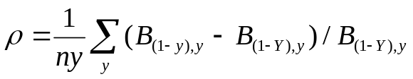 [14]
where ny is the number of years removed, B_{(1-x),y} denotes the result for year y using all data until year x, and Y is the final year (20 here). This statistic has the advantage of taking into account the sign of the updates. A positive ρ indicates that the addition of new data has mostly implied downward revisions of the estimates, and vice versa if negative.

In some versions, notably del2s (minimisation by simplex), you may observe that the estimates for the full times series appearing in the first column of the retrospective panels are not exactly the same as those obtained in the base run (Table in 4.1), and may change again depending on how many bootstrap runs have been made before getting to the retrospective. This irritating problem which occurred with the various NLLS algorithms tried has been explored carefully. A large number of runs were made with varying initial values and the distribution of results were examined: this showed that, although not strictly identical, the results were within the tolerance threshold imposed to the minimisation routines. The small variations thus appeared to be a normal behaviour of these routines. Forcing the retrospective to start from the base run estimates has resolved the issue for the Marquardt versions. Since the simplex algorithm checks for convergence only after making several iterations, each call changes the results but the differences are within the imposed tolerance.

4.3. Same data with s searched

A brief extract of the output obtained when s is searched rather than set (taking option 1 in Step 4, Section 3.1) is shown here for comparison and checking. The search was bracketed by a lower bound of 0.8 and an upper bound of 1.2.

Minimum SSQ=, 0.66514E-04, found for s=, 1.0206

CSA Population Estimates

Year, RecN , FullN , TSBiom , F* , HRrec, Hrfull , CatRec, CatFull, Sratio, M
1, 8295.0, 41572.7, 81763.6, 0.094, 0.008, 0.096, 64.4, 3991.7, 1.021, 0.200
2, 9648.0, 37158.2, 75758.4, 0.105, 0.009, 0.112, 86.4, 4144.5, 1.021, 0.200
3, 4390.4, 34493.4, 67984.6, 0.127, 0.010, 0.121, 43.2, 4165.5, 1.021, 0.200
4, 8673.3, 28027.2, 59745.1, 0.135, 0.012, 0.146, 103.8, 4088.1, 1.021, 0.200
5, 9056.5, 26254.8, 51222.4, 0.137, 0.014, 0.152, 122.5, 3979.1, 1.021, 0.200
6, 8959.5, 25199.2, 43591.2, 0.138, 0.016, 0.153, 139.1, 3842.9, 1.021, 0.200
7, 8504.4, 24363.7, 37430.5, 0.131, 0.016, 0.144, 131.9, 3514.8, 1.021, 0.200
8, 11168.6, 23610.5, 33922.0, 0.120, 0.016, 0.143, 174.8, 3376.7, 1.021, 0.200
9, 7564.5, 25261.2, 32067.9, 0.125, 0.015, 0.133, 115.6, 3369.8, 1.021, 0.200
10, 12305.1, 23721.7, 30815.7, 0.115, 0.016, 0.141, 193.3, 3349.2, 1.021, 0.200
11, 11781.7, 26290.8, 31197.8, 0.112, 0.015, 0.132, 182.3, 3466.6, 1.021, 0.200
12, 4948.0, 27869.5, 31532.8, 0.131, 0.015, 0.128, 73.4, 3564.6, 1.021, 0.200
13, 6738.1, 23576.9, 31333.8, 0.126, 0.013, 0.134, 89.9, 3161.1, 1.021, 0.200
14, 16106.2, 21878.2, 31900.7, 0.087, 0.011, 0.123, 184.6, 2690.0, 1.021, 0.200
15, 13809.7, 28497.9, 34003.5, 0.066, 0.009, 0.081, 131.1, 2305.5, 1.021, 0.200
16, 10903.2, 32433.9, 37479.8, 0.060, 0.008, 0.067, 87.8, 2187.3, 1.021, 0.200
17, 11636.1, 33422.8, 42221.2, 0.058, 0.007, 0.067, 80.7, 2223.9, 1.021, 0.200
18, 14820.4, 34805.9, 47432.3, 0.051, 0.006, 0.062, 88.1, 2141.1, 1.021, 0.200
19, 11752.7, 38613.4, 52702.4, 0.045, 0.005, 0.051, 57.9, 1967.0, 1.021, 0.200
20, 13406.6, 39404.1, 58143.9, 0.000, 0.004, 0.046, 57.6, 1823.5, 1.021, 0.200

q =, 0.10287E-02

SSQ =, 0.665E-04
RMS =, 0.350E-05

The larger s assumed in this case results in larger stocks sizes and lower q, and in a strong reduction in SSQ and RMS (by nearly a factor of 10) which may lead to prefer this run over the previous one. This is a simulated data set for which we know the true states (see bottom panel of the data file), and in no year was the actual s equal or larger than unity. Knowing this (which would not happen in an actual fish stock assessment), we might have misgivings about treating as the 'best' run one in which s is larger than 1.0. Yet, it gives stock estimates matching the true stock size better than the run with s= 0.995 (average relative error of –2.7%, instead of –8.2%, for biomasses over all years; the – sign here indicates that a still better match might be achieved with a slightly larger s). The improvement in accuracy of the assessment observed here does not imply that the same would happen with any data, however (see warning in Appendix A).

Other specific outputs with this option are the bootstrap statistics for s (an extra row under the summary table):

Percentiles in 500 bootstrap runs
, Min , p5 , p10 , p25 , Med , Avg , p75 , p90 , p95 , Max
... ...
s , 1.0160, 1.0178, 1.0183, 1.0192, 1.0206, 1.0206, 1.0217, 1.0229, 1.0236, 1.0266

and the retrospective estimates of s:

Retrospective Analysis of s-ratio
EndYr, 20, 19, 18, 17, 16, 15, 14, 13, 12, 11,
s , 1.0206, 1.0195, 1.0184, 1.0177, 1.0164, 1.0151, 1.0154, 1.0153, 1.0155, 1.0166,

In both of these, one should check that none of the s estimates has been stuck too close to the lower or upper bound imposed for the search; otherwise, repeat the whole assessment with a wider search interval.

5. The S-plus implementations

These versions were initially developed for checking purposes, but may be found to be more flexible to play with, at least by those familiar with the S-plus package. The code provided in the script files named CSAo.ssc. and CSAme.ssc is built around the function nlregb() which is one of the possibilities offered in S to minimise non-linear objective functions. The two variants have many common features and their use is first exemplified with CSAo.ssc which fits the all-measurement-error variant of CSA with q computed as GM (see Section 2.2).

5.1. Installation

The most straightforward way of using the suite of commands is the script facility currently reserved to the Windows versions of S-plus: click File menu, Open… then browse directories to find and load CSAo.ssc. However, the script uses standard S commands that can also be run in Unix versions and probably in R, albeit in a more tedious way: open the script file under a text editor, copy-paste each relevant command into the command window. Some sections of code can perhaps be gathered into functions that can then be used somewhat like a script.

For a first time installation you need to "compile" (run) the suite of associated functions into your workspace. These functions are called CSiniGM.f (sets up initial values for NLLS search), CSresGM.f (returns vector of residuals in each iteration), CSfwd.f (projects fully-recruited N forward), CSoutGM.f (derives stock estimates). The codes of these, and of other useful functions are located in the bottom section of the script file. This compilation process is not required for subsequent use as long as the functions are available in the active workspace.

5.2. Use

CAUTION: the script is intended to be run step by step: do not run it in one go. Should this happen by accident, some commands have been commented out (preceded with #!) to avoid unwanted damage. Only highlight the desired bits then press the F10 key or click the Run button at the top left.

The script is abundantly commented. Only important steps will be further discussed in this section.

You first need to import your data from a text file into an S-plus dataframe object (unless already done). In principle, your data file should have the standard format presented in Section 1.2 in which case simply follow the procedure explained in the script. Name the dataframe at your convenience. As distributed the script assumes that the example data in file sim_DAL20.dat are replayed and imported into the object named sim.DAL20.

All functions have been written to handle the data under the generic name CSdat and the component columns under the standard labels using the $ method of subscripting. For using a given data set, you must first copy it into the working object CSdat and, if necessary, rename its columns (remember that S is case sensitive). Depending on the magnitude of your catch data, you may wish to rescale them in CSdat; this is unimportant for CSA estimation but is useful to obtain plots of estimated stock abundance trajectories with nicer Y-axis labels.

It is ESSENTIAL, however, that you aggregate the catches by stage into a total catch column named CatchN since the functions only manipulate that item. The command reproduced here:
CSdat$CatchN <- CSdat$CatRec + CSdat$CatFull
does this and puts the result into a new column appended to CSdat.

Step 4 is where you set the specific CSA settings for each run and probably loop over to assess sensitivity of the results to changes in input. This script envisages changes in τ, relative weight of error on recruit indices, M and s ratio (as a scaling factor to the original data that must be saved into Srat.ori); by default, it sets M values that are constant with time, but you can use the c() operator to enter year specific values.

The actual minimisation is performed in section 5. Before calling nlregb, you must provide it with starting values obtained by calling the function CSiniGM.f. This must be done everytime you change the input settings in step 4; the output is stored in working object vini. The call to nlregb may take some time and may at times crash, notably if the input s is inadequate. If so, readjust and redo.

The output of nlregb() is stored in object CSmin (a list with many items): it is useful to browse its content, and check in particular the section $message that tells whether convergence was properly achieved.

nlregb returns the estimated parameters but these are not the stock estimates we are finally interested in. To obtain the latter, you must call CSoutGM.f which uses the content of CSmin together with the data in CSdat, and outputs the results in the list CSest. This includes a run title that you should specify carefully so that each output can be clearly identified.

The script then offers to visualise the results in a 4-panel plot showing the trajectories of biomass and recruitment, and the pattern of Log-residuals. This is just one possible suggestion: use the proposed functions as a basis to build up plots fitting your own taste.

Since the content of the working object CSest is overwritten in each call, you may want to save it into a unique object (e.g. for comparing runs). You can also save it to an ASCII file for importing elsewhere. In this case, take care of defining the file name in object fich; refer to the (commented out) specifications given in Step 1 of the script to adjust it depending on your directory structure.

Approximate (co-)variance and CV of the parameters can be obtained, which requires running the function CSjacGM.f, provided that no survey index is missing in your data (see further details in Appendix B).

Return to Step 4 for replaying the same data with other settings, to Step 2 for other data already in workspace, or to Step 1 for importing a new data set.

Example:

The stock estimates obtained using the sim.DAL20 data and the same settings as in Section 4 are shown in the Table below. You can check that they are identical (except for the scaling) to those shown p. 18, which is reassuring.

> CSest
$descrip:
[1] "sim_DAL20 data - NO Q trend - tau= 0.5 - s= 0.995"

$tau:
[1] 0.5

$M:
[1] 0.2 0.2 0.2 0.2 0.2 0.2 0.2 0.2 0.2 0.2 0.2 0.2 0.2 0.2 0.2 0.2 0.2 0.2 0.2 0.2

$Stock:
Year RecN FullN Btot HRrec HRfull
1 1 8.031784 39.38626 77.47788 0.008018144 0.10134752
2 2 9.352904 35.15250 71.68824 0.009237773 0.11790057
3 3 4.253520 32.60967 64.28075 0.010156294 0.12773819
4 4 8.414112 26.37284 56.23956 0.012336418 0.15501177
5 5 8.783493 24.68816 48.18845 0.013946616 0.16117445
6 6 8.684195 23.69299 41.00755 0.016017604 0.16219567
7 7 8.236147 22.90513 35.20987 0.016014769 0.15345033
8 8 10.806497 22.19665 31.91647 0.016175455 0.15212654
9 9 7.317317 23.80716 30.23808 0.015798141 0.14154563
10 10 11.889692 22.32885 29.03188 0.016257780 0.14999430
11 11 11.384785 24.81039 29.46345 0.016012600 0.13972375
12 12 4.785521 26.33244 29.80334 0.015337932 0.13536916
13 13 6.511264 22.18543 29.49893 0.013806843 0.14248540
14 14 15.483694 20.55324 29.99802 0.011922219 0.13087960
15 15 13.278078 26.90350 32.12147 0.009873417 0.08569517
16 16 10.497695 30.69317 35.48350 0.008363741 0.07126342
17 17 11.204998 31.66563 40.01661 0.007202143 0.07023072
18 18 14.269733 33.01421 45.00852 0.006173907 0.06485388
19 19 11.344217 36.69576 50.09988 0.005103922 0.05360293
20 20 12.969466 37.49960 55.35136 0.004441201 0.04862719

$qhat:
[1] 1.090695

5.3. Extras

The associated script file CSAoextra.ssc offers some additional facilities. One does the computation of sensitivity coefficients of CSA estimates to relative changes in s (specified in smult). Note that it depends on the CSAo script being run in parallel and requires that the function CSsen.f has been compiled first.

The example data are particular in that they were generated by simulation, so that the true population values are known and are provided in the data file. The second facility makes graphical comparisons between any run's results in CSest and the true population values. These must first be imported and copied to the working object true.pop. Deviations with the truth are also summarised by the Mean Relative Errors (ARE), or the Root Mean Squared Errors (RMSE).

Extra #4 implements the 'profile minimum s' estimation procedure described in Appendix A, using the function CSprofs.f. The first argument to give it is the object CSdat (input data) which should be in the form required for Step 5 of the CSAo script. You must then give it the lower and upper bound of the s range you want to scan, and the step. Beware: you should first check that all s values in that range are acceptable (error messages returned by nlregb()are not visible); unfortunately it is not obvious to trap cases of convergence failure and these may occur for rather small changes in s. Moreover, you are limited to 50 values within the range (but this is probably much more than reasonably needed). The tau value must also be passed.
The computation takes a long time but if it runs OK it will output a plot of the SSQ versus s where a minimum may be visible if the range is chosen appropriately. In addition a table is produced and the s value giving the lowest SSQ is indicated.
See the warning in Appendix A about the limitations of this procedure.

A simple catch forecast mimicking ICES practice is proposed as Extra #5. It works in 2 steps: first, the standard input data are assembled into a standard object ForIn by the function CSforin.f that takes bits from CSdat and CSest (note the importance of labelling your runs properly in rundesc: this is passed all through). Next, ForIn can be passed to function CSpred.f to run a conventional forecast 2 years ahead (specify the F multipliers by stage for the interim and the 'TAC' years in fmult), or to function CSoptab.f for a catch option table (specify multipliers for the interim year and the range for the 'TAC' year).

A special fitting procedure is proposed for the case where a significant change in the survey protocol has occurred in the time series, such that survey q is very likely to be different before and after the change. This procedure treats the two adjacent series as independent surveys and estimates two catchability parameters (here, the variant where q is computed as GM is particularly useful). However, this procedure should not be used uncritically, as a patch for shaky data. It is important that either period includes a sufficient number of years.

Other extras (e.g. retrospective, bootstrap, …) will be added in the future.

5.4. Mixed-error variant CSAme.ssc

This is installed as explained in 5.1, except that the functions to be loaded initially have suffix ME instead of GM. Steps 1 and 2 are exactly the same as in CSAo and need not be repeated if a CSdat object has already been set up in your environment. Beware to revise the number of parameters and of residual terms in Step 3, and to set up the options for process error in Step 4 (iii).

In step 5, initialise the parameters in vini by calling CSiniME.f. This should be redone whenever M or Srat values are changed. This call silently creates a table TexMex of constants (exponentials in M) which are required by functions used subsequently, a device expected to save run time.
As explained in a comment (see also Appendix C), the option to provide nlregb with analytical derivatives (statement: jac = CSjacME.f) has been removed because of erratic misbehaviour with some data sets and settings. However, you may want to give it a try for your specific data: copy the statement back into the call to nlregb and check what CSmin$message says when you run the command. If it indicates no problem (such as 'false convergence') then continue with the option as this will speed up computations; otherwise, remove it and nlregb will do with numerical derivatives.

The rest goes on as with CSAo. Note in particular that the CSest objects created by CSAme have the same structure as those produced with CSAo, and thus can be used in the catch forecast section of CSAoextra.ssc (Section 5.3). However, for the moment, the other extras are not adequate for the mixed-error structure and should not be used.

Acknowledgements

The development of these programs was greatly facilitated by the detailed description given by Ray Conser in his 1995 ICES WD's.

The Marquardt-Levenberg routines used in CSAo and CSAme were coded by B.S. Garbow, K.E. Hillstrom and J.J. More in 1980 as part of the Minpack package and were obtained from the Netlib library at : http://www.netlib.org.

The extended Simplex, including quadratic surface fitting, used in del2s was coded by D.E. Shaw, R.W.M. Wedderburn and A. Miller (1991 version).

Carl O'Brien (CEFAS, Lowestoft) suggested the procedure to set the s ratio by profiling the SSQ surface over a range of s.

The Brent algorithm implemented in CSAo to search for the profile-minimum s was copied from W.H. Press et al. (1986) Numerical Recipes in Fortran.

Lawrence Kell (CEFAS, Lowestoft) is developing an implementation of CSA in R which will further facilitate the use and testing of the method.

References

About CSA

Cadrin, S.X., 2000. Evaluating two assessment methods for Gulf of Maine northern shrimp based on simulations. J. Northw. Atl. Fish. Sci. 27, 119-132.

Cadrin, S.X., Clark, S.H., Schick, D.F., Armstrong, M.P., McCarron, D., Smith, B., 1999. Application of catch-survey models to the northern shrimp fishery in the Gulf of Maine. N. Am. J. Fish. Man. 19, 551-568.

Collie, J.S., Kruse, G.H., 1998. Estimating king crab (Paralithodes camtschaticus) abundance from commercial catch and research survey data. In: Jamieson, G.S., Campbell, A. (Eds.), Proceedings of the North Pacific Symposium on Invertebrate Stock Assessment and Management. Can. Spec. Publ. Fish. Aquat. Sci. 125, 73-83.

Collie, J.S., Sissenwine, M.P., 1983. Estimating population size from relative abundance data measured with error. Can. J. Fish. Aquat. Sci. 40, 1871-1879.

Conser, R.J., 1991. A DeLury model for scallops incorporating length-based selectivity of the recruiting year-class to the survey gear and partial recruitment to the commercial fishery. Research Document SAW 12/2. Appendix to CRD-91-03, Northeast Regional Stock Assessment Workshop Report, Woods Hole MA, 18 pp.

Conser, R.J., Idoine, J., 1992. A modified DeLury model for estimating mortality rates and stocks sizes of American lobster populations. Research Document SAW 14/7. Appendix to CRD-92-07, Northeast Regional Stock Assessment Workshop Report, Woods Hole MA, 28 pp.

Helser, T.E., Sharov, A., Kahn, D.M., 2002. A stochastic decision-based approach to assessing the status of Delaware Bay blue crab stock. In: J.M. Berkson, L.L. Kline and D.J. Orth (eds.), Incorporating uncertainty into fishery models. American Fisheries Society, Symposium 27, Bethseda, Maryland, pp. 63-82.

ICES, 1995. Report of the Working Group on Methods of Fish Stock Assessments, Copenhagen, 6-14 February 1995. ICES CM 1995/Assess:11, 215 pp.

ICES, 2002. Report of the Working Group on Nephrops Stocks, Lorient, 3-9 April 2002. ICES CM 2002/ACFM:15, 258 pp.

ICES, 2003. Report of the Working Group on Methods of Fish Stock Assessments, Copenhagen, 29 January-5 February 2003. ICES CM 2003/D:03, 171 pp (notably, Appendix A: 130-134).

Mendelssohn, R., 1988. Some problems in estimating population sizes from catch-at-age data. Fish. Bull., US, 86, 617-630.

Mesnil, B., 2003. The Catch-Survey Analysis (CSA) method of fish stock assessment: an evaluation using simulated data. Fish. Res. 63: 193-212.

Mesnil B., 2003. Sensitivity of, and bias in, Catch-Survey Analysis (CSA) estimates of stock abundance. 21st Wakefield Fisheries Symposium, Assessment and Management of New and Developed Fisheries in Data-Limited Situations, Anchorage, 22-25 Octobre 2003, 23 p.

Zheng, J., Murphy, M.C., Kruse, G.H., 1997. Application of a catch-survey analysis to blue king crab stocks near Pribilof and St Matthew Islands. Alaska Fish. Res. Bull. 4(1), 62-74.

Zheng, J., Murphy, M.C., Kruse, G.H., 1998. Abundance estimation of St. Matthew Island blue king crab using survey and commercial catch and effort data. In: Funk, F., Quinn II, T.J., Heifetz, J., Ianelli, J.N., Powers, J.E., Schweigert, J.F., Sullivan, P.J., Zhang, C.-I. (Eds), Fishery Stock Assessment Models. Alaska Sea Grant College Program Report No AK-SG-98-01, University of Alaska Fairbanks, pp. 575-589.

Working Documents

Conser, R.J., Polachek, T., 1988. An extension of the Collie-Sissenwine method for analysis of catch at age data using multiple indices of abundance and age specific catchability. Working paper to the ICES Assessment Methods Workshop, Reykjavik, Iceland, July 1988, 29 pp.

Conser, R.J., 1995a. A modified DeLury modelling framework for data-limited assessments : bridging the gap between surplus production models and age-structured models. Working document to the ICES Working Group on Methods of Fish Stock Assessment, Copenhagen, February 1995, 85 pp.

Conser, R.J., 1995b. A Bayesian framework for the modified DeLury model with application to Atlantic surfclam. Working document to the ICES Working Group on Methods of Fish Stock Assessment, Copenhagen, February 1995, 58 pp.

Mesnil B., 2002a. Implementation of a two-stage assessment model (Collie-Sissenwine, Conser) : presentation of the method and validation of the software. Report of the ICES Working Group on Nephrops stocks, Lorient, 3-9 avril 2002, ICES CM 2002/ACFM:15, Appendix 2 : 232-242.

Mesnil B., 2002b. Exploration of the Bay of Biscay Nephrops data using a two-stage assessment model. Working Document to the ICES Working Group on Nephrops stocks, Lorient, 3-9 avril 2002, 14 p.

Mesnil B., 2003. Catch-Survey Analysis (CSA): a very promising method for stock assessment, particularly when age data are missing or uncertain. Working Document to the ICES Working Group on Methods of Fish Stock Assessment, Copenhagen, 29 January- 5 February 2003, 21 p (+ Appendix A of WG report ICES CM 2003/D:03, 130-134).

Mesnil B., 2004. A crash test of Catch-Survey Analysis (CSA) using the NRC simulated data. Working Document to the ICES Working Group on Methods of Fish Stock Assessment, Lisbon, 2004.

Other cited references

Mohn, R., 1999. The retrospective problem in sequential population analysis: an investigation using cod fishery and simulated data. ICES J. Mar. Sci. 56, 473-488.

Pope, J.G., 1972. An investigation of the accuracy of Virtual Population Analysis using cohort analysis. ICNAF Res. Bull. 9, 65-74.

Venables W.N. & B.D. Ripley, 1999. Modern Applied Statistics with S-plus. Third Edition. Springer-Verlag, New York. 501 pp.
also: http://www.stats.ox.ac.uk./pub/MASS3 or mirror sites, and R sites.

Appendix A: Estimation of the s ratio by SSQ profiling

Exploratory work on CSA indicates that absolute stock size estimates are very sensitive to the value(s) set for the ratio s of recruits to post-recruits catchabilities in the survey. Relative trends in abundance are qualitatively similar under various assumptions for s (within a reasonable range), but current management is mostly dependent on advice phrased in absolute terms. It is thus essential that this parameter be set as objectively as possible.

Consideration of the relative selectivity of recruits and fully-recruited to the survey gear, given the selection parameters of the latter, is one way of estimating the magnitude of s and perhaps its annual variations. It seems, however, that s "absorbs" other processes than survey selectivity (e.g. variation in fish availability, noise in data etc.). Alternatively, we can envisage a purely mathematical route which is to search the s value for which the objective function (residual sum of squares) reaches a minimum. This is a rather common way of dealing with parameters that are confounded with others, and the procedure can be outlined as follows:
- set up a 'search grid' (a 1-dimensional range in this case);
- for each value in the grid, estimate the other parameters conditional on that value and note the residual sum of squares; repeat for all values in the grid;
- retain the value(s) yielding the smallest SSQ (the trough of the profile) as the 'best' estimate.

A graphical illustration is given in the figure below, using the example data set considered elsewhere in this manual. The range 0.99-1.05 was scanned with a step of 0.005, and the minimum SSQ was found for an s factor of about 1.02 (same as in Section 4.3).

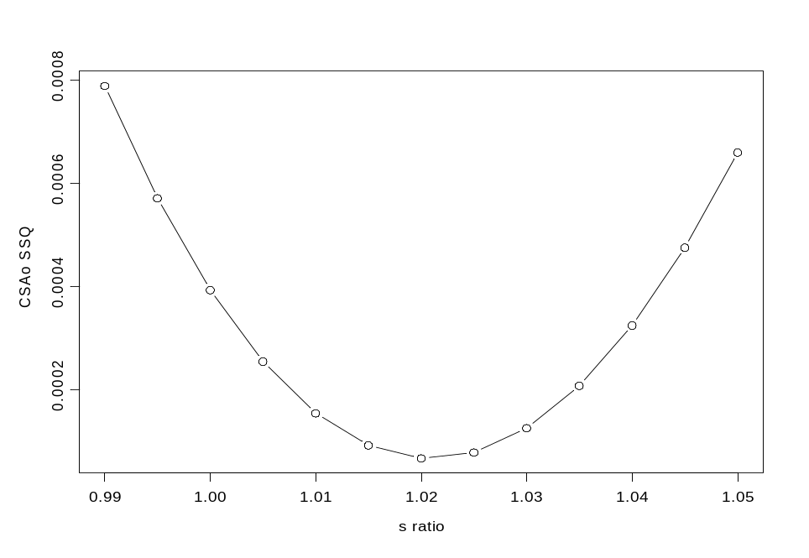

This procedure has the advantage of involving no subjective choice by users and of requiring no extra information than that contained in the basic CSA data. The latter can be viewed as a drawback, however, as one may feel uncomfortable with trusting a purely computational contrivance that does not refer to any feature of the actual survey and fishery.

In the CSAme program and in the Splus implementation of CSAo, a 'manual' version is proposed where users have to define the bounds and the step, and to adjust these over and over until they are satisfied that the s parameter is obtained with the desired accuracy. Then they proceed with the assessment. A more automatic version is proposed in Fortran versions of CSAo where the minimum is searched using the Brent algorithm (an elaborated bisection method); this enables the profiling procedure to be also included in the boostrap and retrospective analysis, where a different s is estimated for each (sub-)set. Users still need to provide the lower and upper bounds of the range, which also apply in the bootstrap and retrospective.

WARNINGs: Although this procedure (Option 1 in Section 3.1, Step 4) is proposed by default in CSAo.exe and proved to perform well with some simulated data sets, there is NO GUARANTEE that this yields the 'best' value (that is, providing estimates closest to the true stock states) in all cases, and it should never be used uncritically. It can fail badly, yielding extravagant stock size estimates, with some data sets that are too noisy or where the CSA assumptions (survey indices linearly related with abundance, stationarity in q, M as specified) are violated.
It is mostly useful to give you an idea of the likely magnitude of s, when you have no other clue, but the sensitivity of the assessment results to changes in s about the value obtained with this procedure should be systematically checked, by re-running the program with various imposed s (option 2 in Step 4).
Also remember that this procedure can only provide one estimate of s for the whole time series, whereas s does actually vary with time (and you cannot know the extent nor the pattern), even when your survey protocol did not change, due to changes in the structure of the underlying population when recruitment and fishing pressure vary.

More work is needed to understand how and why the s obtained with this procedure varies when some data that have nothing to do with the survey (M, catches) are altered.

Appendix B: Derivatives of the objective function used in all-observation-error
approach (CSAo)

At present, in both the Fortran and S+ implementations of CSA, parameters are estimated by iteratively searching the minimum of a sum-of-squared-residuals objective function using a Marquardt non-linear minimisation algorithm. This involves computing at each step the gradient of the function, that is the matrix (Jacobian) of first derivatives of the function relative to the parameters. Some library routines make life easier by computing an approximation of the Jacobian numerically (changing each parameter in turn with a tiny offset). However, providing analytical derivatives explicitly may be of interest, e.g. to speed up the minimisation or for estimating approximate variances and covariances of the parameters. This appendix documents the development of the analytical derivatives.

B.1. Residuals

In the all-observation-error approach, it is assumed that the dynamics equation applies exactly and that errors only arise in the measurement of population size through the survey indices (Eq. [2] and [3]). The objective function to be minimised is:
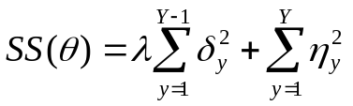 [A1]
where λ is the (user defined) weight of the observation error on recruits δ, relative to the observation error on the fully-recruited η, and θ is the set of parameters. Summation in the first RHS term only runs to Y-1 because the recruits index in the terminal year is not considered. The "primary" parameters that are estimated are: the post-recruits catchability q, the recruits abundance in all years but the last {R₁ … R_{Y-1}}, and the post-recruits abundance in the first year N₁ (thus, Y+1 parameters). Stock sizes of post-recruits in years 2 to Y are derived from the parameters using the CSA dynamics equation [1].

In practice, the NLLS routines used in the Fortran program CSAo and by the S+ function nlregb() do not deal with the sum of squares [A1] directly, but rather need to be provided with the vector of individual residual terms (noted V with subscript k), and the Jacobian is formed with the derivatives of these terms wrt the parameters. The residuals are the (possibly weighted) deviations between observed and model-predicted abundance indices, on log scale, that is, for the first Y-1 terms relative to recruits indices:
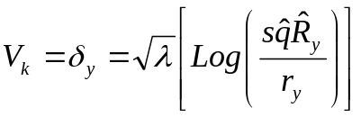 ; k= y= 1,Y-1
and for the next Y terms relative to post-recruits indices:
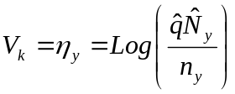 ; k= y+Y-1; y= 1,Y
where hats denote the estimates of parameters in each iteration.

Derivatives

For the first group of residuals, the general form of the derivatives wrt the i^{th} parameter, after cancelling constants, is:
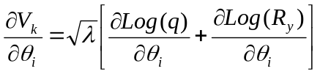 ; k= 1,Y-1 [A2]
and for the second group:
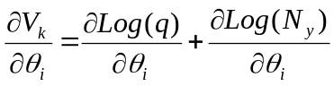 ; k= Y,2Y-1 [A3]

As can be seen, the derivatives of Log(q) apply to all terms. There are thus two variants, depending on whether q is searched by the NLLS routine (the general case), or computed based on the "current" estimates of abundance (only possible in the all-observation-error case). The former case is simpler and will be considered first. In this illustration, it will be supposed that there are four years of data (Y= 4) since this is sufficient to set up the recursions for cases with longer time series.

B.2. Case 1: q searched – M constant

With Y= 4 we have 7 residual terms and 5 parameters (R₁, R₂, R₃, N₁ and q). Consider first the Y-1 (3 here) residual terms relative to recruits indices. Individual elements in [A2] are:
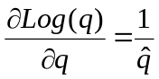 ; and = 0 for derivatives in all other parameters;

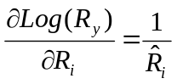 when i= y (along the "diagonal"), and = 0 otherwise;

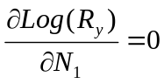

Now, for the 4 remaining residuals relative to post-recruits, the derivatives of Log(q) are as above, and the derivatives of the second summand in [A3] involve derivation of the dynamics equation [1], using the general formula for logarithmic derivatives:
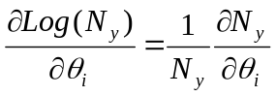

With constant M, the notation can be simplified by writing exp(-M) = S, the survival rate. Individual bits are:
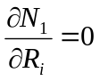 for all i ; 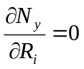 for all y ≥ i ; 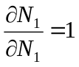
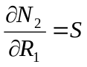 ; 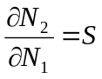
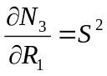 ; 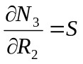 ; 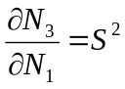
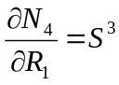 ; 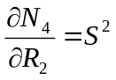 ; 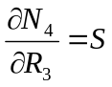 ; 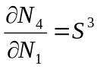
and so on in cases with more data years.

Finally, the Jacobian looks like this (with residual terms in rows, and parameters in columns):

θ_{i} \ V_{k} | R₁ | R₂ | R₃ | N₁ | q
V₁ | 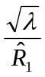 | 0 | 0 | 0 | 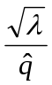
V₂ | 0 | 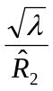 | 0 | 0
V₃ | 0 | 0 | 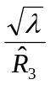 | 0
V₄ | 0 | 0 | 0 | 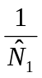 | 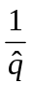
V₅ | 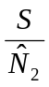 | 0 | 0
V₆ | 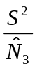 | 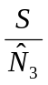 | 0
V₇ | 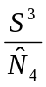 | 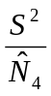 | 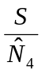

It is straightforward to extend this template when dealing with longer time series. Note that for terms V₅-V₇ (rank k= Y+1 to last in general) the derivative in N₁ is equal to the derivative in R₁ (first column). Here N₂-N₄ have been, perhaps abusively, noted with a hat although they are not parameters, to indicate that they are the values estimated in the current iteration from the actual parameters through equation [1]. Also note that the catch data and the assumed catchability ratio s do not appear explicitly in the derivatives, in contrast with the assumed M (through S), but of course they affect the estimates of N_{y}.

Unfortunately, this simpler variant where q is searched cannot be used to estimate variances. Under S+, both the solve(t(J) %*% J) function using the analytical Jacobian, and the MASS library function vcov.nlregb(), which computes a numerical approximation to J when no explicit gradient matrix is provided, return an error ("apparently singular matrix"), and the generalised matrix inversion function ginverse() gives unrealistic covariances. It is not immediately apparent why this singularity occurs and is likely due to q being a function of the other parameters as is made explicit in the computed q version. Anyway, this leaves the more complicated variant with q computed as the only operational option to avoid this problem. Note that the CSA stock estimates obtained with either variant are strictly identical.

B.3. Case 2: q computed – M constant

An advantage of the all-observation-error approach as implemented here is that the stock abundance by stage is "known" (estimated directly) for each year in each iteration, and the indices are also known (input data). Hence, we can get an estimate of catchability q in each year by the ratio [index/abundance], and an overall estimate for the time series by averaging the annual estimates (geometric mean, consistent with the assumed error structure). This removes one parameter from the NLLS search, which can potentially improve the performance (speed and stability) of the search.

Things are slightly complicated by the fact that recruits also contribute to the estimate of q, which needs to be accounted for. The maximum-likelihood equation for q is:
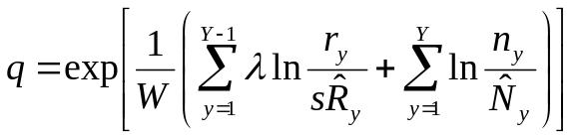 [7]
where W is the sum of weights, that is W= [(Y-1)*λ + Y*1] in the case where no index data is missing (otherwise, discount the weight, λ or 1, whenever an index is missing).

The real complication here is that q is a function of all parameters, which makes the elaboration of the term in Log(q) in [A2] or [A3] somewhat more tedious. The derivation of this term is exemplified here by looking at the first few steps which set up the scheme to be used incrementally when there are more parameters. The example still considers Y= 4.

For derivatives in R_{i}, i= 1,Y-1:
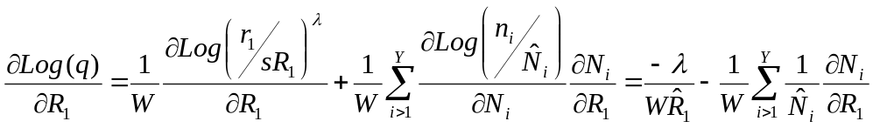 , that is:
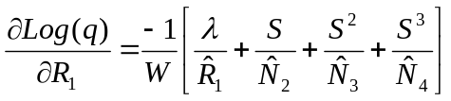

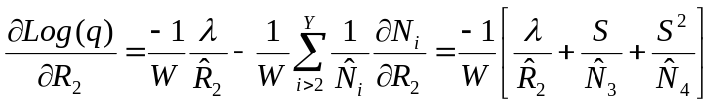

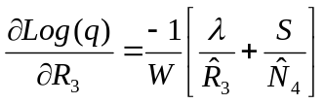

and for the derivative in N₁:
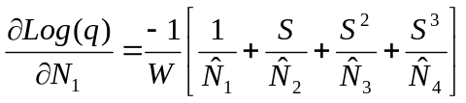

Elements in [A2] and [A3] can now be gathered into the Jacobian which looks like this (where "dLq" stands for δLog(q) to simplify the notation; also note that q has been removed from the set of explicit parameters):

θ_{i} \ V_{k} | R₁ | R₂ | R₃ | N₁
V₁ | 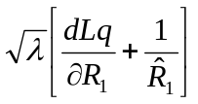 | 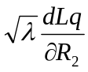 | 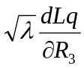 | 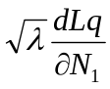
V₂ | 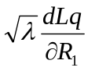 | 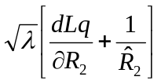
V₃ |  |  | 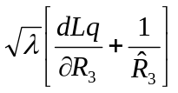
V₄ | 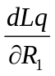 | 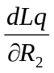 | 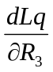 | 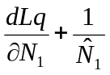
V₅ | 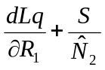 |  |  | 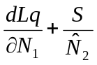
V₆ | 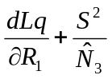 | 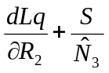 |  | 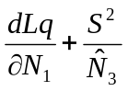
V₇ | 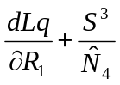 | 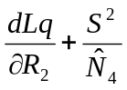 | 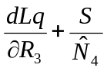 | 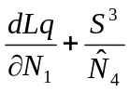

Here again, the catches and the catchability ratio s do not appear explicitly.

B.4. Case 3: M variable over time

Letting M vary by year should only be considered when there is good justification based on appropriate experiments. CSA is mostly designed for data-limited cases and it would be uncommon to have hard data about M but insufficient data for 'normal' assessments. Thus, this case is mostly relevant for comparisons with VPA assessments that assume variable M. Moreover, this development was needed for the S+ version which handles M as a vector: otherwise, users playing with changes in M would have got erroneous results. Yet, no allowance is made for M to vary by stage.

The simple rule involving increasing powers of S is no longer applicable and has to be replaced by the formulas:
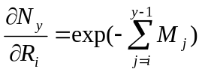 and
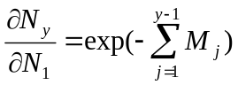for y>1, or = 1 when y= 1
in computing both the derivatives of Log(q) and the 'lower triangle'. For example:
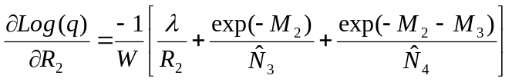
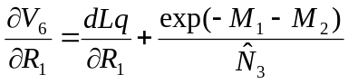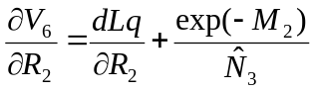
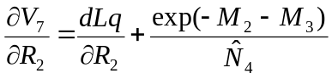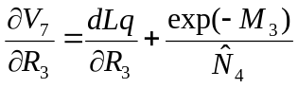
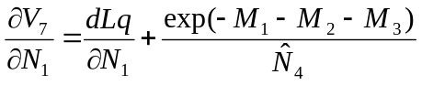 (last column)
and so on.

B.5. Remarks

The current Fortran versions of CSAo in Unix and Windows allow for variable M with time and implement the derivatives as described in B.4. The Marquardt minimisation routine now uses the analytical Jacobian passed by the routine computing the objective function, which has resulted in much faster runs compared to earlier version involving numeric derivatives (particularly in bootstrap coupled with s searched). Further savings are due to tabulating the various exp(-cumM) once for all in the main program, before any call to the minimisation, since these factors only depend on the input Ms. This avoids invoking a lot of exponentials in each iteration.

The issue is less obvious for the S+ (or R) versions. The derivatives involve a number of loops and (together with the objective function) would be computed in slow interpreted language over a number of iterations. In most CSA applications, with typically 10-20 years of data, it is probably more efficient to let the non-linear regression function (nlregb or ms) compute numerical derivatives for which it calls a much faster compiled code. Nevertheless, the derivatives in B.4 have been implemented in the CsjacGM.f function returning the Jacobian used to compute the covariances: it is called only once, after the fit is completed, which makes run time less of a concern.

The analytical derivatives tabulated above have been validated against the numerical Jacobians returned by the Netlib/minpack Marquardt routine Lmdif on a few examples. In S+, for the computed q variant, the covariances estimated with the command:
solve(t(J) %*% J) * SSQ/df
using the analytical Jacobian returned by CsjacGM.f are identical to those estimated by Venables & Ripley's MASS library function vcov.nlregb() involving a numerical computation of the Jacobian, provided that the number of degrees of freedom assumed in the former is taken to be:
df= # of residual terms - # of searched parameters
that is Y-1. This accounts for the fact that an additional equation is provided (for q) which releases an extra df compared to the case where q is searched.

Appendix C: Derivatives of the objective function in the mixed-error
approach (CSAme)

The background for this variant is presented in Section 2.2. Here, computing q is not an option and we will deal directly with the case where M can vary by year.

C.1. Residuals

The objective function [6] comprises 3 types of (squared) residuals that we will consider here in this order:
- Observation errors on recruits indices:
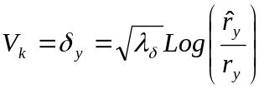 k= y= 1,Y-1
- Observation errors on fully-recruited indices:
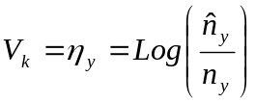 k= y+Y-1; y= 1,Y
- Process errors, for k= y+2Y-2; y= 2,Y:
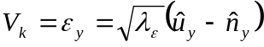 if additive or
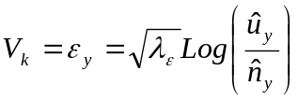 if multiplicative,
where 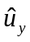 is the fully-recruited index for year y predicted by Eq. [5], given the parameters 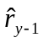, 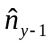 and q as estimated in the 'current' iteration.

C.2. Derivatives

Derivation of the observation-error residuals is pretty straightforward. We have:
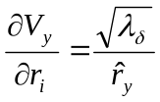 for i= y (y= 1, Y-1), and = 0 for all other i's and all other parameters;
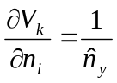 for i= y, and = 0 for all other i's and all other parameters.
That is, the upper part of the Jacobian is full of zeroes, except the diagonal, and likewise for the column in q.

For multiplicative process errors, the general form is:
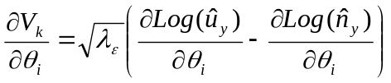
where is a function of q and of the parameters and .

Thus, for y= 2,Y and k= y+2Y-2, we have:
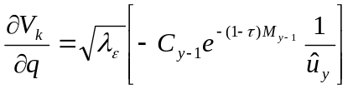
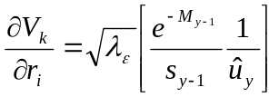 for i= y-1 and = 0 otherwise
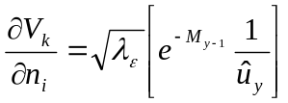 for i= y-1 and = 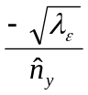 for i= y, and = 0 otherwise.

In the case of additive process errors, the factor 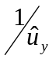in the square brackets disappears, and the derivative wrt the 'current' n (i= y) is simply 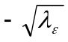.

Overall, the layout of the Jacobian can be illustrated as follows, considering a short example with Y= 4 years of data as in Appendix B:

θ_{i} \  V_{k} | q | r₁ | r₂ | r₃ | n₁ | n₂ | n₃ | n₄
1 | 0 | 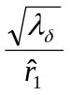 | 0 | 0 | 0 | 0 | 0 | 0
2 | 0 | 0 | 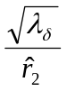 | 0 | 0 | 0 | 0 | 0
3 | 0 | 0 | 0 | 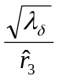 | 0 | 0 | 0 | 0
4 | 0 | 0 | 0 | 0 | 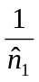 | 0 | 0 | 0
5 | 0 | 0 | 0 | 0 | 0 | 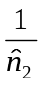 | 0 | 0
6 | 0 | 0 | 0 | 0 | 0 | 0 | 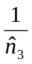 | 0
7 | 0 | 0 | 0 | 0 | 0 | 0 | 0 | 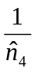
8 | 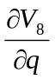 | 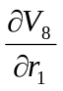 | 0 | 0 | 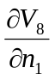 | 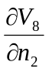 | 0 | 0
9 | 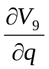 | 0 | 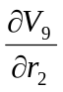 | 0 | 0 | 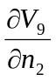 | 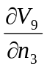 | 0
10 | 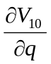 | 0 | 0 | 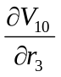 | 0 | 0 | 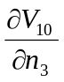 | 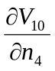

where terms V₈ to V₁₀ refer to process error residuals (years 2 to 4). The associated derivatives are given in their generic form since they differ depending on the form of the process errors (use equations at the top of this page)

C.3. Remarks

It is apparent in the layout above that the Jacobian in this case has rather few non-zero elements, and these involve simple expressions. Gains in computation speed were thus expected, and the CSAme programs in both Fortran and S-plus were modified to provide analytical derivatives to the minimisation routines.

However, the Fortran CSAme program lets users choose between mixed-error or all-observation-error structures, and the latter option had to be accommodated properly. The derivatives proved to be rather complex, involving terms in exp(-cumM) similar to those presented in B.4 and in exp(-(1-τ)M). They are too cumbersome to be detailed here (interested readers can perhaps read from the source code). Here again, these constants in M are tabulated once for all early in the program to speed up computations.

The analytical jacobians were validated against numerical derivatives computed by the Lmdif routine for various combinations of M, τ or error weightings and forms. This revealed a strange behaviour of the CSjacME.f function implemented in the S-plus version: small differences were observed, but only for the derivative wrt the same year's n parameter, which are fairly trivial expressions; these differences were not systematic since they did not affect all terms of that derivative, for a given data set, and disappeared with other sets and/or settings. The evidence of a problem was most conspicuous in the message returned by nlregb() which indicated 'false convergence' with the problematic sets. No reason was found for this behaviour and, by precaution, the option to use the explicit jacobian in the call to nlregb() was removed in the standard script. As indicated in Section 5.3, it is easy for curious users to try it and see what happens with their data. Still, CSjacME.f can be called at the end to estimate variances and CV's of the parameters; these are approximate anyway, and even with the problematic sets they were fairly close to those returned by Venables & Ripley's function.

Appendix D: Summary of methods' specifications.

Program | CSAo
Version | April 2004
Model type | Two-stage Collie-Sissenwine (1983)
Data needs | Total catches (in number); "survey" indices in number by stage; natural mortality M; timing of catch in year. Mean weights by stage, to convert stock numbers to biomass.
Input settings | Ratio of recruits to post-recruits survey catchability; relative weight of measurement errors on recruits; timing of catch in year.
Catchability | Only considers catchability in survey (not in fishery). Post-recruits catchability assumed constant in time series. Catchability of recruits is a set fraction of that of post-recruits.
Estimated parameters | Stock size of recruits in all years except the last; stock size of fully recruited in first year; fully-recruited catchability (computed as GM), i.e. Y+1 parameters if Y years of data. Optionally, recruits to post-recruits catchability ratio s.
Estimation approach | Non-linear least squares. Only considers measurement errors on indices, assumed log-normal. Process errors are ignored.
Objective function | Weighted sum (user defined weights) of 2 sums of squared log-residuals between model-predicted and observed survey indices, one for recruits, the other for post-recruits.
Minimisation | Marquardt-Levenberg, with explicit derivatives (not in S+). Brent algorithm for s ratio search (manual in S+).
Variance estimates/ uncertainty | Non-parametric model-conditioned bootstrap: residuals from base run drawn randomly and added to fitted indices, for each stage independently. Table of percentiles produced for biomasses and q; no bias correction (yet) on percentiles.  Retrospective analysis. Approx. Variances & CVs based on Jacobian.
Other issues | Trials on simulated and real data indicate that absolute estimates of stock size are mostly sensitive to the assumed ratio of recruits catchability (s) which has to be set by users based on external information and analyses, but trends are weakly sensitive to s.  Estimates weakly sensitive to weights of error sources in objective function.  Estimated q negatively correlated with assumed M.  Performance degrade, even for trends, when indices too noisy.  Unaccounted trends in survey q result in biased stock size estimates.
Language | Fortran (Unix & Windows); Splus; both in double precision.
Restrictions | Handles maximum of 25 data years (takes 25 last if more in input file) and only one "fleet" for survey (or cpue) indices; M can vary by year but same for both stages; at least 10 years of data in retrospective analyses; missing indices allowed (albeit in small number).  No bootstrap nor retrospective in S+ version.
History | - V1 (June 2002): based on del2m; q computed as GM  - V2 (January 2004): profile s with Brent  - V3 (April 2004): analytical derivatives; parameters' variance & CV; variable M.

Program | CSAme / del2s
Version | April 2004
Model type | Two-stage Collie-Sissenwine (1983)
Data needs | Total catches (in number); "survey" indices in number by stage; natural mortality M; timing of catch in year. Mean weights by stage, to convert stock numbers to biomass.
Input settings | Ratio of recruits to post-recruits survey catchability; relative weights of measurement errors on recruits and of process errors; timing of catch in year.
Catchability | Only consider catchability in survey (not in fishery). Post-recruits catchability assumed constant in time series. Catchability of recruits is a set fraction of that of post-recruits.
Estimated parameters | Recruits indices in all years but the last; fully-recruited indices in all years; fully-recruited catchability, i.e. 2Y parameters if Y years of data.
Estimation approach | Non-linear least squares. Consider both measurement errors on indices, assumed log-normal, and process errors assumed normal or log-normal; users can choose to ignore the latter.
Objective function | Weighted sum (user defined weights) of 3 sums of squared log-residuals between model-predicted and observed survey indices, one for recruits, one for fully-recruited, and one for process error terms.
Minimisation | Marquardt-Levenberg with analytical derivatives (or Nelder-Mead simplex with quadratic extension in del2s).
Variance estimates/ uncertainty | Approximate CV of parameters based on the Jacobian (Hessian in del2s).  Non-parametric model-conditioned bootstrap: residuals from base run drawn randomly, for each error source independently, and added to fitted indices. Table of percentiles produced for biomasses and q; no bias correction (yet) on percentiles.  Retrospective analysis.
Other issues | Trials on simulated and real data indicate that absolute estimates of stock size are mostly sensitive to the assumed ratio of recruits catchability (s) which has to be set by users based on external information and analyses, but trends are weakly sensitive to s.  Estimates weakly sensitive to weights of error sources in objective function.  Estimated q negatively correlated with assumed M.  Performance degrade, even for trends, when indices too noisy.  Unaccounted trends in survey q result in biased stock size estimates.
Language | Fortran (Unix & Windows); Splus; both in double precision.
Restrictions | Handles maximum of 25 data years (takes 25 last if more in input file) and only one "fleet" for survey (or cpue) indices; M can vary by year but same for both stages; at least 10 years of data in retrospective analyses. Missing indices not allowed.  No bootstrap nor retrospective in S+ version.
History | - V1 (January 2002): minimisation by simplex (delurys), then Marquardt (delurym); bootstrap & retrospective; choice all-observation error added (-> del2m/s).  - V2 (April 2004): manual s profiling; variable M  - V3 (CSAme, April 2004): analytical derivatives; parameters' variance & CV

The acronym CSA may also stand for Collie-Sissenwine Analysis. However, Jeremy Collie himself calls it Catch-Survey Analysis and we keep on with this usage. Another synonym used at times is 'modified DeLury method'.
"Survey" is used in its broad sense here; indices can be CPUEs of a well-behaved, properly standardised subset of a commercial fishing fleet.
E-mail contact: Benoit.Mesnil@ifremer.fr
The .exe have been produced with a Watcom v.11 compiler which is now freely available on the Web.
Use under Linux has not been tried yet but the instructions should be valid for this OS as well. Also, compilation with the GNU compiler g77 still has to be tested.
New format as of March 2004; earlier data files should be edited with an M column appended.
Arbitrarily limited to less than 30% of the number of data years.
Not implemented yet.
There is no difference between q computed as AM or GM, nor between q searched (in del2m) or computed with this formula (in CSAo).
This terminal R value can be overwritten, e.g. for catch forecasts, using all possible recipes normally used with VPA assessments (GM, AM, shrunk estimate, etc.).
In this section values entered by users are shown in bold italics typeface.
Messages mentioning the Brent algorithm refer to this s search procedure.
'Hard coded' for the moment, which may not be ideal, but this has always worked well so far.
Possibly with some editing in order to squeeze the output within a page width. The heading section of the output file (title, date, settings, etc.) has been omitted.
You may want to overwrite this default value by e.g. recent or long-term mean recruitment etc., just as in usual VPA assessments.
del2s provides approximate standard error and CV of the parameters based on the Hessian matrix, computed by the quadratic extension of the simplex algorithm, assuming linearity in the vicinity of the solution.
You may get slightly different values than those shown here, depending on how many bootstrap runs you made previously in the same session, implying different random number sequences.
In versions > summer 2003, the CSest objects include the M and tau values used in the fit which no longer need to be passed as arguments to CSforin.f.
The literature concerning CSA is fairly small. This list nearly exhausts what is publicly available.
If the profiling procedure is considered as a valid way of estimating s, then it is correct to use it in the bootstrap and retrospective as well. The fixed-s version which is the only possibility offered in CSAme should be replaced if agreement is reached on this issue.
Equations already seen in Section 2 of this manual are referenced by their number in that Section and are not repeated. 'Local' equations are noted [A#].
Note that if ms was used, this would require a vector of squared residuals, and the derivatives above would need to be amended accordingly (2*V*V').
See Venables & Ripley 1999, p. 245 or 264 for comparisons on cases with very few parameters.

