Vrh obrazca

Dno obrazca

Vrh obrazca

Dno obrazca

**Bash tips: Colors and formatting (ANSI/VT100 Control sequences)**

The **ANSI/VT100** terminals and terminal emulators are not just able to display black and white text ; they can display **colors** and formatted texts thanks to **escape sequences**. Those sequences are composed of the **Escape character** (often represented by “^[” or “<Esc>”) followed by some other characters: “<Esc>[*FormatCode*m”.

In Bash, the <Esc> character can be obtained with the following syntaxes:

* \e
* \033
* \x1B

*Examples:*

|  |  |
| --- | --- |
| **Code (Bash)** | **Preview** |
| echo -e "\e[31mHello World\e[0m" | Hello World |
| echo -e "\033[31mHello\e[0m World" | Hello World |

*NOTE¹:* The -e option of the echo command enable the parsing of the escape sequences.

*NOTE²:* The “\e[0m” sequence removes all attributes (formatting and colors). It can be a good idea to add it at the end of each colored text. ;)

*NOTE³:* The examples in this page are in **Bash** but the **ANSI/VT100** escape sequences can be used in every programming languages.

**Formatting**

Here are the most commonly supported control sequences for formatting text. Their support depends on the used terminal ([see the compatibility list](https://misc.flogisoft.com/bash/tip_colors_and_formatting#terminals_compatibility)).

**Set**

|  |  |  |  |
| --- | --- | --- | --- |
| **Code** | **Description** | **Example** | **Preview** |
| 1 | Bold/Bright | echo -e "Normal \e[1mBold" | Normal Bold |
| 2 | Dim | echo -e "Normal \e[2mDim" | Normal Dim |
| 4 | Underlined | echo -e "Normal \e[4mUnderlined" | Normal Underlined |
| 5 | Blink 1) | echo -e "Normal \e[5mBlink" | Normal Blink |
| 7 | Reverse (invert the foreground and background colors) | echo -e "Normal \e[7minverted" | Normal inverted |
| 8 | Hidden (useful for passwords) | echo -e "Normal \e[8mHidden" | Normal Hidden |

**Reset**

|  |  |  |  |
| --- | --- | --- | --- |
| **Code** | **Description** | **Example** | **Preview** |
| 0 | Reset all attributes | echo -e "\e[0mNormal Text" | Normal Text |
| 21 | Reset bold/bright | echo -e "Normal \e[1mBold \e[21mNormal" | Normal Bold Normal |
| 22 | Reset dim | echo -e "Normal \e[2mDim \e[22mNormal" | Normal Dim Normal |
| 24 | Reset underlined | echo -e "Normal \e[4mUnderlined \e[24mNormal" | Normal Underlined Normal |
| 25 | Reset blink | echo -e "Normal \e[5mBlink \e[25mNormal" | Normal Blink Normal |
| 27 | Reset reverse | echo -e "Normal \e[7minverted \e[27mNormal" | Normal inverted Normal |
| 28 | Reset hidden | echo -e "Normal \e[8mHidden \e[28mNormal" | Normal Hidden Normal |

**8/16 Colors**

The following colors works with most terminals and terminals emulators 2), [see the compatibility list](https://misc.flogisoft.com/bash/tip_colors_and_formatting#terminals_compatibility) for more informations.

*NOTE:* The colors can vary depending of the terminal configuration.

**Foreground (text)**

|  |  |  |  |
| --- | --- | --- | --- |
| **Code** | **Color** | **Example** | **Preview** |
| 39 | Default foreground color | echo -e "Default \e[39mDefault" | Default Default |
| 30 | Black | echo -e "Default \e[30mBlack" | Default Black |
| 31 | Red | echo -e "Default \e[31mRed" | Default Red |
| 32 | Green | echo -e "Default \e[32mGreen" | Default Green |
| 33 | Yellow | echo -e "Default \e[33mYellow" | Default Yellow |
| 34 | Blue | echo -e "Default \e[34mBlue" | Default Blue |
| 35 | Magenta | echo -e "Default \e[35mMagenta" | Default Magenta |
| 36 | Cyan | echo -e "Default \e[36mCyan" | Default Cyan |
| 37 | Light gray | echo -e "Default \e[37mLight gray" | Default Light gray |
| 90 | Dark gray | echo -e "Default \e[90mDark gray" | Default Dark gray |
| 91 | Light red | echo -e "Default \e[91mLight red" | Default Light red |
| 92 | Light green | echo -e "Default \e[92mLight green" | Default Light green |
| 93 | Light yellow | echo -e "Default \e[93mLight yellow" | Default Light yellow |
| 94 | Light blue | echo -e "Default \e[94mLight blue" | Default Light blue |
| 95 | Light magenta | echo -e "Default \e[95mLight magenta" | Default Light magenta |
| 96 | Light cyan | echo -e "Default \e[96mLight cyan" | Default Light cyan |
| 97 | White | echo -e "Default \e[97mWhite" | Default White |

**Background**

|  |  |  |  |
| --- | --- | --- | --- |
| **Code** | **Color** | **Example** | **Preview** |
| 49 | Default background color | echo -e "Default \e[49mDefault" | Default Default |
| 40 | Black | echo -e "Default \e[40mBlack" | Default Black |
| 41 | Red | echo -e "Default \e[41mRed" | Default Red |
| 42 | Green | echo -e "Default \e[42mGreen" | Default Green |
| 43 | Yellow | echo -e "Default \e[43mYellow" | Default Yellow |
| 44 | Blue | echo -e "Default \e[44mBlue" | Default Blue |
| 45 | Magenta | echo -e "Default \e[45mMagenta" | Default Magenta |
| 46 | Cyan | echo -e "Default \e[46mCyan" | Default Cyan |
| 47 | Light gray | echo -e "Default \e[47mLight gray" | Default Light gray |
| 100 | Dark gray | echo -e "Default \e[100mDark gray" | Default Dark gray |
| 101 | Light red | echo -e "Default \e[101mLight red" | Default Light red |
| 102 | Light green | echo -e "Default \e[102mLight green" | Default Light green |
| 103 | Light yellow | echo -e "Default \e[103mLight yellow" | Default Light yellow |
| 104 | Light blue | echo -e "Default \e[104mLight blue" | Default Light blue |
| 105 | Light magenta | echo -e "Default \e[105mLight magenta" | Default Light magenta |
| 106 | Light cyan | echo -e "Default \e[106mLight cyan" | Default Light cyan |
| 107 | White | echo -e "Default \e[107mWhite" | Default White |

**88/256 Colors**

Some terminals ([see the compatibility list](https://misc.flogisoft.com/bash/tip_colors_and_formatting#terminals_compatibility)) can support 88 or 256 colors. Here are the control sequences that permit you to use them.

*NOTE¹*: The colors number 256 is only supported by **vte** (GNOME Terminal, XFCE4 Terminal, Nautilus Terminal, Terminator,…).

*NOTE²*: The 88-colors terminals (like **rxvt**) does not have the same color map that the 256-colors terminals. For showing the 88-colors terminals color map, run the “[256-colors.sh](https://misc.flogisoft.com/bash/tip_colors_and_formatting#colors2)” script in a 88-colors terminal.

**Foreground (text)**

For using one of the 256 colors on the foreground (text color), the control sequence is “<Esc>[38;5;*ColorNumber*m” where ColorNumber is one of the following colors:

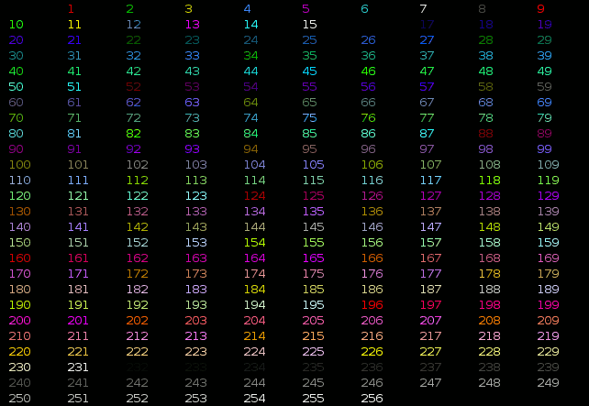

*Examples:*

|  |  |
| --- | --- |
| **Code (Bash)** | **Preview** |
| echo -e "\e[38;5;82mHello \e[38;5;198mWorld" | Hello World |
| for i in {16..21} {21..16} ; do echo -en "\e[38;5;${i}m#\e[0m" ; done ; echo | Blue gradiant |

**Background**

For using one of the 256 colors on the background, the control sequence is “<Esc>[48;5;*ColorNumber*m” where ColorNumber is one of the following colors:

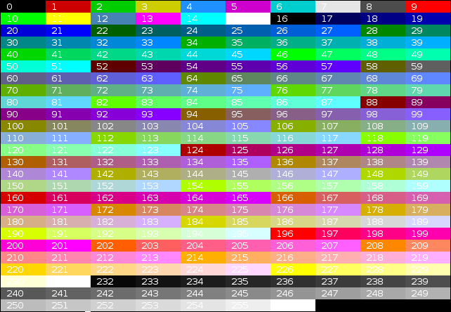

*Examples:*

|  |  |
| --- | --- |
| **Code (Bash)** | **Preview** |
| echo -e "\e[40;38;5;82m Hello \e[30;48;5;82m World \e[0m" | Hello World |
| for i in {16..21} {21..16} ; do echo -en "\e[48;5;${i}m \e[0m" ; done ; echo | Blue gradiant |

**Attributes combination**

Terminals allow attribute combinations. The attributes must be separated by a semicolon (“;”).

*Examples:*

|  |  |  |
| --- | --- | --- |
| **Description** | **Code (Bash)** | **Preview** |
| Bold + Underlined | echo -e "\e[1;4mBold and Underlined" | Bold and Underlined |
| Bold + Red forground + Green background | echo -e "\e[1;31;42m Yes it is awful \e[0m" | Yes it is awful |

**Terminals compatibility**

|  |  |  |  |  |  |  |  |  |  |  |  |
| --- | --- | --- | --- | --- | --- | --- | --- | --- | --- | --- | --- |
| **Terminal** | **Formatting** | | | | | | **Colors** | | | | **Comment** |
| **Bold** | **Dim** | **Underlined** | **Blink** | **invert** | **Hidden** | **8** | **16** | **88** | **256** |
| [aTerm](http://www.afterstep.org/aterm.php) | ok | - | ok | - | ok | - | ok | ~ | - | - | Lighter background instead of blink. |
| [Eterm](http://www.eterm.org/) | ~ | - | ok | - | ok | - | ok | ~ | - | ok | Lighter color instead of Bold. Lighter background instead of blink. Can overline a text with the “^[[6m” sequence. |
| [GNOME Terminal](http://library.gnome.org/users/gnome-terminal/) | ok | ok | ok | ok | ok | ok | ok | ok | - | ok | Strikeout with the “^[[9m” sequence. |
| [Guake](http://guake.org/) | ok | ok | ok | ok | ok | ok | ok | ok | - | ok | Strikeout with the “^[[9m” sequence. |
| [Konsole](http://konsole.kde.org/) | ok | - | ok | ok | ok | - | ok | ok | - | ok |  |
| [Nautilus Terminal](https://github.com/flozz/nautilus-terminal) | ok | ok | ok | ok | ok | ok | ok | ok | - | ok | Strikeout with the “^[[9m” sequence. |
| [rxvt](http://rxvt.sourceforge.net/) | ok | - | ok | ~ | ok | - | ok | ok | ok | - | If the background is not set to the default color, Blink make it lighter instead of blinking. Support of italic text with the “^[[3m” sequence. |
| [Terminator](http://www.tenshu.net/terminator/) | ok | ok | ok | - | ok | ok | ok | ok | - | ok | Strikeout with the “^[[9m” sequence. |
| [Tilda](http://tilda.sourceforge.net/tildaabout.php) | ok | - | ok | ok | ok | - | ok | ok | - | - | Underline instead of Dim. Convert 256-colors in 16-colors. |
| [XFCE4 Terminal](http://www.xfce.org/projects/terminal) | ok | ok | ok | ok | ok | ok | ok | ok | - | ok | Strikeout with the “^[[9m” sequence. |
| [XTerm](http://invisible-island.net/xterm/xterm.html) | ok | - | ok | ok | ok | ok | ok | ok | - | ok |  |
| xvt | ok | - | ok | - | ok | - | - | - | - | - |  |
| Linux TTY | ok | - | - | - | ok | - | ok | ~ | - | - | Specials colors instead of Dim and Underlined. Lighter background instead of Blink, Bug with 88/256 colors. |
| [VTE Terminal](http://developer.gnome.org/vte/) 3) | ok | ok | ok | ok | ok | ok | ok | ok | - | ok | Strikeout with the “^[[9m” sequence. |

*Notations used in the table:*

* “ok”: Supported by the terminal.
* “~”: Supported in a special way by the terminal.
* “-”: Not supported at all by the terminal.

**Demonstration programs**

**Colors and formatting (16 colors)**

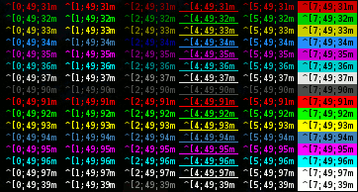

The following shell script displays a lot of possible combination of the attributes (but not all, because it uses only one formatting attribute at a time).

[colors_and_formatting.sh](https://misc.flogisoft.com/_export/code/bash/tip_colors_and_formatting?codeblock=55)

#!/bin/bash

# This program is free software. It comes without any warranty, to

# the extent permitted by applicable law. You can redistribute it

# and/or modify it under the terms of the Do What The Fuck You Want

# To Public License, Version 2, as published by Sam Hocevar. See

# http://sam.zoy.org/wtfpl/COPYING for more details.

#Background

for clbg in {40..47} {100..107} 49 ; do

#Foreground

for clfg in {30..37} {90..97} 39 ; do

#Formatting

for attr in 0 1 2 4 5 7 ; do

#Print the result

echo -en "\e[${attr};${clbg};${clfg}m ^[${attr};${clbg};${clfg}m \e[0m"

done

echo #Newline

done

done

exit 0

**256 colors**

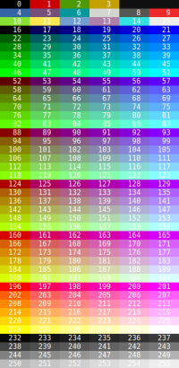

The following script display the 256 colors available on some terminals and terminals emulators like **XTerm** and **GNOME Terminal**.

[256-colors.sh](https://misc.flogisoft.com/_export/code/bash/tip_colors_and_formatting?codeblock=56)

#!/bin/bash

# This program is free software. It comes without any warranty, to

# the extent permitted by applicable law. You can redistribute it

# and/or modify it under the terms of the Do What The Fuck You Want

# To Public License, Version 2, as published by Sam Hocevar. See

# http://sam.zoy.org/wtfpl/COPYING for more details.

for fgbg in 38 48 ; do # Foreground / Background

for color in {0..255} ; do # Colors

# Display the color

printf "\e[${fgbg};5;%sm %3s \e[0m" $color $color

# Display 6 colors per lines

if [ $((($color + 1) % 6)) == 4 ] ; then

echo # New line

fi

done

echo # New line

done

exit 0