COL-216

ASSIGNMENT-1

Area under the curve

Made By

*Dishant Dhiman 2019CS10347*

*R Hari Shankar 2019CS10386*

**DESIGN DESCRIPTION**

We created a MIPS assembly program to calculate the area under the curve. We have used 16 registers each of whose function has been explained in the code as well.

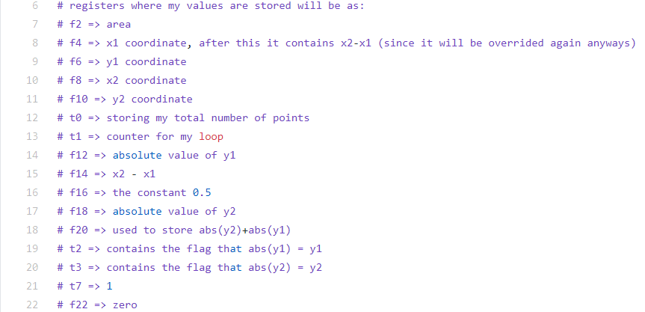

The area of the curve is stored in a double register. For calculating the area, we have relied on the area of trapezium between two points which can be always used if the adjacent y coordinates are both positive or both negative.

**Area of trapezium: abs{(½)*(xi-xi-1)*(yi-1+yi)}**

But if one is positive and the other is negative or vice-versa then we have to calculate the area of the two triangles formed at both side of x-axis.

**Sum of Area of both the triangles:**

**abs{(1/(2*(|yi-1|+|yi|)))*(xi-xi-1)*(yi-12+yi2)}**

The total area under curve will be the summation of areas for every coordinate according to the above cases.

We have used main label for taking the inputs from the console, the loop label is used for taking input of the next coordinate ,the area1 label is used to calculate area between the 2 adjacent coordinates when their Y coordinate have opposite signs ,the area2 label is used to calculate area between 2 adjacent coordinates when their Y coordinates have same sign ,the exit label is used print the output and to exit the program.

In each loop we replace x1,y1 with x2,y2 respectively and the next coordinates are taken as input for x2,y2.

*Comments have been added to the code to make it as easily readable and understandable as possible.*

**INPUT FORMAT**

The first line of each test case contains one integer n which is the number of coordinates of the curve.

The next 2*n contains the integers of the X and Y coordinate such that we take x and y coordinate on separate line.

FORMAT:

n

x0

y0

:

:

xn

yn

**OUTPUT FORMAT**

The output will be given in the form:

*The area computed is: area*

Where area is the area under the curve.

**TESTING STRATEGY**

To check the correctness of our code to solve the problem of finding the area under graph we have used exhaustive test cases so that our program runs correctly in all cases (including corner cases).

We have understood that our program should give correct result when:

1. All the y-coordinates are positive.
2. All the y-coordinates are negative.
3. Mix of positive and negative y-coordinates. (small and large testcase)
4. When n is small but coordinates are large.
5. When n and coordinates are large. (i.e. large area)

There will be some corner cases or exception cases as well like:

* When n=0 area is 0.
* When n=1 that is we have only 1 coordinate so area is 0.
* When two or more inputs have same X coordinate, then area will be calculated according to the order of the inputs.
* When we exceed the bounds of int or float for the input coordinates or the output area.

*All the testcases used to check correctness of program are given in the file testcases.txt.*

The expected outputs in the text file are generated using a CPP program and the smaller inputs were also verified manually while the larger test case like n=100 we relied on the CPP program .

