**R.Harini**

**18BCE1010**

1)

#include<stdio.h>

void main(){

int a[10],n,h=0,x;

printf("Enter n:");

scanf("%d",&n);

for (int i=0;i<n;i++){

scanf("%d",&a[i]);

}

if (n%2==0){

x=(n/2)+1;

}

else{

x=n/2;

}

for (int i=0;i<x;i++){

if (a[i]!=a[n-i-1]){

h++;

}

}

if (h!=0){

printf ("Not same");

}

else{

printf("Same");

}

}

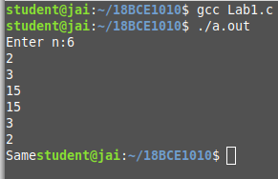

2)

#include<stdio.h>

void main(){

int a[10],a1[10],a2[10];

for (int i=0;i<10;i++){

scanf("%d",&a[i]);

}

for (int i=0;i<5;i++){

a1[i]=a[i];

}

int j=0;

for (int i=5;i<10;i++){

a2[j]=a[i];

j++;

}

printf("The output is: \n");

for (int i=0;i<5;i++){

printf("%d\t %d \n",a1[i],a2[i]);

}

}

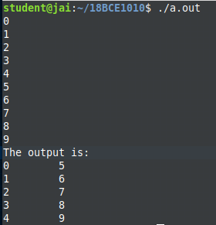

3)

#include<stdio.h>

void main(){

int n,x,y;

printf("Enter n:");

scanf("%d",&n);

printf ("Enter x and y:");

scanf("%d %d",&x,&y);

int a[n];

for (int i=0;i<n;i++){

scanf("%d",&a[i]);

}

printf("The output is: \n");

for (int i=x;i<y+1;i++){

printf("%d \n",a[i-1]);

}

}

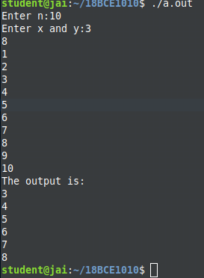

4)

#include<stdio.h>

void main(){

int n,sum;

printf("Enter n:");

scanf("%d",&n);

int a[n],b[n];

printf("Enter the elements of the array:");

for (int i=0;i<n;i++){

scanf("%d",&a[i]);

}

for (int i=0;i<n;i++){

sum=0;

for (int j=0;j<n;j++){

if(j==i){

continue;

}

else{

sum+=a[j];

}

}

printf("%d \t", sum);

}

}

