**R.Harini**

**18BCE1010**

a)

#include<stdio.h>

#include<string.h>

struct Employee{

int empno;

char e_name[50];

char designation[50];

int basicpay,hra,pa;

int netpay;

};

int Calc_Netpay(struct Employee e){

int netpay=e.basicpay+e.hra+e.pa;

//printf("The netpay is: %d \n",e.netpay);

return netpay;

}

void Check_Manager(struct Employee e){

if (strcmp(e.designation,"Manager")==0){

printf("Manager details: \n %d \n %s \n %s \n %d \n %d \n %d \n %d \n", e.empno, e.e_name, e.designation, e.basicpay, e.hra, e.pa, e.netpay );

}

}

void Check_netpay(struct Employee e){

if (e.netpay>200000){

printf("Employee details with high salary: \n %d \n %s \n %s \n %d \n %d \n %d \n %d \n",e.empno, e.e_name, e.designation, e.basicpay, e.hra, e.pa, e.netpay );

}

}

void Check_name(struct Employee e){

if (e.e_name[0]=='A'){

printf("Employee details whose name starts with A: \n %d \n %s \n %s \n %d \n %d \n %d \n %d \n",e.empno, e.e_name, e.designation, e.basicpay, e.hra, e.pa, e.netpay );

}

}

void main(){

struct Employee e[5];

for (int i=0;i<3;i++){

scanf("%d %s %s %d %d %d",&e[i].empno, e[i].e_name, e[i].designation, &e[i].basicpay, &e[i].hra, &e[i].pa );

e[i].netpay=Calc_Netpay(e[i]);

printf("The netpay is: %d \n",e[i].netpay);

}

for (int i=0;i<3;i++){

Check_Manager(e[i]);

}

for (int i=0;i<3;i++){

Check_netpay(e[i]);

}

for (int i=0;i<3;i++){

Check_name(e[i]);

}

}

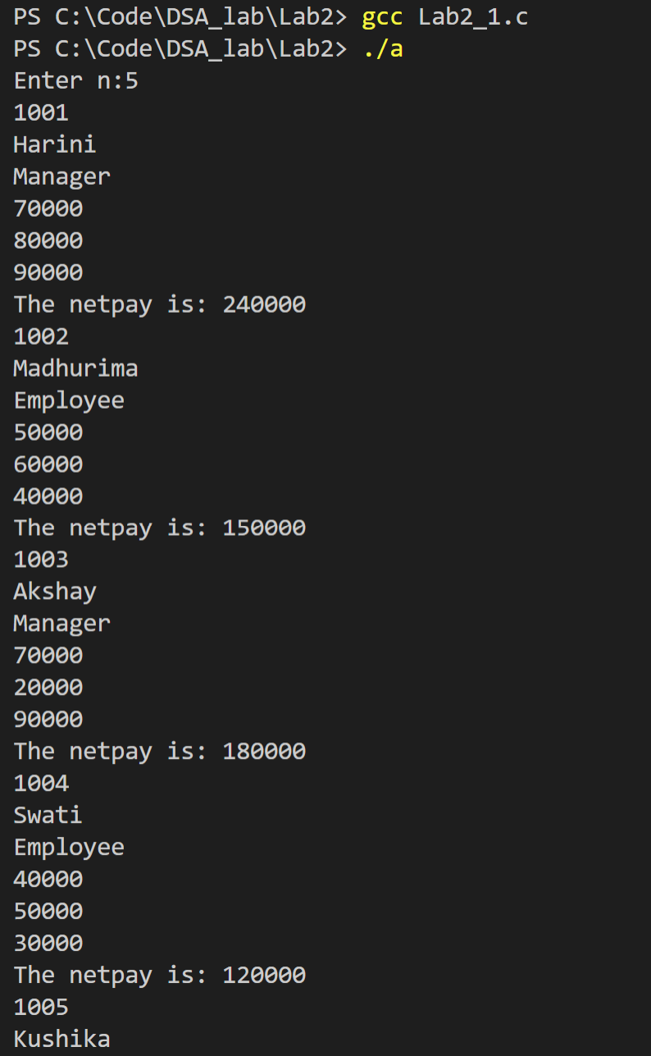

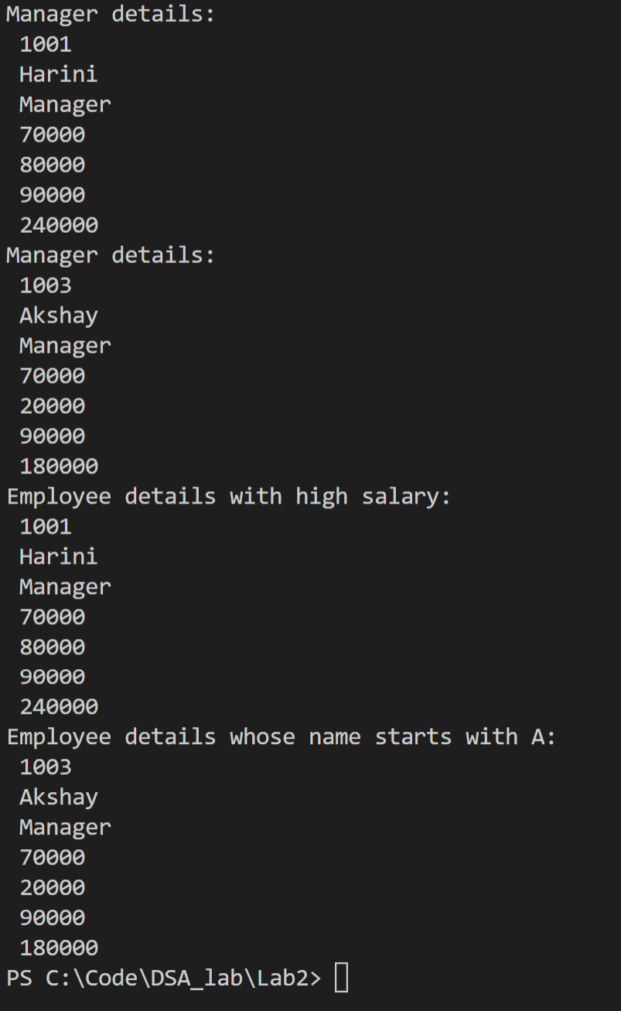

b)

#include<stdio.h>

#include<string.h>

struct Student{

int regno;

char name [50];

int n;

struct coursereg{

char subcode[10];

char subname[50];

char slot[50];

int cred;

}cr[10];

}s[10];

void List_Students(struct Student s){

printf("%d\n%s \n ", s.regno, s.name);

}

void main(){

for (int i=0;i<3;i++){

printf("Enter the student details:");

scanf( "%d %s %d", &s[i].regno, s[i].name, &s[i].n);

for (int j=0;j<s[i].n;j++){

printf(" Enter the subcode, subname, slot, credits:");

scanf ("%s %s %s %d", s[i].cr[j].subcode, s[i].cr[j].subname, s[i].cr[j].slot, &s[i].cr[j].cred);

}

}

printf("List of students\n");

for (int i=0;i<3;i++){

List_Students(s[i]);

//printf("%d\n%s \n ", s[i].regno, s[i].name);// s[i].cr.subcode, s[i].cr.subname, s[i].cr.slot, s[i].cr.cred);

}

char slot[10];

printf("Enter the slot to be searched:");

scanf("%s",slot);

for (int i=0;i<3;i++){

for (int j=0;j<s[i].n;j++){

if (strcmp(s[i].cr[j].slot,slot)==0){

printf("%d\n%s \n", s[i].regno, s[i].name); //s[i].cr.subcode, s[i].cr.subname, s[i].cr.slot, s[i].cr.cred);

}

}

}

int regno;

printf("Enter the regno:");

scanf("%d",&regno);

int cred=0,num;

for (int i=0;i<3;i++){

if (s[i].regno==regno){

for (int j=0;j<s[i].n;j++){

cred+=s[i].cr[j].cred;

}

printf("%d\n%s \n%d \n", s[i].regno, s[i].name, cred);

}

}

}

