***Lab 12***

***R. Harini***

***18BCE1010***

***ANALYSIS OF SAMPLE SUPER STORE DATASET WITH DASHBOARD AND STORY TELLING***

1. **Identify the average sales and profit in each country and find out maximum and minimum average sales and profit**

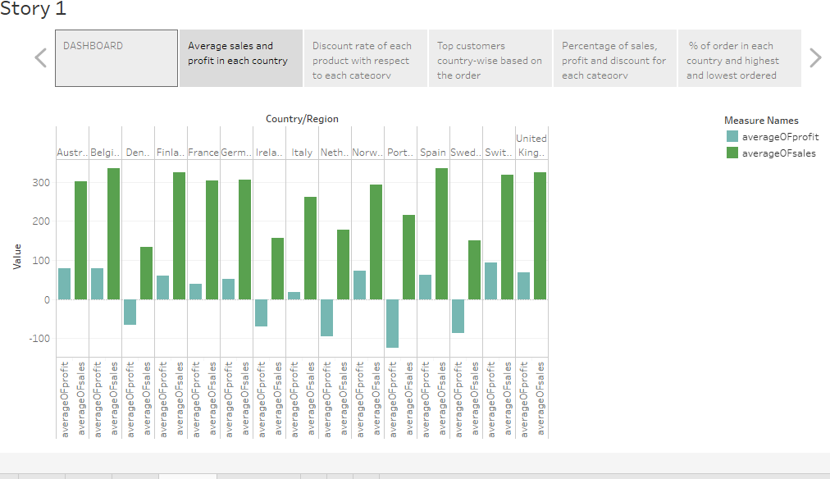

*Maximum average profit – Switzerland*

*Minimum average profit –Portugal*

*Maximum average sales – Belgium*

*Minimum average sales – Denmark*

1. **Identify the discount rate of each product with respect to each category using Tree map visualization**

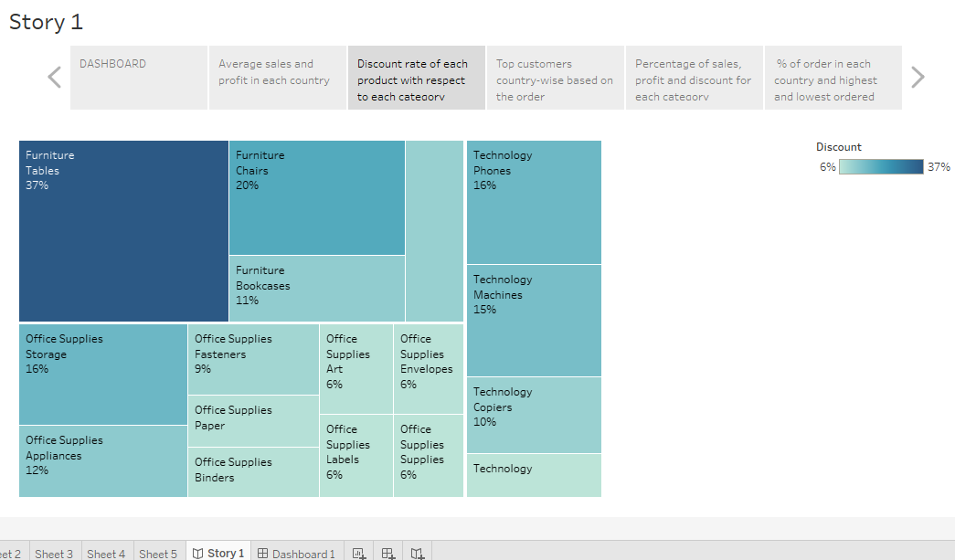

1. **Identify the Top customers country-wise based on the order**

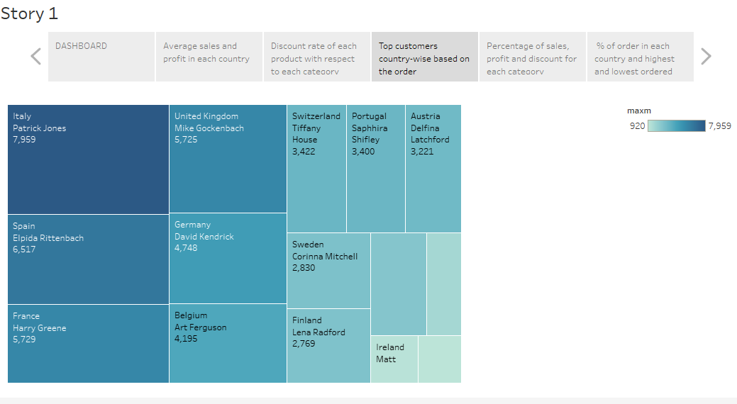

1. **Identify the % sales, profit and discount with respect to each category**

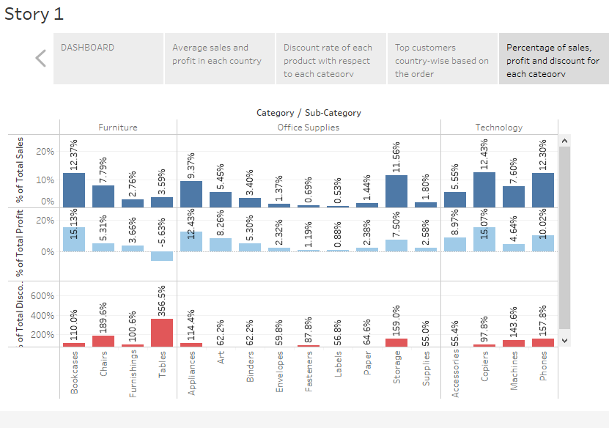

1. **Identify the % of order in each country and find out highest and lowest ordered country using treemap**

*Highest ordered country: France (28.6%)*

*Lowest ordered country: Finland (0.53%)*

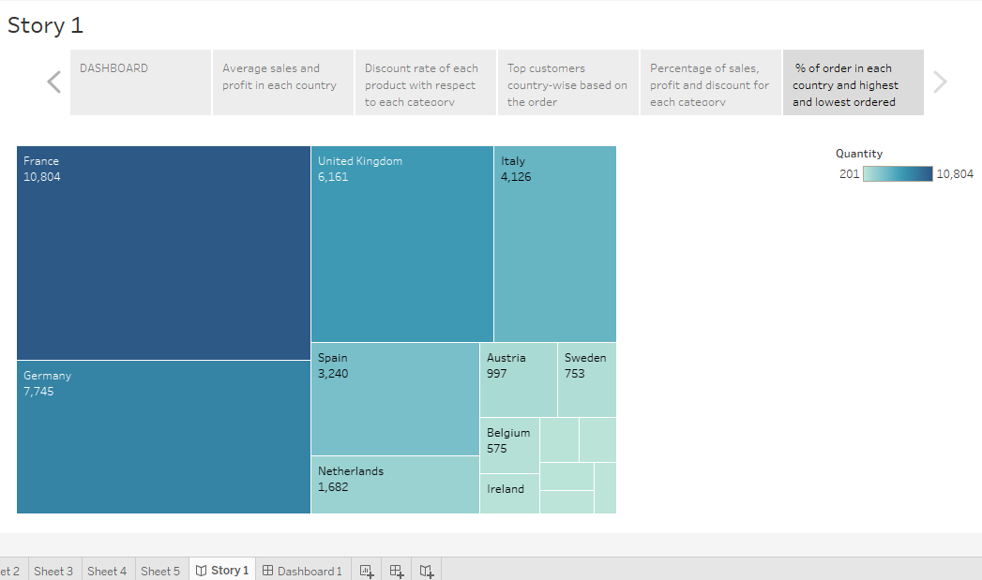

**Dashboard:**

