**Lab 13**

**R. Harini**

**18BCE1010**

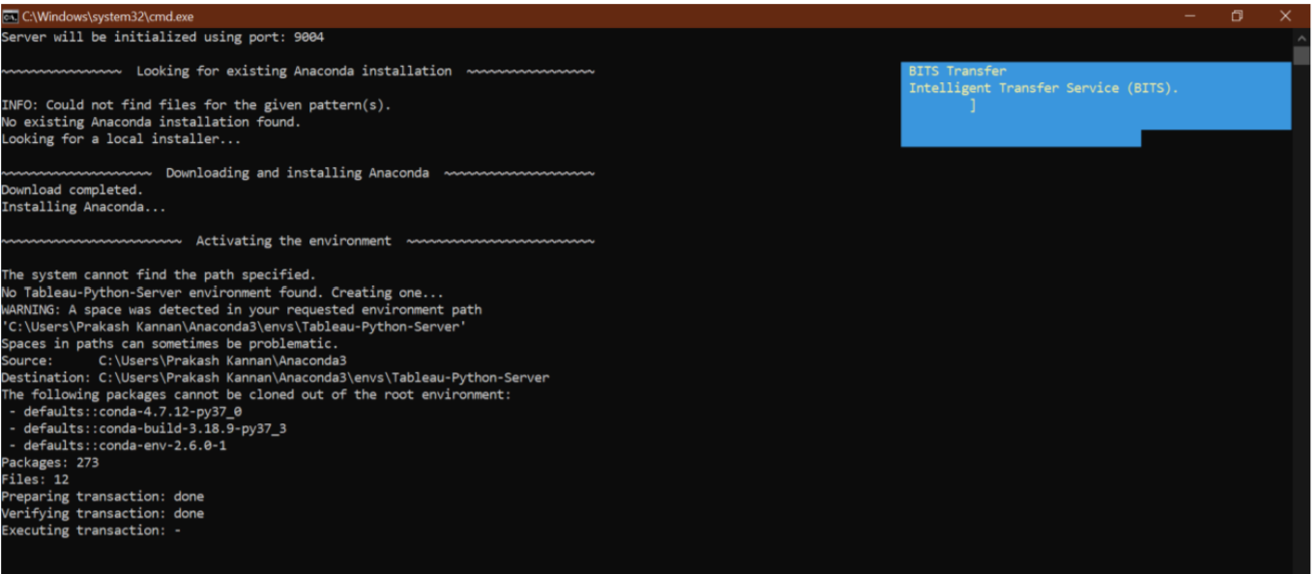

**Using Naïve Bayes algorithm for Iris dataset:**

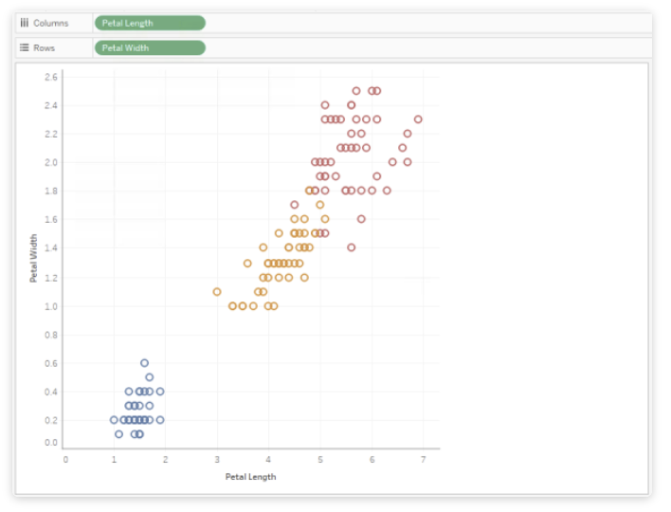

SCRIPT_REAL("

import numpy as np

from sklearn.naive_bayes import GaussianNB

# create the model

model = GaussianNB()

# transform input data

data_x = np.transpose(np.array([_arg1, _arg2, _arg3, _arg4]))

data_y = np.array(_arg5)

# fit the model

model.fit(data_x, data_y)

# predict the category for input data

predicted_category = model.predict(data_x)

# transform output

return list(np.round(predicted_category, decimals=2))

", ATTR([Petal Length]),

   ATTR([Petal Width]),

   ATTR([Sepal Length]),

   ATTR([Sepal Width]),

   ATTR([Category]))

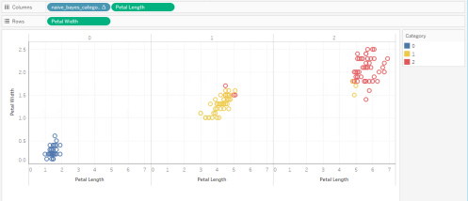

**Regression model for Air Passengers data:**

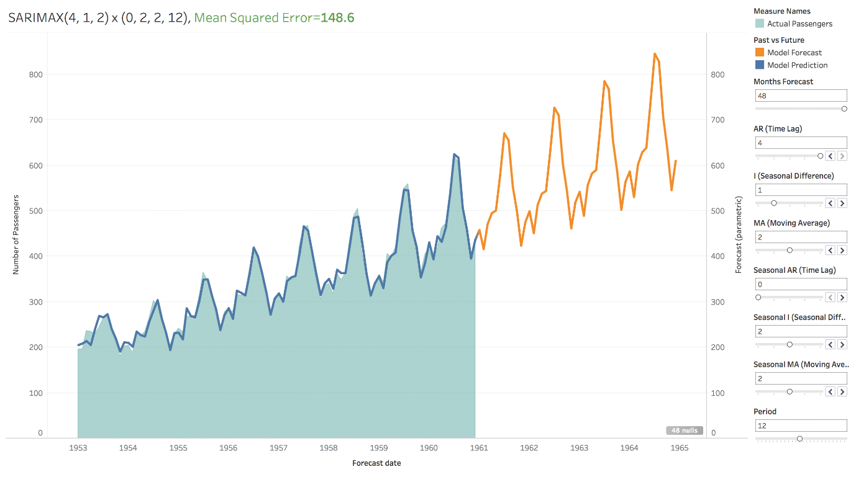

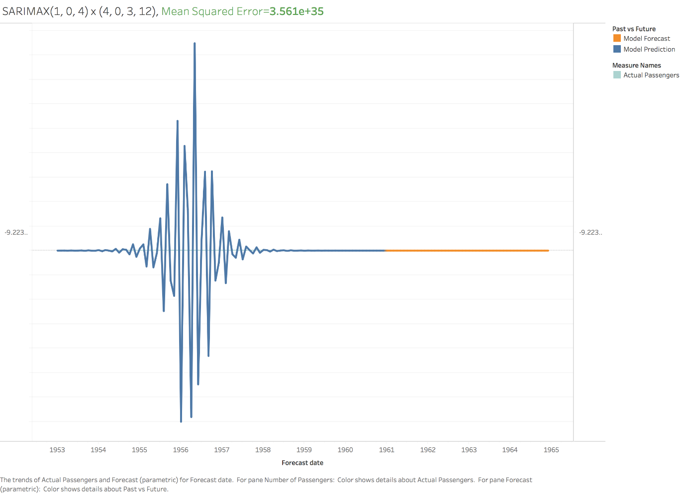

|  |
| --- |
| SCRIPT_REAL( |
|  | ' |
|  | import pandas as pd |
|  | import statsmodels.api as sm |
|  |  |
|  | dates = _arg1 |
|  | passengers = _arg2 |
|  | order_ar = min(_arg3) |
|  | order_i = min(_arg4) |
|  | order_ma = min(_arg5) |
|  | months_forecast = min(_arg6) |
|  | seasonal_ar = min(_arg7) |
|  | seasonal_i = min(_arg8) |
|  | seasonal_ma = min(_arg9) |
|  | period = min(_arg10) |
|  |  |
|  | y = pd.Series(data=passengers, index=dates) |
|  |  |
|  | mod = sm.tsa.statespace.SARIMAX(y, |
|  | order=(order_ar, order_i, order_ma), |
|  | seasonal_order=(seasonal_ar, seasonal_i, seasonal_ma, period), |
|  | enforce_stationarity=False, |
|  | enforce_invertibility=False) |
|  |  |
|  | results = mod.fit() |
|  |  |
|  | pred_uc = results.get_forecast(steps=months_forecast) |
|  |  |
|  | pred = results.get_prediction(start=(pd.to_datetime("1949-01-01")) + pd.DateOffset(months=months_forecast), dynamic=False) |
|  |  |
|  | data = list(pred.predicted_mean) |
|  | data.extend(pred_uc.predicted_mean) |
|  |  |
|  | return data |
|  | ', |
|  | ATTR([Month]), |
|  | ATTR([#Passengers]), |
|  | MIN([AR (Time Lag)]), |
|  | MIN([I (Seasonal Difference)]), |
|  | MIN([MA (Moving Average)]), |
|  | MIN([Months Forecast]), |
|  | MIN([Seasonal AR (Time Lag)]), |
|  | MIN([Seasonal I (Seasonal Difference)]), |
|  | MIN([Seasonal MA (Moving Average)]), |
|  | MIN([Period])) |