**Lab3: Correlation plot**

**R.Harini**

**18BCE1010**

**Code:**

install.packages("corrplot")

library(corrplot)

dataset=quakes

cm=cor(dataset)

corrplot(cm, method="circle")

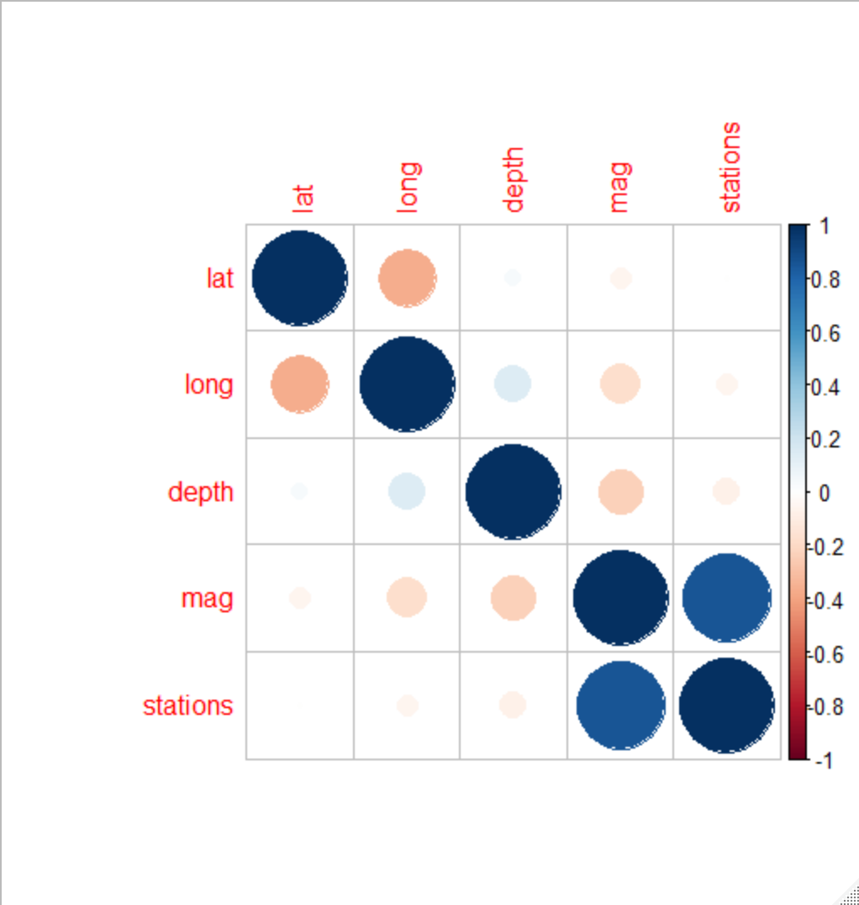

corrplot(cm, method="pie")

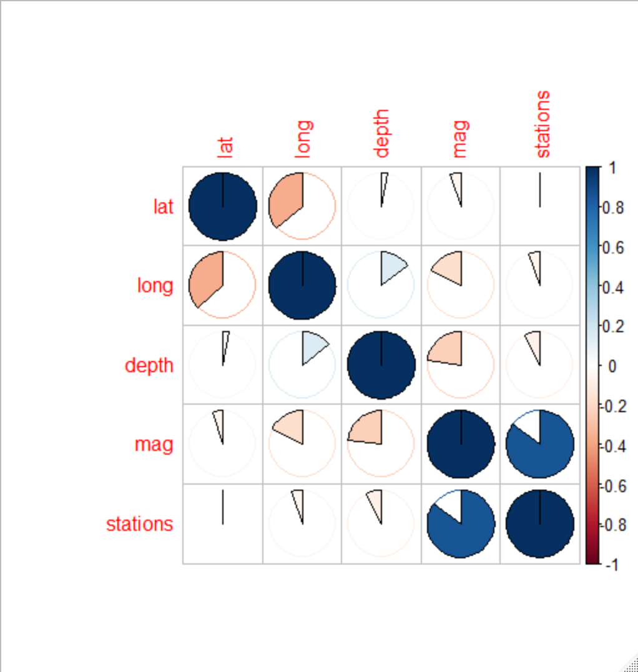

corrplot(cm, method="square")

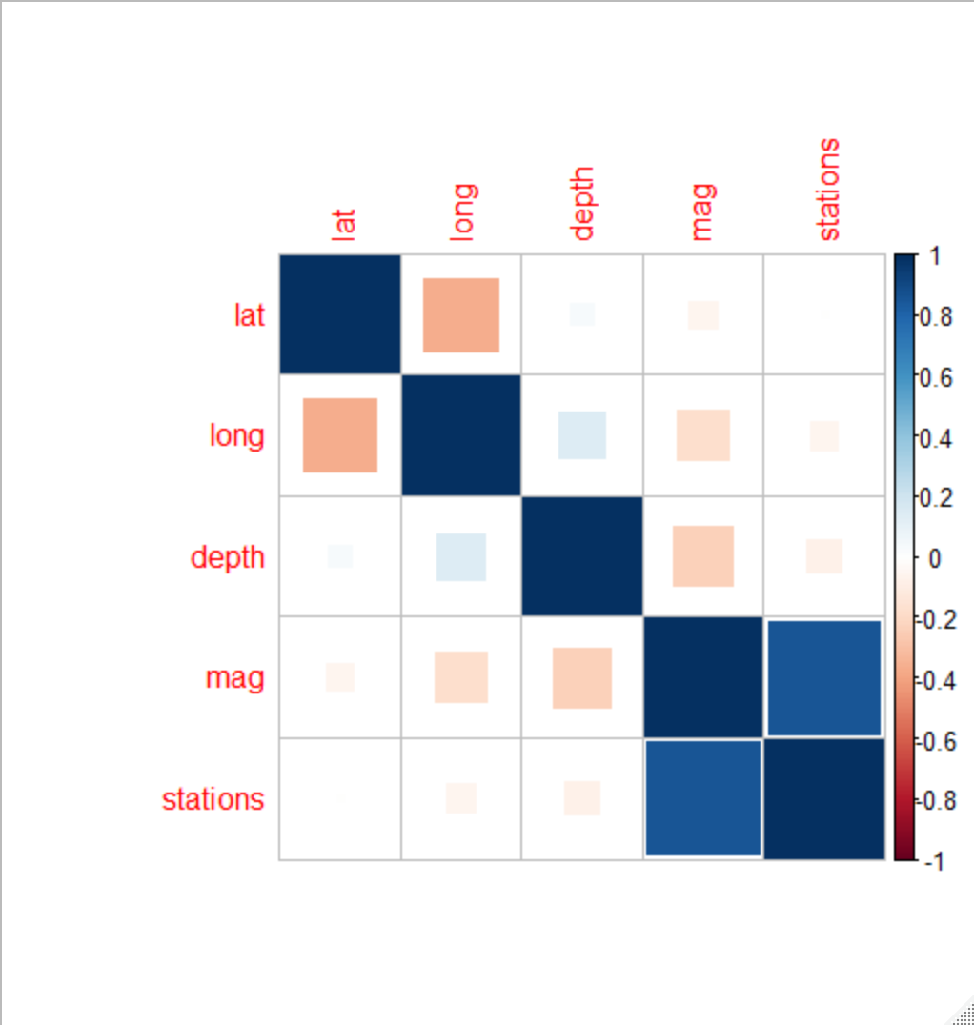

corrplot(cm, method="number")

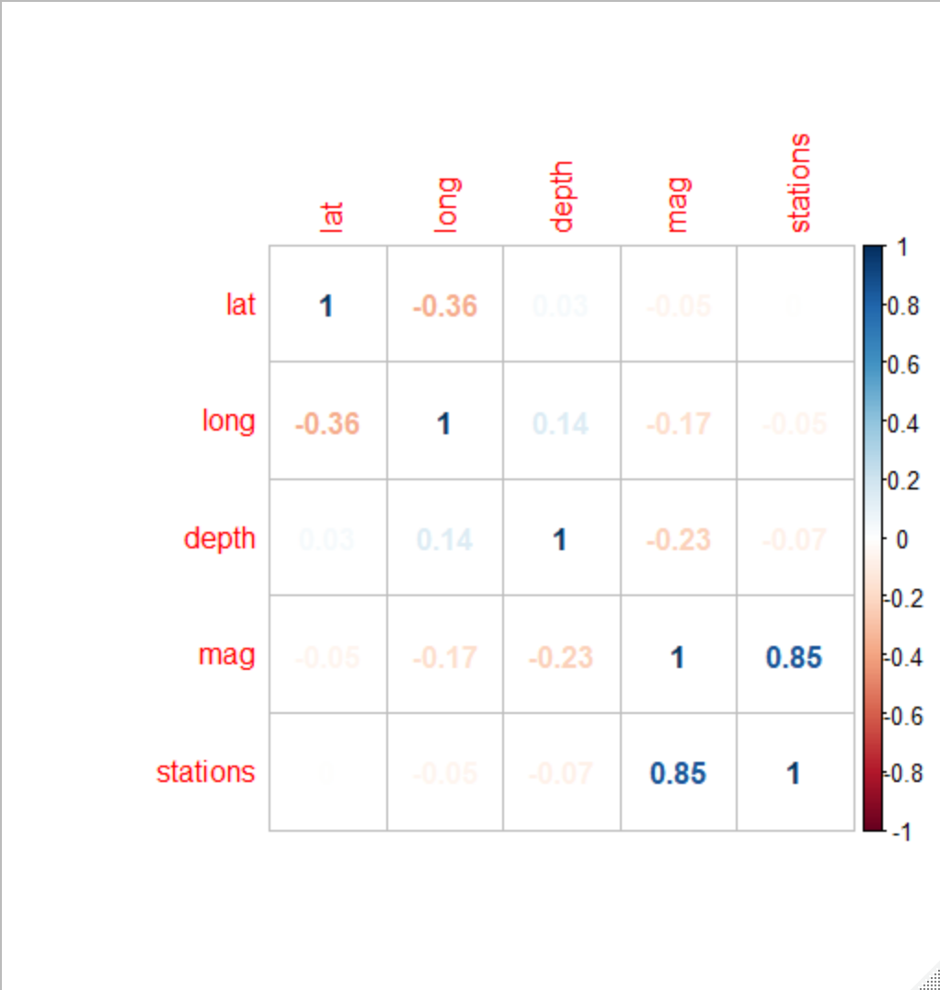

corrplot(cm, method="color")

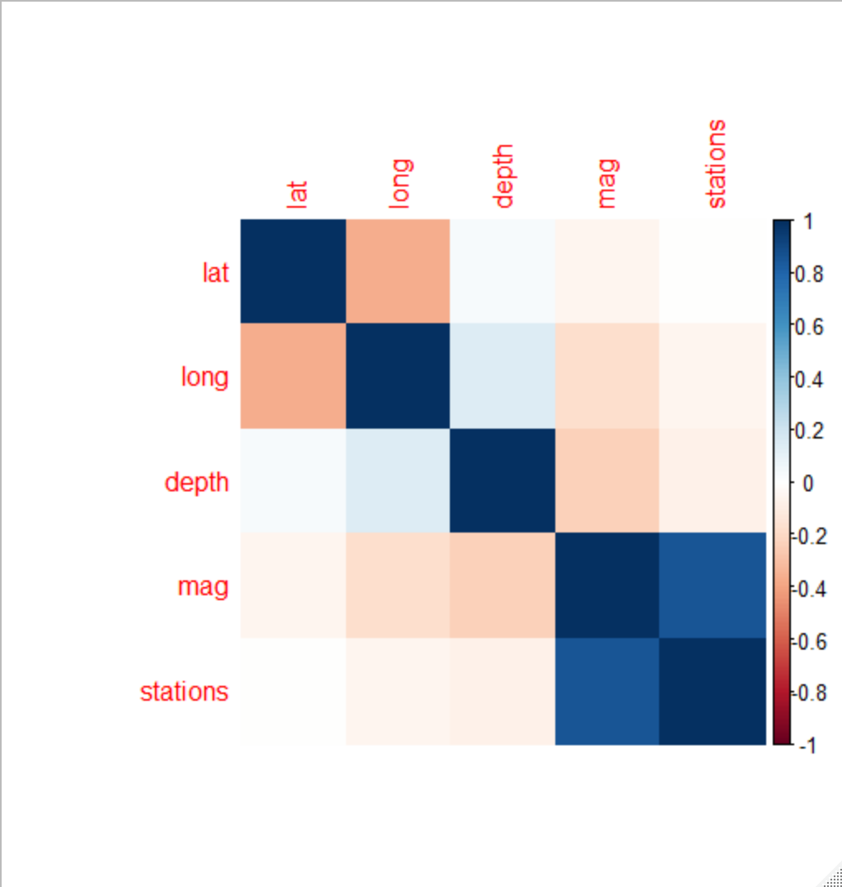

corrplot(cm, method="ellipse")

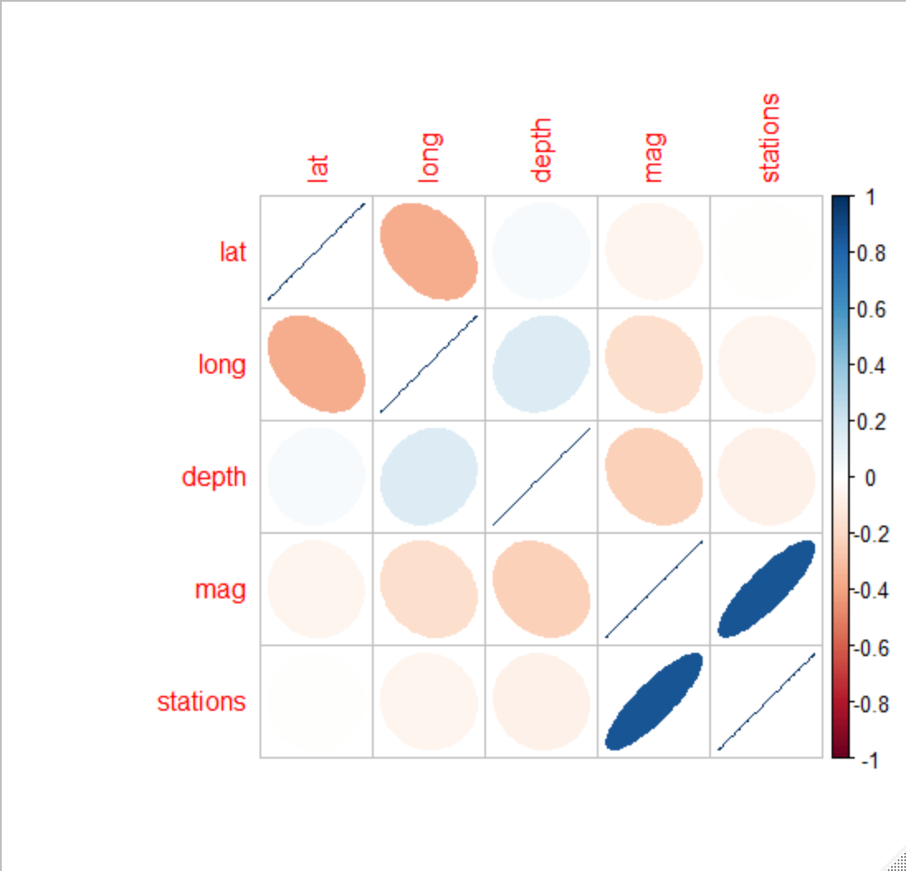

corrplot(cm, method="shade")

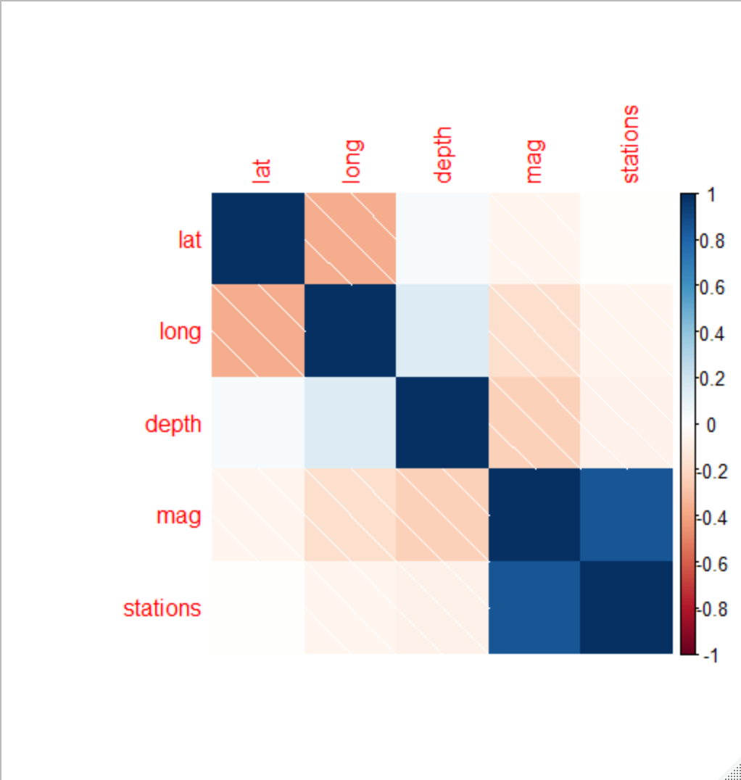

corrplot(cm, type="upper")

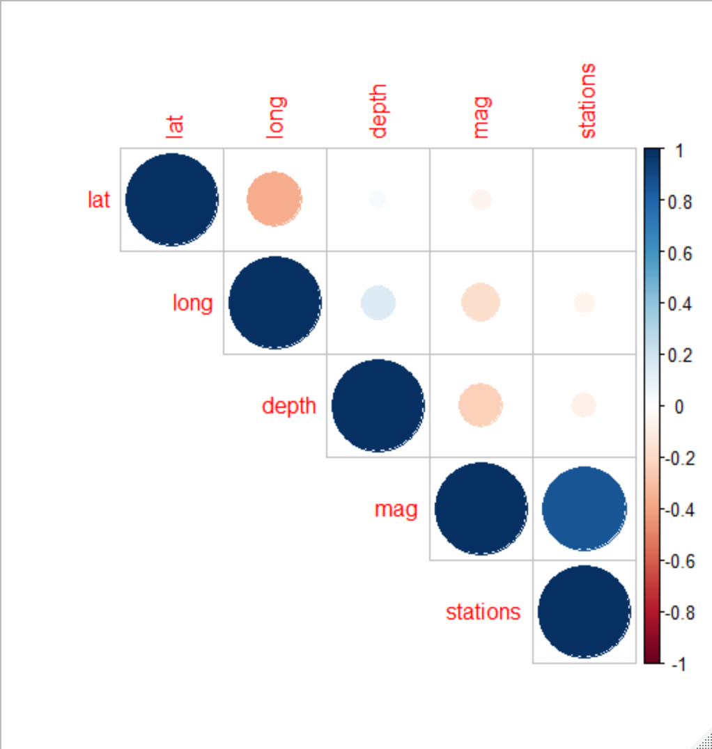

corrplot(cm, type="lower")

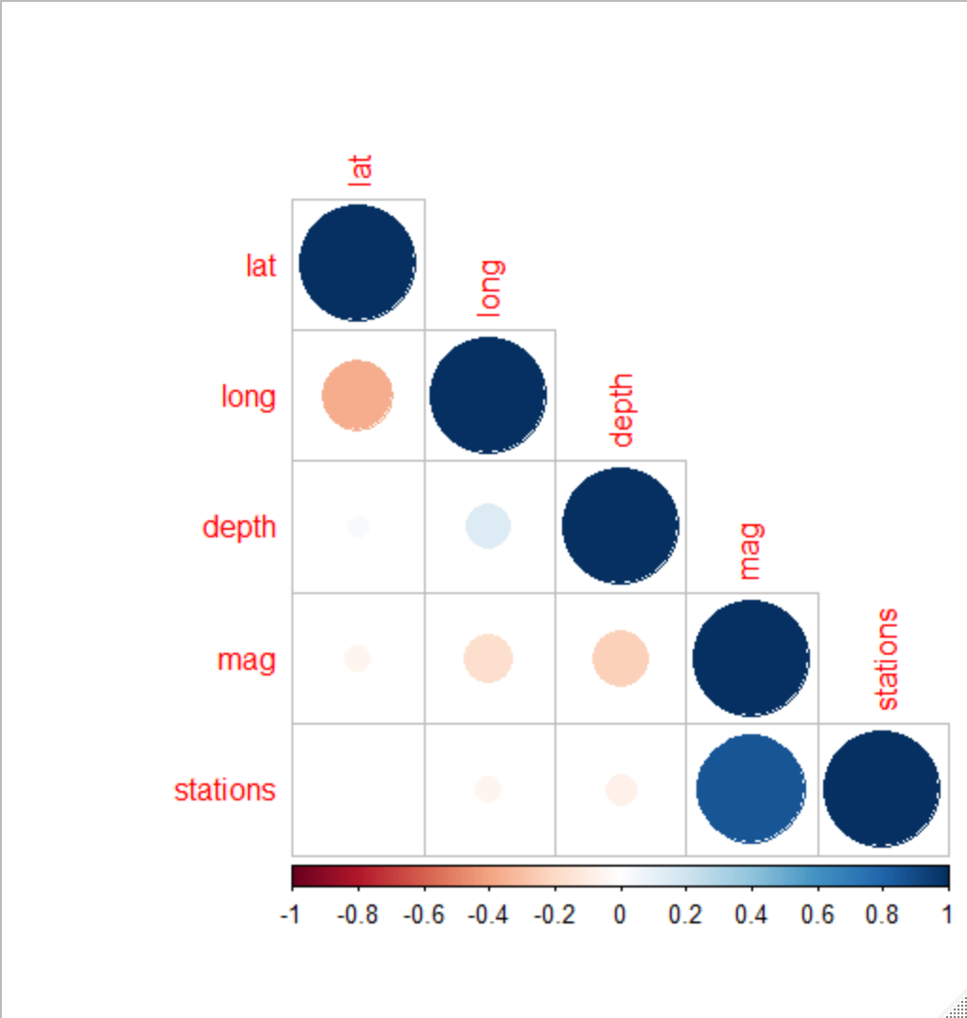

corrplot.mixed(cm)

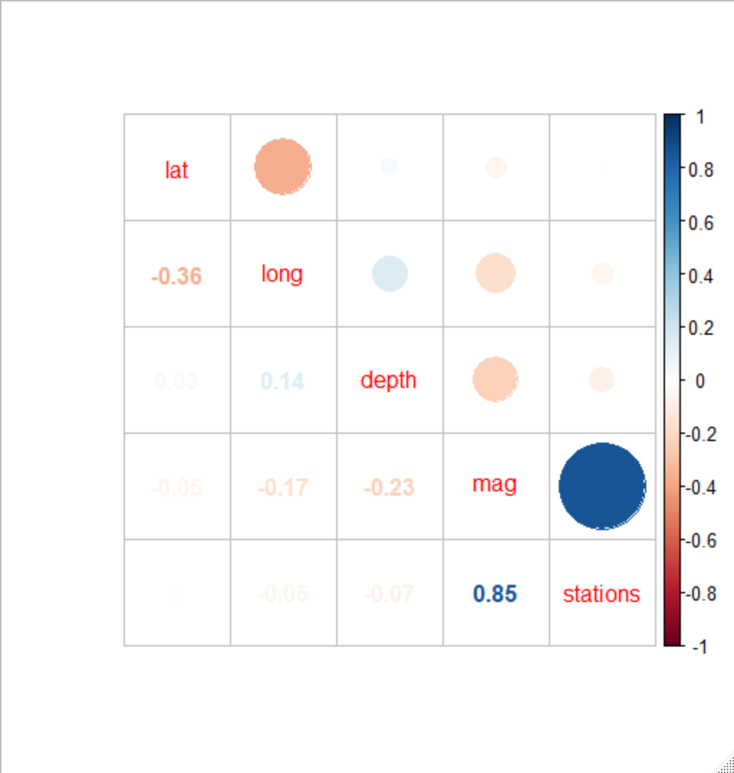

corrplot.mixed(cm, lower.col = "black", number.cex = .7)

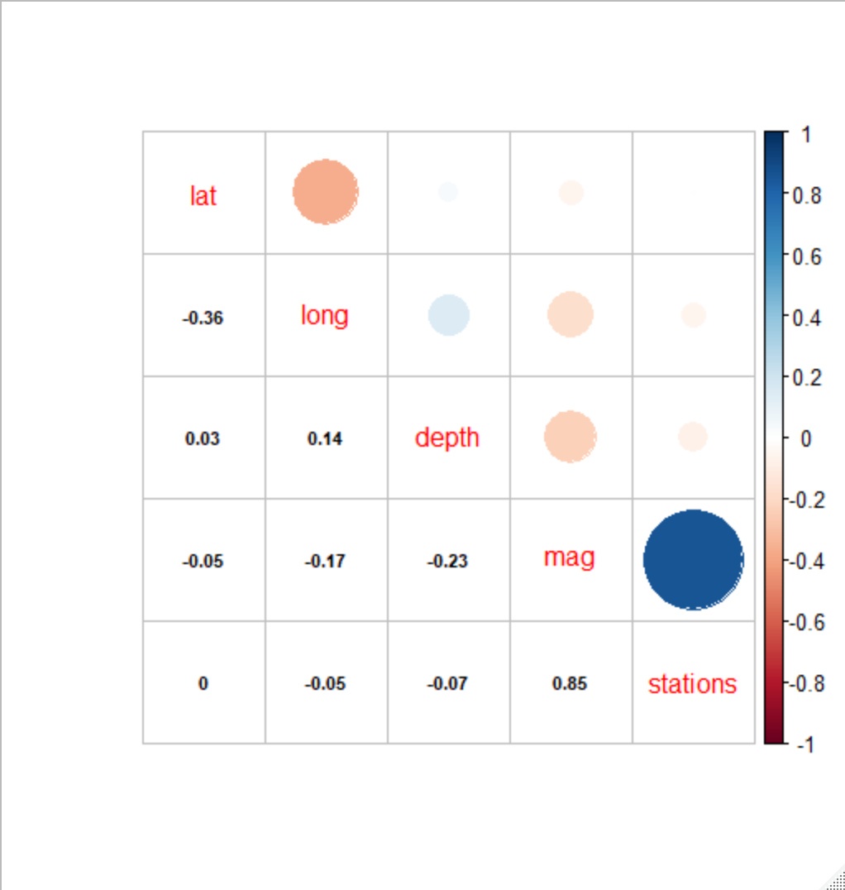

corrplot.mixed(cm, lower = "ellipse", upper = "circle")

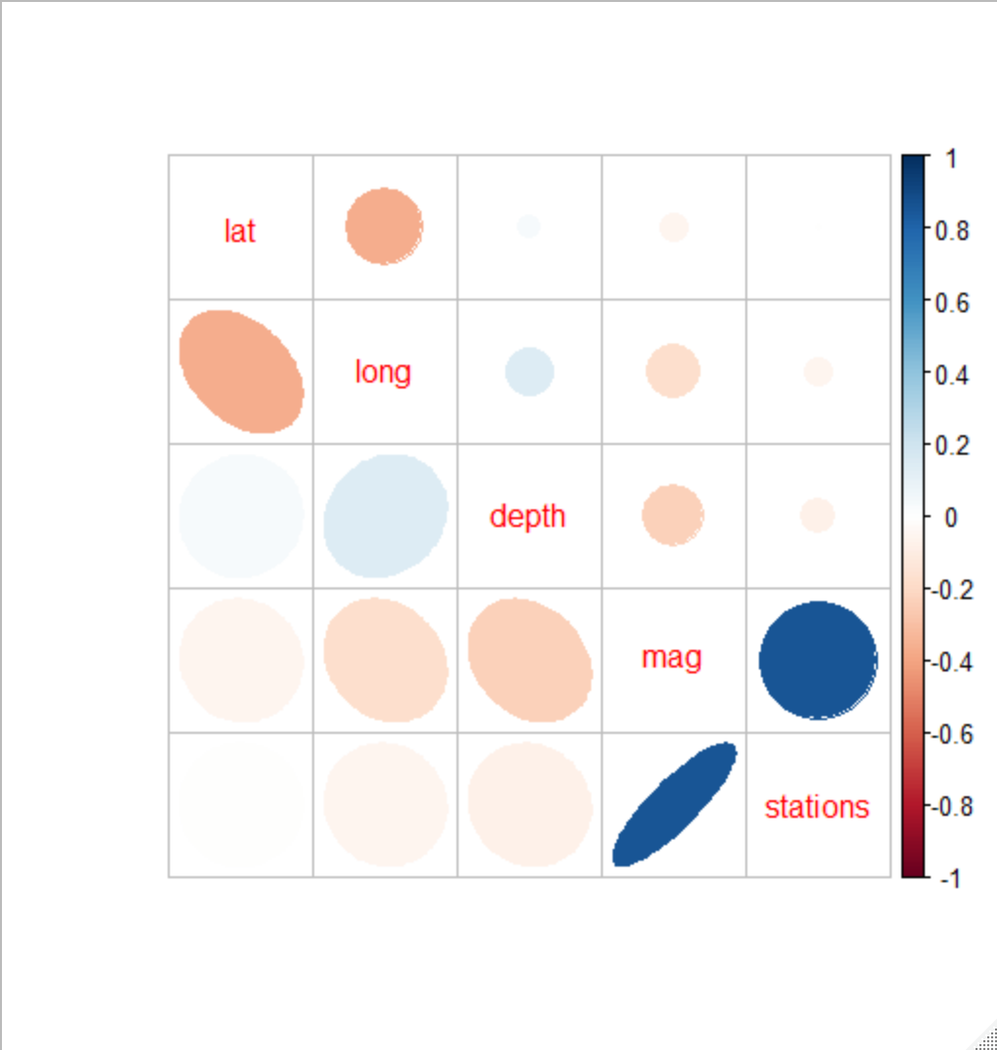

corrplot.mixed(cm, lower = "square", upper = "circle", tl.col = "black")

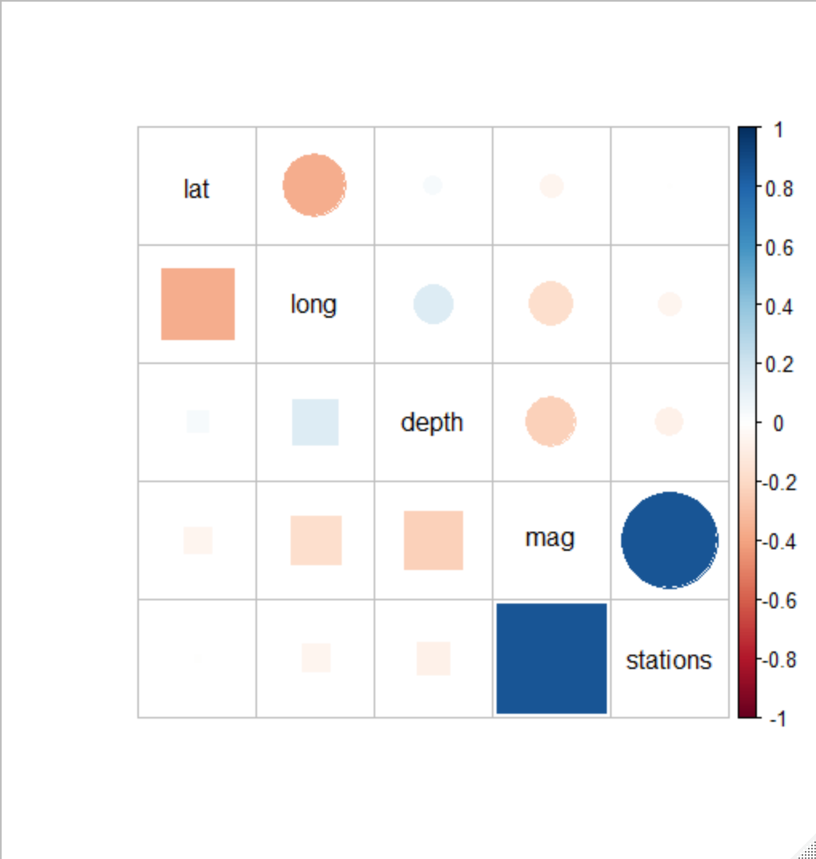

corrplot(cm, order = "hclust", addrect = 2)

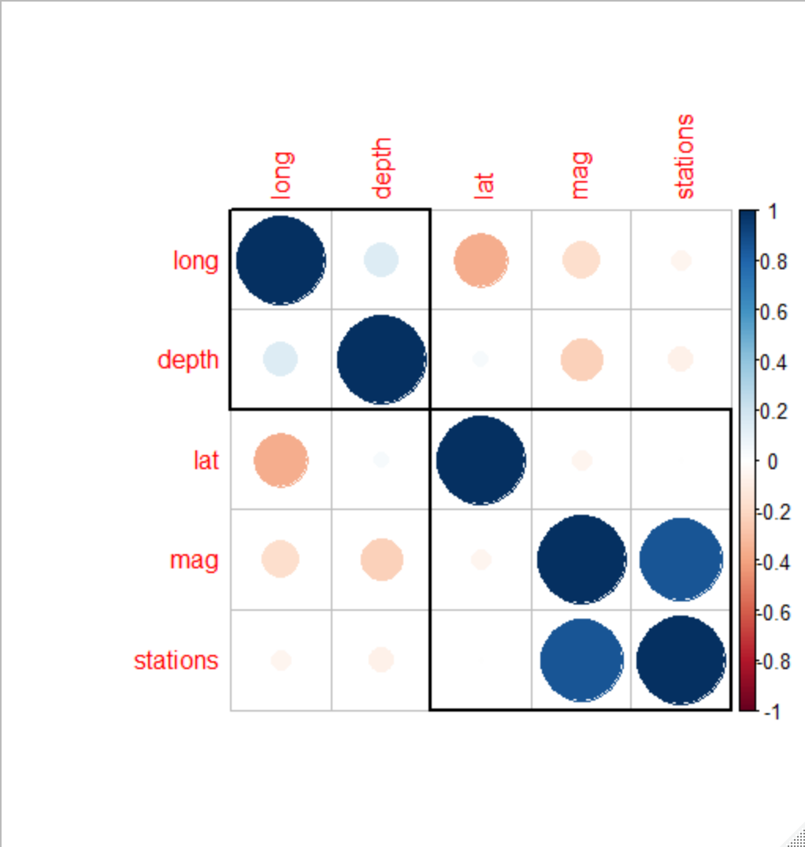

**Positive correlations are displayed in blue color and negative correlations are displayed in red color.**

dataset_select=dataset[dataset$lat<(-20) & dataset$long>180 & dataset$depth>200 & dataset$mag<(4.5) & dataset$stations<20, ]

#ScatterPlot with encircling

ggplot(dataset, aes(x=lat, y=long))+

geom_point(aes(col=depth, size=mag))+geom_smooth(method="loess", se=F)+

xlim(c(-30, 30))+

ylim(c(100,200))+

geom_encircle(aes(x=lat, y=long), data=dataset_select, color="red", size=2, expand=0.08)+

labs(subtitle="Latitude vs Longitude",

y="Longitude", x="Latitude", title="Scatterplot+ Encircle", caption="Source: Quakes")

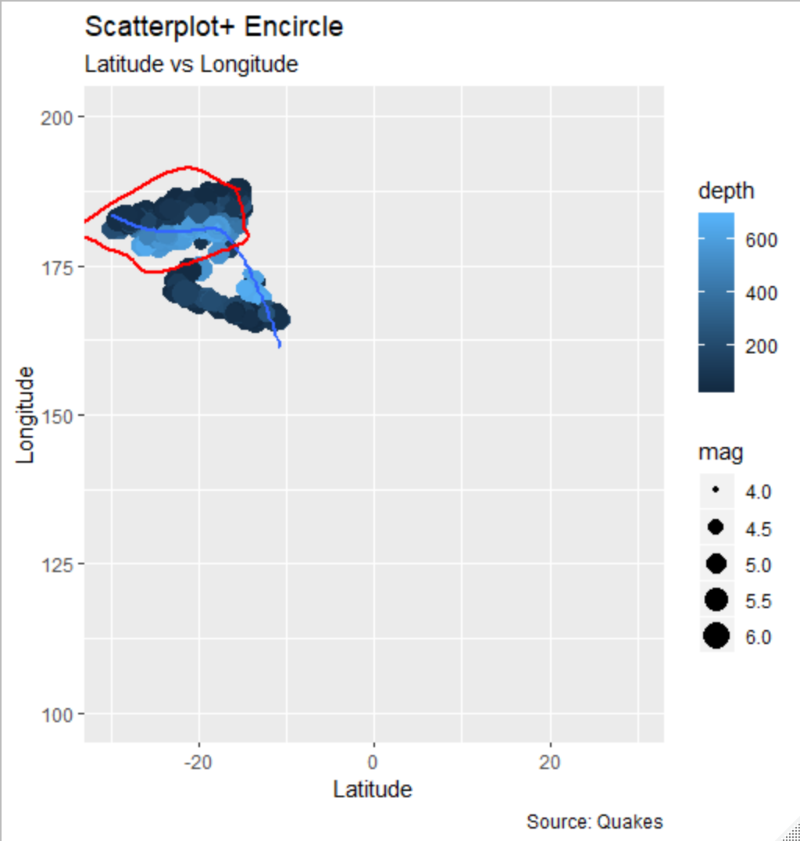

**Jitter Plot:**

#Jitter Plot

theme_set(theme_bw())

g+geom_jitter(width=.5, size=1)+labs(subtitle = "Quakes: Latitude vs Longitude", y="Longitude", x="Latitude", title="Jittered Points")

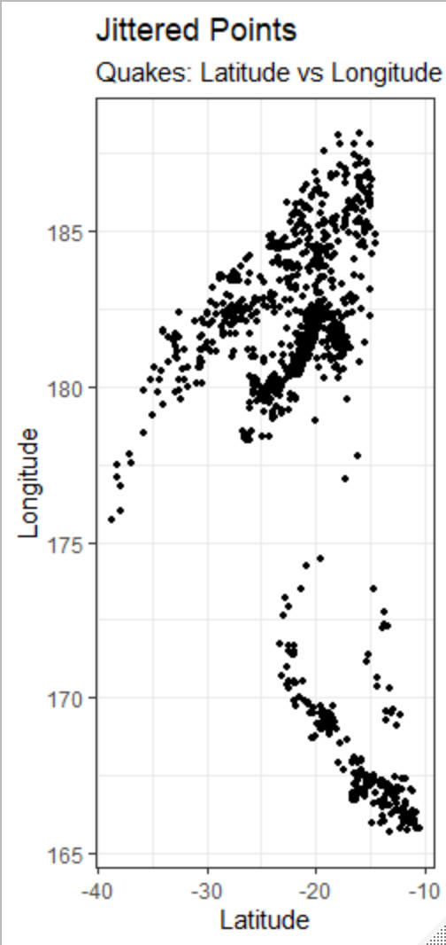

**Counts Plot:**

#Counts Chart

g+geom_count(col="red", show.legend = F)+labs(subtitle = "Latitude vs Longitude", y="Latitude", x="Longitude", title="Counts Plot")

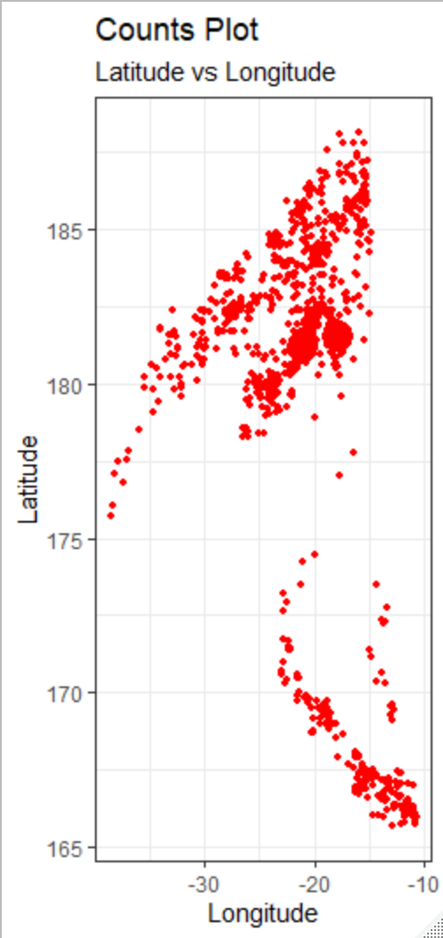

**Bubble Plot:**

#Bubble Chart

gg=ggplot(dataset_select, aes(lat, long))+ labs(subtitle="Quakes: Latitude vs Longitude", title="Bubble Plot")

g+geom_jitter(aes(col=depth, size=mag))+geom_smooth(aes(col=depth), method="lm", se=F)

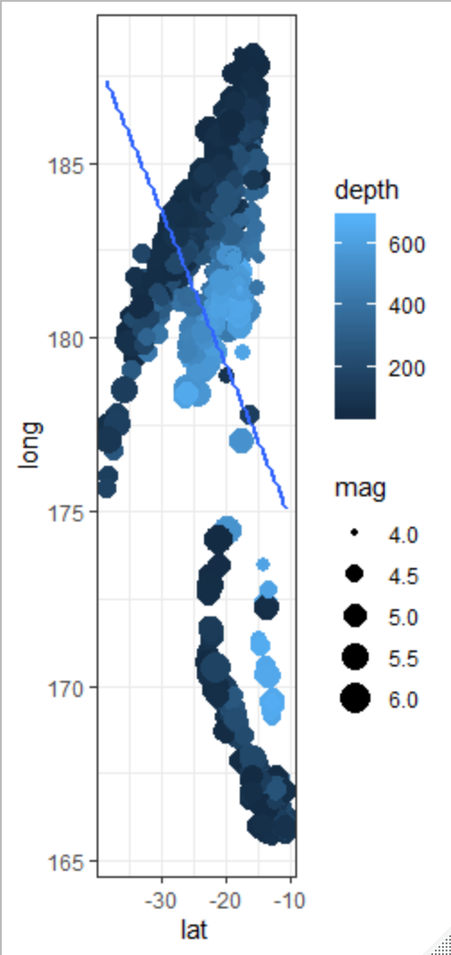

Since the line drawn through the point has a negative slope, this graph shows negative correlation.